Solubility of Drugs
Definition of Terms:
• Solution- a mixture of two or more components that form a single phase which is homogenous down to the molecular level. Mixing is spontaneous, mixtures are thermodynamically stable, in-homogeneties on molecular levels, properties of solution are independent on the way they are prepared.

• Solvent(s)- Dissolves the solute. Determines the phase of solution. Usually constitute the largest proportion of the system.

• Solute(s)- Dissolved in the solvent(s)- dispersed as molecules throughout the solvent.

• Dissolution- the transfer of molecules from a solid state into a solution.

• Solubility- of a substance is the amount of the solute that passes into solution when the equilibrium is established. The solution that is obtained under these conditions is saturated.

• Unsaturated- less than max. amount of solute dissolved in solvent.

• Supersaturated- solutions that are formed by dissolving the solute to a level in excess of its solubility in a particular solvent with the aid of heat.
• Miscibility- 2 gases or 2 liquids

True solution : A true solution is a mixture of two or more components that form a homogeneous molecular dispersion (a one-phase system).
•In a true solution, the suspended particles: completely dissolve .
•are not large enough to scatter light are small enough to be evenly dispersed resulting in a homogeneous appearance.

Dispersion systems:
•A dispersion consists of at least two phases with one or more dispersed (internal) phases contained in a single continuous (external) phase.
-coarse dispersions.
-colloidal dispersion

•The diameter of particles in coarse dispersions is greater than ~500 nm (0.5 µm). Two common pharmaceutical coarse dispersions are emulsions (liquid– liquid dispersions) and suspensions (solid–liquid dispersions).

A colloidal dispersion represents a system having a particle size intermediate between that of a true solution and a coarse dispersion, roughly 1 to 500 nm. A colloidal dispersion may be considered as a two-phase (heterogeneous) system under some circumstances.

Types of Solutions:
♠A solution may be classified according to the states in which the solute and solvent occur. gas, liquid and
crystalline , nine types of homogeneous mixtures of solute and solvent are possible.
♠The solutes (whether gases, liquids or solids) are divided into two main classes; non electrolytes and electrolytes.
▪ Non electrolytes
Electrolytes

Expressions of Concentration in solutions:
• Quantity per quantity- the weight/volume of solute that is contained in a given weight/volume of the solution. E.G. 1g/L, 0.1g per 100mL.

• Percentage- used with one of the four different meanings according to circumstances: % w/w, % w/v, % v/v and % v/w.

• Parts- number of ‘parts’ of solute dissolved in a stated no. ‘parts’ of solution, e/g/ ppm and ppb.

• Molarity- no. moles of solute in 1L of solution. Unit= mol/L.

• Molality- no. moles of solute divided by the mass of the solvent. Unit= mol/kg.

• Equivalent- mass (in g) of a substance that reacts with 6x10²³ (Avogadro’s Number). It is equal to the amount of substance in moles divided by the valence of the substance. For monovalent ions, 1

equivalent (Eq) = 1 mole. For divalent ions, 1Eq = 0.5 mol -> 2Eq = 1 mole.

• Normal solutions- no. equivalents (in g) in 1L of solution. E.G. 1Eq/L (1N).

• Ratio- no. g or mL of solute in g of mL of solution -:- w/w, -:- w/v, -:- v/v, -:- v/w. E.G. 1:1000 w/v (1g solute in 100mL preparation).

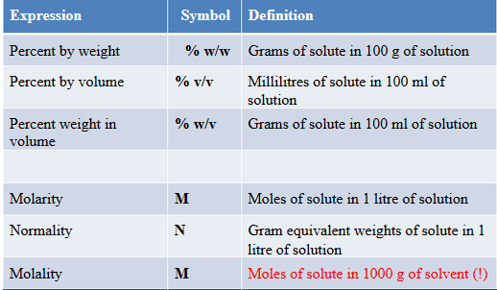

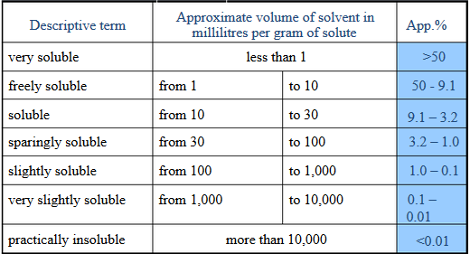

Importance of Solubility:
Oral ingestion is the most convenient and commonly employed route of drug delivery due to its ease of administration, high patient compliance, costeffectiveness, least sterility constraints, and flexibility in the design of dosage form. As a result, many of the generic drug companies are inclined more to produce bioequivalent oral drug products.
However, the major challenge with the design of oral dosage forms lies with their poor bioavailability. The oral bioavailability depends on several factors including aqueous solubility, drug permeability, dissolution rate, first-pass metabolism, presystemic metabolism, and susceptibility to efflux mechanisms. The most frequent causes of low oral bioavailability are attributed to poor solubility and low permeability.
Solubility also plays a major role for other dosage forms like parenteral formulations as well. Solubility is one of the important parameters to achieve desired concentration of drug in systemic circulation for achieving required pharmacological response. Poorly water soluble drugs often require high doses in order to reach therapeutic plasma concentrations after oral administration. Low aqueous solubility is the major problem encountered with formulation development of new chemical entities as well as generic development.
Any drug to be absorbed must be present in the form of an aqueous solution at the site of absorption. Water is the solvent of choice for liquid pharmaceutical formulations.
Most of the drugs are either weakly acidic or weakly basic having poor aqueous solubility.
More than 40% NCEs (new chemical entities) developed in pharmaceutical industry are practically insoluble in water. These poorly water soluble drugs having slow drug
absorption leads to inadequate and variable bioavailability and gastrointestinal mucosal toxicity. For orally administered drugs solubility is the most important one rate limiting parameter to achieve their desired concentration in systemic
circulation for pharmacological response. Problem of solubility is a major challenge for formulation scientist.
The improvement of drug solubility thereby its oral bioavailability remains one of the most challenging aspects of drug development process especially for oral-drug delivery system. There are numerous approaches available and reported in literature to enhance the solubility of poorly water-soluble drugs. The techniques are chosen on the basis of certain aspects such as properties of drug under consideration, nature of excipients to be selected, and nature of intended dosage form.
The poor solubility and low dissolution rate of poorly water soluble drugs in the aqueous gastrointestinal fluids often cause insufficient bioavailability. Especially for class II (low solubility and high permeability) substances according to the BCS, the bioavailability may be enhanced by increasing the solubility and dissolution rate of the drug in the gastrointestinal fluids. As for BCS class II drugs rate limiting
step is drug release from the dosage form and solubility in the gastric fluid and not the absorption, so increasing the solubility in turn increases the bioavailability for BCS class II drugs.
The negative effect of compounds with low solubility include poor absorption and bioavailability, insufficient solubility for IV dosing, development challenges leading to increasing the development cost and time, burden shifted to patient (frequent high-dose administration).

