In the pharmaceutical industry, “technology transfer” refers to the processes that are needed for successful progress from drug discovery to product development to clinical trials to full-scale commercialization or it is the process by which a developer of technology makes its technology available to commercial partner that will exploit the technology.

Learn about how to write “Technology Transfer” Protocol.
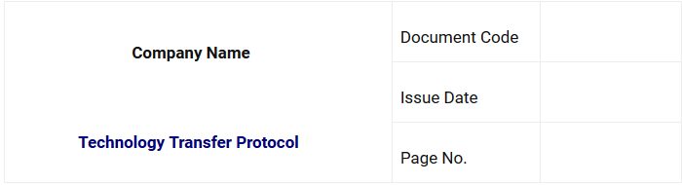

TECHNOLOGY TRANSFER PROTOCOL APPROVAL:
The technology transfer protocol is prepared by integrated inter-disciplinary team of cross functional experts from different departments including Research & Development (R&D), Quality Control (QC), Production Department, Quality Assurance (QA) and Maintenance.

II. PURPOSE
To provide documented evidence that (developed by R&D) can be reproduced consistently against a set of predefined specifications.
III. OBJECTIVE
To elucidate necessary information to transfer technology from R&D to actual manufacturing by sorting out information obtained during R&D work.
IV. SCOPE
This protocol applies for complete technology transfer of product within (Company Name).

V. KEY PERSONNEL AND THEIR RESPONSIBILITIES:
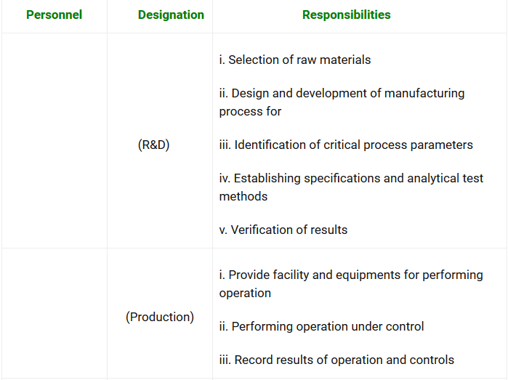
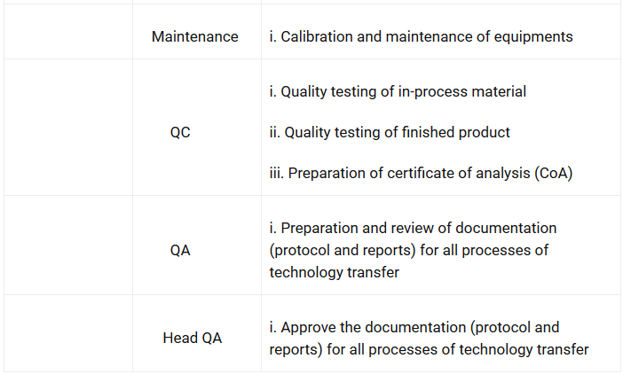

VI. TECHNOLOGY TRANSFER PROCESS

Quality is designed based on basic data concerning efficacy and safety obtained from various studies. Various standards for manufacturing and tests will be established in process during reviewing factory production and will be upgraded to the quality of product and the actual production will be started. The technology transfer consists of actions taken in these flows of development to realize the quality as designed during the development stage. The technology transfer processes are classified broadly as mentioned below:

a. Quality Design (Research Phase)
During experimentation work at lab scale, various experiments are designed in order to comply with international quality standards and viability of product in terms of yield of the product. Following lab experiments are conducted:

b. Scale-up and detection of quality variability factors (Development Phase)
i. Research for factory production
To manufacture as per quality standards obtained during lab experiments, it is required to establish appropriate quality control method and manufacturing method, after detecting variability factors to secure stable quality in the scale-up batches that is performed to realize factory production of designed on the basis of results from small-scale experiments.

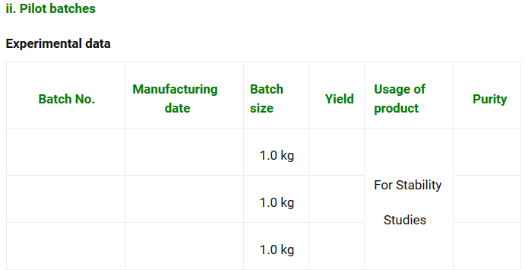

iii. Assurance of consistency through development and manufacturing
The quality parameters should be reproducible in the product. For this purpose, Research and Development (R&D) transfers development data to production for commercial production.

c. Technology transfer from R&D to Production
R&D transfers technology to production department and it is essential to establish responsibility system and prepare documents to have adequate technology exchange between the both departments for successful transfer. While transferring technology of from R&D department to production department technical information is compiled as development report.

d. Validation and Production (Production Phase)
Based on the above studies of process at various steps during development of manufacturing process, Master Manufacturing Formula (MMF) is prepared by R&D, which is reviewed and approved by Quality Assurance (QA) Department. From MMF, Batch Manufacturing Record (BMR) is derived and production is started in the plant at commercial scale based on the successful pilot scale batches which are proven to be validated batches. While starting production of in the plant, the data obtained from R&D department in the form of MMF is followed.

6.0 BENCHMARKING
Benchmarking is the process of measuring quality standards of against the best market product available. Benchmarking provides necessary insights to help us understand how our drug substance compares with market samples. In this process drug product has been compared with market samples; data shows that our material is comparable to market samples and HPLC chromatograms are also studied in terms of impurity profile.
7.0 CRITICAL STEPS AND CONTROL RANGE OF PROCESS PARAMETERS
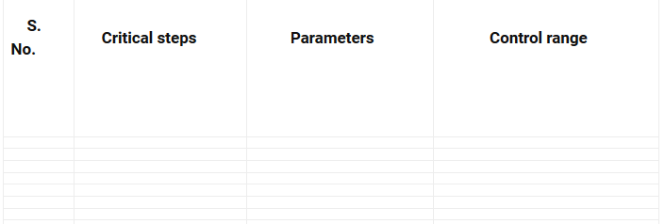
8.0 PRODUCT SPECIFICATIONS:

