Liquid-Liquid Interfaces
Distinct characteristics of liquids compared with solid and gas:
- Relative high density (than gas) and fixed volume
- Posses a mobility many order of magnitude greater than solids so, interface involving liquids generally behave as
homogeneous.

The nature of a liquid surface: surface tension
Surface tension:
    - An imbalance of the forces on surface molecules pulling into the bulk liquid and out into the adjoining vapor phase. Unit: force/length (dyne/cm, mN/m)
    - Surface energy: amount of work required to increase the surface area of the liquid by a unit amount. (unit: J/m², erg/cm²)

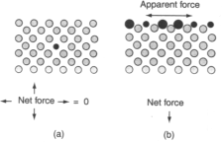
a s oap f ilm
x
l
F

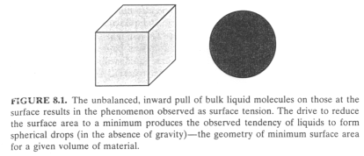

- The various attractive interactions of the two phases across the interface:
Liquid-gas > liquid-liquid, so
The interfacial tension (excess surface energy) in liquid-liquid system will be lower than in liquid-gas interface.
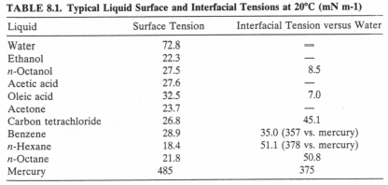

Summary found in Table 8.1
- The surface tension of water (71-73 dyne/cm at room temp.) is larger than those of the organic solvent.
- The surface tension of organic solvent changes only slightly with the chain length (molecular weight).
- The interfacial tension between two liquids:
(a). two liquids of highly immiscible σ₁₂ ≈ │σ₁₂ - σ₁₂│
(b)significantly miscible σ₁₂ << │σ₁₂ - σ₁₂│

Surface Tensions of Solutions
The presence of solute often results in the alternation of surface tension. Most commonly, the effect is to lower the surface tensions, however, the opposite effect is also found.

For two miscible liquids:
For an ideal binary mixture, the surface tension of the solution σ_{mix} :
σ_{mix} = σ₁X + σ₂(1-X) , X: mole fraction of component 1
  - Normally, there will be some positive of negative deviation from linearity. (Fig. 8.5)

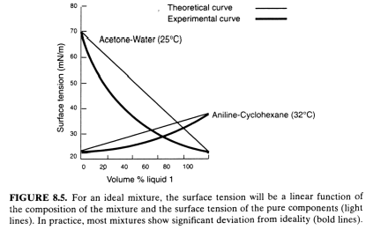

When the second component is an inorganic electrolyte
The addition of inorganic electrolyte always results in an increase in the surface tension of the solution. (the effect is not dramatic and requires rather high salt concentration) Fig. 8.6

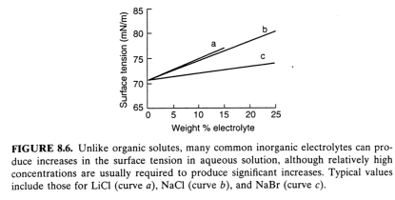

  - The relative effectiveness of ions in increasing the surface tension of water generally follows the Hofmeister series:

Li⁺ > Na⁺ > K⁺ and F⁻ > Cl⁻ > Br⁻ > I⁻
    - The effect results from a structuring of the water molecules at the surface due to salvation phenomenon.

The solute is an organic material in aqueous solution
The surface tension will decrease with addition of organic solute and the extent of such lowing depends on: (1) hydrophilic head, (2). hydrophobic tail, (3) the tendency of the material to adsorb at the
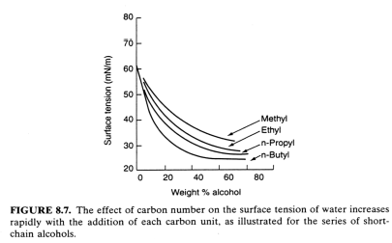
air-water interface. Fig. 8.7

- Typical surface tension-concentration curve Fig. 8.8

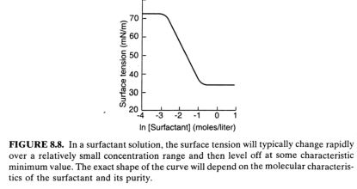

Surfactants and the Reduction of Surface Tension
Fundamental principle--- Gibbs adsorption equation

Г₂ = -(1/RT)[dσ/dlnc₂]
Surface tension of a liquid is determined by:
      - Surface excess concentration,
      - Surface activity of a surfactant molecules (K_{L}:Langmuir equilibrium adsorption constant))
The Szyszkowski equation of Langmuir isotherm:

σ = σ_{o} – nRTГ_{m} ln(1 +K_{L}C)

    - Effect of phase Densities
If the vapor phase is replaced by a condensed phase that has a higher molecular density and more opportunity for attractive interaction between molecules in the interfacial region, the interfacial tension will be reduced.
Example: Octane-water--- (weak dispersion force): to 52 mN/m Octanol-water – (polar group interact more specifically with water): to
8.5 mN/m
      - Any alteration in the nature of the molecules composing the surface would be expected to result in lowing of surface energy of the system.---action of surfactant in lowing the surface tension.
      - Most surfactants do not the affect the surface tension of organic liquid.

Surfactant Adsorption and Gibbs Monolayers
----- the basic concepts governing the adsorption of surface active molecules at the interface. –Gibbs adsorption isotherm.

Efficiency, Effectiveness, and Surfactant structure
      - Two aspects of process used to discuss the performance of a surfactant
- The concentration of surfactant in the bulk phase required to produce a given surface tension reduction-surfactant efficiency.
Ex: the concentration required to reduce 20 mN/m of surfave tension, C₂₀.
- The maximum reduction in surface tension that can be obtained –surfactant effectiveness.

  - Surfactant characteristic is relative to:
(1). surfactant structure, (2). substitution of surfactant for solvent molecules at the interface.
A surfactant can be expressed as:
CH₃(CH₂)_{n}-S, S: hydrophilic head group
    - The efficiency of a surfactant can be defined mathematically by the expression
-log (C)₂₀ = pC₂₀ = n(-A)/2.3RT +(-B)/2.3RT + K (8.9)
A, B, K: terms for the free energies of transfer of methylene (CH₂), terminal methyl (CH₃), and head groups (S), respectively.
      - Surfactant efficiency: directly related to the thermodynamics of chain transfer from bulk to interface.
      - For a given head group, the efficiency is directly dependent on the length of the hydrocarbon chain.
    - Chain modification €alter characteristic of surfactant (change in
hydrophobic character)
      - Branching in the hydrophobic group results in a reduction in the hydrophobicity of surfactant chain.
      - Carbon atoms located on branch sites contribute approximately 2/3 as much to the character as one located in the main chain.
      - A benzene ring usually contributes an effect equivalent to ≈
3.5 methylene group.
      - The methylene group lying between two polar groups contribute an effect equivalent to ≈ 1/2 of that located in the main body of the hydrophobe.

- Polyoxyethylene (POE) nonionic surfactants with an average of 7-30 OE units, exhibite adsorption efficiencies that follow an approximately linear relationship:
pC₂₀ = A_{tr} + mB_{tr}
A_{tr}: constant related to - CH2 – B_{tr}: constant related to OE group,
m : number of OE units in POE chain
  - The efficiency of adsorption decreases slightly as m
increases.

Adsorption Effectiveness
Related to the character of the maximum lowing of surface tension, (σ_{min}).
      - Approaches at maximum amount of surfactant adsorbed, Г_{m}, which is reached at maximum bulk concentration of free surfactant.
      - (σ_{min}) will be determined by one of two factors:
(a). solubility limit of Krafft temperature (T_{k}) surfactant
should be used above its T_{k}.
(b) critical micelle concentration (CMC).
Typical relationship of σ vs. lnC €linear, for concentration below CMC
-∆σ_{cmc} = (σ_{o}- σ₁) +2.3 nRTГ_{m}log(C_{cmc}/C₁) (8.11)

- A usuful method to evaluate surfactant effectiveness is by Ccmc/C20
  - A large value of C_{cmc}/C₂₀ indicates that the available free surfactant is being used more effectively. Table 8.2

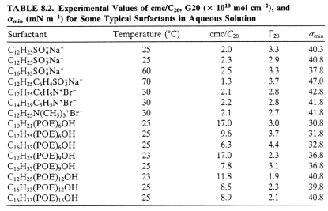

  - The efficiency and effectiveness of surfactants may not run parallel.--- It is commonly observed that the materials that produce significant lowering of the surface tension at low concentrations (i.e., are more efficient) are less effectiveness (i.e., have a smaller Г_{m})

σ
more effectiveness
more
efficiency
CMC 1
CMC 2

ln C

- The role of molecular structure in effectiveness is directed related to the size of the adsorbed molecules either hydrophobic or
hydrophilic portions
  - Maximum number of molecules that can be fitted into a given area (Γ_{m}) depends on the cross-sectional area of the hydrophobic chain or of the head group, whichever is greater. (Fig. 8.9)

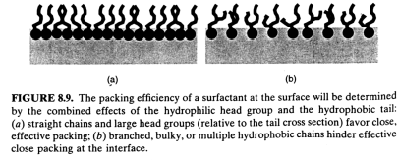

  - For straight chain ionic surfactant€the head group is always predominated.-----so, σ_{min} varies only slightly with the length of the hydrocarbon chain.(Table 8.2)
  - σ_{min} relate toΓ_{m}, Γ_{m} increases €σ_{min} decreases (higher effectiveness)
  - The sign of the charge on the ionic surfactant has only minor effect indicating that geometric requirement are fairly
constant from one head group to the next.
  - In the presence of electrolyte€electrostatic repulsion between adjacent molecules are reduced €effective area becomes smaller
€slight increase in surfactant effectiveness.
  - For normal alkyl surfactants, chain lengths C₈ – C₂₀ have minor effect on the effectiveness.
- Other structure changes that give much more dramatic effects:
  - Branching and multiple-chain hydrophobe €increases in CMC€increase in effectiveness (smaller effect on efficiency)

  - Introduction of another polar groups located well away from the head group (Fig. 8.10) €change in orientation of the adsorbed molecules €significant lowing of both efficiency and effectiveness.
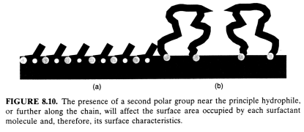

- When fluorine atoms are substituted for hydrogen in the hydrophobic group €significant increase in the efficiency and effectiveness
  - fluorinated organic materials have a little interaction with adjacent phase€high driving force for adsorption€high efficiency
  - fluorine has very low surface energy €very low surface tension (high effectiveness)
- Effects of counterion: tight ion bounding reduces the electrostatic repulsion between adsorbed molecules €tighter packing of surfactant € increases in both the efficiency and the effectiveness.
- The head group may be of minor importance for hydrophiles closely related in size and charge character.
Ex: R-N⁺(CH₃)₃X⁻ (cationic surfactant)
  - The substitution of larger alkyl groups for methyl groups results in significantly reduction in efficiency of adsorption, while not affecting σ_{min} significantly.

Insoluble Monomolecular Films
Insoluble monolayer: for materials that have very low solubility in the supporting liquid phase and are essentially isolated on the surface.
A schematic comparison of the adsorbed monolayer (Gibbs monolayer) and the insoluble monolayer (Langmuir monolayer)--- Fig. 8.11

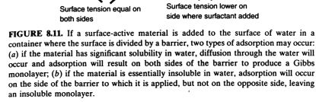
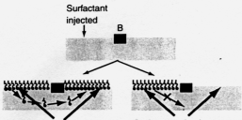

    - If surfactant is injected to one side of the surface (as shown in Fig. 8.11) and wait for equilibrium.
      - For the left figure (Gibbs monolayer), σ_{L} = σ_{R}, the barrier B does not move
      - For the right figure (insoluble monolayer), the barrier will move away from the side to which the surfactant (stearic acid) is added due to higher surface pressure.

