Molecules and ions that are adsorbed at interfaces are termed
surface-active agents or surfactants.
Surfactants have two distinct regions in their chemical structure, one of which is water-liking (hydrophilic) and the other of which is lipid-liking (lipophilic). These molecules are referred to as amphiphile.
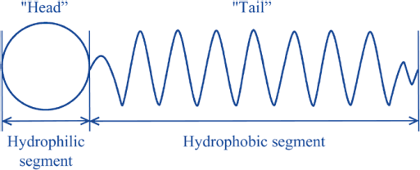

17

When such molecule is placed in an air-water or oil-water system, the polar groups are oriented toward the water, and the nonpolar groups are oriented toward the air or oil.

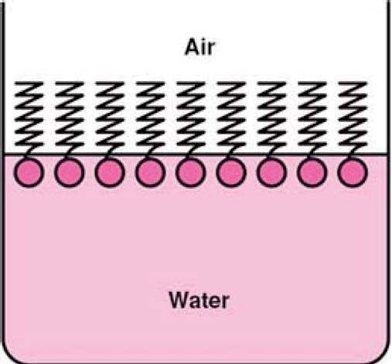
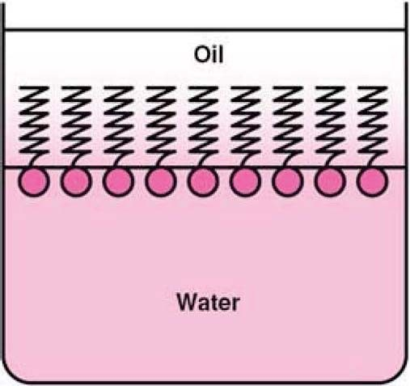

Non-ionic surfactants
Have low toxicity and high stability and compatibility, e.g. Sorbitan esters (spans) and Polysorbates (tweens).

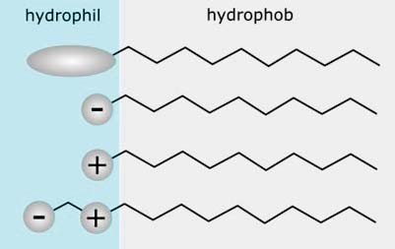
Anionic surfactants
Have bacteriostatic action
e.g. Sodium Lauryl Sulphate

Cationic surfactants
Have bactericidal activity
e.g. benzalkonium chloride

Ampholytic Surfactants

19

Reduction of Surface Tension

Principle
When surfactants are dissolved in water they can reduce surface tension by replacing some of the water molecules in the surface so that the forces of attraction between surfactant and water molecules are less than those between water molecules themselves, hence the contraction force is reduced.
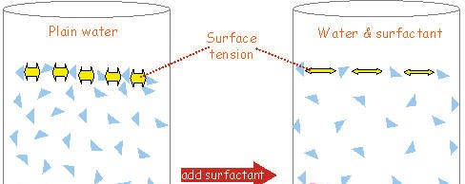
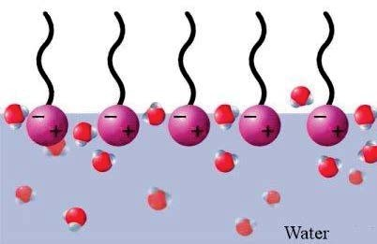

Effect of Structure on Surface Activity
The surface activity (surface tension reduction) of a particular surfactant depends on the balance between its hydrophilic and hydrophobic properties.
An increase in the length of the hydrocarbon chain (hydrophobic) of a surfactant increases the surface activity.
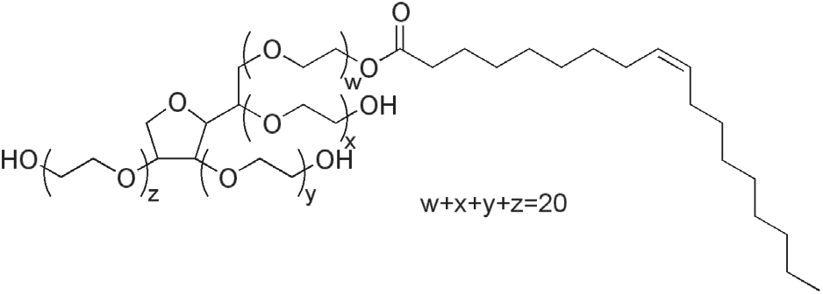
An increase in the length of the ethylene oxide chain (hydrophilic) of a non-ionic surfactant results in a decrease of surface ac ivity. Why
tivity
Why?

21

Reduction of Surface Tension

Surface Excess Concentration
Surface excess concentration (F) is the extra amount per unit area of the solute that is present in the surface
It is the difference between the amount per unit area of a solute in the surface of a real system and that of a hypothetical system (without adsorption).
Surface excess is expressed by the Gibbs equation:

1
F = ×
RT
dy

d lnc

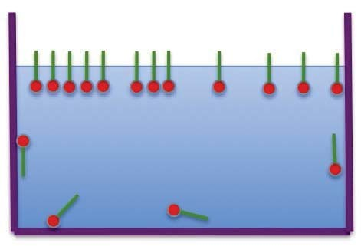
F = surface excess (g/cm2)
R = gas constant (8.314 J mol–1 K–1)
T = absolute temperature (kelvins)
c = concentration (mol m–3)

Surface Area
The surface area (A) is the area occupied by one surfactant molecule at the solution surface.
It can be calculated from the equation:

1
A =
NA F
NA = Avogadro number (6.023 × 1023 molecules mol–1)

23

Micellisation

Definition

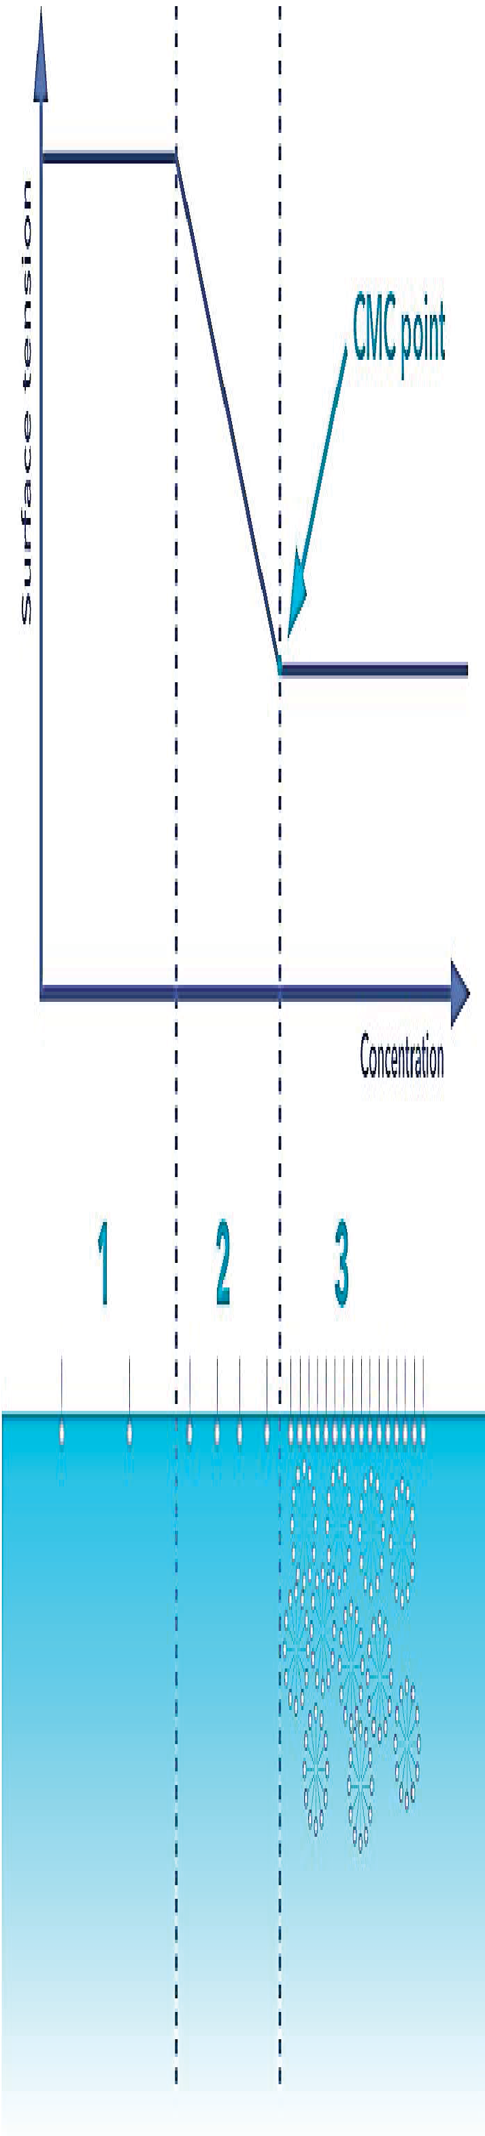
Micelles are formed when the concentration of a surfactant reaches a given concentration called critical micelle concentration (CMC) in which the surface is saturated with surfactant molecules.
Concentration

When the concentration of the surfactant is increased above the CMC, the number of micelles increases but the free surfactant concentration and surface tension stays constant at the CMC value
Surface Tension

24

Definition
Micelles are dynamic structures and are continually formed and broken down in solution (they are not solid spheres).
The main reason for micelle formation is to obtain a minimum free energy state.
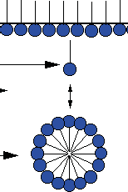
In a micelle, polar or ionic heads form an outer shell in contact with water, while non polar tails are sequestered in the interior to avoid water.

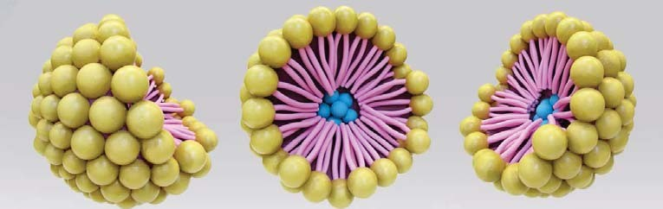

25

Micellisation

Solubilization

Solubilization is the process where water-insoluble substances are brought into solution by incorporation into micelle.
Solubilization does not occur until the milcells are formed (i.e. above CMC)
The amount of substance solubilized increases as the number of micelles increases.

Structure of the surfactant
Increase in length of the hydrocarbon chain results in a decrease in CMC and a an increase in micellar size.
An increase in the ethylene oxide chain length of a non-ionic surfactant makes the molecule more hydrophilic and the CMC increases.

Type of counterion
Micellar size increases for a cationic surfactant as the counterion is changed according to the series Cl– < Br– < I–, and for a particular anionic surfactant according to Na+ < K+ < Cs+.

27

Micellisation

Factors Affecting Micellisation

Addition of electrolytes
Electrolyte addition to solutions of ionic surfactants decreases the CMC and increases the micellar size.
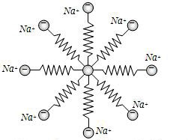
This is because the electrolyte reduces the forces of repulsion between the charged head groups at the micelle surface, allowing the micelle to grow.

Effect of temperature
For non-ionic surfactants, Increasing temperature increases micellar size and decrease CMC.
The effect of temperature stops at a characteristic temperature called the cloud point where the solution become turbid due to the separation of the solution into two phases.
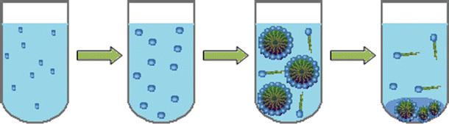
Temperature has a comparatively small effect on the micellar properties of ionic surfactants.

29

Micellisation

Insoluble Monolayers

Insoluble amphiphilic compounds (e.g. surfactants with very long hydrocarbon chains) can also form films on water surfaces when they are dissolved in a volatile solvent and carefully injected onto the surface.
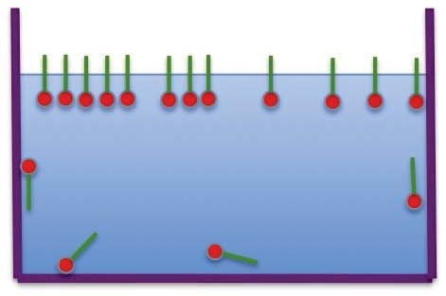
They differ from soluble amphiphilic compounds in that all the molecules injected on to the surface stay at the surface, and do not continually move back and forward between the surface and the bulk of the solution in equilibrium.
Insoluble monolayer
Soluble monolayer

