PLATING TECHNIQUES

The common plating techniques employed in microbiology are Streak Plate Method, Spread Plate Method and Pour Plate Method.
- Streak Plate Method

This method was developed by two bacteriologists, Leoffler and Gaffkey in the laboratory of Robert Koch. This method is routinely employed for the isolation of bacteria in pure culture. In this method a sterilized inoculating loop or transfer needle is dipped into a suitable diluted suspension of microorganisms which is then streaked on the surface of an already solidified agar plate to make a series of parallel, non-overlapping streaks. The process is known as streaking and the plate so prepared is called a streak plate. The main objective of the streak plate method is to produce well separated colonies of bacteria from concentrated suspensions of cells.
A sterilized inoculating needle with a loop made up of either platinum or nichrome wire is used for streaking. One loopful of specimen is transferred onto the surface of the agar plate in a sterile petridish and streaked across the surface in the form of a zig-zag line. This process is repeated thrice to streak out the bacteria on the agar plate so that some individual bacteria are separated from each other. The first streak will contain more organisms than the second and the second more than the third and so on. The last streaks should thin so on. The last streaks should thin out the culture sufficiently to give isolate colonies. The successful isolation depends on spatial separation of single cells. Each colony usually represents the growth from a single organism when such a plate is incubated colonies will appear on the surface of the medium. Because of the high concentration of water in agar, some water of condensation forms in petriplate during incubation. Moisture is likely to drip from the cover to the surface of the agar and spread out, resulting in a confluent mass of growth and running individual colony formation. To avoid this, petriplates are routinely incubated bottom side up. Pure colonies can be obtained from well isolated colonies by transferring a small portion of each to separate culture media.
- Spread Plate Method

The spread plate technique is used for the separation of a dilute, mixed population of the microorganisms so that individual colonies can be isolated. In this technique, a small volume of dilute microbial mixture is transferred to the center of an agar plate and spread evenly over the surface with a sterile L-shaped bent glass rod, while the petridish is spun, at some stage, single cells will be deposited with the bent glass rod on the agar surface. Incubate the agar plate at 37ºC for 24 hours, in the inverted position. The dispersed cells will develop into isolated colonies. Because the number of colonies will be equal to the number of viable organisms in the sample spread plates can be used to count the microbial population.
- Pour Plate Method

In pour plate method, successive dilutions of the inoculum (serially diluting the original specimen) are added into sterile petriplate to which is poured melted and cooled (42ºC - 45ºC) agar medium and thoroughly mixed by rotating the plates which is then allowed to solidify. After incubation, the plates are examined for the presence of individual colonies. The pure colonies may be isolated and transferred into test tube culture media for making pure cultures. This technique is employed to estimate the viable bacterial count in a suspension.

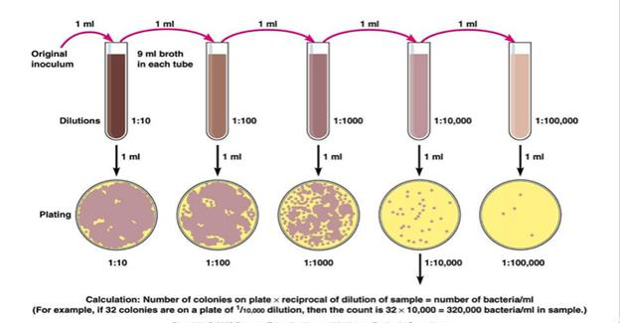
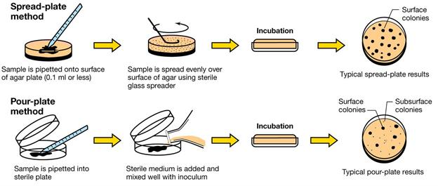
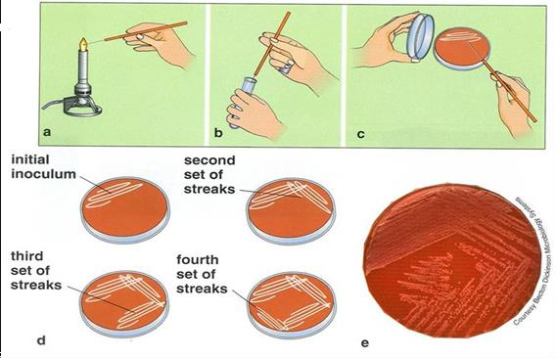

Fig. 9. Plating Techniques

7
METHODS OF ISOLATION OF PURE CULTURE

A culture that contains only one kind of microorganisms is called a pure culture. A culture which contains more than one kind of microorganisms is called mixed culture. Most of the cultures obtained in nature are mixed cultures. Pure cultures are essential to study the cultural, morphological and physiological characters of an individual species. There are different methods for obtaining pure cultures from mixed cultures.

Streak Plate Method Spread Plate Method Pour Plate Method

Follow the procedures as discussed in chapter 6 Plating techniques

Micromanipulator Method

  - In this technique, a microscope is used to pick out a single bacterial cell with the help of a device known as micromanipulator. A single viable cell may be transferred on the culture medium to develop turbidity.
  - Enrichment, selective and indicator media are widely used for the isolation of pathogens from specimens such as faeces with varied flora.
  - Pure culture may be obtained by pre-treatment of specimens with appropriate bactericidal substances which destroy the unwanted bacteria. This method is the standard practice for the isolation of tubercle bacilli from sputum and other clinical specimen.
  - Obligate aerobes and anaerobes may be separated by cultivation under aerobic or anaerobic conditions.
  - Microorganisms can also be violated by controlling physical environment especially temperature. Bacteria with different optimum growth temperature can be separated by incubating at different temperature. Only thermophiles bacteria grow to 60ºC. A mixture containing vegetative and spore forming bacteria can be separated by heating at 80ºC. In this method, the bacteria in the vegetative state will be eliminated. This method is useful for the isolation of tetanus bacilli from dust and similar sources.
  - Separation between motile and non-motile bacteria can be effected using Craigie’s tube. This consists of a tube of semisolid agar with a narrow tube open at both ends placed in the center of the medium in such a way that it projects above the level of the medium. The mixture is inoculated into the central tube, the motile bacteria alone transverse the agar and appear at the top of the medium outside the central tube.

