Solubility and the Solution Process:
• The solid dissolves rapidly at first, but as the solution approaches saturation the net rate of dissolution decreases since the process is in dynamic equilibrium.
• Once at equilibrium, the amount of solute does not change with time.
• At equilibrium- rate of dissolution = rate of solution.

Solubility Thermodynamics:
• The Gibbs Free Energy of Mixing- ΔG = ΔH – T.ΔS
Where ΔG= Gibbs Free Energy of Mixing, ΔH = enthalpy (energy, heat), ΔS = entropy (disorder), T = temperature.
• The entropy of mixing favours complete miscibility of all components.
• Enthalpy- balance of the:
o Drug-drug interactions (D-D) (cohesive forces).
o Solvent-solvent interactions (S-S) (cohesive forces).
o Drug-solvent interactions D-S (adhesive forces).
•
ΔH is sometimes negative, and sometimes positive, as it is a sum of the following:
o S-S – energy required to break weak bonds between solvent molecules.
o D-D – energy required to break intermolecular bonds between the solute molecules.
o D-S – ΔH is negative since bonds are formed between the species.

• Intermolecular forces are important in determining the solubility of a substance as ‘like’ intermolecules forces for solute and solvent will make the solute soluble in the solvent.
• ΔG must be negative for a solution to form. (ΔG - = stable system, + = unstable system)
ΔH should be minimal.
• ΔS should be maximal (increases stability)
Clinical Relevance of Solubility:
• Solubility can affect bioavailability and therapeutic response.
• Need enough drug in solution to reach concentrations that are therapeutically meaningful.
• Stability of drug.
• Formulated drug product disintegrates into dispersed drug particles, which undergo dissolution into solubilised drug which passes a membrane (must be permeable to drug) and is absorbed.

Increasing no. drugs BCS Class II and IV (poorly soluble drugs). 90% and higher = high permeability. Below
90% - low permeability.
API = Active Pharmaceutical Ingredient, NCE= New Chemical Entity (still in developmental stages).
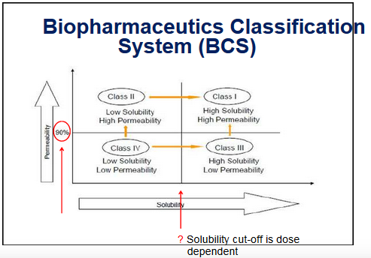

Measurement of Solubility:
N.B. –
➢ The solvent and solute must be pure.
➢ A saturated solution must be obtained before any solution is removed for analysis.
Clinical Relevance of Solubility:
• Solubility can affect bioavailability and therapeutic response.
• Need enough drug in solution to reach concentrations that are therapeutically meaningful.
• Stability of drug.
• Formulated drug product disintegrates into dispersed drug particles, which undergo dissolution into
solubilised drug which passes a membrane (must be permeable to drug) and is absorbed.
•
Increasing no. drugs BCS Class II and IV (poorly soluble drugs). 90% and higher = high permeability. Below
90% - low permeability.
API = Active Pharmaceutical Ingredient, NCE= New Chemical Entity (still in developmental stages).

