Ideal and Real Solutions
  - ideal solution:
  - no change in the properties of the components, other than dilution, when they are mixed to form the solution.

  - No heat is evolved or absorbed during the mixing process,

  - the final volume of the solution represents an additive property of the individual constituents. no shrinkage or expansion occurs when the substances are mixed.

  - The constitutive properties, for example, the vapor pressure, refractive index, surface tension, and viscosity of the solution, are the weighted averages of the properties of the pure individual constituents.

  - Mixing substances with similar properties forms ideal solutions.

  - when 100 mL of methanol is mixed with 100 mL of ethanol, the final volume of the solution is 200 mL, and no heat is evolved or absorbed. The solution is nearly ideal.

  - When 100 mL of sulfuric acid is combined with 100 mL of water, the volume of the solution is about 180 mL at room temperature, and the mixing is attended by a considerable evolution of heat; the solution is said to be nonideal, or real.

Ideal Solutions and Raoult's Law

  - in an ideal solution, the partial vapor pressure of each volatile constituent is equal to the vapor pressure of the pure constituent multiplied by its mole fraction in the solution. Thus, for two constituents A and B,

- Example:
- What is the partial vapor pressure of benzene and of ethylene chloride in a solution at a mole fraction of benzene of 0.6? The vapor pressure of pure benzene at 50°C is 268 mmHg, and the corresponding pA° for ethylene chloride is 236 mmHg. (ideal solution)

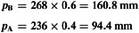
Hg Hg

  - The total pressure is the sum of the partial pressures of all the constituents

Hg

Aerosols and Raoult's Law

- An aerosol contains the drug concentrated in a solvent or carrier liquid and a propellant mixture of the proper vapor characteristics.
- Propellants:
- Chlorofluorocarbons (CFCs):
- volatile hydrocarbons: used as propellants in metered dose inhalers for treating asthma,
- hydrofluoroalkane 134a (1,1,1,2,tetrafluoroethane) 2. hydrofluoroalkane 227 (1,1,1,2,3,3,3-
heptafluoropropane)
- or combinations of the two.

  - Example:
  - The vapor pressure of pure CFC 11 (molecular weight 137.4) at 21°C is p11° = 13.4 lb/in2 (psi) and that of CFC 12 (molecular weight 120.9)
is p12° = 84.9 psi.
  - What is the partial pressure of CFCs 11 and 12 in the 50:50 mixture, and what is the total vapor pressure of this mixture?

  - A 50:50 mixture by gram weight of the two propellants consists of:
  - 50g ÷ 137.4 g/mole = 0.364 mole of CFC 11
  - 50g ÷ 120.9 g/mole = 0.414 mole of CFC 12.

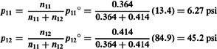

  - The total vapor pressure of the mixture is

Real Solutions

  - Ideality in solutions presupposes complete uniformity of attractive forces.

  - Many examples of solution pairs are known, however, in which the “cohesive” attraction of A for A exceeds the “adhesive” attraction existing between A and B. Similarly, the attractive forces between A and B may be greater than those between A and A or B and B.

  - Such mixtures are real or nonideal;

  - Ideal solutions do not adhere to Raoult's law throughout the entire range of composition.

  - Two types of deviation from Raoult's law

negative deviation.
- positive deviation.

  - negative deviation:
  - When the “adhesive” attractions between molecules of different species exceed the “cohesive” attractions between like molecules,

  - the vapor pressure of the solution is less than that expected from Raoult's ideal solution law,

  - chloroform and acetone.

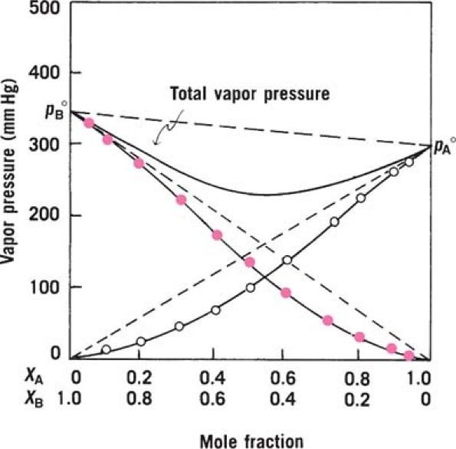

positive deviation:
  - When the interaction between A and B molecules is less than that between molecules of the pure constituents,

  - The partial vapor pressure of the constituents is greater than that expected from Raoult's law,

  - benzene and ethyl alcohol, chloroform and ethyl alcohol.

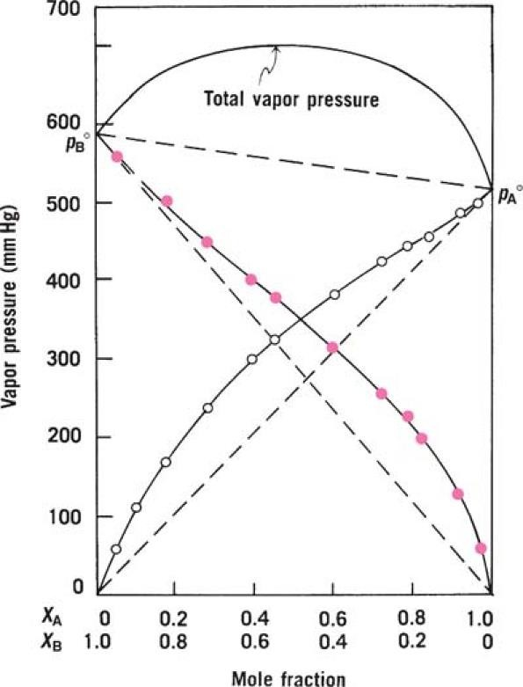

  - In real solutions, the behavior of the component present in high concentration (the solvent) can be described by Raoult's law as:

  - It cannot hold for the component in low concentration (the solute).

Henry's Law

  - The molecules of solute, being in relatively small number are completely surrounded by molecules of solvent and so reside in a uniform environment.

  - Therefore, the partial pressure or escaping tendency of the solute at low concentration is in some way proportional to its mole fraction, but, as the proportionality constant is not equal to the vapor pressure of the pure substance.

  - The vapor pressure–composition relationship of the solute cannot be expressed by Raoult's law but instead by an equation known as Henry's law:

  - where k for solute is less than p°solute.

  - Henry's law applies to the solute and Raoult's law applies to the solvent in dilute solutions of real liquid pairs.

Give 5 examples for each of followings :
  - Ideal Solution
  - Positive deviated solution
  - Negative deviated Solution

Physical Properties of Substances

    - classified as:
- colligative,
- additive,
- constitutive.

    - In thermodynamics, classified as:
- extensive properties
- intensive properties

    - Extensive properties:
    - Physical properties of a system depend on the
quantity of the matter in the system
    - (e.g., mass and volume),

    - Intensive properties:
    - is a bulk property, meaning that it is a Physical properties of a system that does not depend on the system size or the amount of material in the system
    - (e.g., temperature, pressure, density, surface tension, and viscosity of a pure liquid).

Additive properties
    - depend on the total contribution of the atoms in the molecule or on the sum of the properties of the constituents in a solution.

    - An example of an additive property of a compound is the molecular weight, that is, the sum of the masses of the constituent atoms.

    - The masses of the components of a solution are also additive, the total mass of the solution being the sum of the masses of the individual components.

Constitutive properties
    - depend on the arrangement and to a lesser extent on the number and kind of atoms within a molecule.

    - Many physical properties may be partly additive and partly constitutive.

    - The refraction of light, electric properties, surface and interfacial characteristics, and the solubility of drugs are at least in part constitutive and in part additive properties.

Colligative properties
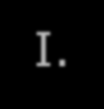
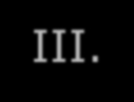
Colligative properties depend only on the number of dissolved particles (molecules or ions, small or large) in solution and not on their identity.

- Osmotic pressure
- Vapor pressure lowering
- Boiling point elevation
- Freezing point depression

Explanation
compare the properties of:
  - M aq. sugar solution to a 0.5 M aq. solution of NaCl.
Despite the conc. of NaCl = ½ the conc. of sucrose both solutions have precisely the same number of dissolved particles, why?
because each NaCl unit creates two particles upon dissolution a Na+ and a Cl-.
Both solutions have the same colegative propertiesn as freezing point, boiling point, vapor pressure, and osmotic pressure because those colligative properties of a solution only depend on the number of dissolved particles.
Other non-colligative properties including e.g. viscosity, surface tension, and solubility are different.

Diffusion in liquids:
Substance tend to move or diffuse from regions of higher concentration to region of lower concentration so the differences in concentration disappear.
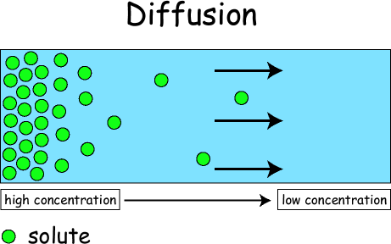

Osmotic Pressure

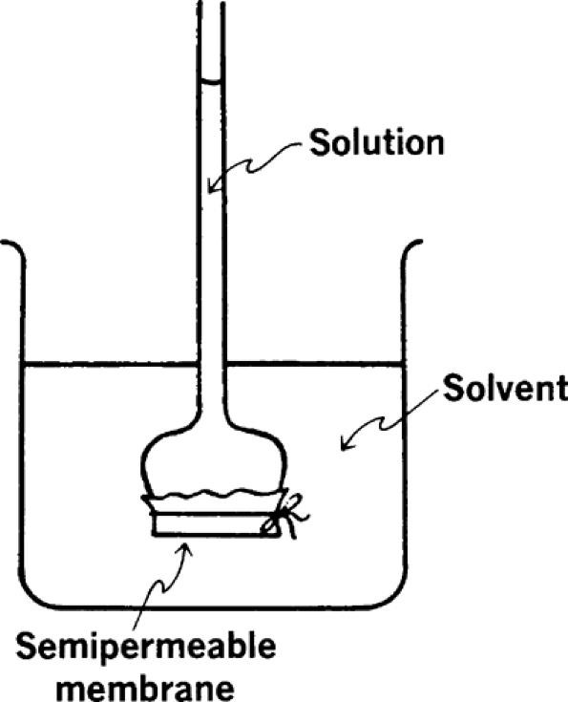
    - Osmosis is the passage of the solvent into a solution through a semipermeable membrane.

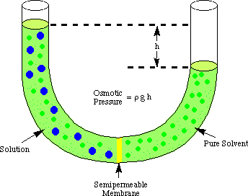

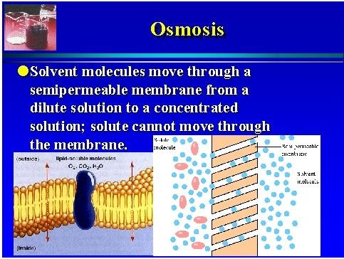

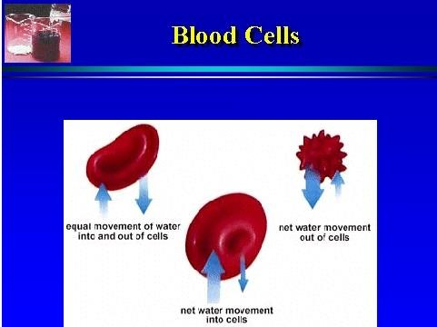
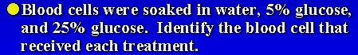

- The solvent moves into the tube and the height of the solution will rise till the hydrostatic pressure exerted by the column of solution equal to osmotic pressure

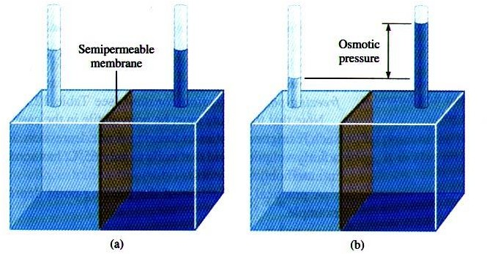

Osmotic pressure
- Is the external pressure that must be applied to the solution in order to prevent it being diluted by the entry of solvent via osmosis.

  - This process tends to equalize the escaping tendency of the solvent on both sides of the membrane.

  - The osmotic pressure is proportional to the reduction in vapor pressure brought about by the concentration of solute present.

  - osmotic pressure is a colligative property

van't Hoff's equation:

  - π is the osmotic pressure in atm,
  - V is the volume of the solution in liters,
  - n is the number of moles of solute,
  - R is the gas constant, equal to 0.082 liter atm/mole deg,
  - T is the absolute temperature.

  - Example
  - One gram of sucrose, molecular weight 342, is dissolved in 100 mL of solution at 25°C. What is the osmotic pressure of the solution?

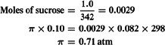

Colligative properties

The values of the colligative properties are approximately the same for equal concentrations of different nonelectrolytes in solution regardless of the species or chemical nature of the constituents.

Osmotic pressure of Non-electrolytes (not ionized)
Osmotic pressure ∝ concentration

twice concentration twice osmotic pressure

Osmotic pressure ∝
number of molecules

Osmotic pressure of 2 solutions having the same molal concentration are identical

Example:
Explain why?
Solution contains 34.2 g sucrose (mol wt 342) in 1000 g water has the same osmotic pressure as dextrose solution (mol wt 180) contains 18 g/1000 g water?

- No. of moles of sucrose = wt/mol wt
= 34.2/342 = 0.1 molal

- No. of moles of dextrose
= 18/180 = 0.1 molal So that the 2 solutions are iso-osmotic

- When non-volatile solute is dissolved in solvent, the vapor pressure of solvent is lowered
- Solvent molecules on the surface which can escape into vapor is replaced by solute molecules have little (if any) vapor pressure.
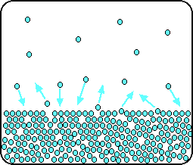
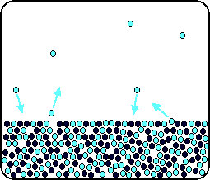
Why is vapor pressure lowering a colligative property? It only depends on number of dissolved solute particles.

  - The Lowering of the vapor pressure is

- The boiling point of a liquid is defined as the temperature at which the vapor pressure of that liquid equals the atmospheric pressure(760mm Hg).

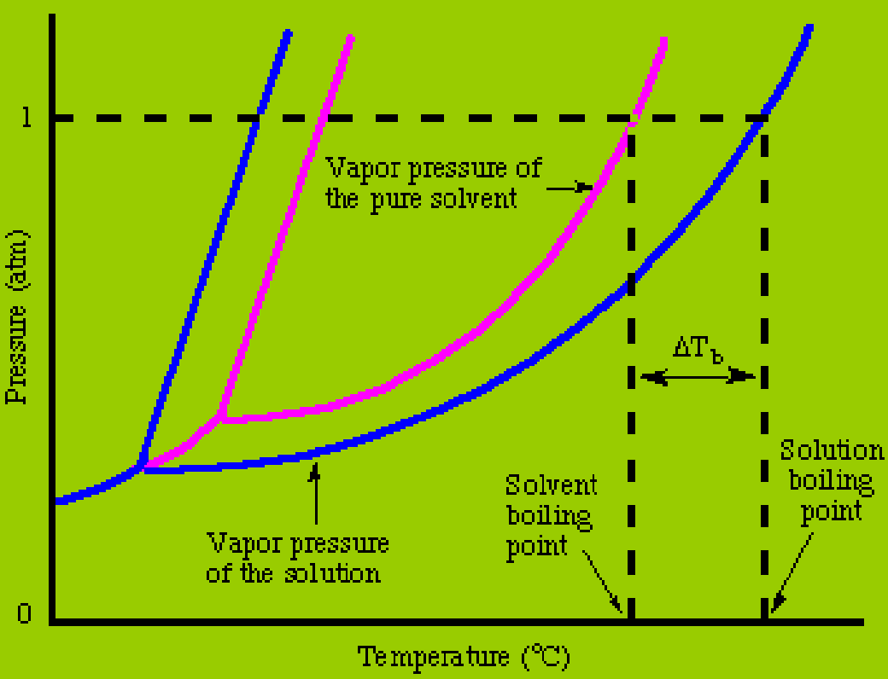
For a solution:
the vapor pressure of the solvent is lower at any given temperature.
Therefore, a higher temperature is required to boil the solution than the pure solvent.

Elevation of the Boiling Point

  - The boiling point of a solution of a nonvolatile solute is higher than that of the pure solvent owing to the fact that the solute lowers the vapor pressure of the solvent.

  - This is the colligative property called boiling point elevation.

  - the more of the solute that is dissolved, the greater is the effect.

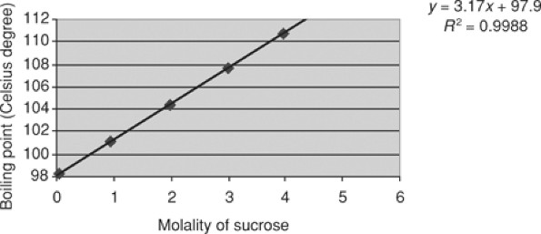

Addition of solute will decrease the vapor pressure and so will increase the boiling point

  - The elevation of the boiling point is
  - ΔTb =T - To .

m: molality (because molality is temperature independent).
Kb: boiling point elevation constant that depends on the particular solvent being used. (Kb water = 0.51)

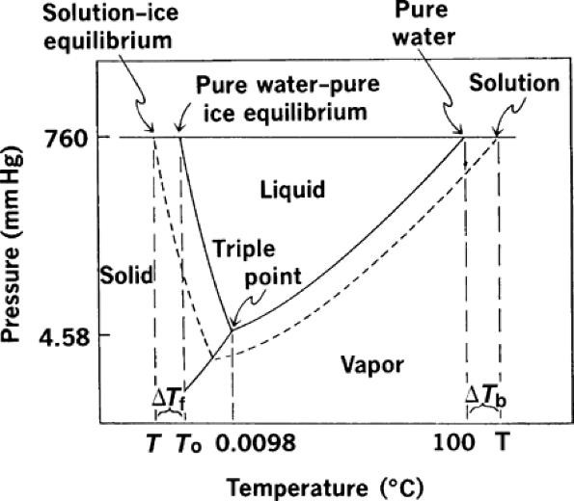
- Normal freezing or melting point: is the temp. at which solid &liquid are in equilibrium under 1 atm.
- Addition of solute will decrease the vapor pressure and so will decrease the freezing point

In order for a liquid to freeze it must achieve a very ordered state that results in the formation of a crystal.
If there are impurities in the liquid, i.e. solutes, the liquid is inherently less ordered. Therefore, a solution is more difficult to freeze than the pure solvent so a lower temperature is required to freeze the liquid

Depression of the Freezing Point

  - If a solute is dissolved in the liquid at the triple point, the escaping tendency or vapor pressure of the liquid solvent is lowered below that of the pure solid solvent.

  - The temperature must drop to reestablish equilibrium between the liquid and the solid.

  - Because of this fact, the freezing point of a solution is always lower than that of the pure solvent.

  - The freezing point depression of a solvent is a function only of the number of particles in the solution, and for this reason it is referred to as a colligative property.

  - The more concentrated the solution, the farther apart are the solvent and the solution curves in the diagram and the greater is the freezing point depression.

  - Example
  - What is the freezing point of a solution containing
3.42 g of sucrose and 500 g of water? The molecular weight of sucrose is 342. In this relatively dilute solution, Kf is approximately equal to 1.86.

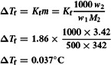
the freezing point of the aqueous solution is
-0.037°C.

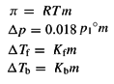
Colligative properties
Colligative properties depend only on the number of dissolved particles (molecules or ions, small or large) in solution and not on their identity.

- Osmotic pressure
- Vapor pressure lowering
- Freezing point depression
- Boiling point elevation

Electrolyte Solutions

Colligative Properties of Electrolytic Solutions and Concentrated Solutions of Nonelectrolytes
  - the osmotic pressure, π, of dilute solutions of nonelectrolytes, such as sucrose and urea, could be expressed by the equation π = RTc

  - solutions of electrolytes gave osmotic pressures approximately two, three, and more times larger than expected from this equation, depending on the electrolyte investigated.

Electrolytes osmotic pressures

  - i approaches the number of ions into which the molecule dissociated as the solution.

  - 2 for solutes such as NaCl and CaSO4,
  - 3 for K2SO4 and CaCl2,
  - 4 for FeCl3.

  - The osmotic pressures Solution of 1M K2SO4 is three time more that of 1M urea solution

  - The colligative properties in dilute solutions of electrolytes are expressed on the molal scale by the equations:

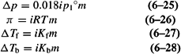

  - Example
  - Calculate the freezing point depression of:
  - (a) 0.154 m solution of NaCl
The i factor for a 0.154 m solution of sodium chloride is about 1.86
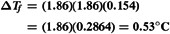
  - (b) 0.154 m solution of glucose.

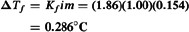

  - Example
  - What is the osmotic pressure of a 2.0 m solution of sodium chloride at 20°C?
  - The i factor for a 2.0 m solution of sodium chloride is about 1.9.

  - When electrolytes are dissolved in water, the solute exists in the form of ions in the solution,

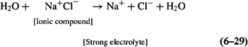

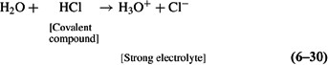

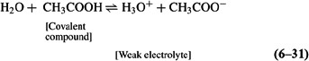

Activity and Activity Coefficients

In strong electrolytes solutions The large number of oppositely charged ions in solutions of electrolytes influence one anther through interionic attractive forces and also associate at
high concentration into groups known as ion pairs (e.g., Na+Cl-) and ion triplets (Na+Cl-Na+).

Strong electrolyte moderatly concentrated Solutions

    - Because of interionic attractive forces and ion association , in moderatly concentrated solutions of strong electrolytes , the value of the freezing point depression and other Collegiative properties are less than expected for solutions of unhindered free ions

    - Consequently, a strong electrolyte may be completely ionized, yet incompletely dissociated into free ions.

The freezing point depression of Solution of 1m K2SO4 more that of 5m urea solution

  - Thus strong electrolytes solutions have an “effective concentration” or an activity (a).
  - The activity of ions , is less than the actual concentration of the solute, because some of the ions are effectively “taken out of play” by the electrostatic forces of interaction.

  - Where : γm is activity coefficient,
  - activity (a),
  - ɱ concentration.

  - γm increases for dilute strong electrolytes solutions and decreases for concentrated strong electrolytes solutions or concentrated non electrolytes solutions

  - At infinite dilution, in which the ions are so widely separated that they do not interact with one another, the activity a of an ion is equal to its concentration.

100% of the drug concentration is active free ions

Ionic Strength

  - ionic strength, µ, is used to relate interionic attractions and activity coefficients.

  - The ionic strength is defined on the molar scale as:

  - The term ci is the concentration in moles/liter of any of the ions and zi is its valence.

- Example
- What is the ionic strength of:

- (a) 0.010 M KCl, 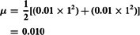

- (b) 0.010 M BaSO4, 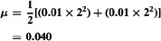
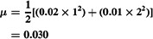
(c) 0.010 M Na2SO4,

  - µ of a 1:1 electrolyte is the same as the molar concentration;

  - µ of a 1:2 electrolyte is three times the concentration;

  - µ for a 2:2 electrolyte is four times the concentration.

    - Example
    - A buffer contains 0.3 mole of K2HPO4 and 0.1 mole of KH2PO4 per liter of solution. Calculate the ionic strength of the solution.
    - The concentrations of the ions of K2HPO4 are [K+] = 0.3 × 2 and [HPO42-] = 0.3.
    - The values for KH2PO4 are [K+] = 0.1 and [H2PO4-] = 0.1
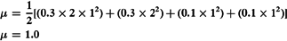

The Debye-Hückel Theory

  - used to calculate the activity coefficients of drugs whose values have not been obtained experimentally and are not available in the literature.

  - The Debye-Hückel equation for a binary electrolytes consisting of ions with valiancy z+ and z- and present in dilute solution ( µ < 0.02)

- Example
Calculate the mean ionic activity coefficient for 0.005 M atropine sulfate (1:2 electrolyte) in an aqueous solution containing 0.01 M NaCl at 25°C. For water at 25°C, A is 0.51.

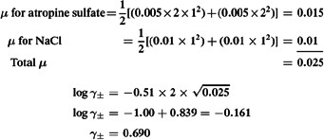
atropine sulfate (1:2 electrolyte) 1X2

x
69% of the atropine sulfate is active

a = 0.005x0.69 = 0.0034 M
Concentration of active free ions

