Beer’s Law
Beer's Law is an equation that relates the attenuation of light to properties of a material. The law states that the concentration of a chemical is directly proportional to the absorbance of a solution. The relation may be used to determine the concentration of a chemical species in a solution using a colorimeter or spectrophotometer. The relation is most often used in UV-visible absorption spectroscopy.
Beer's Law states that the concentration of a chemical solution is directly proportional to its absorption of light.
The premise is that a beam of light becomes weaker as it passes through a chemical solution. The attenuation of light occurs either as a result of distance through solution or increasing concentration.

Importance of Beer's Law
Beer's Law is especially important in the fields of chemistry, physics, and meteorology. Beer's Law is used in chemistry to measure the concentration of chemical solutions, to analyze oxidation, and to measure polymer degradation. The law also describes the attenuation of radiation through the Earth's atmosphere.
Lambert’s Law
The rate of decrease of intensity (monochromatic light) with the thickness of the medium is directly proportional to the intensity of incident light.
Lambert’s-Beer Law
The Beer-Lambert law is a linear relationship between the absorbance and the concentration, molar absorption coefficient and optical coefficient of a solution: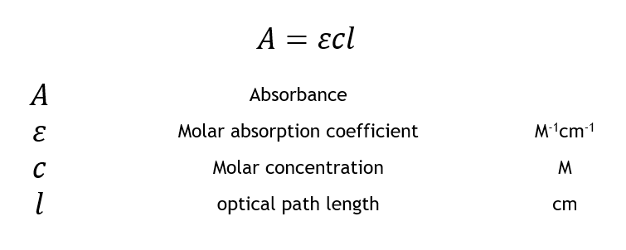

The molar absorption coefficient is a sample dependent property and is a measure of how strong an absorber the sample is at a particular wavelength of light. The concentration is simply the moles L⁻¹ (M) of the sample dissolved in the solution, and the length is the length of the cuvette used for the absorbance measurement and is typically 1 cm.

The Beer-Lambert law states that there is a linear relationship between the concentration and the absorbance of the solution, which enables the concentration of a solution to be calculated by measuring its absorbance.
Calculating the absorbance of a sample using the equation depends on two assumptions:
- The absorbance is directly proportional to the path length of the sample (the width of the cuvette).
- The absorbance is directly proportional to the concentration of the sample.

