Aim of the Practical: - EXP-1
To study of different types of Network cables and practically implement the cross-wired cable and straight through cable using clamping tool.

Component Required:

Theory:
- Unshielded Twisted pair cables.
- RJ 45 Plug.
- Crimping tool.
- Network cable tester/LAN Patch cable testing kit for RJ 45.
- Maker.

  - Ethernet Cable: Common Network Media/Cabling

Electrical (copper)
- Coaxial Cable-Single copper conductor in the center surrounded by a plastic layer for insulation and a braided metal outer shield.
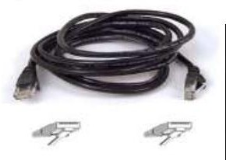
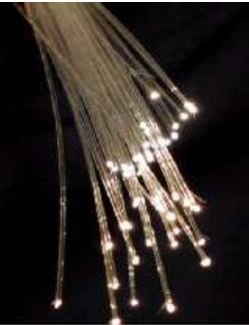
- Twisted pair-Four pairs of wires twisted to certain specifications. Available in shielded and unshielded versions.
    - Fiber-optic- A cable, consisting of a center glass core surrounded by layers of plastic, that transmits data using light rather than electricity.
    - Atmosphere/Wireless - Uses Electromagnetic waves. whose frequency range is above that of microwaves, but below that of the visible spectrum.

  - Choose Media based on:
- Wiring configurations
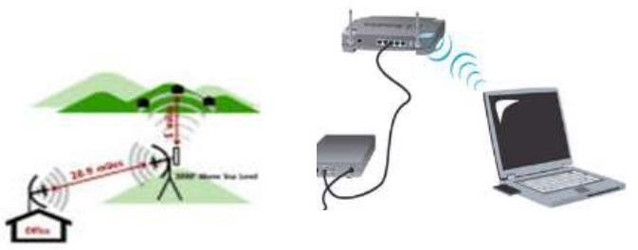
- Distance and location limitations
- Speed Reliability
- Security
- Budget

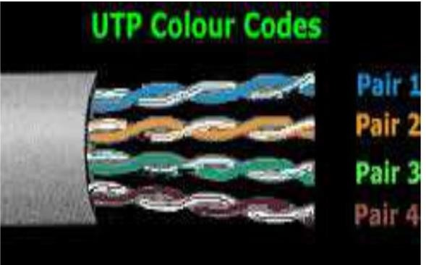
Unshielded Twisted Pair (UTP) Cable:
It is composed of 4-pair twist wirings.
- Orange & White
- Green & White
- Blue & White
- Brown & White

Straight-Through cable:
A straight-through cable is a type of twisted pair cable that is used in local area networks to connect a computer to a network hub such as a router. This type of cable is also sometimes called a patch cable and is an alternative to wireless connections where one or more computers access a router through a wireless signal. On a straight-through cable, the wired pins match. Straight-through cable use one wiring standard: both ends use T568A wiring standard or both ends use T568B wiring standard. The following figure shows a straight-through cable of which both ends are wired as the T568B standard.
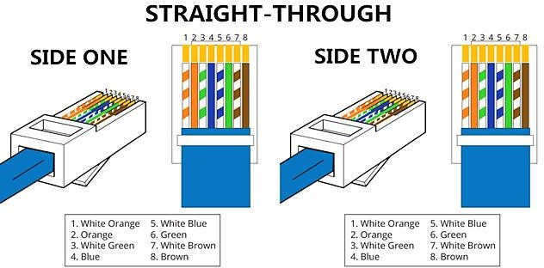

Crossover Cable:
An Ethernet crossover cable is a type of Ethernet cable used to connect computing devices together directly. Unlike straight-through cable, crossover cables use two different wiring standards: one end
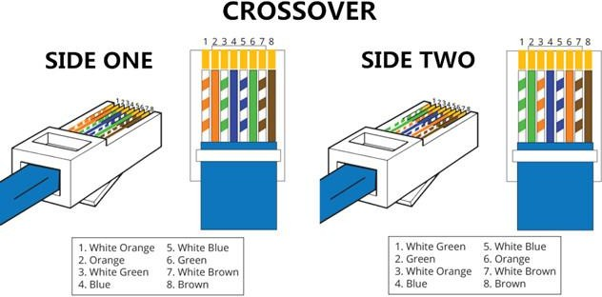
uses the T568A wiring standard, and the other end uses the T568B wiring standard. The internal wiring of Ethernet crossover cables reverses the transmit and receive signals. It is most often used to connect two

devices of the same type: e.g., two computers (via network interface controller) or two switches to each other.

Procedure:
PROCESS OF MAKING Cu STRAIGHT-THROUGH CABLE CONNECTION:

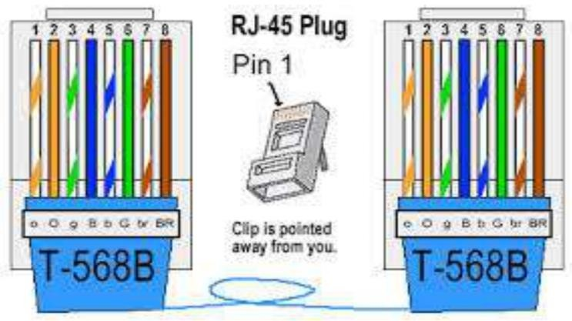
- Cut the one end of the cable.
- Strip/skin the outer sleeve of UTP cable.
- Arrange the colour combination (see T568B below).
- Cut straight the conductors.
- Insert the wires to RJ45.
- Insert the RJ45 to crimp the cables.
- Test the straight cable.

PROCESS OF MAKING Cu CROSS-OVER CABLE CONNECTION:

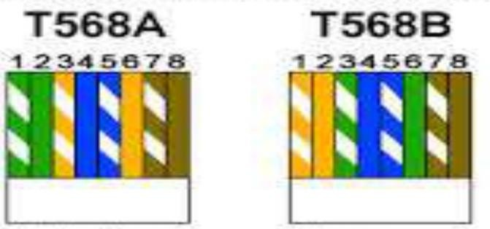
- Cut the one end of the cable.
- Strip/ skin the outer sleeve of UTP cable.
- Arrange the colour combination (see T568A below)
- Cut straight the conductors.
- Insert the wires to RJ45.
- Insert the RJ45 to crimp the cables.
- Test the cross-over cable.
FOR WIRING THE CABLES WITH RJ 45: Step 1: Strip back the outer sleeve.

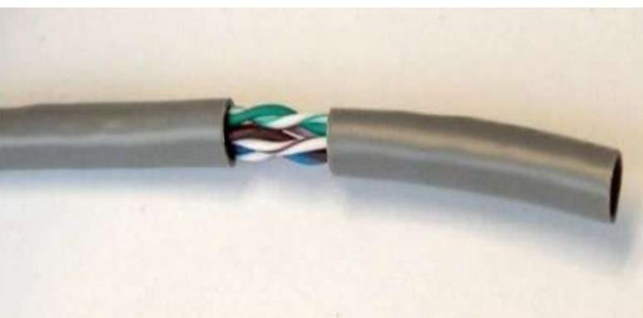

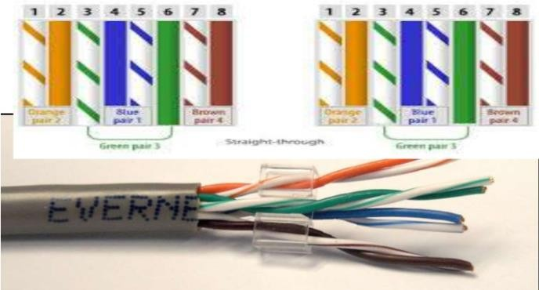
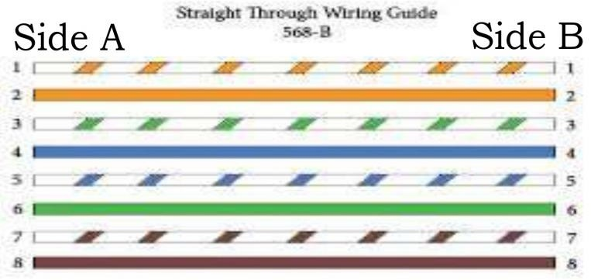
Step 2: Arrange in particular Design.
- Step 3: Cut every wire in straight line....
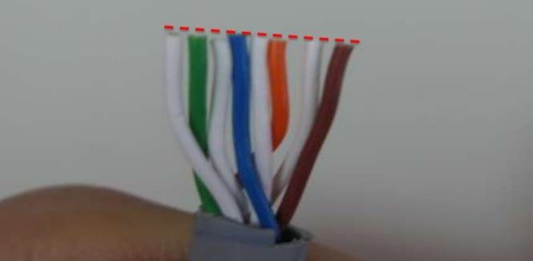
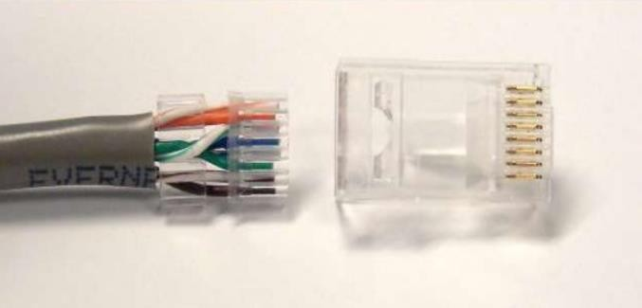

Step 4: Now Insert Wires into RJ45
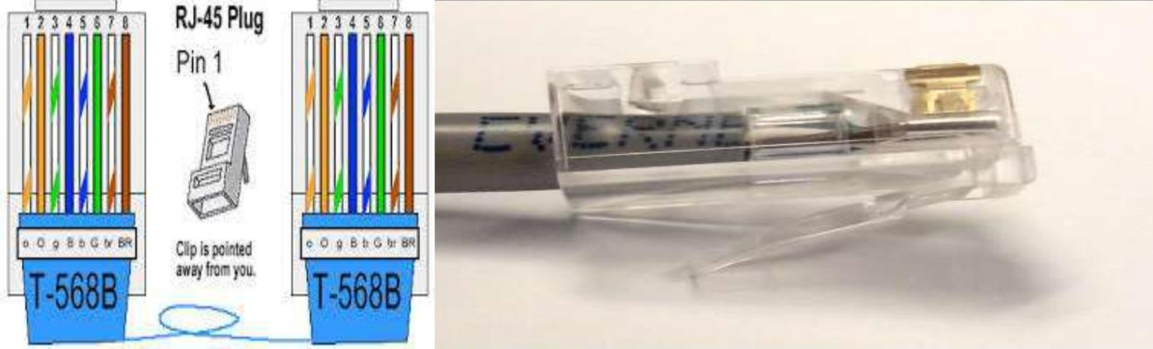
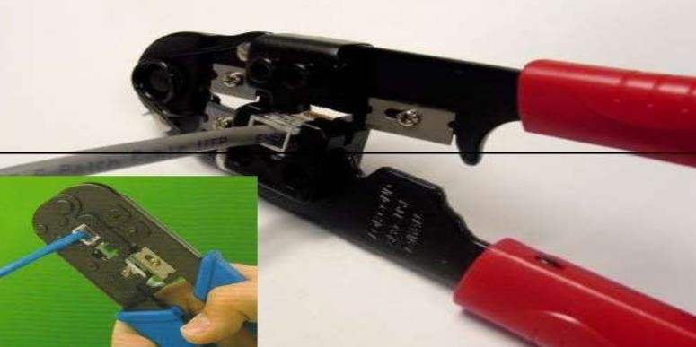
- Step 5: Crimp the RJ45 plug with the crimping tool.

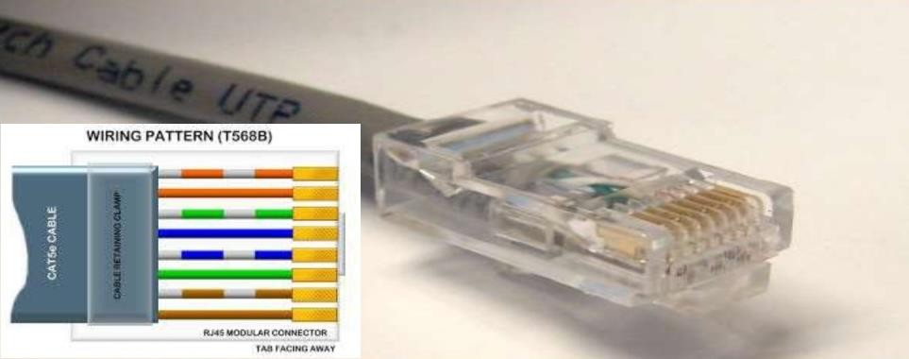
Step 6: Verify the order of the wires is correct and all the wires are correctly making good contact with the metal contacts in the RJ45 plug.

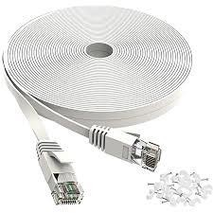
- Step 7: Cut the cable into suitable length and repeat all the steps for the other side.

- Step 8: And test it with patch cable tester.
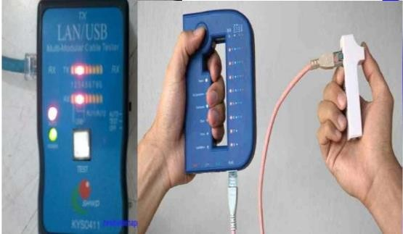
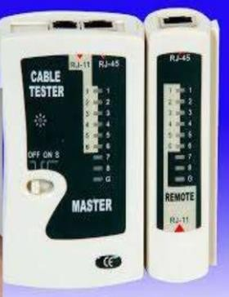

Conclusion:

By this practical we are now able to make straight-through, cross-over connections successfully.

