Aim of the Experiment: - EXP5
To Establish a LAN Connection Using Four Systems Through Ring Topology.

Component Required:

Hardware:

- 4 Numbers of System.
- 4 Numbers of Switches.
- 4 Numbers of Cross-over UTP Cables.
- 4 Numbers of Straight UTP Cables.

Software:

- Cisco Packet Tracer 7.2.2

Theory: -
  - Local area network:
A local area network (LAN) is a collection of devices connected together in one physical location, such as a building, office, or home. A LAN can be small or large, ranging from a home network with one user to an enterprise network with thousands of users and devices in an office or school.

Computer System:
A computer system is a set of integrated devices that input, output, process, and store data and information. Computer systems are currently built around at least one digital processing device. There are five main hardware components in a computer system: Input, Processing, Storage, Output and Communication devices. Which have a Nic Card through Which it is connected to a network by the help of RJ 45 Port.

Network Switches:
A network switch (also called switching hub, bridging hub, and, by the IEEE, MAC bridge) is networking hardware that connects devices on a computer network by using packet switching to receive and forward data to the destination device.
A network switch is a multiport network bridge that uses MAC addresses to forward data at the data link layer (layer 2) of the OSI model. Some switches can also forward data at the network layer (layer 3) by additionally incorporating routing functionality. Such switches are commonly known as layer-3 switches or multilayer switches.

Cross-over UTP Cables:
An Ethernet crossover cable is a type of Ethernet cable used to connect computing devices together directly. Unlike straight-through cable, crossover cables use two different wiring standards: one end uses the T568A wiring standard, and the other end uses the T568B wiring standard. The internal wiring of Ethernet crossover cables reverses the transmit and receive signals. It is most often used to connect two devices of the same type: e.g., two computers (via network interface controller) or two switches to each other. UTP stands for unshielded twisted pair cables with are connected with RJ 45 at both ends.

Straight UTP Cables:
A straight-through cable is a type of twisted pair cable that is used in local area networks to connect a computer to a network hub such as a router. This type of cable is also sometimes called a patch cable and is an alternative to wireless connections where one or more computers access a router through a wireless signal. On a straight-through cable, the wired pins match. Straight-through cable use one wiring standard: both ends use T568A wiring standard or both ends use T568B wiring standard.

Cisco Packet Tracer:
Packet Tracer is a cross-platform visual simulation tool designed by Cisco Systems that allows users to create network topologies and imitate modern computer networks. The software allows users to simulate the configuration of Cisco routers and switches using a simulated command line interface.

Procedure:

- First, we open our Cisco Packet Tracer.
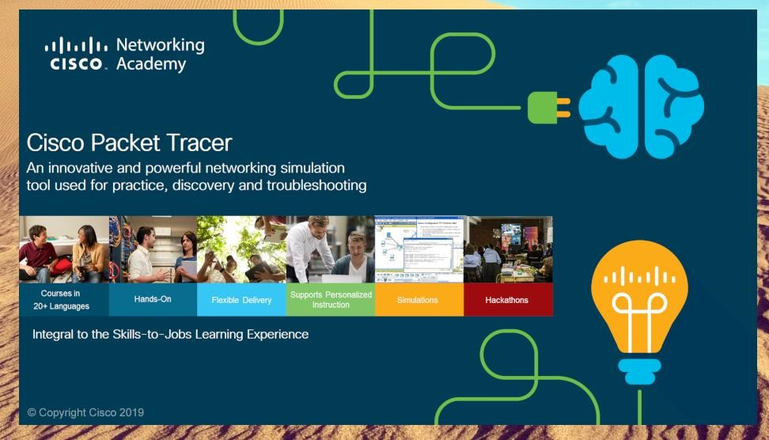

- At the bottom left we have all sort of devices present.

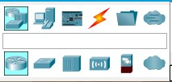

- Among them we drag 4 numbers of systems, 4 numbers of Switches as per need to the white screen. (Switch 0,1,2,3& Pc 0,1,2,3)
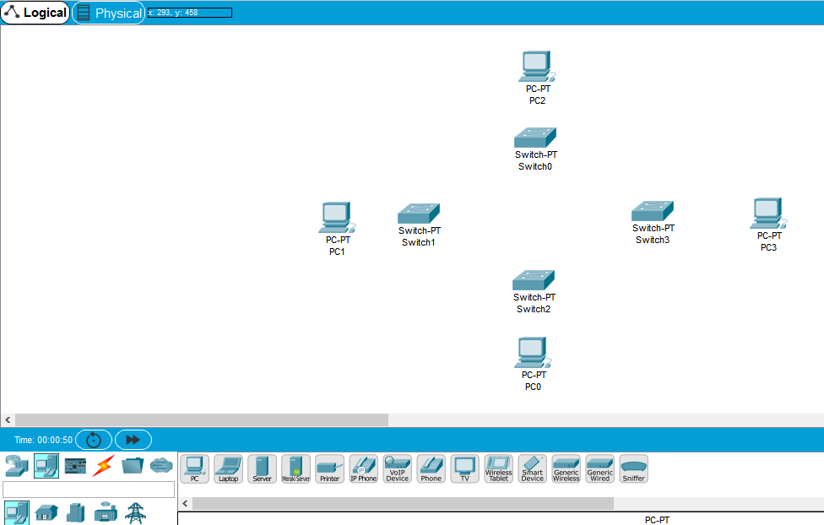

- Then we connect the switches with Cross-over UTP Cables by going to connections present at bottom left Panel.
  - SWITCH0(GigabitEthernet0/1) (GigabitEthernet0/1) SWITCH1.
  - SWITCH1(GigabitEthernet0/2) (GigabitEthernet0/1) SWITCH2.
  - SWITCH2(GigabitEthernet0/2) (GigabitEthernet0/1) SWITCH3.
  - SWITCH3(GigabitEthernet0/2) (GigabitEthernet0/2) SWITCH0.
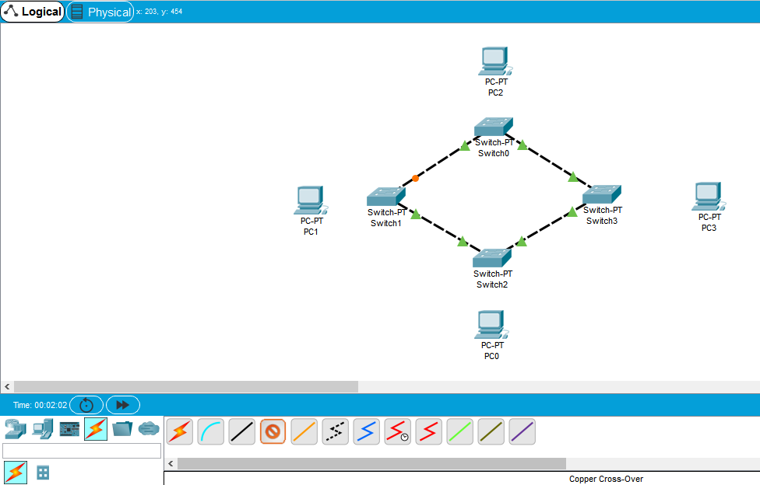

- Then we connect each switch with one system with Straight UTP cable. SWITCH0(FastEthernet0/1) (FastEthernet0)PC0.
SWITCH1(FastEthernet0/1) (FastEthernet0)PC1.
SWITCH2(FastEthernet0/1) (FastEthernet0)PC2.
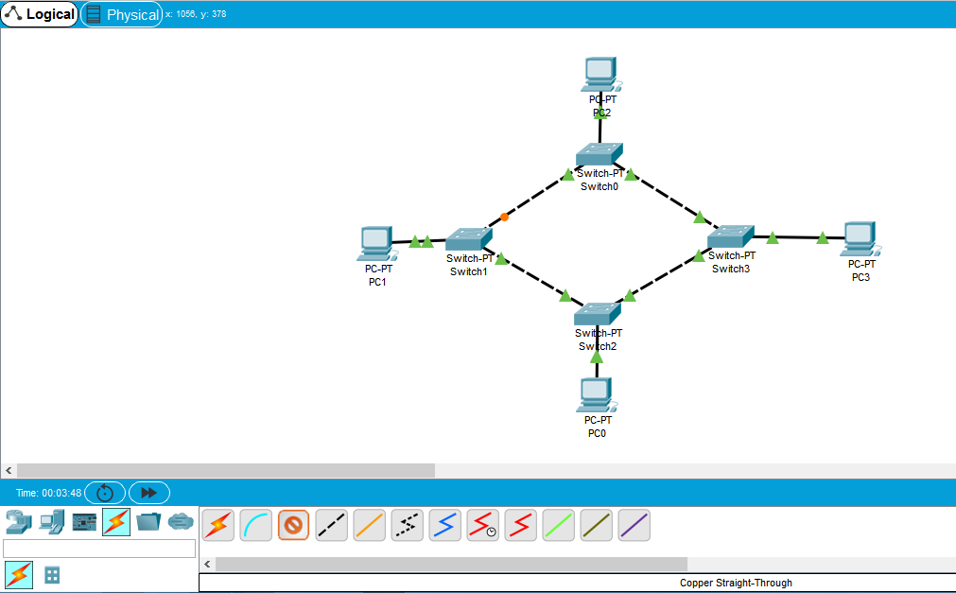
SWITCH3(FastEthernet0/1) (FastEthernet0)PC3.

- After the Physical connection we set up the IP configuration inside the Desktop of each PC. PC0 - 192.168.10.1
PC1 - 192.168.10.2
PC2 - 192.168.10.3
PC3 - 192.168.10.4
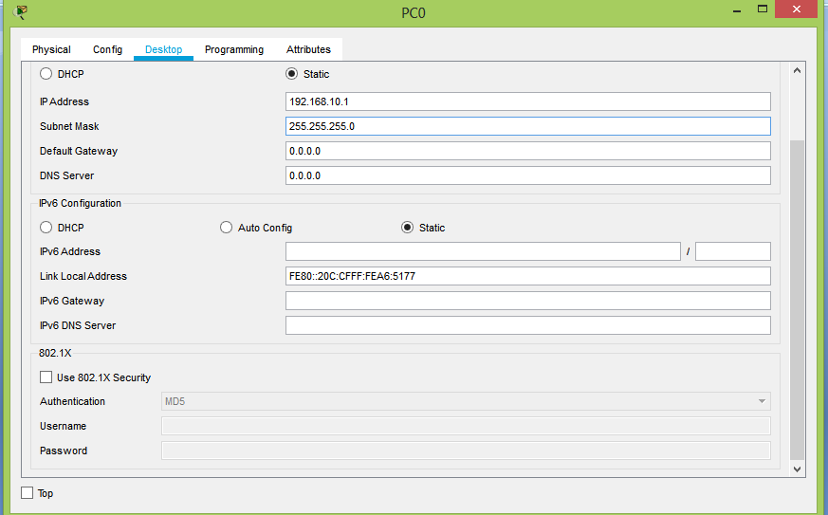

- Then we send message from PC0 to PC2 to see if our connection is correct.
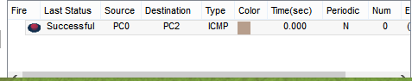
OR

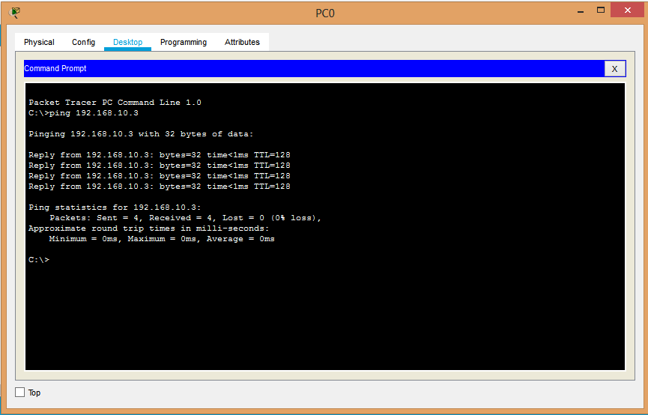
We go to Command Prompt of PC0, & type ping 192.168.10.3 then press enter.

Conclusion:

We have successfully Established a LAN connection Using Four Systems through Ring Topology.

