Aim of the Experiment: - EXP8
To login a system remotely using telnet protocol in Microsoft operating system.

Theory:
- Telnet:
Telnet is an application protocol used on the Internet or local area network to provide a bidirectional interactive text-oriented communication facility using a virtual terminal connection. User data is interspersed in-band with Telnet control information in an 8-bit byte oriented data connection over the Transmission Control Protocol (TCP).
  - Telnet is one of the earliest remote login protocols on the internet.
  - Through telnet, an administrator or another user can access someone else computer remotely.
  - On the web, HTTP and FTP protocols allow you to request specific files from remote computers but not to actually be log-on as user of that computer.
  - With telnet, you log-on as a regular user with whatever privileges you may have been granted to specific application and data on that computer.

Remote Login:
Remote login is a network application that permits a user sitting at a different location to work on a specific program on another computer
  - The user need ID of that computer generated by remote login application.
  - It is done only when both PC's are connected to the internet.
  - The main programs are:- Telnet, Any desk, Team viewer.

Procedure:
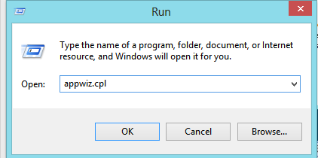
- First, we open windows run and type appwiz.cpl which will take us to programs and features of control panel where at the left side there is a tab named- turn windows feature on or off click on it.

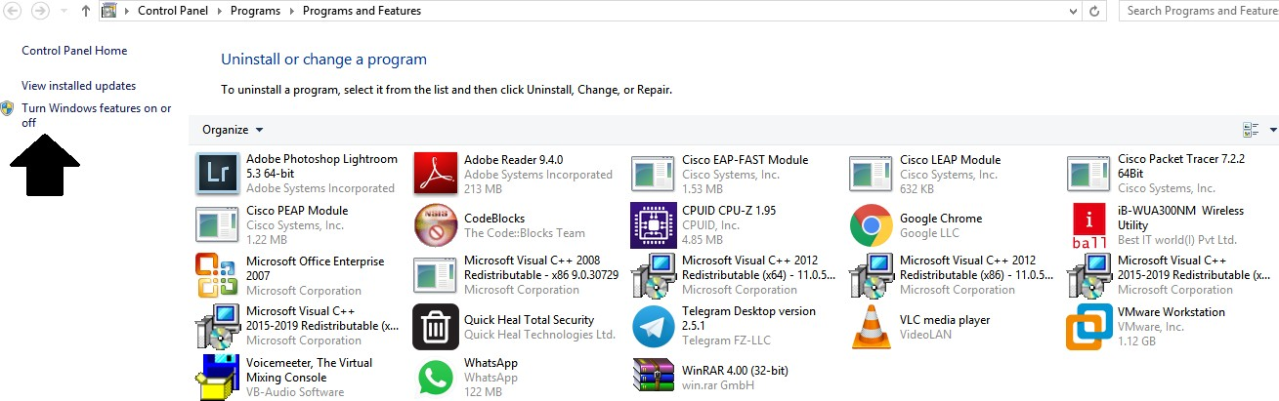

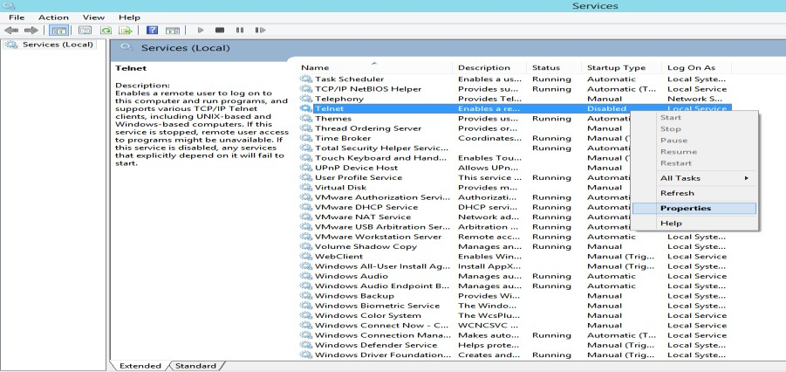
- Then after clicking windows feature a dialogue box will open in which there will be telnet client, telnet server which would be initially unchecked we have to click it and turn it to checked.
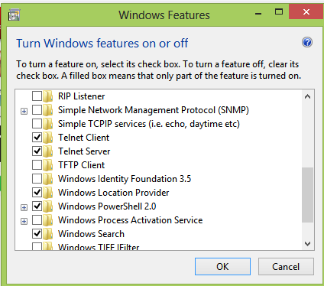

- Then we go to windows run and type services.msc to enable the telnet service.
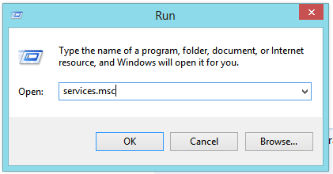

  - A services dialogue box will open in which there will be telnet.
  - Right-click telnet and go to properties.
  - In properties, general tab there is a " Startup type" initially it would be disabled.

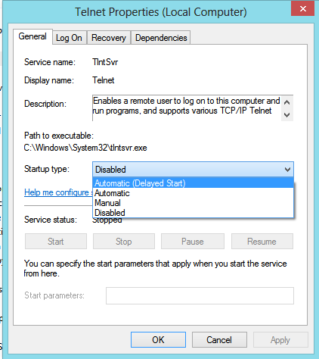
  - Change it to automatic and apply the settings.

- To enter remote computers:-
  - In command line
    - Open windows run and type "cmd" to open command prompt.
    - In command prompt type "telnet" and enter.
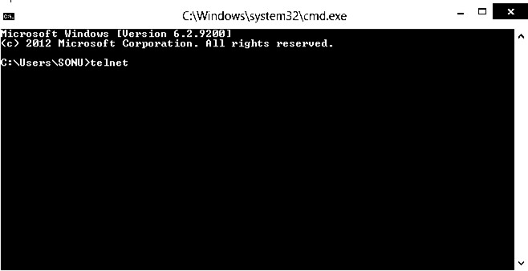

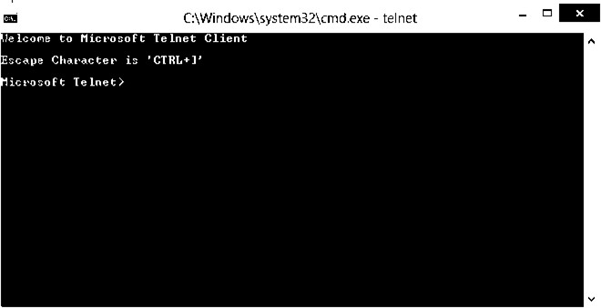
    - Add the remote computer and you are good to go.
  - In GUI
    - Open windows run and type "mstsc" and click ok.

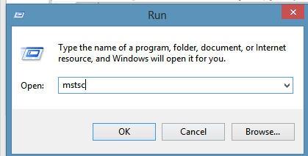
    - A dialogue box will appear which is remote desktop connection.

ii. Add the computer and you are good to go.
i

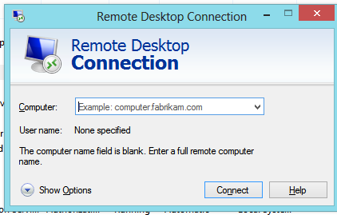

Conclusion:

We have successfully logined a system remotely using telnet protocol in Microsoft operating system

