Aim of the Experiment: - EXP9
To Install and configure Wired or Wireless Network Interface Card in a System within Cisco Packet Tracer.

Component Required:

Hardware:

Software:

Theory: -
- One system.
- NIC (Network Interface Card).
- Cisco Packet Tracer 7.2.2

  - NICs (Network Interface Card): Network Interface Card, or NIC is a hardware card installed in a computer so it can communicate on a network. The network adapter provides one or more ports for the network cable to connect to, and it transmits and receives data onto the network cable.
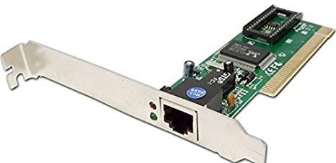
•
•
•
•

  - Wireless LAN card: Every networked computer must also have a network adapter driver, which controls the network adapter. Each network adapter driver is configured to run with a certain type of network adapter.

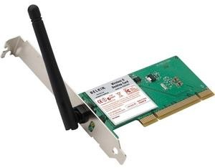

Procedure:

- First we open Cisco packet tracer
- Then we Drag a System on the white screen as per need. (PC0)
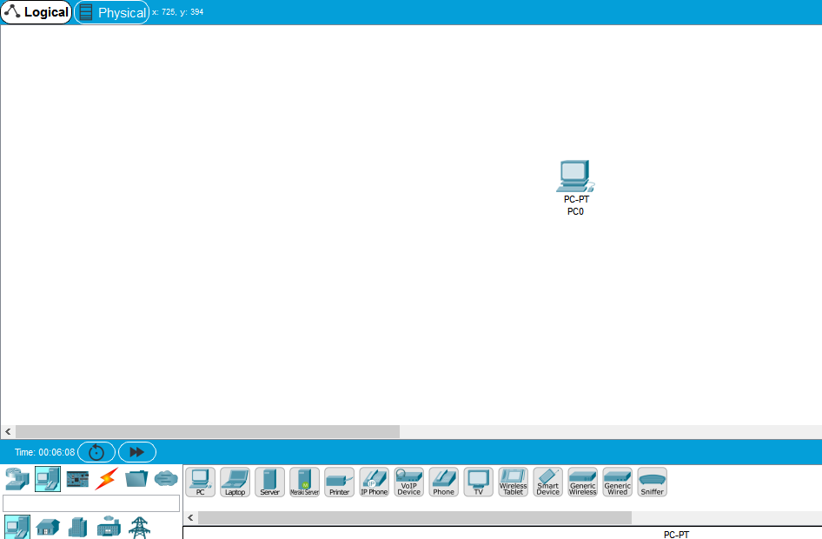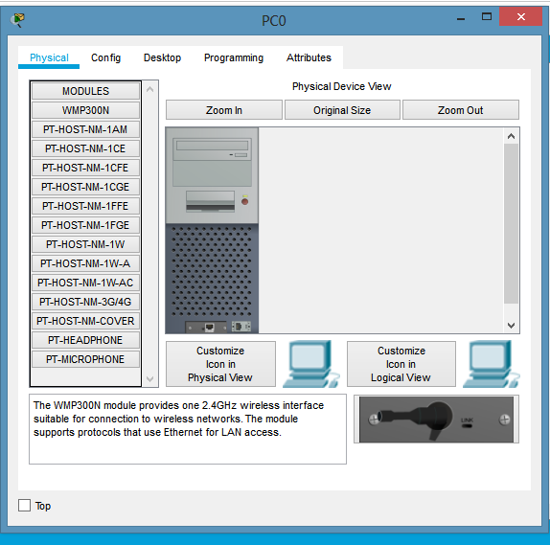
- Now we click on the PC0 to enter the physical tab of the system.
- Then we Switch-off the system.

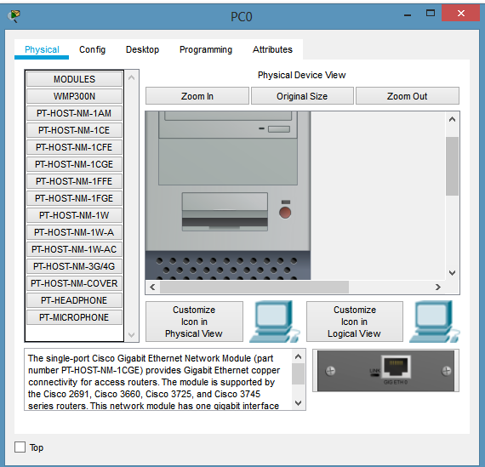

- After that we Dragged a NIC card(PT-HOST-NM -1CGE) into the system to attach it.
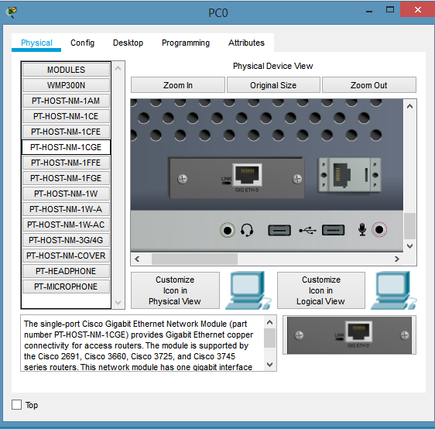
- Now at the end we have to switch-on the system.
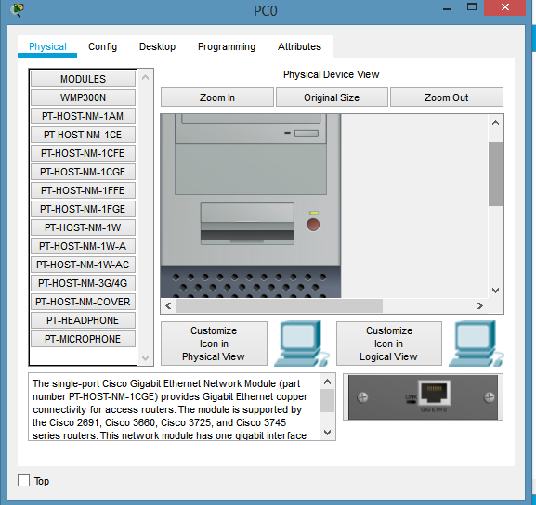
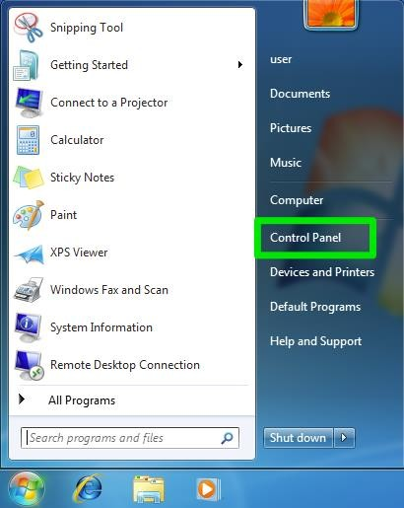
- Click on the Start button and select Settings then Control Panel.

- Double click on the Hardware and Sound Tab.
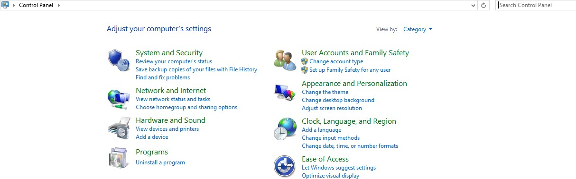

- Click on Device Manager in Devices and Printers.
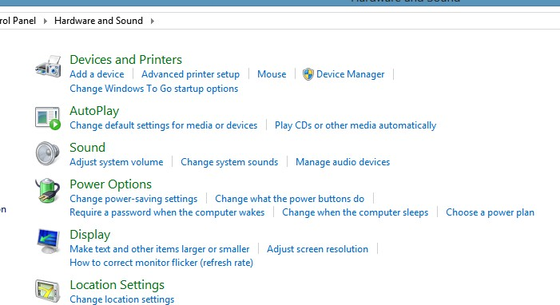

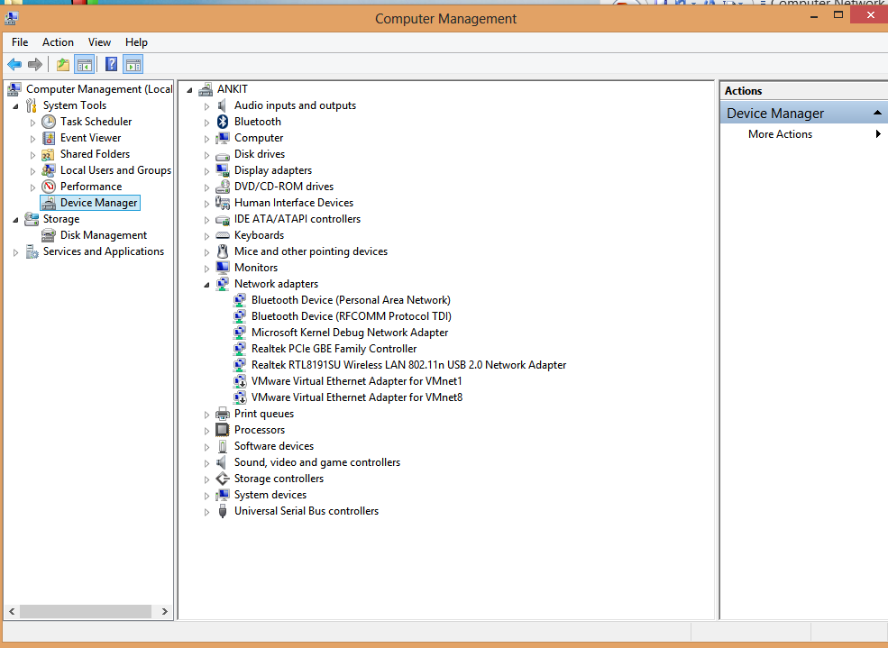
- You will see a list of devices installed in your computer.

- If necessary, click on the + sign next to Network Adapters to expand the list.
- Ensure that there is no yellow exclamation mark (!) next to the Network Adapter. This indicates a possible problem with the card or configuration.
- Double click on your network driver (e.g., NE2000 Compatible).
- In the Device Status box, you should see the message: This Device is working correctly.
- If you do not see this message or if there is no Network Adapter displayed, then your Ethernet card will probably need configuring.

Conclusion:
Installation and configuration of Wired (remotely) NIC in Cisco packet tracer have been done successfully.

