Poverty in India

Introduction
- Poverty is a state or condition in which a person or community lacks the financial resources and essentials for a minimum standard of living. Poverty means that the income level from employment is so low that basic human needs can't be met.
- According to World Bank, Poverty is pronounced deprivation in well-being, and comprises many dimensions. It includes low incomes and the inability to acquire the basic goods and services necessary for survival with dignity. Poverty also encompasses low levels of health and education, poor access to clean water and sanitation, inadequate physical security, lack of voice, and insufficient capacity and opportunity to better one's life.
- In India, 21.9% of the population lives below the national poverty line in 2011.
- In 2018, almost 8% of the world’s workers and their families lived on less than US$1.90 per person per day (international poverty line).
Types of Poverty: There are two main classifications of poverty:
- Absolute Poverty: A condition where household income is below a necessary level to maintain basic living standards (food, shelter, housing). This condition makes it possible to compare between different countries and also over time.
  - It was first introduced in 1990, the “dollar a day” poverty line measured absolute poverty by the standards of the world's poorest countries. In October 2015, the World Bank reset it to $1.90 a day.
- Relative Poverty: It is defined from the social perspective that is living standard compared to the economic standards of population living in surroundings. Hence it is a measure of income inequality.
  - Usually, relative poverty is measured as the percentage of the population with income less than some fixed proportion of median income.

Poverty Estimation in India
- Poverty estimation in India is carried out by NITI Aayog’s task force through the calculation of poverty line based on the data captured by the National Sample Survey Office under the Ministry of Statistics and Programme Implementation (MOSPI).
- Poverty line estimation in India is based on the consumption expenditure and not on the income levels.
- Poverty is measured based on consumer expenditure surveys of the National Sample Survey Organisation. A poor household is defined as one with an expenditure level below a specific poverty line.
- The incidence of poverty is measured by the poverty ratio, which is the ratio of the number of poor to the total population expressed as a percentage. It is also known as head-count ratio.
- Alagh Committee (1979) determined a poverty line based on a minimum daily requirement of 2400 and 2100 calories for an adult in Rural and Urban area respectively.
- Subsequently different committees; Lakdawala Committee (1993), Tendulkar Committee (2009), Rangarajan committee (2012) did the poverty estimation.
- As per the Rangarajan committee report (2014), the poverty line is estimated as Monthly Per Capita Expenditure of Rs. 1407 in urban areas and Rs. 972 in rural areas.

Causes of Poverty in India
- Population Explosion: India’s population has steadily increased through the years. During the past 45 years, it has risen at a rate of 2.2% per year, which means, on average, about 17 million people are added to the country’s population each year. This also increases the demand for consumption goods tremendously.
- Low Agricultural Productivity: A major reason for poverty in the low productivity in the agriculture sector. The reason for low productivity is manifold. Chiefly, it is because of fragmented and subdivided land holdings, lack of capital, illiteracy about new technologies in farming, the use of traditional methods of cultivation, wastage during storage, etc.
- Inefficient Resource utilisation: There is underemployment and disguised unemployment in the country, particularly in the farming sector. This has resulted in low agricultural output and also led to a dip in the standard of living.
- Low Rate of Economic Development: Economic development has been low in India especially in the first 40 years of independence before the LPG reforms in 1991.
- Price Rise: Price rise has been steady in the country and this has added to the burden the poor carry. Although a few people have benefited from this, the lower income groups have suffered because of it, and are not even able to satisfy their basic minimum wants.
- Unemployment: Unemployment is another factor causing poverty in India. The ever-increasing population has led to a higher number of job-seekers. However, there is not enough expansion in opportunities to match this demand for jobs.
- Lack of Capital and Entrepreneurship: The shortage of capital and entrepreneurship results in low level of investment and job creation in the economy.
- Social Factors: Apart from economic factors, there are also social factors hindering the eradication of poverty in India. Some of the hindrances in this regard are the laws of inheritance, caste system, certain traditions, etc.
- Colonial Exploitation: The British colonisation and rule over India for about two centuries de-industrialised india by ruining its traditional handicrafts and textile industries. Colonial Policies transformed india to a mere raw-material producer for european industries.
- Climatic Factors: Most of india’s poor belong to the states of Bihar, UP, MP, Chhattisgarh, odisha, Jharkhand, etc. Natural calamities such as frequent floods, disasters, earthquake and cyclone cause heavy damage to agriculture in these states.
- Poverty Trap:
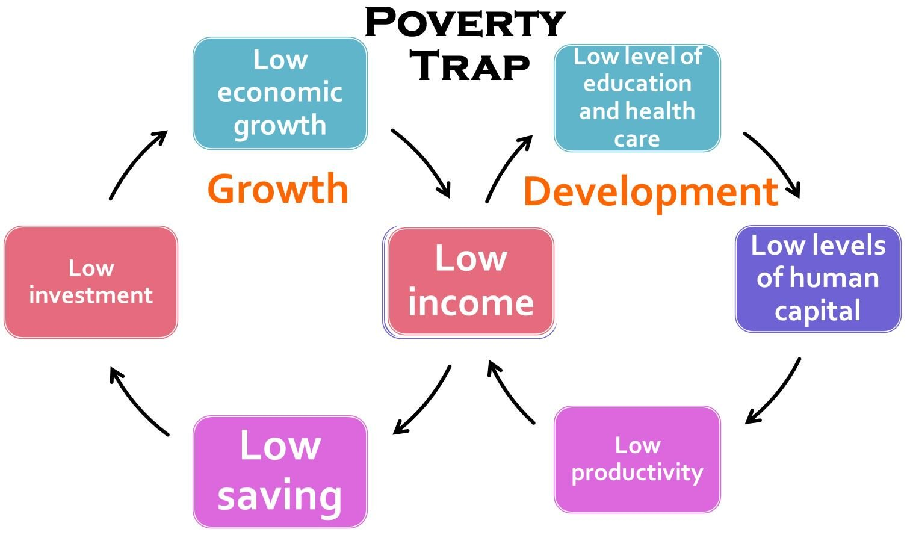

Poverty Alleviation Programs in India
- Integrated Rural Development Programme (IRDP): It was introduced in 1978-79 and universalized from 2nd October, 1980, aimed at providing assistance to the rural poor in the form of subsidy and bank credit for productive employment opportunities through successive plan periods.
- Jawahar Rozgar Yojana/Jawahar Gram Samridhi Yojana: The JRY was meant to generate meaningful employment opportunities for the unemployed and underemployed in rural areas through the creation of economic infrastructure and community and social assets.
- Rural Housing – Indira Awaas Yojana: The Indira Awaas Yojana (LAY) programme aims at providing free housing to Below Poverty Line (BPL) families in rural areas and main targets would be the households of SC/STs.
- Food for Work Programme: It aims at enhancing food security through wage employment. Food grains are supplied to states free of cost, however, the supply of food grains from the Food Corporation of India (FCI) godowns has been slow.
- National Old Age Pension Scheme (NOAPS): This pension is given by the central government. The job of implementation of this scheme in states and union territories is given to panchayats and municipalities. The states contribution may vary depending on the state. The amount of old age pension is ₹200 per month for applicants aged 60–79. For applicants aged above 80 years, the amount has been revised to ₹500 a month according to the 2011–2012 Budget. It is a successful venture.
- Annapurna Scheme: This scheme was started by the government in 1999–2000 to provide food to senior citizens who cannot take care of themselves and are not under the National Old Age Pension Scheme (NOAPS), and who have no one to take care of them in their village. This scheme would provide 10 kg of free food grains a month for the eligible senior citizens. They mostly target groups of ‘poorest of the poor’ and ‘indigent senior citizens’.
- Sampoorna Gramin Rozgar Yojana (SGRY): The main objective of the scheme continues to be the generation of wage employment, creation of durable economic infrastructure in rural areas and provision of food and nutrition security for the poor.
- Mahatma Gandhi National Rural Employment Guarantee Act (MGNREGA) 2005: The Act provides 100 days assured employment every year to every rural household. One-third of the proposed jobs would be reserved for women. The central government will also establish National Employment Guarantee Funds. Similarly, state governments will establish State Employment Guarantee Funds for implementation of the scheme. Under the programme, if an applicant is not provided employment within 15 days s/he will be entitled to a daily unemployment allowance.
- National Rural Livelihood Mission: Aajeevika (2011): It evolves out the need to diversify the needs of the rural poor and provide them jobs with regular income on a monthly basis. Self Help groups are formed at the village level to help the needy.
- National Urban Livelihood Mission: The NULM focuses on organizing urban poor in Self Help Groups, creating opportunities for skill development leading to market-based employment and helping them to set up self-employment ventures by ensuring easy access to credit.
- Pradhan Mantri Kaushal Vikas Yojana: It will focus on fresh entrant to the labour market, especially labour market and class X and XII dropouts.
- Pradhan Mantri Jan Dhan Yojana: It aimed at direct benefit transfer of subsidy, pension, insurance etc. and attained the target of opening 1.5 crore bank accounts. The scheme particularly targets the unbanked poor.

Conclusion
- The Global Multidimensional Poverty Index-2018 released by the UN noted that 271 million people moved out of poverty between 2005-06 and 2015-16 in India. The poverty rate in the country has nearly halved, falling from 55% to 28% over the ten-year period. Still a big part of the population in India is living Below the Poverty Line.
- Rapid economic growth and the use of technology for social sector programs have helped make a significant dent in extreme poverty in the country.
- Despite rapid growth and development, an unacceptably high proportion of our population continues to suffer from severe and multidimensional deprivation. Thus, a more comprehensive and inclusive approach is required to eradicate poverty in India.
(Source: Dristiias.com)

