REFRACTOMETRY
INTRODUCTION
Refractometry is the method of measuring the refractive index of substances. Refractive index is defined as the ratio of the speed of light in a vacuum to the speed of light in another substance is defined as the index of refraction or refractive index (n) for the substance.

Refraction phenomenon
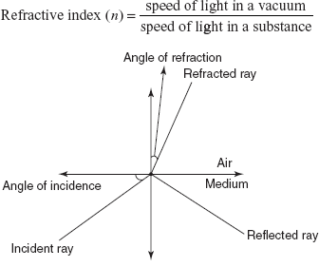

PRINCIPLE AND THEORY
The main principle involved in refractometry is the refraction based on the speed of the light that passes in the different mediums.
Light enters into the light denser medium to high denser medium at an angle, that is, with bent. The bent in the light ray is known as the refraction. The relation between the refraction of the light between the air and the medium is given by Snell's law:

n = sin i/sin r

where n = refractive index; sin i = angle of incidence; sin r = angle of refraction.
Samples with different refractive index will produce different angles of refraction. This helps in the assessment of the compounds’ composition and the purity of the compounds.
There are different methods for the determination of the refractive index as follows:

Becke line method: This method was first proposed by Mittchell and is mainly used for the determination of facetted stones. It is comprised of the microscope with the light field illumination. By using the known substance, the refractive index of the unknown substance is measured.

Immersion contrast method: This method involves the determination of the relief and appearance of the girdle and the facet edges when immersed in the known liquid.

Direct measurement method: This method involves the measurement of the refractive index by using the microscope with a verneir scale. This method is more effective for the single refracting stones.

Minimum deviation method: This method involves the use of the table spectrometer and is the most accurate method for the measurement of the refractive index. It requires skill and ideal conditions.

INSTRUMENTATION
The instrument used for the determination of the refractive index is known as the refractometer. There are different refractometers used for the determination of the refractive index. They are as follows:

Traditional handheld refractometer: The main principle involved in this refractometer is the measurement of the critical angle. It is comprised of the lenses and prisms to project the black line on the glass when the sample is placed between the measuring prism and the plate.

Digital hand held refractometer: The principle is the same as the traditional handheld refractometer. The main difference is that the light from the LED light source is focused on the prism. This creates the black line due to the refection of the photodiode arrays.

Abbes refractometer: This is a benchtop refractometer, designed by Ernst Abbe, which provides high accuracy. In this refractometer, the sample is held between the illuminating prism and the refracting prism. A light source is allowed through the illuminating prism and the detector is placed behind the refracting prism.

Inline process refractometer: This is mainly used for the continuous measurement of a fluid flowing through a pipe. This refractometer consists of a sensor placed in the flow of the fluid. This is connected to the control box which gives the digital readout.

FACTORS AFFECTING THE REFRACTIVE INDEX

Temperature: It is inversely proportional to the refractive index.
Viscosity: It is inversely proportional to the refractive index.
Wavelength: The sodium D-line at 595 nm is the appropriate wavelength for the determination of the refractive index.

APPLICATIONS

Used in the determination of the refractive index of the compounds
Used in the determination of the concentration of the compounds
Used in the determination of the structure
Used in the determination of the critical micelle concentration of the compounds

POLARIMETRY

INTRODUCTION
Polarimetry is a sensitive non-destructive method for the measurement of the optical activity of the compounds which are organic or inorganic in nature. This measures the rotation of the polarized light as it passes through an optically active compound. This method i s mainly used in the determination of the unknown solution concentrations. A substance is said to be optically active if it rotates the plane of the polarized light.

Optical activity phenomenon
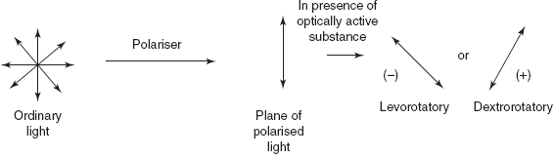

When the polarized light passes through the optically active substance and rotates the plane of polarized light to the left side, or clockwise, then the compound is known as the dextrorotatory substance. If the rotation is observed in the right side, or anti-clockwise direction, then the compound is known as the levorotatory substance.

THEORY
The rotation of the plane polarized light is mainly based upon the asymmetric molecules and the steric configuration. The rotation is directly proportional to the concentration and the path length. The angle of rotation is calculated by Biot's formula:

α = [α]D25 × C × d

Where, C = concentration of the sample solution; d = path length of the sample cell; [α]D25 = specific rotation of the sample at D line of the sodium at 25°C.

Factors affecting the optical activity:

Nature of the sample
Concentration
Length of the sample tube
Wavelength of the incident light
Temperature of the sample solution

CONCEPT OF THE CIRCULAR DICHROISM (CD) AND OPTICAL ROTATORY DISPERSION (ORD):
The measurement of the optical rotation as the function of the wavelength is known as the ORD, and the measurement of the unequal absorption of the right and left circularly polarized light is known as the CD.
This means that by changing the wavelength, the rotation of the optically active compound is changed in ORD.

ORD and CD phenomenon
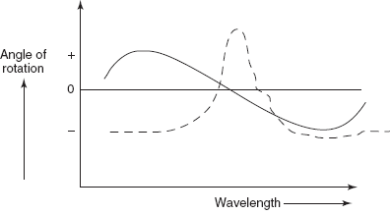

The change in the specific rotation with the wavelength change is known as the cotton effect. Above the zero is known as the positive cotton effect, and below the zero is known as the negative cotton effect. The concept of the ORD was first given by Crabbe and Djerassi.
In CD, the two components of the polarized light have two different absorptivities, that is, circularly polarized light is converted to the elliptically polarized light. This mainly measures the difference of the optical rotation between the dextrorotatory and the levorotatory substances. Hence the CD is the plot between the molar ellipticity and the wavelength.

Molar ellipticity (θ) = [ψ]M/100
= ∊₁−∊_{r}

where Ψ = specific ellipticity; M = molecular weight; εl and εr are the molar absorptivities of the left and right circularly polarized light.
CD is an absorptive quantity and ORD is a dispersive quantity. CD has a higher resolution than ORD.

INSTRUMENTATION
The optical activity is determined by the polarimeter which consists of the following components:

Source
Filter
Sample cell
Analyzer
Detector

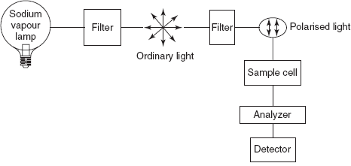
Polarimeter
Source
Generally, sodium vapour lamp is employed. This produces wavelengths above 450 nm.
Filter
Filter is mainly used to polychromatic light into monochromatic light by absorbing the undesired radiation.
Sample Cell
Sample cells are long tubes which are made up of glass.
Analyzer
A nicol prism is used for this purpose. This is mainly used to analyze the samples whether they rotate the plane of polarized light on the right or left side.
Detector
The photomultiplier tube is commonly employed for the detection of the wavelength.
The procedure followed is sample tube filled with the sample solution which is placed between the polarizer and the analyzer. Then, allow the source of light to pass through the radiation. This ordinary light is polarized by the polarizer and the polarized light is passed through the sample solution.
The optically active substance present in the sample solution rotates the plane polarized light into clockwise or in an anti-clockwise direction. Then, the analyzer measures the angle of rotation and is detected by the detector.

APPLICATIONS

Used in the determination of the unknown solutions concentration
Used in the identification of several compounds
Used in quantitative determinations in the sugar industry
Used in proteomics
Used in the determination of the optical purity of substances
Used in the determination of chiral compounds

ADVANTAGES

Simple
Random analysis
Simple sample preparation

DISADVANTAGES

Only optically active substances can be measured
Less accurate
Less reproducibility
High interferences

