Atropisomerism
- Biphenyls are compounds whereby a phenyl ring is connected to another through a central σ bond.

- In unsubstituted biphenyl, there is sufficient amount of freedom of rotation around the central single bond to allow for free interconversion between the various conformers or rotamers so that the various rotamers cannot exist independently.
- However, biphenyls with large substituents at the ortho positions on either side of the central σ bond experience restricted rotation along this bond due to steric hindrance. If the substituents are different, a chiral molecule existing as a pair of enantiomers called atropisomers is obtained.
- Polynuclear aromatic systems such as binol also exist as enantiomers.
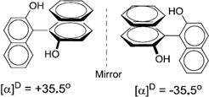
- Atropisomerism are stereoisomers as a result of restricted rotation about a single bond.
- Atropisomers are stereoisomers resulting from hindered rotation about single bonds where the steric strain barrier to rotation is high enough to allow for the isolation of the conformers (from Greek, a = not and tropos = turn).
- If bulky group on ortho position of bi-phenyl or strained ring structural features. Bulky substituents or strained rings may enhance the barrier to rotation between two distinct conformations to such an extent as to allow observation of atropisomers.
- Atropisomerism is also called axial chirality and the chirality is not simply a centre or a plane but an axis.
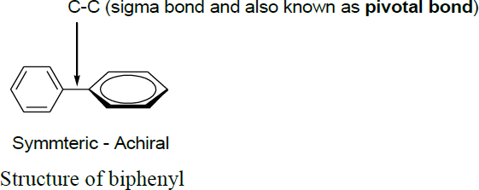

- Biphenyl substituted on ortho position, which contains a chiral axis along the biphenyl linkage. The biphenyl rings are perpendicular to each other in order to minimize steric clashes between the four ortho substituents meaning that rotation about the biphenyl bond through pivotal bond is restricted.
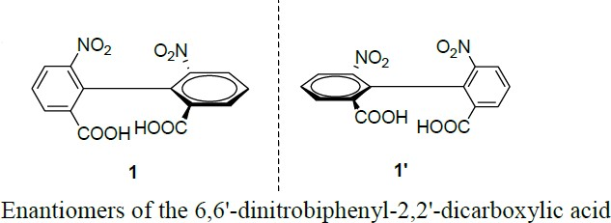
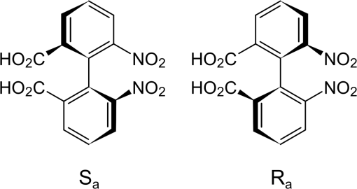

Conditions of Atropisomerism:
  - A rotationally stable axis
  - Presence of different substituents on both sides of the axis
  - The configurational stability of axially chiral biaryl compounds is mainly determined by three following factors:
    - The combined steric demand of the substituent in the combined steric demand of the substituents in the proximity of the axis.
    - The existence, length and rigidity of bridges.
    - Atropisomerisation mechanism different from a merely physical rotation about the axis, e.g. photo chemically or chemically induced processes.

Stereochemical assignment
- Determining the axial stereochemistry of biaryl atropisomers can be accomplished through the use of a Newman projection along the axis of hindered rotation.
- The ortho, and in some cases meta substituents are first assigned priority based on Cahn–Ingold–Prelog priority rules.
- Starting with the substituent of highest priority in the closest ring and moving along the shortest path to the substituent of highest priority in the other ring, the absolute configuration is assigned P or Δ for clockwise and M or Λ for counterclockwise.
