Information Storage & Retrieval

Contents
- Information storage and retrieval
- Basic concept of information storage
- Types of Information storage media
- Basic concept of Information Retrieval
- Major Components of IR
- Retrieval Techniques
- Information Retrieval Systems

Cont.…
- Evaluation of information Retrieval Systems
- Evaluation Measures for IR
- Steps for Evaluation
- Future Trends of IR
- Conclusion

Information storage and retrieval

- Systematic process of collecting and cataloging data so that they can be located and displayed on request. Computers and data processing techniques have made possible to access the high-speed and large amounts of information for government, commercial, and academic purposes.

- A branch of computer or library science relating to storage, locating, searching and selecting, upon demand , relevant data on a given subject.
(Encyclopedia of Medical concept)

Basic concept of information storage

It can refer to a place like a storage room where paper records are kept. It can also refer to a storage device such as a computer hard disk, CD, DVD, or similar device which can hold data.

Types of Information storage media

Storage keeps data and information for use in the future. Common storage mediums are:
  - Hard Drive
  - Floppy Disk
  - CD&DVD
  - USB Flash Drive

Hard Drive
  - It is always inside the computer.
  - It stores all the programs that the computer needs to work.

Floppy Disk
- It is a portable storage medium.
- Put it into the computer save your information

Hard Drive Floppy Disk
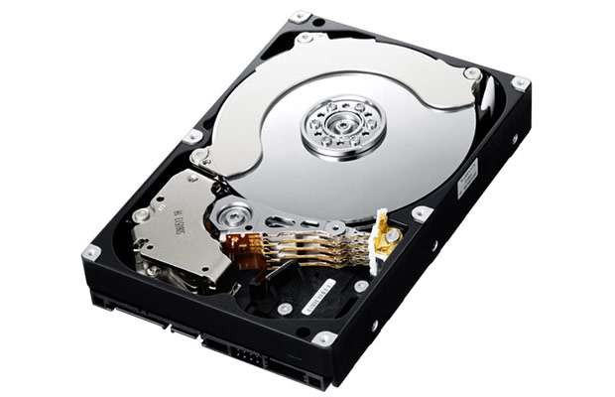

CD&DVD
- It is a portable storage.
- It allows you to save information on it.

USB Flash Drive
- It is very easy to carry
- It holds more data than a floppy disk.
- It is very small device than others.

CD&DVD USB Flash Drive

Basic concept of Information Retrieval

"An information retrieval system is an information system, that is, a system used to store items of information that need to be processed, searched, retrieved, and disseminated to various user populations” (Salton, 1983 )

Major Components of IR

Information retrieval can be divided into several major constitutes which include:
- Database
- Search mechanism
- Language
- Interface

Database

A system whose base, whose key concepts, is simply a particular way of handling data & its objective is to record and maintain information.

Search mechanism

- Information organized systematically that can be searched and retrieved when a corresponding search mechanism is provided.
- Search procedures can be categorized as basic or advance search procedure.
- Capacity of search mechanism determines what retrieval techniques will be available to users and how information stored in databases can be retrieved.

Language

  - Information relies on language when being processed, transferred or communicated.
  - Language can be identified as natural language and controlled vocabulary.

Natural Language

Natural language concerned with the interaction between computer and human interaction. In which:
- Any user-created terms assigned to images by users, such as
tags, folksonomies, and keywords
- Up-to-date, new terms are immediately available
- Words of author used
- Unstructured data
- Easier exchange of material between databases

Controlled Vocabulary

Controlled vocabularies are structured hierarchies of terms used to categorize images.
- Such vocabularies are typically created and maintained by a particular institution of authority
- No immediate up to date
- Words of author liable to be misconstrued
- Structure Data
- Incompatibility a barrier to easy exchange

Interface

Interface regularly considered whether or not an information retrieval system is user friendly.
  - Quality of interface checked by interaction mode
  - Determines the ultimate success of a system for information retrieval

Retrieval Techniques

Major retrieval techniques are:
- Basic Retrieval Techniques
- Advanced Retrieval Techniques

Basic Retrieval Techniques

- Boolean Searching
- Case sensitivity searching
- Truncation
- Proximity searching
- Range searching

Boolean Searching

Logical operations are also known as Boolean Logic. When Boolean logic is applied to information retrieval, the three operators, called Boolean operators.
- The AND operate for narrowing down a search
- The OR operate for broadening a search
- The NOT operator for excluding unwanted results

Cont.…

=.OOLEAM OPERATORS

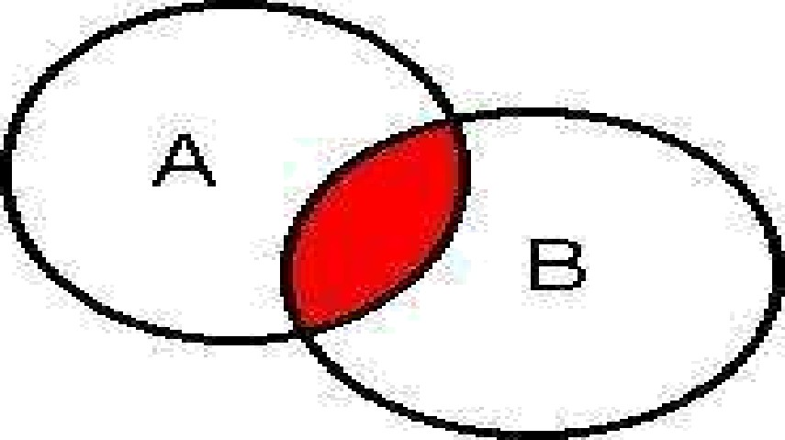

A Al‘dD B
A OR B A I'JOT B

Boolean Operators at Emerald

- Athe tit I i
- F r r
Home » Advanced search: AI

Advanced search
gj Search ri: All Journals Books Elibliographic databases Case Stu&es Site Pages

in All fields - in All fields

OR NOT
in All fields -

I3*omse.

Case sensitivity searching

  - Text sometimes exhibits case sensitivity; that is, words can differ in meaning based on differing use of uppercase and lowercase letters. Words with capital letters do not always have the same meaning when written with lowercase letters.
  - For example, Bill is the first name of former U.S. president William Clinton, who could sign a bill
  - The opposite term of "case-sensitive" is "case-insensitive“
  - For example, Google searches are generally case-insensitive and Gmail is case-sensitive by default.

Truncation
- Truncation allows a search to be conducted for all the different forms of a word having the same common roots
- Used symbol (Question mark? , asterisk* and pound sign # ) for truncation purpose.
- A number of different options are available for truncation like Left truncation, Right truncation and middle truncation.

Cont.…

- Left truncation retrievals all the words having the same characteristics at the right hand part, for example, *hyl will retrieval words such as “methyl” and “ethyl”

- Right truncation, for example the term of Network* as a query results in retrieving documents on networks and networking.

- Similarly middle truncation retrieval the words having the same characteristics at the left hand and right hand part, for example, “Colo*r” will retrieval both the term “colour” and “color”.

Truncation
Home » Advanced search: AI

Advanced search

- ten e
- F r r
ty Search : All JOUmal s Boo ks Bibliographic Oatabas es Case fluxes Site Pages
I n
Se zrcfi for

AND
manag* in All fields -

in All fields -

AND in All fields -

[kcmvse.
itwus tween: All - arms All -

Truncation

O Login
U sern ame:
Pa ssw ard:

- Athen elmstitutian al la qin
- Fnrqnt passxv nrd*
Welcome:
G u est

Se arch for:

in. All content
Ad ma nced search I.1arked lists Browse:
B a a ks & a urn a \s
B iblia gra phic Data ba ses
Ca se Btu dies

Pro du ct Information:
la r Ja urn a Is Fa r B a a ks
H a me > Adcanced search > Search resu ks: All

Search Results
F\ View resuIts for: .DII J o urn al s Bo oKs Bibli o gra p hic D atab ase s C ase Stu di es Site P ages

Content = All content, (manag* in All fields ), inc. EarlyCite artic les, inc. Bac kfiles content
New se arch I M o dill se arch I Add save d search alert | Se arch in re s ult s.
Icon key: la u h a we a ccess ta this item B B a ckfiles E E arlycite A Abstra ct a n

ournals:
View all 1 70183 results
1 Managing project portfolios . balancing flexibility and structure by improvising
Type: Research pa per
Auth or(s}: Ann a J erbrant, Tin a Karrbo m G u sta Asso n
la urce: Intern aticin al J aurnaI a i I.fana qin q Prai ects in B u sin ess Va lume: 6 Issue: 1 2013
Plea se la gin v Preview abstra ct & purcha se [ HTC.IL & PDF (116kb} a va ila ble ] Related items Reprints & permissia n s

Sustainable development and project stakeholder management. what standards say
Type: Research pa per
Auth a r(s}: Pernille E skera d, I.1artin a Hu eman n
to urce: Intern ation al J ournaI a f I.fana qin q Pro iects in Busin ess Vo lume: 6 Issu e: 1 2013
Plea se la gin a Preview abstra ct & purcha se [ HTf.1L & PDF (92kb} a va ila ble ] Related items Reprints & permissian s

Robust project portfolio management: capability evolution and maturity
Type: Research pa per
Auth ar(s}: Cath erin e P. Killen, la bert W. Hunt
to urce: Intern atinn al .inurnaI n f I.1ana qin q Prn iels in Busin ess Vo lume: 6 Issue 1 2013

Truncation

Sadaf Rafiq T Shari

Advanced Search

Find pages with...

all these wDrds.

this exact wDrd Dr phrase.
To do this in the seorch box.

Type th e impartant xv a rd s

Put exact word s in qu otes: " xa t: t:e xxi e x "

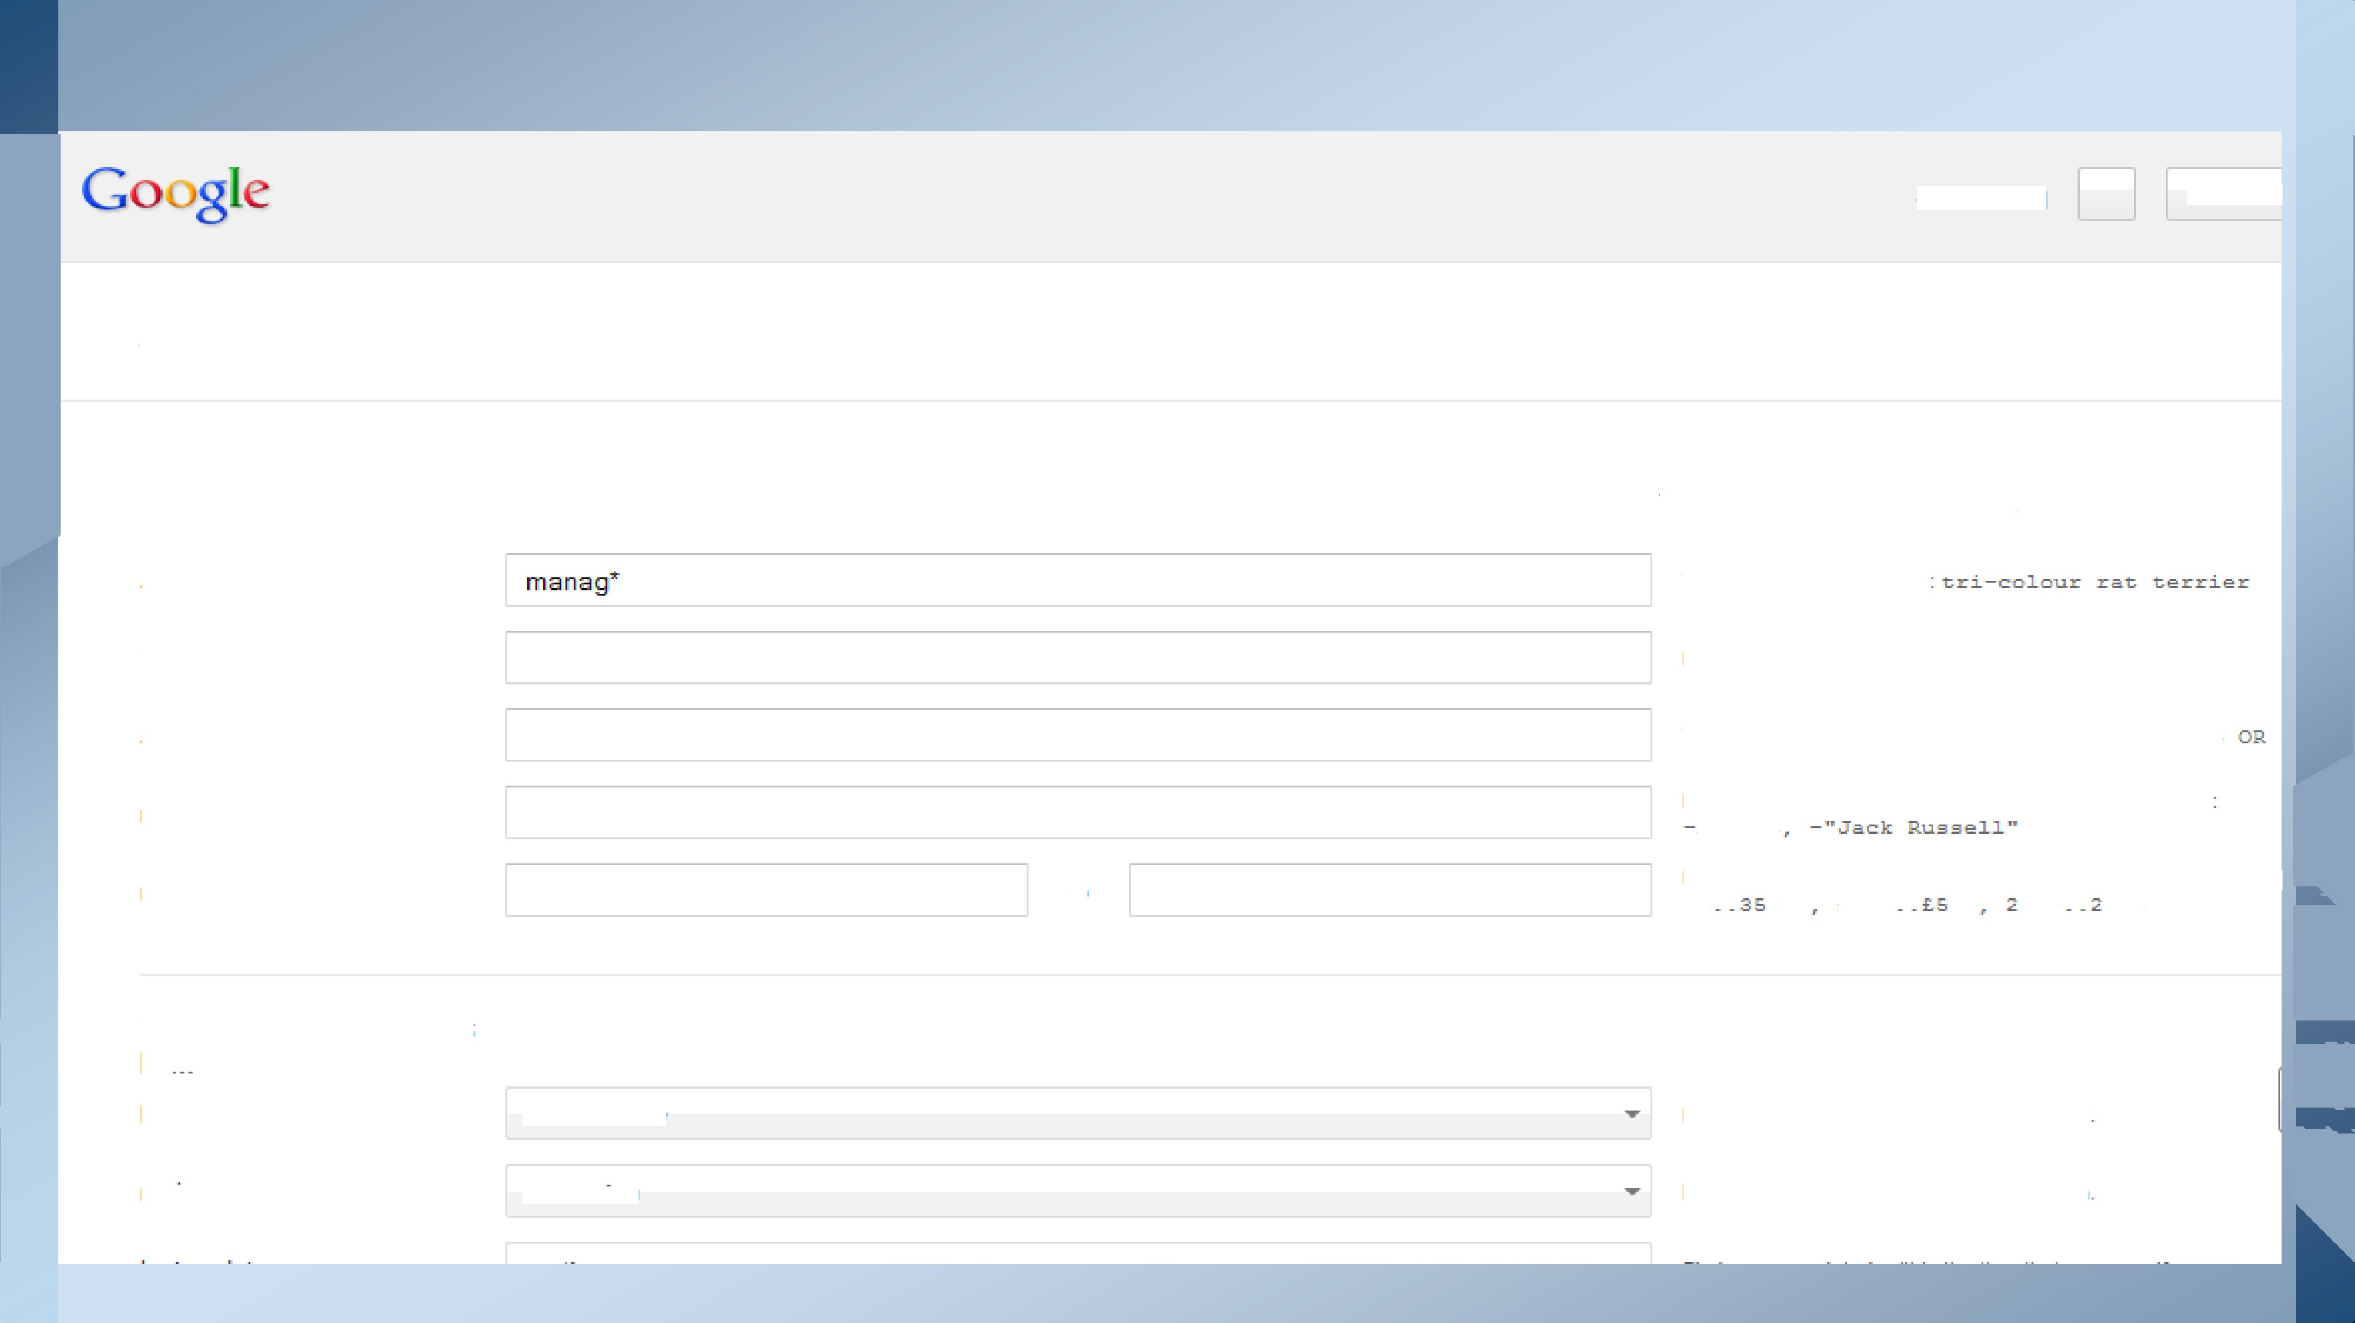any Df these wDrds.

nDne Df these wDrds.

numbers ranging ffDFFi.

Then narrow your results

language.

region.

tO

any lanQuaQe

any region
Type 0ñ betw een all th e word s you v ant: xt rz1a cuxe

Put a min u s sign ju st before xv ords th at you d a n1 xv ant x c 4e rzc

Put t\v o fuII sto ps betw een the numbers and a d d a unit a f mea

Find pa ges in th e Ian gu a g e th at you select

Find pa ges publish ed in a particula r regio n

Proximity searching

A proximity search allows you to specify how close two (or more) words must be to each other in order to register a match.
There are three types of proximity searches:
- Word proximity
- Sentence proximity
- Paragraph proximity

Ooo;gle

Proximity searching

VVeb Images Vi d e Ds M Dre
Abo ut 4 32. 0 CI CI re s u Ist i” O . 2 3 s e c a la d s)
Drop 1 — Li berzztian - Drop2 — his - Drop Z — J n=•rwzztch - Drop 4- — fIsa•zk E <z>c Drop R —
fIzz•zk Ice - Drop6 — N tisztar - Drop T — nctuaryr - Drop B — Faunc zztian ...

Apr 16, 2Ci 3 — Items thszt are sec cIeeI th rough t tu Wn£ II Ie cNic>n be us e<:I in
It <foes nat cIete•zt Unani II I<z<rti<>n items thzzL he been Nez câe< to a
Nmvicsettir›cs tL›e• C<>mm C<>lle<rti<>n - E3Ietokbc›etrcf Help
https:77neIp.DIackDoaro Cz>n€en€ Cz>II eoticsn7o1O hl avijg atinjg tne
Dec 1,8 2012 — After I<>jpginjg inta I I kkzossrcl Learn,s el at th e Unani DII+> tic>n tzsb
eat ... If you hzzv clifficu IQ fi nclinp th e x>ninc lice ti<>n zzfter I<>jpginjg i,n ...

www.youtu .c orrz/watc n ?v I hIZTHhIaHTB -
J un , 2CI12 — M I Dad ed Lry II a-c kVVaI kth rDujz/hs
II I f Dub - Mo<Jem VU'arfssre Z - mind II Iez<zti<>n 2 - Oas si - E§zi so<Je U. EDI kVU'aI kth roughs -ED9 vicIe•os ...
Mare vicIe•os for "<z<>rzind <>o•IIe•crti<>n"J'R o

Range searching

It is most useful with numerical information. The following options are usually available for range searching
  - greater than (>) less than (<)
  - equal to (=)
  - not equal to (/= or o)
  - greater than equal to (>=)
  - less than or equal to (<=)

Example of Range Searching
To search for documents or items that contain numbers within a range, type your search term and the range of numbers separated by two periods (“..”). For example, to search for pencils that costs between $1.50 and $2.50, type the following:

Advanced Retrieval Techniques

  - Fuzzy searching
  - Query expansion
  - Multiple databases searching

Fuzzy searching
It is designed to find out terms that are spelled incorrectly at data entry and query point.
For example the term computer could be misspelled as compter, compiter, or comyter. Optical Character Recognition (OCR) or compressed texts could also result in erroneous results. Fuzzy searching is designed for detection and correction of spelling errors that result from OCR and text compression.

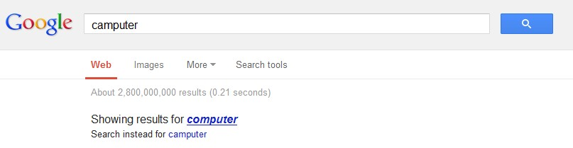

Query expansion

Query expansion is a | retrieval technique that allows the end | user to | improve
retrieval performance | by revising search queries based on | results | already
retrieved

Start
NO
YES
Satisfied?
END
Query
Expansion
Present
search result
Conduct Search
Submit Query

Multiple Database Searching
It means searching more than one IR systems. The need for searching multiple databases seems threefold.
- First, searching in single IR system may not get what the user is looking for.
- Secondly, multiple databases searching can serve as a selection tool if the user is not sure which systems would be the best choice for a given query .
- Third, result obtained from multiple databases searching can suggest or indicate suitable systems for the user to conduct further searches.
Examples: EBSCOhost, ProQuest

Information Retrieval Systems
  - Online systems
  - CD-ROM systems
  - OPAC
  - Web information Retrieval Systems

Online systems

Online information retrieval systems allow the user to search databases located remotely with the help of the computer and telecommunication technology.
  - Basic searching techniques
  - Advanced retrieval techniques

Examples:
Library of Congress, University of Punjab Library

CD-ROM systems
- CD-ROM systems are usually searched locally and it works if the systems are not networked.
- Basic retrieval techniques are supported in CD-ROM systems while advanced search facilities are applied in limited scope.
- The data which is stored on compact disc (CD) can to read by any computer operating systems and any CD-ROM drive.
Example:

LISA

OPAC
  - Online public access catalogs (OPACs) are traditional catalogs executed in a different medium.
  - Different features of OPACs are
- First, OPACs contains bibliographic information about library resources.
- Second, OPACs can be considered as an extension of MARC records.
- Third, OPACs support at least field searching, keyword searching and Boolean searching.
Examples

Library of congress catalogue University of Punjab online catalogue

Web information Retrieval Systems

  - It deals with text as well as multimedia information resources that are linked with other documents and there is no target user’s community as such.
  - Basically web is a platform where anyone from anywhere can publish virtually any information, in any language or in any format.
Examples,
Google, Alta Vista

Evaluation of information Retrieval Systems
Lancaster states that we can evaluate an information retrieval system by considering the following three issues.
- How well the system is satisfying its objectives, how well it is satisfying the demands placed upon it
- How efficiently it is satisfying its objectives and finally
- Whether the system justifies its existence

Evaluation Measures for Information Retrieval

Recall and Precision
Measure of whether or not a particular item is retrieved or the extent to which the retrieval of wanted items occurs
  - The performance of a system is often measured by recall ratio, which denotes the percentage of relevant items retrieved in a given situation.
Number of relevant items retrieve
Recall= × 100
Total number of relevant items in the collection

Cont.

  - By precision we mean how precisely a particular system functions. It is quite obvi•ous that when the system retrieves items that are relevant to a given query it also retrieves some documents that are not relevant
Number of relevant items retrieved Precision = × 100
Total number of items retrieved

Fallout & Generality
  - Fallout describes what proportion of non-relevant items has been retrieved in a given search. This is often termed as fallout ratio.

  - Generality describes what proportion of relevant documents in the collection for a given query.

Possible Retrieval Outcomes

Judgment  Result | Relevant | Not Relevant | Total
Retrieved | a  (Hits) | B  (Noise) | a+b  (all retrieved)
Not retrieved | c  (misses) | D  (rejects) | c+d  (all non-retrieved)
Total | a+c  (all relevant) | b+d  (all non-relevant) | a+b+c+d (total in the system)

Retrieval Measures

Symbol | Evaluation Measure | Formulas | Explanation
R | Recall | a/(a+c) | Proportion of relevant items retrieved
P | Precision | a/(a+b) | Proportion of relevant items that are relevant
F | Fallout | b/(b+d) | Proportion of non-relevant items retrieved
G | Generality | (a+c)/(a+b+c+d) | Proportion of relevant items per query

Limitations of Recall & Precision

- Recall assumes all relevant items have the same value which is not true
- Measuring recall is difficult because it is often difficult to know how many relevant records exist in a database. Different users want different level of recall.

Steps for Evaluation
  - Designing the scope of evaluation
  - Designing the evaluation program
  - Execution of the evaluation
  - Analysis and interpretation of results, and
  - Modifying the system in the light of the evaluation results

Future Trends in Online Information Retrieval Systems

  - A great increase in the number of information services that can be accessed from around the world,
  - Specialized systems will be more “user oriented,” easily accessible
  - They should be oriented to natural language rather than controlled vocabularies
  - Computer aided instruction should be incorporated into systems.
  - Future of on-line systems must require less effort to use. They should adapt to the user rather than expecting the user to adapt to them.

Conclusion

Internet and web developments have brought significant changes to the economics of the information industry, from which end-users are benefits. Through the information storage and retrieval system, Users can freely or on payment of a fee access the relevant information.

