Introduction to databases, MYSQL-
Databases are organized collections of structured data that are designed to efficiently store, manage, and retrieve information. They provide a structured and reliable way to store data for various applications and allow for easy data manipulation and querying.

MySQL is a popular open-source relational database management system (RDBMS) that is widely used for building and managing databases. It offers a comprehensive set of features and tools for data storage, retrieval, and manipulation. Here's a brief introduction to databases and MySQL:

- Relational Databases:
- Relational databases are based on the concept of tables, where data is organized into rows and columns. Each table represents an entity or a set of related data, and the relationships between tables are defined using keys. Relational databases follow the principles of ACID (Atomicity, Consistency, Isolation, Durability) and offer strong data consistency and integrity.

- SQL (Structured Query Language):
- SQL is a standardized language used for managing and manipulating data in relational databases. It provides a set of commands for creating, modifying, and querying databases. MySQL uses SQL as its primary language for interacting with the database. SQL allows you to perform tasks such as creating tables, inserting data, updating records, querying data, and defining relationships between tables.

- Key Features of MySQL:
- MySQL offers a wide range of features that make it a popular choice for database management. Some key features of MySQL include:

- Scalability and Performance: MySQL can handle high-volume databases and supports multiple concurrent users. It is designed for efficient data storage and retrieval.

- Data Security: MySQL provides various security features, including user authentication, access control, encryption, and data backup mechanisms to ensure data protection.

- Replication and High Availability: MySQL supports database replication, allowing you to create copies of the database for backup and load balancing purposes. This enhances availability and fault tolerance.

- Stored Procedures and Triggers: MySQL supports the creation of stored procedures and triggers, which are reusable code blocks that can be executed within the database to automate tasks and enforce business rules.

- Compatibility: MySQL is compatible with various operating systems and programming languages, making it highly versatile and widely supported.

- Tools and Ecosystem:
- MySQL has a rich ecosystem of tools and technologies that enhance its functionality. These include graphical user interface (GUI) tools like phpMyAdmin and MySQL Workbench, connectors for various programming languages, frameworks like Django and Ruby on Rails that integrate with MySQL, and extensive documentation and community support.

MySQL is used in a wide range of applications, from small websites and applications to large-scale enterprise systems. It is well-suited for web development, content management systems, e-commerce platforms, and data-driven applications that require reliable and efficient data storage and retrieval.

In summary, databases provide a structured way to store and manage data, and MySQL is a powerful and widely used RDBMS that offers a robust set of features for database management.
Microsoft Access, commonly referred to as MS Access
is a relational database management system (RDBMS) developed by Microsoft. It is part of the Microsoft Office suite and provides a user-friendly interface for creating, managing, and manipulating databases. MS Access is particularly useful for small to medium-sized projects and is commonly used for personal and small business applications.

Here are some key features and aspects of MS Access:

- Database Creation:
- MS Access allows you to create databases, tables, forms, queries, reports, and more. You can design the structure of your database by defining tables with fields and their respective data types. MS Access provides a graphical interface for designing tables and setting relationships between them.

- User Interface and Forms:
- MS Access provides a user-friendly interface for creating forms, which allow users to enter, view, and modify data in the database. Forms can be customized with various controls, such as text boxes, checkboxes, buttons, and dropdown lists, to create intuitive data entry forms.

- Querying and Data Manipulation:
- MS Access offers a powerful query builder that enables you to retrieve specific data from your database. You can use SQL (Structured Query Language) or the graphical query builder to create complex queries involving filtering, sorting, and joining multiple tables. MS Access also provides built-in functions and expressions for data manipulation and calculations.

- Reporting and Data Analysis:
- MS Access allows you to create professional-looking reports based on your database data. Reports can include tables, charts, graphs, and other visual elements. You can apply formatting, sorting, grouping, and calculations to present data in a meaningful way. MS Access also supports exporting reports to different file formats, such as PDF and Excel.

- Integration with Other Office Applications:
- MS Access seamlessly integrates with other Microsoft Office applications, such as Excel, Word, and Outlook. You can import and export data between MS Access and these applications, allowing for data sharing and integration.

- Security and Multi-user Access:
- MS Access provides security features to protect your database, including user-level security, encryption, and password protection. It supports multi-user access, allowing multiple users to work with the database simultaneously, with options to manage concurrency and handle conflicts.

- File-based Database:
- MS Access databases are file-based and can be easily shared and distributed as a single file. This makes it convenient for small-scale projects and situations where a standalone database is required.

- While MS Access offers many advantages for smaller projects, it may have limitations when it comes to large-scale enterprise-level applications with high concurrency and performance requirements. In such cases, more robust RDBMS systems like MySQL, SQL Server, or Oracle are often preferred.

Overall, MS Access provides an accessible and user-friendly solution for creating and managing databases, making it a popular choice for small-scale database applications and personal projects.

Pharmacy Drug database-
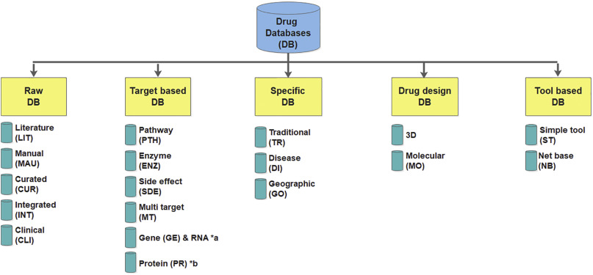
A pharmacy drug database is a specialized database designed to store and manage information related to pharmaceutical drugs. It serves as a central repository for drug-related data, including details about medications, their dosages, formulations, interactions, indications, contraindications, side effects, and more. A drug database is essential for pharmacies and healthcare organizations to ensure accurate and up-to-date information for medication management and patient safety.

Here are some key components and features of a pharmacy drug database:

- Drug Information:
- The database stores comprehensive information about drugs, including their generic and brand names, therapeutic classifications, active ingredients, dosage forms, strengths, and routes of administration. This information helps pharmacists and healthcare professionals identify and dispense the correct medications.

- Dosage and Administration Guidelines:
- The drug database includes dosage recommendations, administration instructions, and guidelines for various patient populations (e.g., adults, children, elderly, patients with specific conditions). This information ensures appropriate dosing and administration of medications.

- Drug Interactions:
- Information about potential drug interactions is crucial for identifying and managing potential adverse reactions or interactions between multiple medications. The drug database may include data on known drug-drug interactions, drug-food interactions, and drug-allergy interactions.

- Indications and Contraindications:
- The database provides details about the approved indications for each drug, as well as contraindications—conditions or situations in which the drug should not be used due to potential risks or incompatibilities. This information helps ensure the safe and appropriate use of medications.

- Side Effects and Adverse Reactions:
- The drug database stores information about known side effects, adverse reactions, and warnings associated with each medication. This helps healthcare professionals and patients understand the potential risks and take appropriate precautions.

- Formulary Management:
- In a pharmacy setting, the drug database can be used to manage a formulary—a list of approved medications and their coverage. It allows pharmacies to maintain an updated list of medications covered by insurance plans, formulary tiers, preferred drug options, and pricing information.

- Updates and Integration:
- The drug database should be regularly updated to reflect new drugs, dosage guidelines, safety information, and regulatory changes. Integration with external drug databases and reference sources, such as FDA databases or drug compendia, can ensure access to the most current and reliable information.

- Search and Retrieval:
- The drug database should provide robust search capabilities, enabling quick retrieval of drug information based on various criteria, such as drug name, therapeutic class, indications, or interactions. This supports efficient medication verification, counseling, and patient education.

A well-designed and comprehensive pharmacy drug database is crucial for accurate medication management, minimizing errors, and ensuring patient safety. It serves as a valuable resource for healthcare professionals, pharmacists, and patients to access reliable and up-to-date information about medications.

