Interpol – Introduction
Interpol is the world’s largest international police organization, with 196 member countries. It is headquartered in Lyon, France, with seven regional bureaus worldwide. Interpol provides investigative support, expertise and training to law enforcement worldwide, focusing on three major areas of transnational crime: terrorism, cybercrime and organized crime. Its broad mandate covers virtually every kind of crime, including crimes against humanity, child pornography, drug trafficking and production, political corruption, intellectual property infringement, as well as white-collar crime.^{[9]} The agency also facilitates cooperation among national law enforcement institutions through criminal databases and communications networks. Contrary to popular belief, Interpol is itself not a law enforcement agency.
- Established in 1923, it enables cross-border police cooperation and supports and assists all organisations, authorities and services whose mission is to prevent or combat international crime.
- Interpol has an objective to facilitate international police cooperation even where diplomatic relations are not present between certain countries.
- Action is taken within the limits of existing laws in different countries and in the spirit of the Universal Declaration of Human Rights. Interpol’s constitution prohibits ‘any intervention or activities of a political, military, religious or racial character.’
Interpol’s -Leadership
The international organization is led by a President and a Secretary-General who work in close tandem with each other and provide the required direction for the smooth functioning of the organization.
Interpol – Structure
According to Interpol’s Constitution, the organization comprises the following administrative departments:
- General Assembly
- General Secretariat
- Executive Committee
- National Central Bureaus
The General Assembly and the Executive Committee form the organization’s governance.
General Assembly
The General Assembly of Interpol is responsible for taking all the important decisions related to the working methods, policies, finances, resources and other activities and programs.
- An annual meeting is held and attended by the delegates appointed by the respective member countries.
- Each country is represented by one or more delegates at the Assembly, who are typically chiefs of law enforcement agencies.
- The Assembly also elects the members of the Interpol Executive Committee, the governing body which “provides guidance and direction in between sessions of the Assembly”.
Executive Committee
The Executive Committee is responsible for overseeing the implementation of decisions made by the General Assembly. It meets at least three times a year and consists of the President, three Vice Presidents, and the delegate of the host country.
The General Assembly elects this committee of 13 members which comprises of:
- A President
- 3 Vice Presidents
- 9 Delegates that cover 4 different regions
General Secretariat
The General Secretariat is the day-to-day operational arm of INTERPOL. It is headquartered in Lyon, France. The Secretary-General, who is elected by the General Assembly, leads the General Secretariat.
This organ of the Interpol works for 365 days 24/7.
- The General Secretariat has 6 regional offices for efficient functioning:
  - Argentina (South America)
  - Côte d’Ivoire (West Africa)
  - El Salvador (Central America)
  - Kenya (East Africa)
  - Thailand (South East Asia)
  - Zimbabwe (Africa)
- It has its headquarters in Lyon, France and a liaison office in New York, United States.
National Central Bureaus (NCB)
Each member country has a National Central Bureau, which serves as a liaison between the country's law enforcement agencies and INTERPOL. NCBs facilitate communication and cooperation between national and international law enforcement entities. The NCB is the designated contact point for the General Secretariat, regional offices and other member countries requiring assistance with overseas investigations and the location and apprehension of fugitives.
INTERPOL has regional offices strategically located around the world to provide support and coordination at the regional level. These offices help address specific regional crime challenges
Advisers
These are experts in a purely advisory capacity, who may be appointed by the Executive Committee and confirmed by the General Assembly.
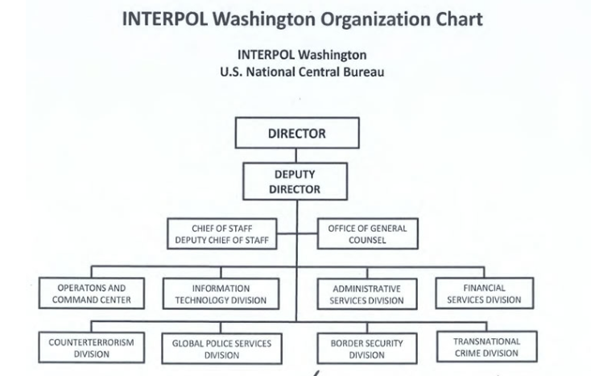
Functions:
- Information Exchange:
  - INTERPOL facilitates the exchange of information between member countries to assist in investigations, apprehension of criminals, and prevention of crimes. It operates a secure global police communications system known as I-24/7.
- Criminal Databases:
  - INTERPOL manages a range of global databases containing information on criminals, stolen property, missing persons, and other crime-related data. Member countries can access and contribute to these databases.
- Operational Support:
  - INTERPOL provides operational support to member countries by deploying specialized teams, such as Incident Response Teams, to assist in specific investigations or crises.
- Training and Capacity Building:
  - INTERPOL offers training programs and resources to law enforcement personnel to enhance their skills and knowledge in areas such as counter-terrorism, cybercrime, human trafficking, and drug enforcement.
- Notices:
  - INTERPOL issues notices (e.g., Red Notices) to alert member countries about individuals wanted for extradition based on a valid national arrest warrant.
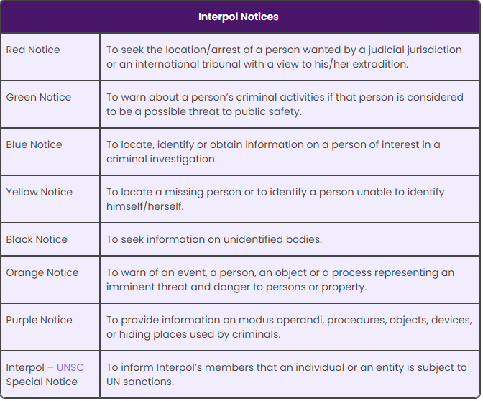

- Capacity Building:
  - INTERPOL assists member countries in enhancing their law enforcement capacities by providing technical assistance, expertise, and resources.
- Specialized Units:
  - INTERPOL has specialized units focusing on specific crime areas, such as human trafficking, cybercrime, terrorism, and drug trafficking. These units provide expertise and coordination in their respective domains.
- Public Awareness:
  - INTERPOL engages in public awareness campaigns to educate the public about various forms of crime and how to protect themselves.
INTERPOL's strength lies in its ability to foster collaboration and coordination among law enforcement agencies globally, transcending national borders to address the increasingly transnational nature of crime. It operates within the framework of international law and respects the sovereignty of its member countries.

