EXPERIMENT -8
Determination of viscosity of semisolid by using Brookfield viscometer.

Aim:
To determine the viscosity of semisolid by using Brooke field viscometer

Principle:
Newton was the first to study the flow properties of liquids in quantitative terms liquids
that obey newton’s law of flow are called as Newtonian fluids
F= ɳG
Shear stress- shear rate
- The relationship is normally in the form of a curve rheogram or consistency curve. When data are plotted by taking “F” on the x-axis and “G” on the y-axis, a flow curve is obtained. The rheogram passes through the origin and the slope given the coefficient of viscosity system that follows this linear relationship are called Newtonian fluids. This class includes liquids such as water, glycerine, chloroform, solutions of syrups, and very dilute colloidal solutions. Simple liquids exhibit Newtonian flow. Rheological properties of heterogeneous dispersions such as emulsions, suspensions and semisolid are more complex and do not obey newton’s equation of flow based on the pattern of consistency curve, Non-Newtonian fluids are categorized as
- Plastic flow
- Pseudo plastic flow
- Dilatant flow

Procedure:
- Prepare bentonite magma (5%w/v), methylcellulose (2%w/v) and mineral oil. They show a Non-Newtonian rheological profile
- Measure the viscosity of these liquids using a Brookfield viscometer and observe the thixotropy phenomenon
- Place the spindle with the correct number listed in the data sheet in each liquid and rotate the spindle at the speeds indicated. Once the dial reading has stabilized, record the values of viscosity in (cps).
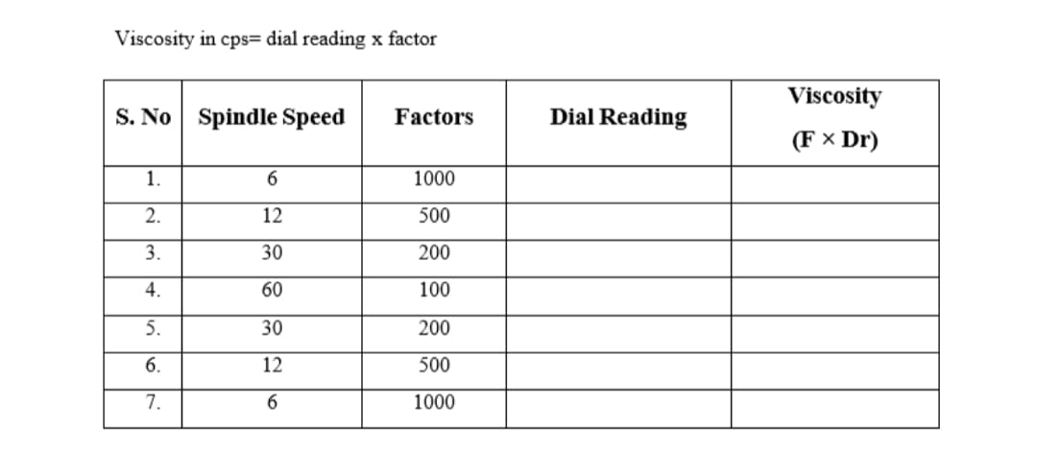

REPORT:
The viscosity of the given sample was found to be= centipoise (cps)

