- Go to www.virtualbox.org.
- Click on “Downloads – Oracle VM VirtualBox”.
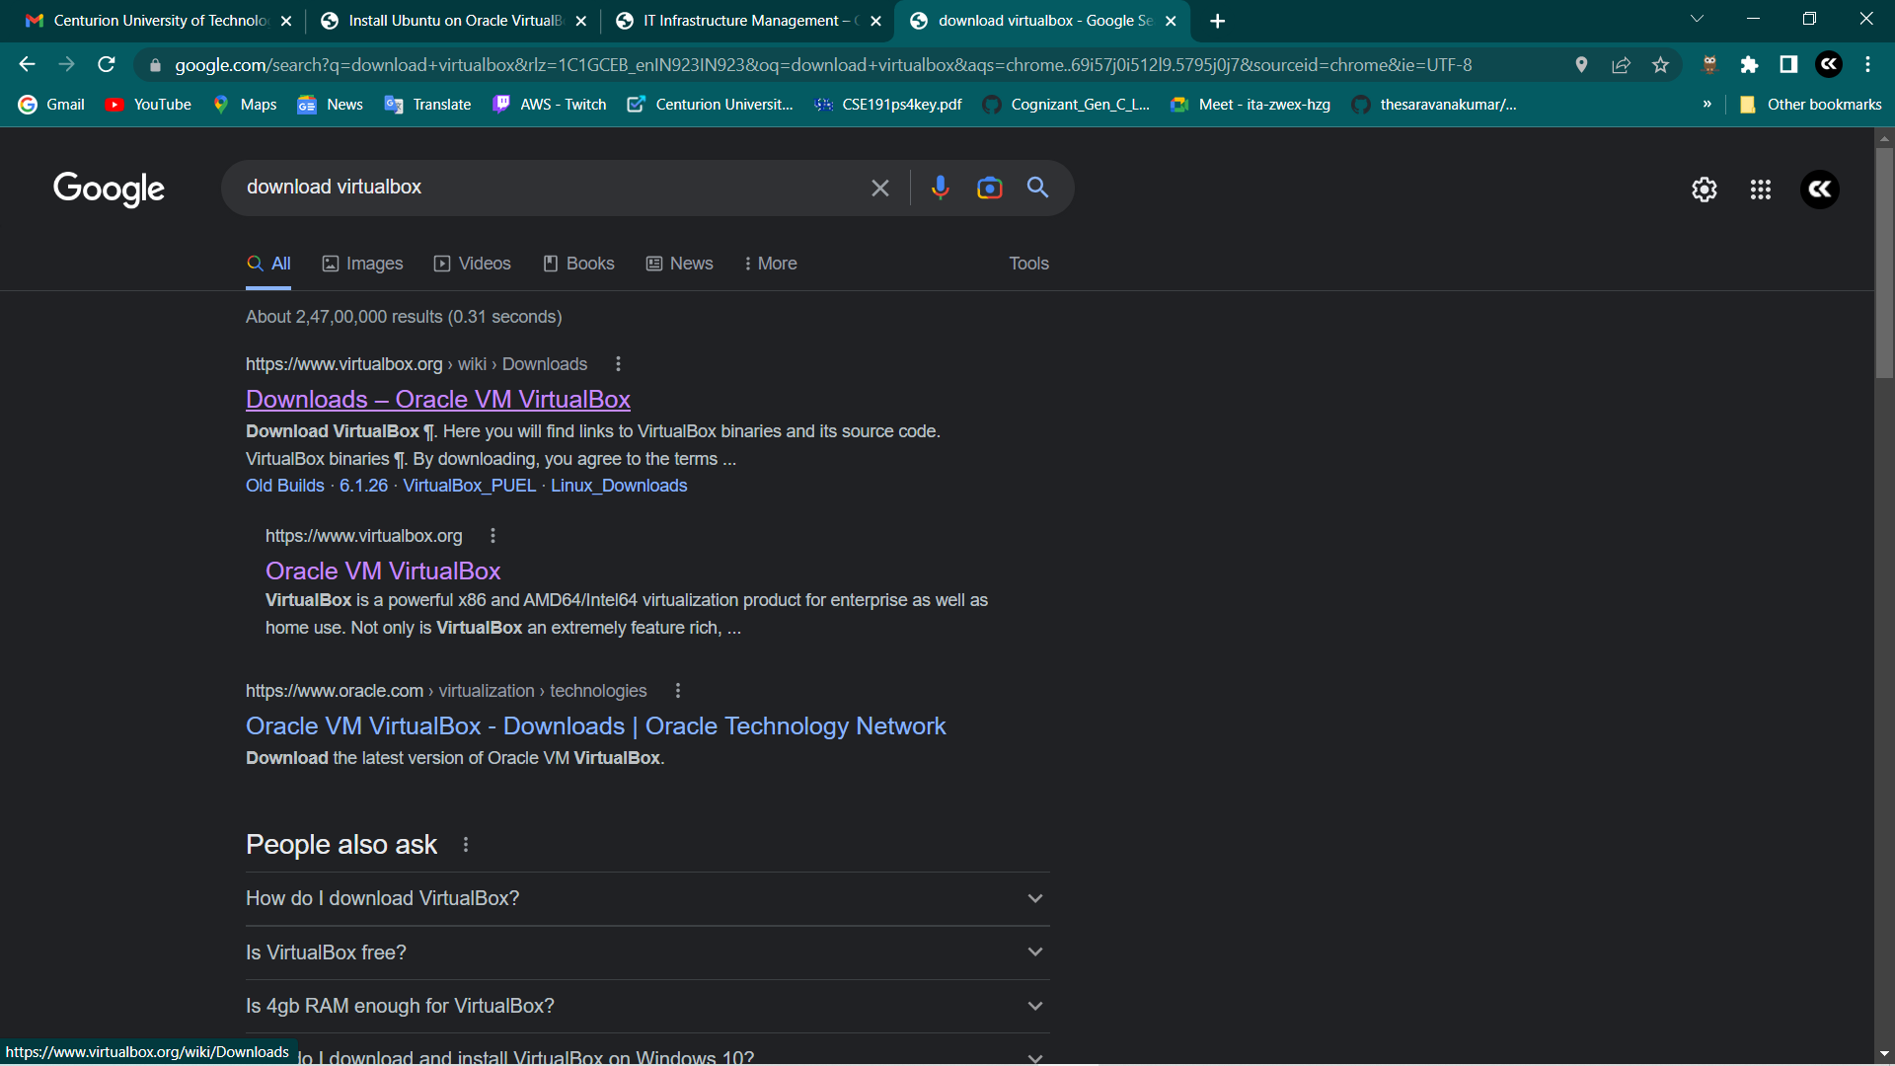

- Click on “Windows Hosts” (if you’re using Windows OS). VirtualBox will start downloading as an exe file.
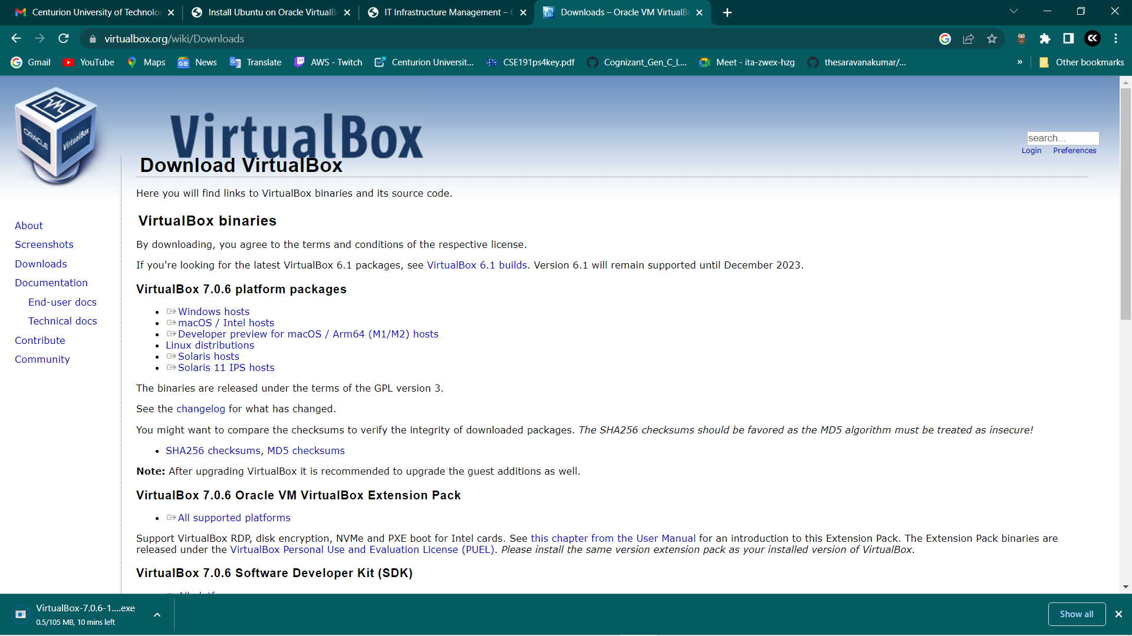

- After downloading it, double click on the exe file. The Setup Dialog box will appear.
- Click on Next.
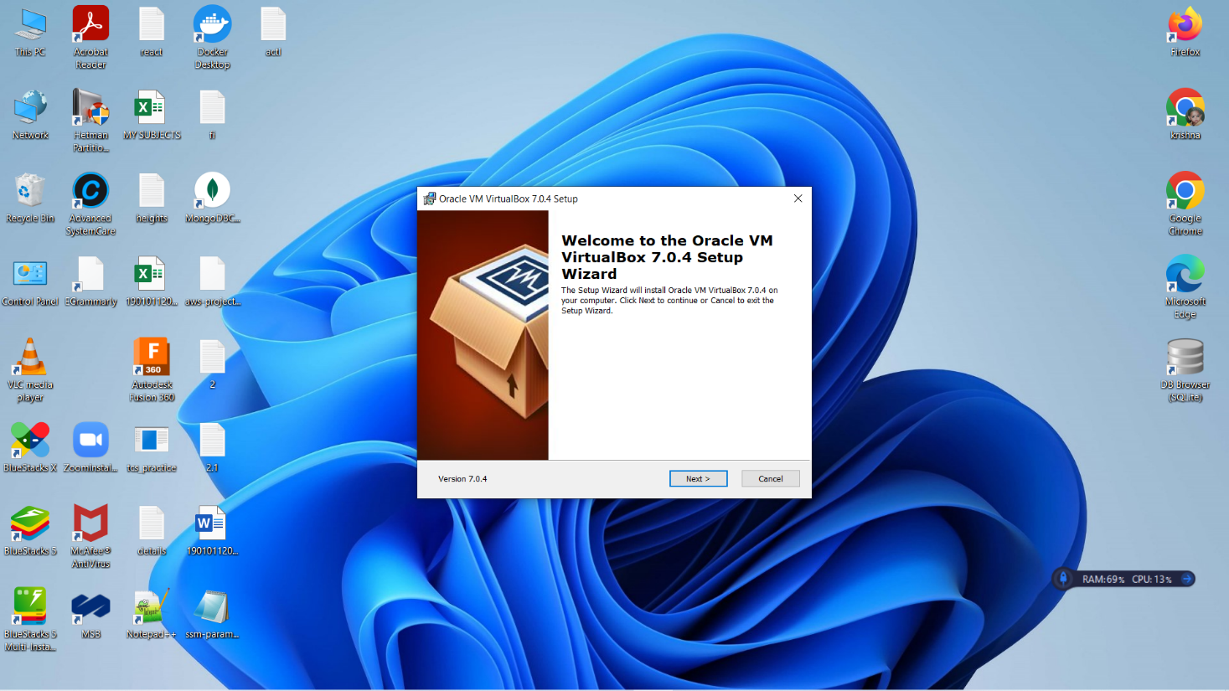

- Take a look at the License Agreement.
- Choose the option “I accept the terms in the License Agreement”.
- Click on Next.
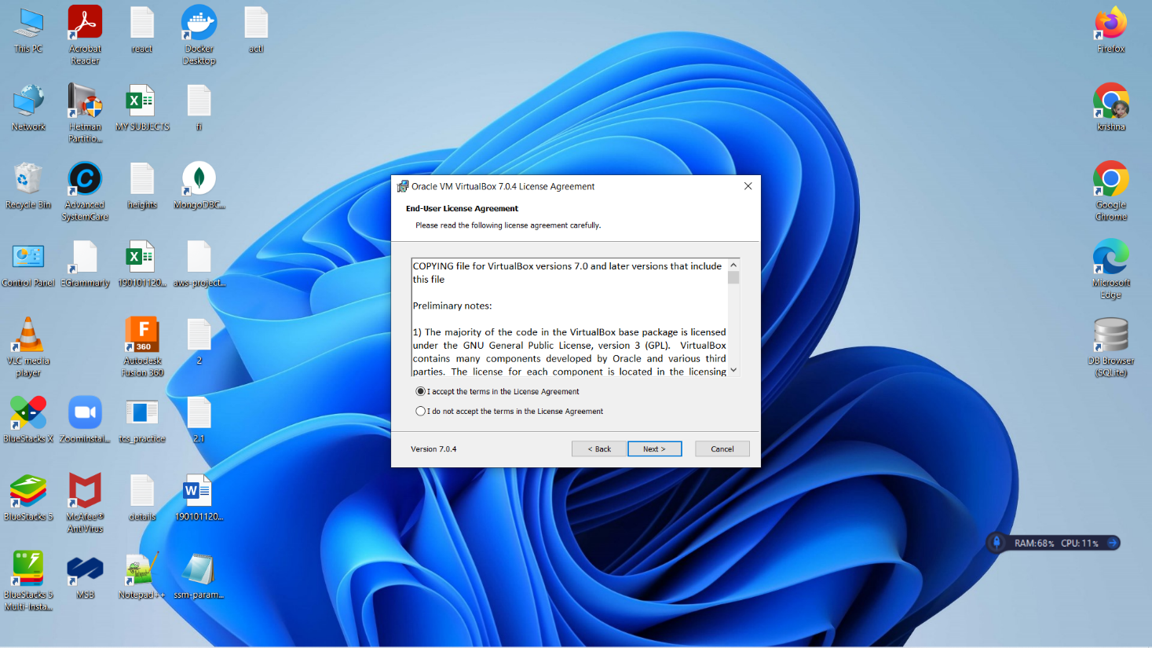

- Now, Custom Setup dialog box appears. By default, the whole VirtualBox

Application will be selected for installation. If you don’t want to install some of the components, deselect them and click on Next.
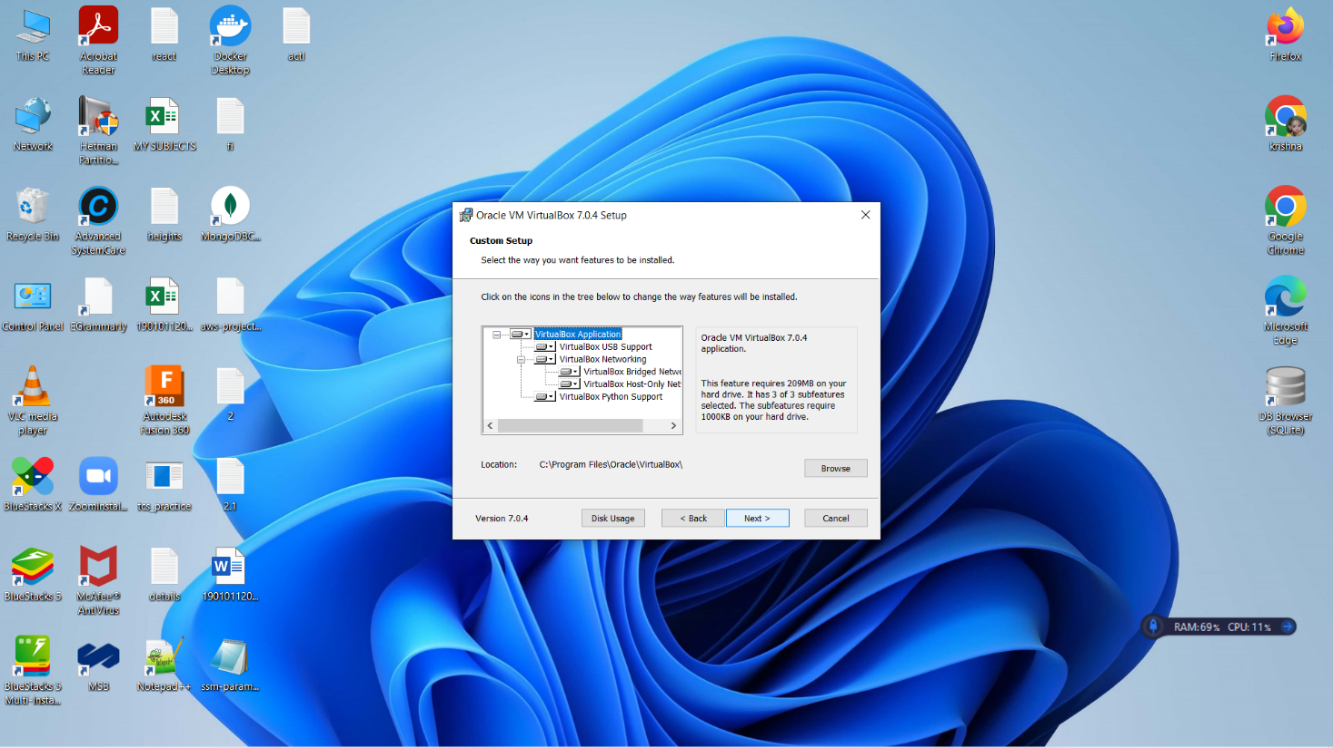

- A simple warning regarding network interfaces will be displayed. Don’t worry about that. Proceed with the installation.
- Click on Yes.
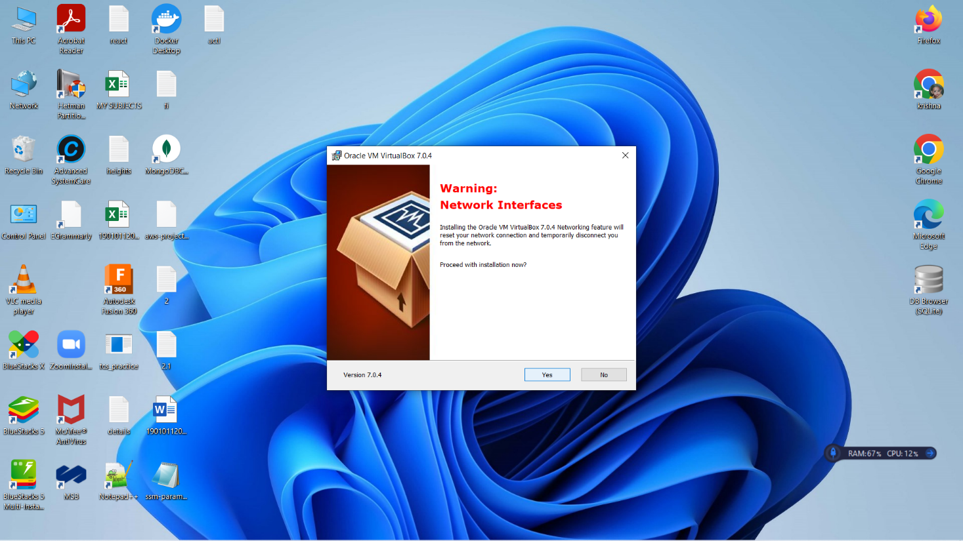
- Next, it will prompt you that it will install the Python core packages first.
- Proceed with the installation.
- Click on Yes.
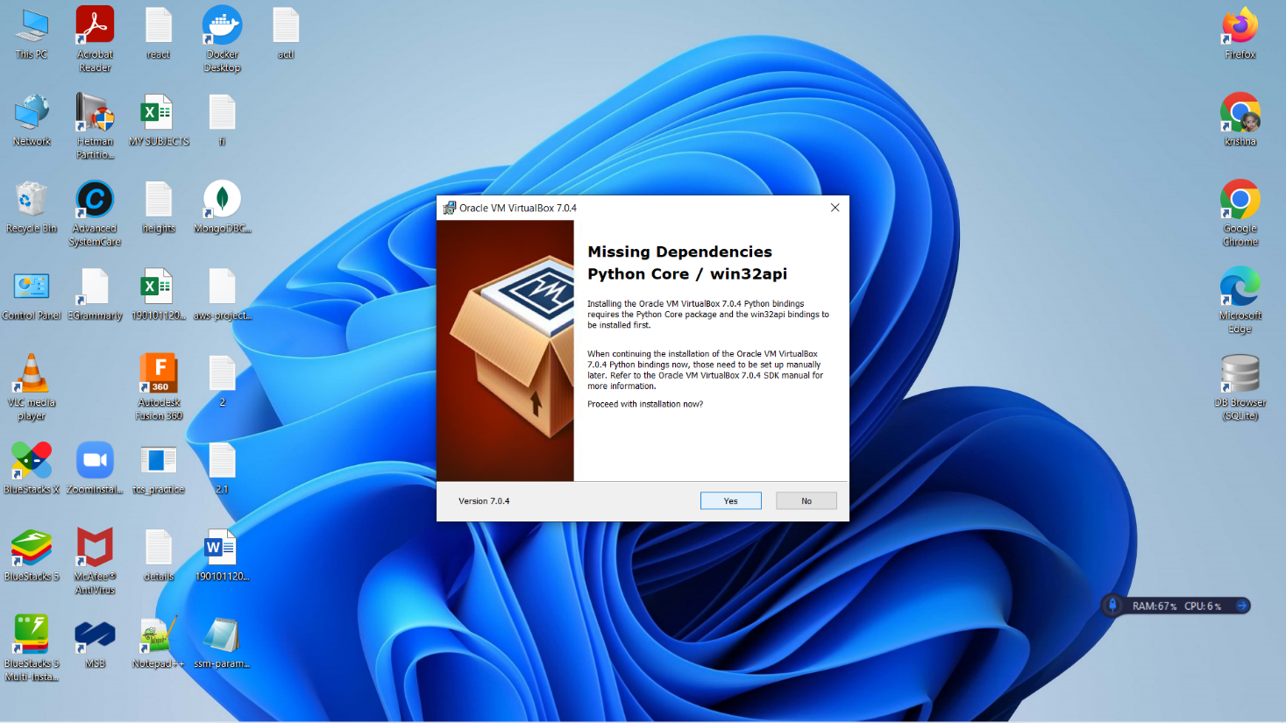

- To confirm the installation, click on Install or if you want to review or change any settings, click Back.
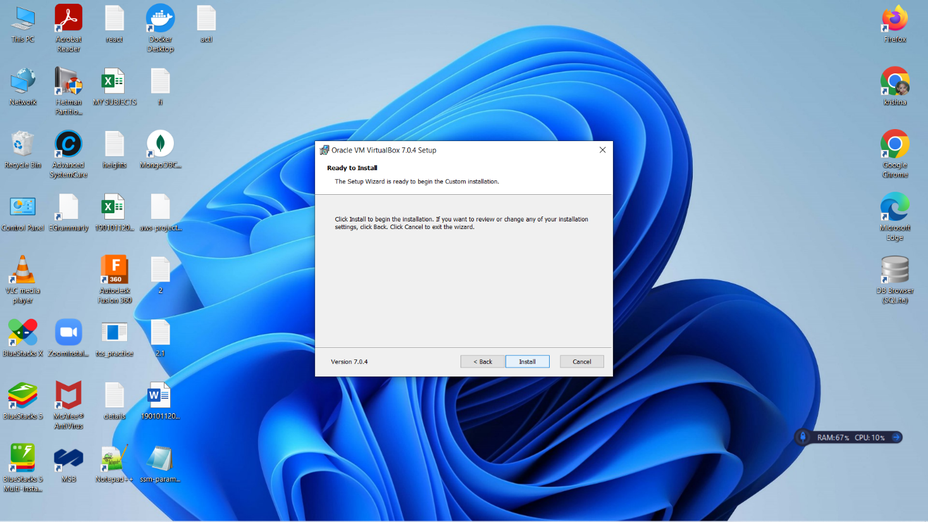

- Now, you can see the status of your installation. It might take few minutes.
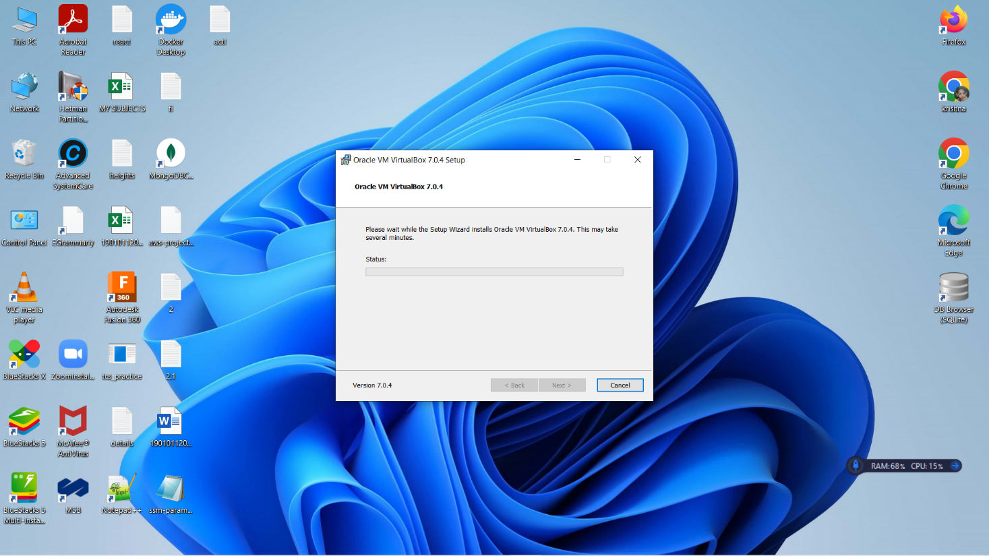

- VirtualBox has been successfully installed. Click on Finish.
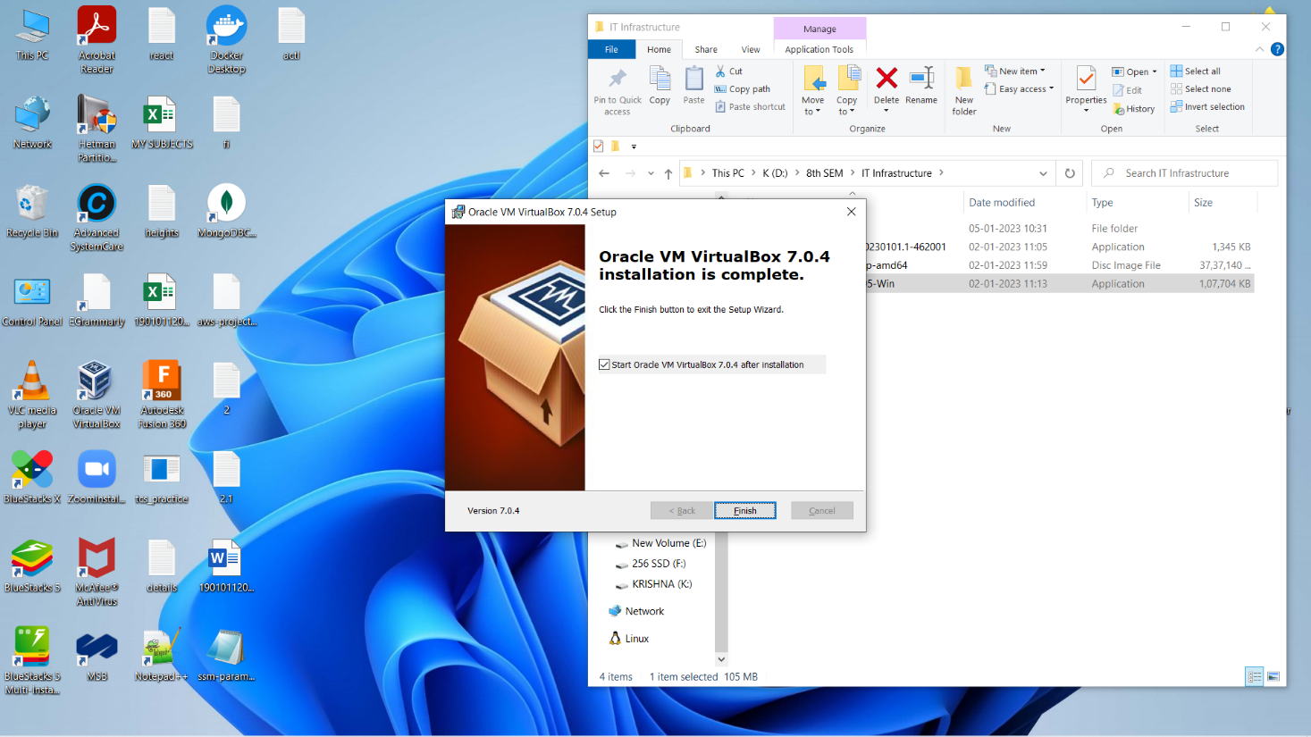

- To open and work with it, double click on the VirtualBox application.

Step 1: Download Ubuntu ISO Image
- Navigate to https://ubuntu.com/download/desktop.
- Download the latest version of Ubuntu ISO Image.
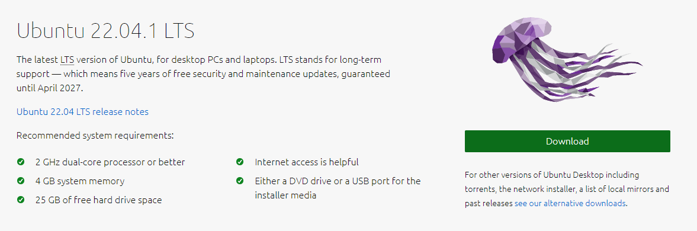

Step 2: Create Virtual Machine
- Open VirtualBox.
- Click ‘New’ button to open a dialog.
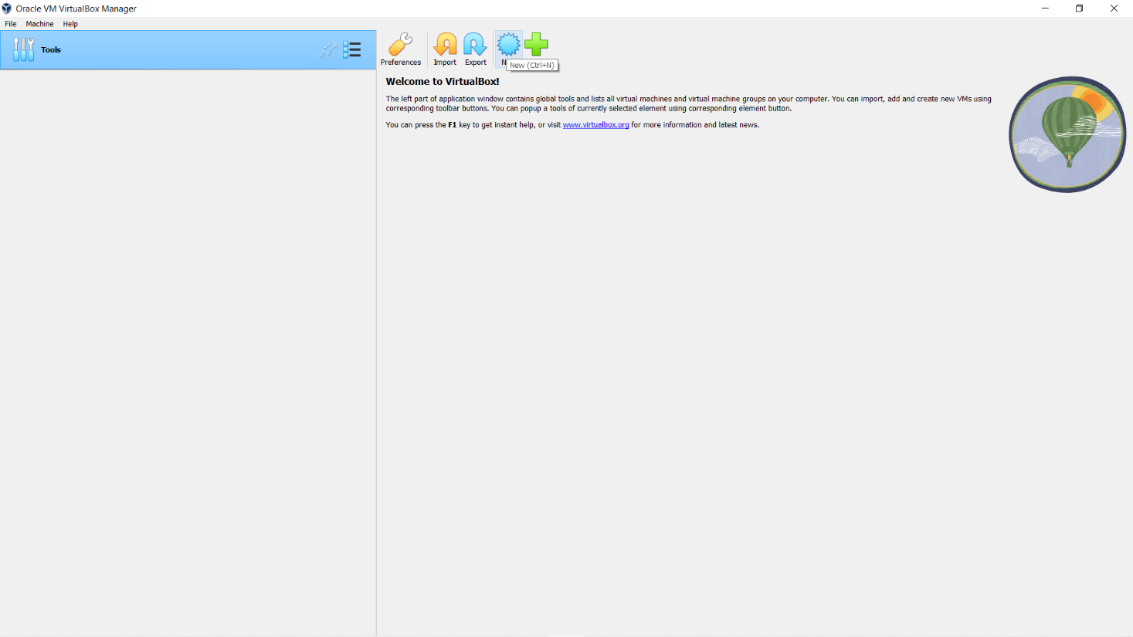

- Type a name for the new virtual machine. Since I am planning to install Ubuntu 22.04, I'll enter 'Ubuntu'.
- Choose the folder to where you want to install your Virtual machines.
- Next, browse the path of Ubuntu ISO Image. Click on Next.
Note that VirtualBox automatically changes 'Type' to Linux and 'Version' to 'Ubuntu (64 bit)'. These two options are exactly what we need.
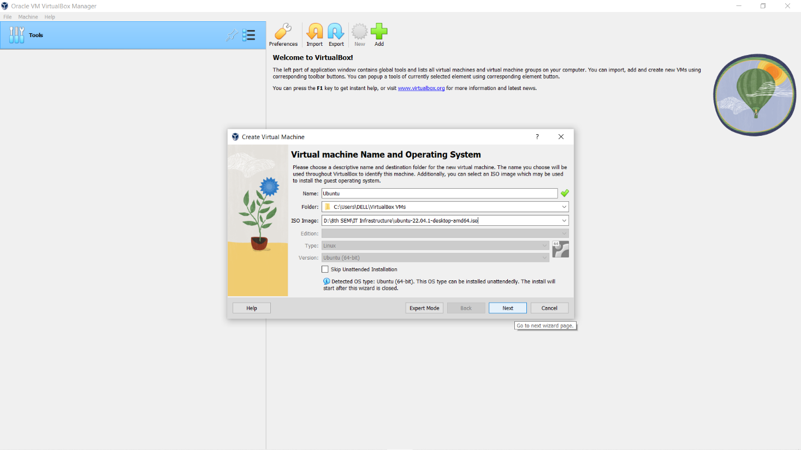
- Leave the default username and change the password.
- Remember this password as it is required when you’re logging into the virtual machine.
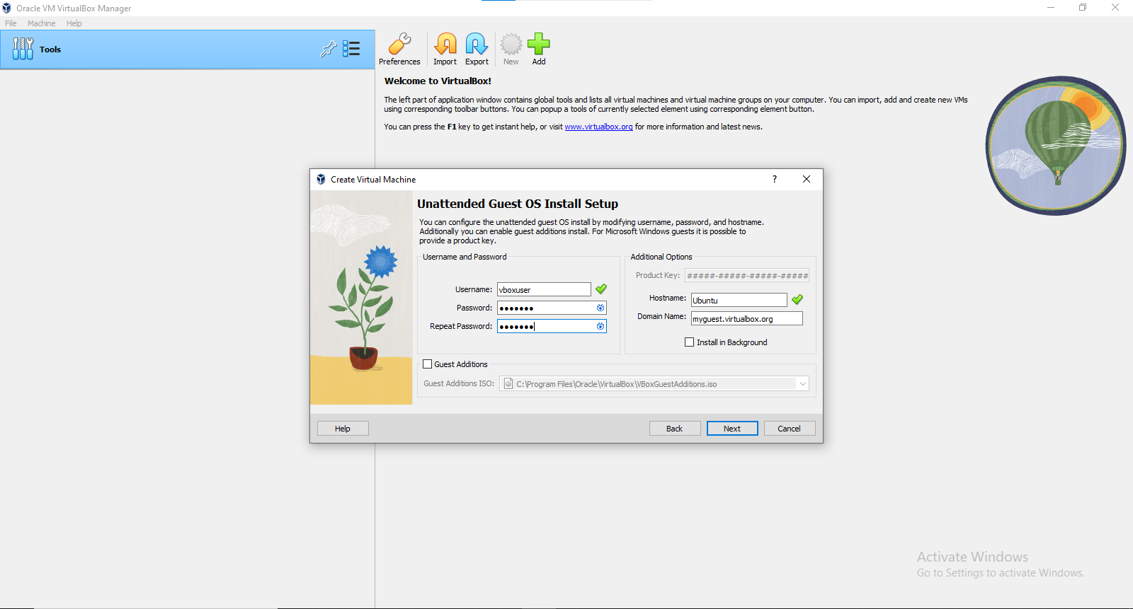
- The Base memory size and Processors depends on your host machine memory size.
- Increase them up to the green mark for better performance.
Note that VirtualBox will create a swap partition with the same amount space as base memory you have entered here. So later when you are selecting the size of the virtual hard drive, make sure it is large enough since the hard drive will be splitted into root (/) and swap partitions. The root partition contains by default all your system files, program settings and documents.
- Accept the default 'Create a virtual hard drive now' and click 'Create' button.
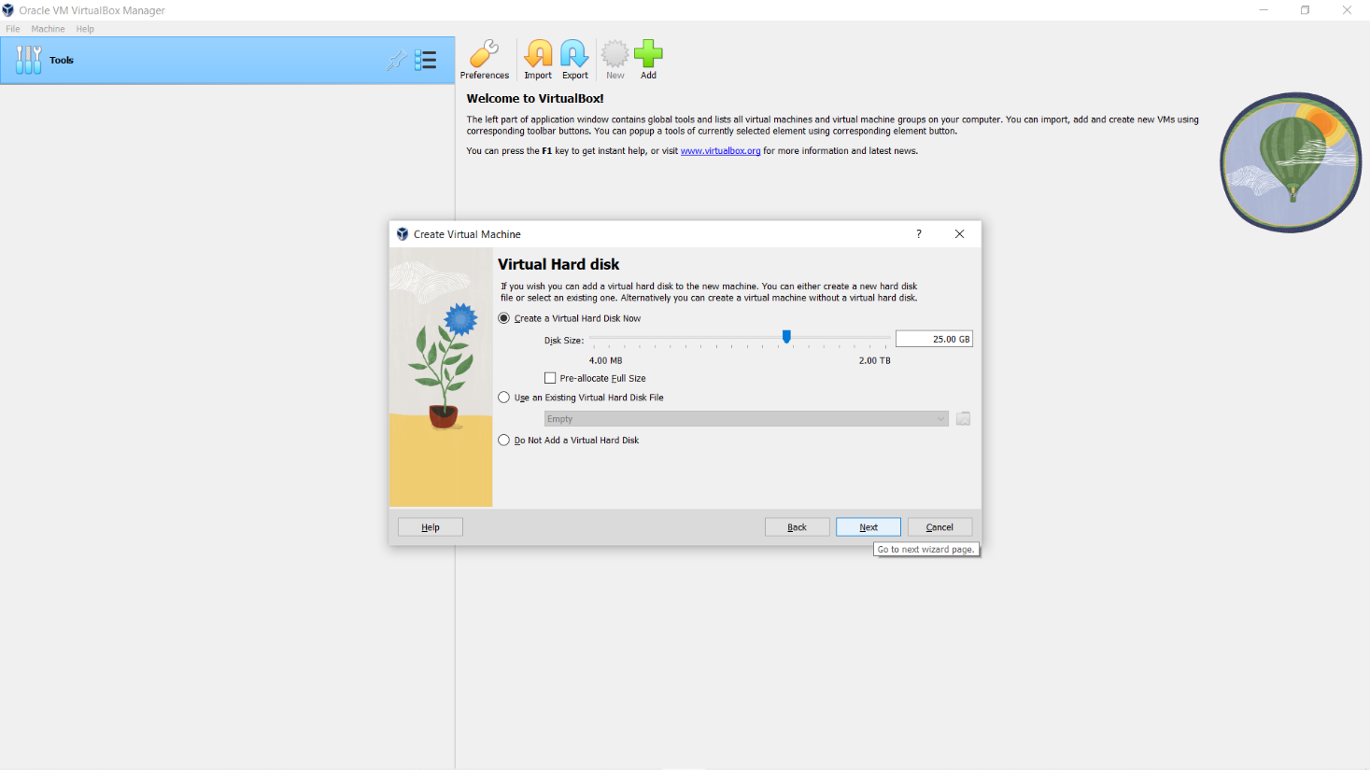

- Take a look at the settings which you’ve selected up to now.
- Remember the password
- Click on ‘Finish’.
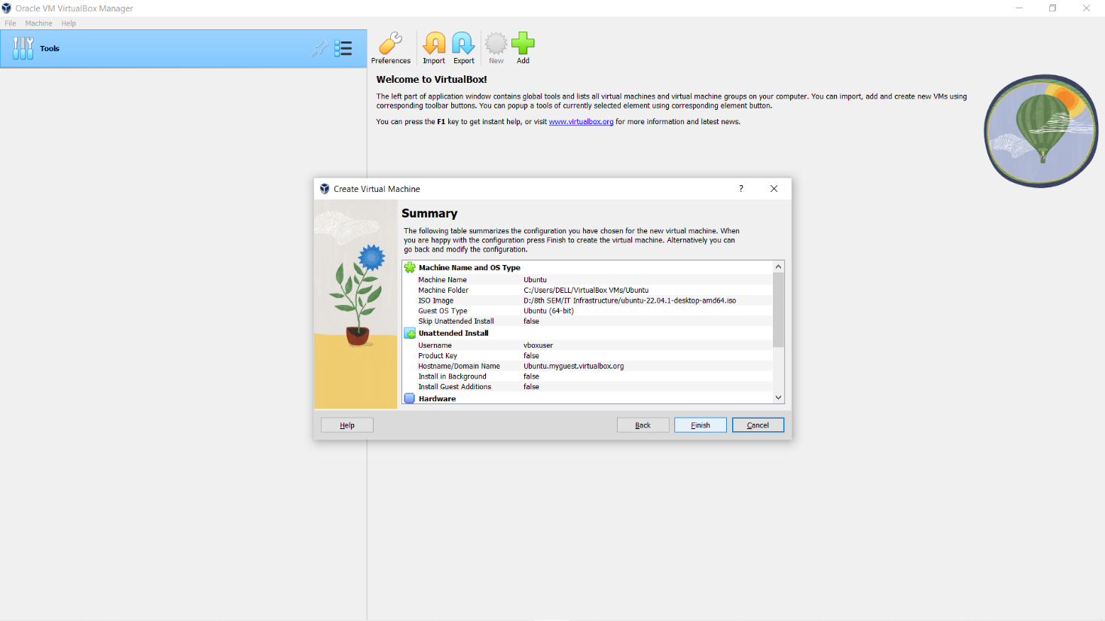

- It will take time to create the virtual machine. Wait until it is created completely.
- You can see that it’s been created, started and running.
- You will see a message saying ‘Powering VM up …’ and your desktop window will appear.
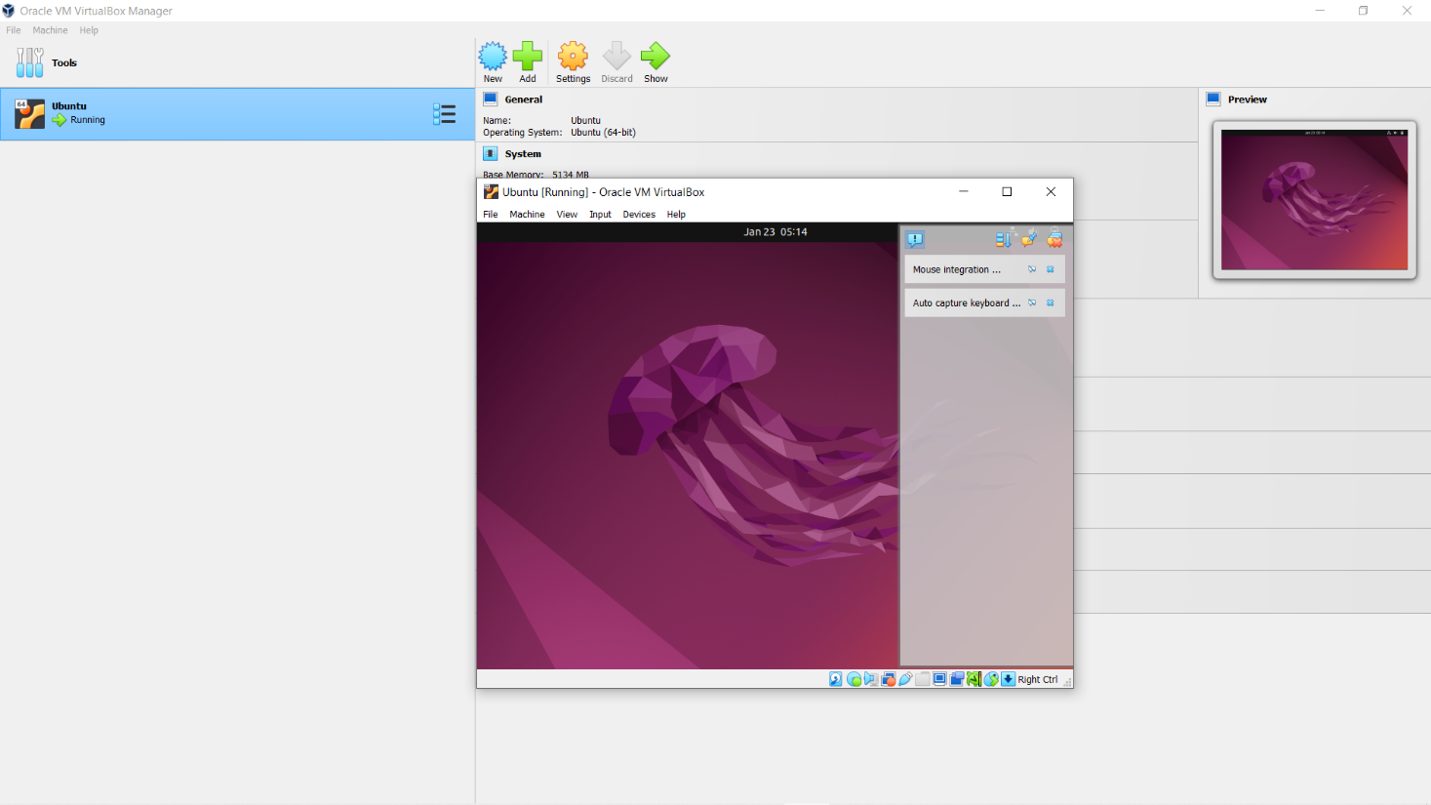
- On first boot the unattended installation will kick in so do not interact with the prompt to ‘Try and Install Ubuntu’ and let it progress automatically to the splash screen and into the installer.
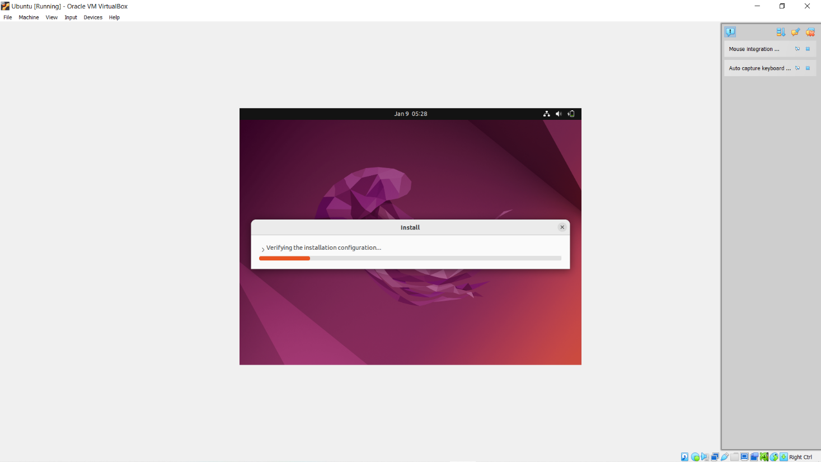
- You will notice at this stage that the resolution of the window is fixed at 800x600. This is because the Guest Additions features are not installed until after the Ubuntu installation has completed.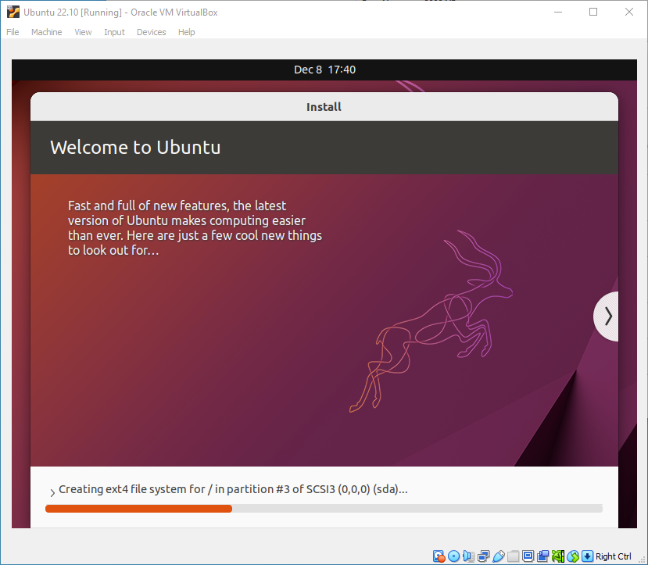
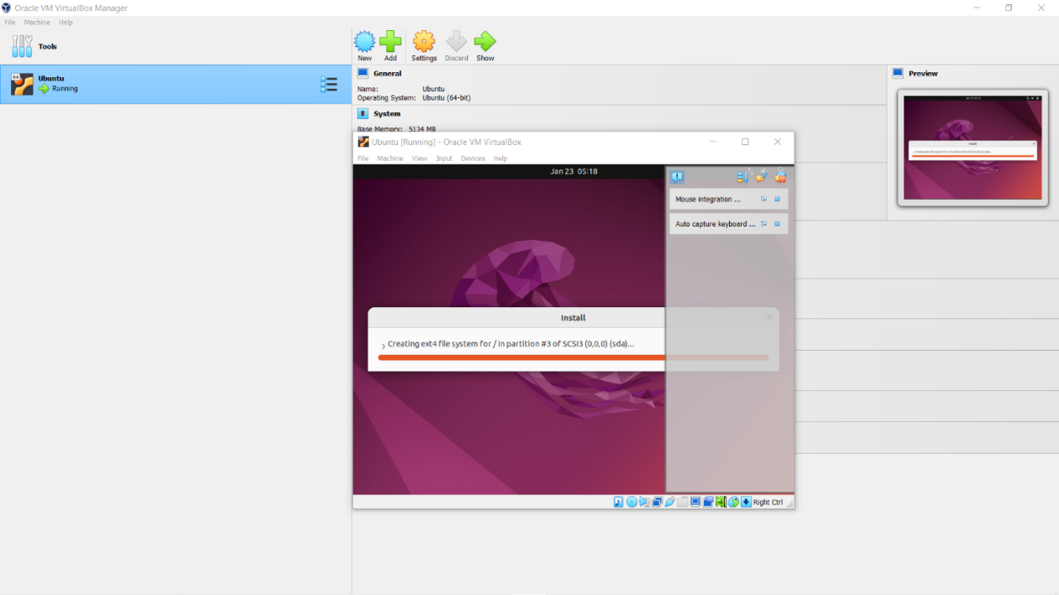
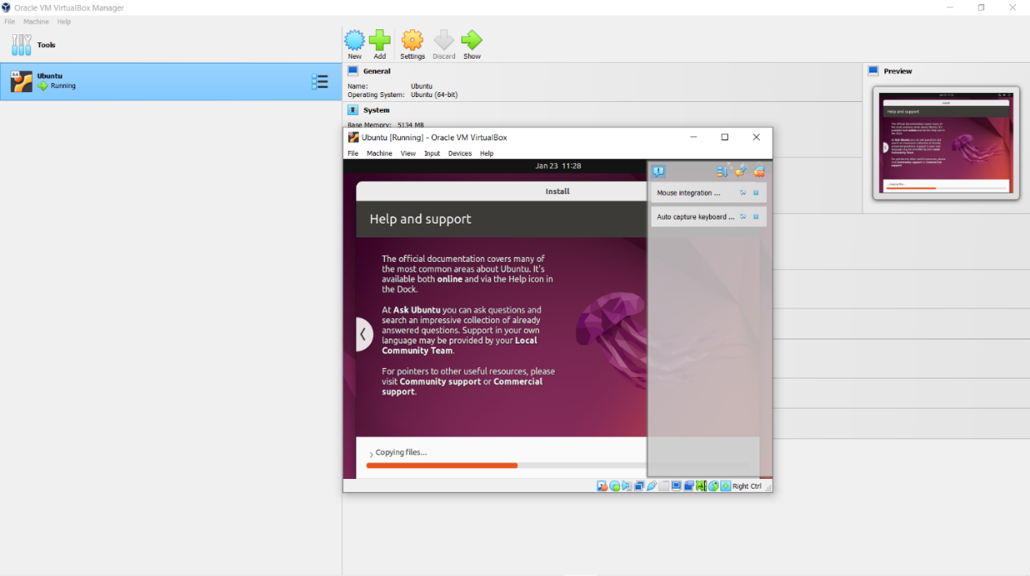
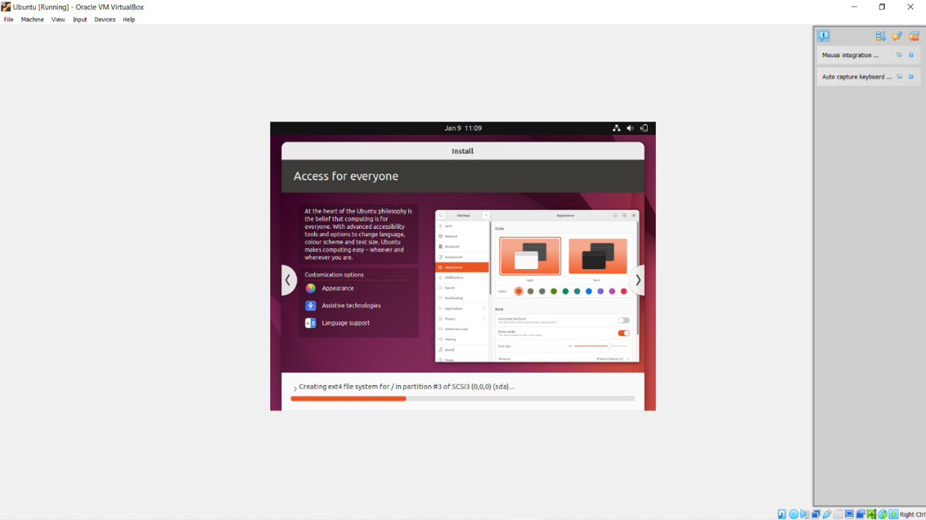
- Once the installation completes, the machine will automatically reboot to complete the installation.
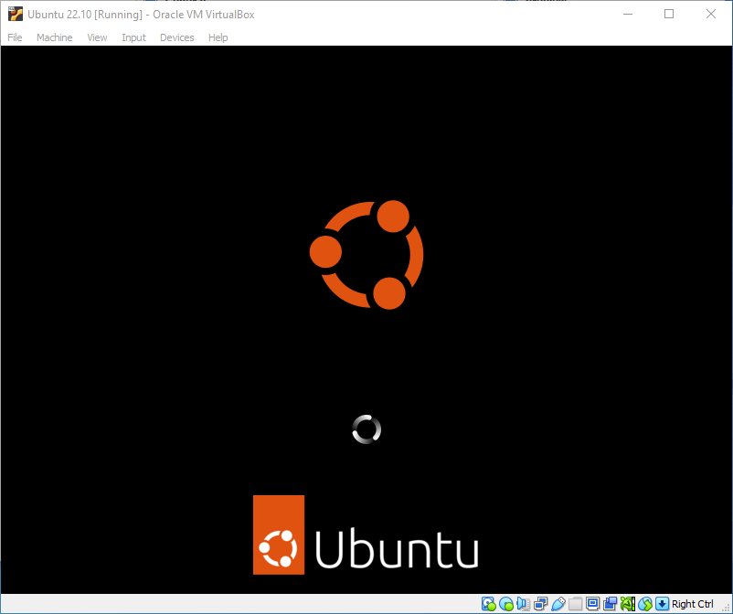
- Finally, you will be greeted with the Ubuntu log-in screen where you can enter your username and password defined during the initial setup.

- Upon the successful login, you will be entered into Ubuntu system.
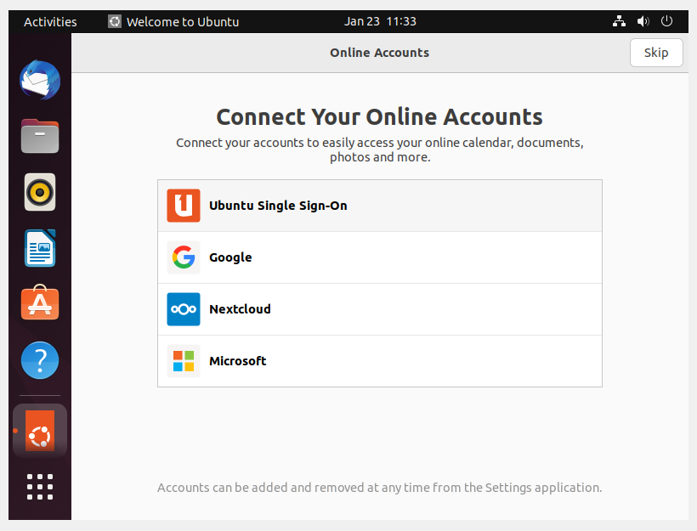

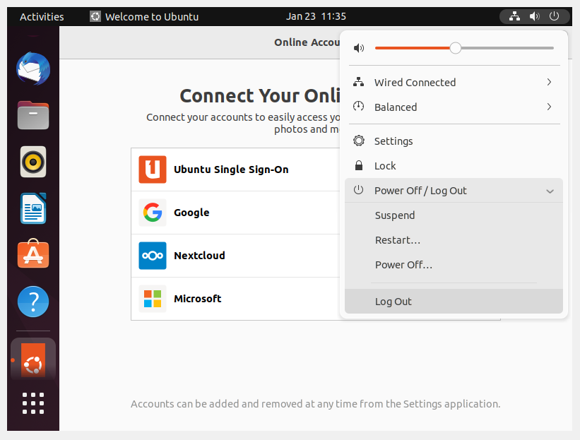
- Once you’ve finished your session you can close your machine by clicking the power button in the top right of the window and choosing whether to keep your machine frozen in its current state, logout or shut it down completely.

