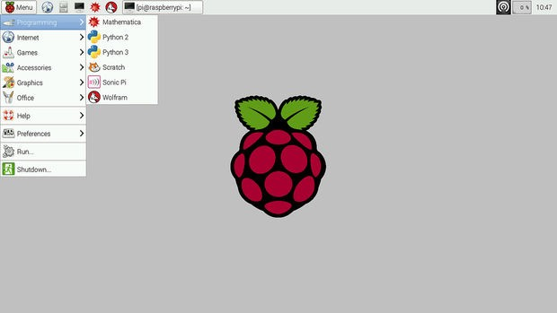

Step 1: Download the required software and files
You need to download 2 software and 1 OS i.e. Raspbian for this complete process. 1st software: The first software is Win32 Disk Imager. https://sourceforge.net/projects/win32diskimager/
2nd software: Second software is SD Card Formatter. https://www.sdcard.org/downloads/formatter_4/
Raspbian OS: This is the Main operating system of the Pi. https://www.raspberrypi.org/downloads/raspbian/
Extract all files to the desktop.

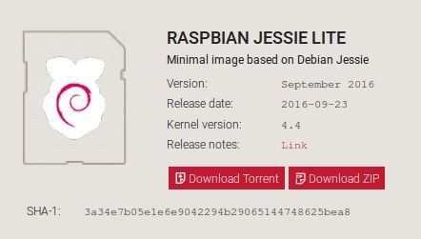
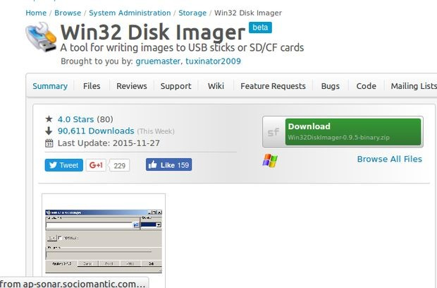

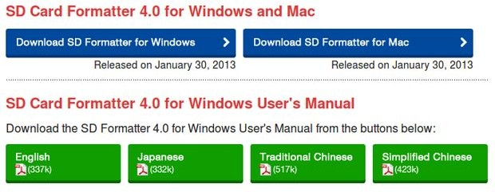

Step 2: Get the SD card and the card reader
Get a minimum 8GB class 10 SD card with a card reader. Insert that card into the card reader and plug that to the USB port.

Step 3: Check the drive in which the SD card is mounted
Go to my computer or My PC and find the drive name where the SD card is mounted.

Step 4: Format the SD Card
Open SD Card Formatter and select the drive you noticed in the previous step. Click on format and don't alter any other options.
When formatting is completed, click on OK.

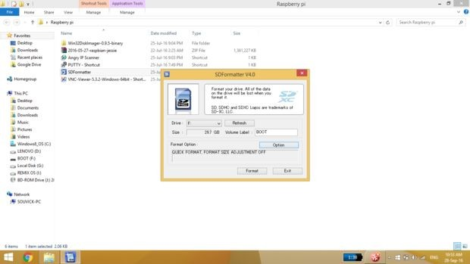
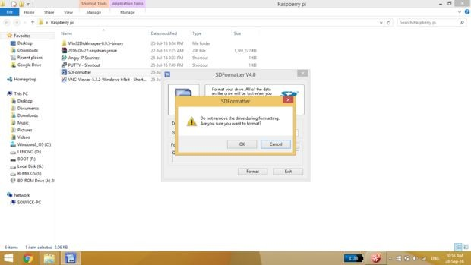

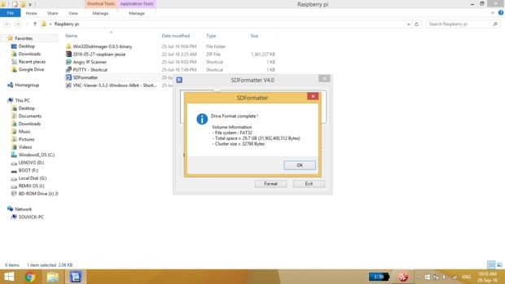

Step 5: Write the OS on the SD Card
Open win32diskimager.

Browse the .img file of Raspbian OS that was extracted from the downloaded file.

Click on open and then click on Write. If any warning pops up then ignore those by clicking OK. Wait for the write to be completed and it may take some minutes. So be patient.
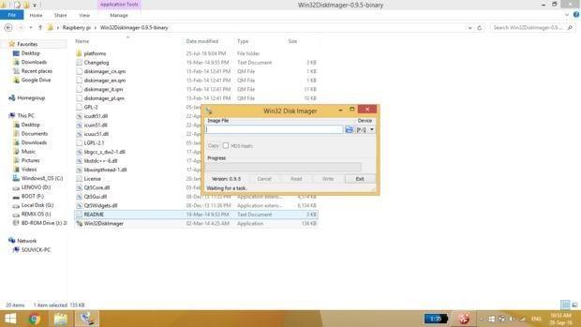
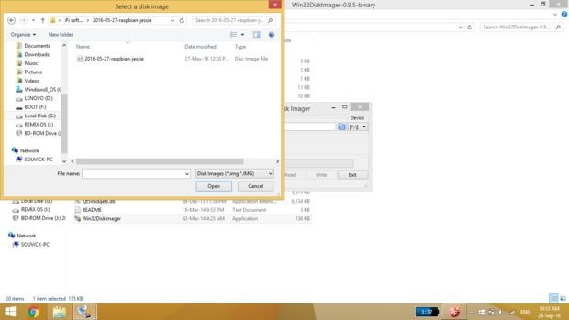
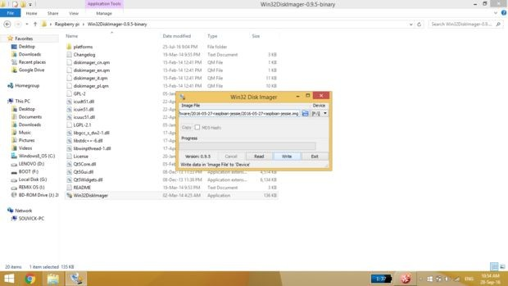
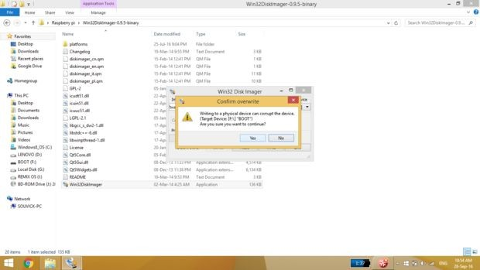
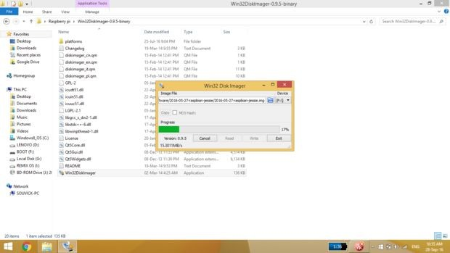
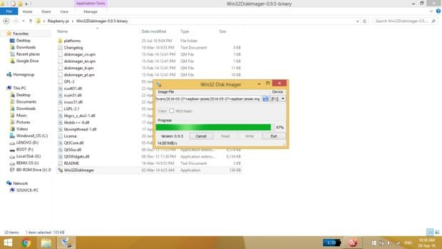

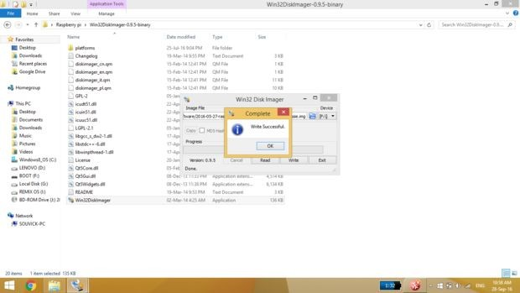

Step 6: Eject the SD Card
Now your OS in installed on your Raspberry Pi.

