Tillage
It is a mechanical manipulation of soil to provide favourable condition for crop production. Soil tillage consists of breaking the compact surface of earth to a certain depth and to loosen the soil mass, so as to enable the roots of the crops to penetrate and spread into the soil. Tillage may be called the practice of modifying the state of soil to provide favourable conditions for plant growth. Tillage operation is most labour consuming and difficult operation, compared to all subsequent operation in the field.

Objective of tillage
- to obtain deep seed bed, suitable for different type of crops.
- to add more humus and fertility to soil by covering the vegetation.
- to destroy and prevent weeds.
- to aerate the soil for proper growth of crops.
- to increase water absorbing capacity of the soil.
- to destroy the insects, pests and their breeding places and
- to reduce the soil erosion.

Classification and types of tillage
Tillage is divided into two classes: 1. Primary tillage, 2. Secondary tillage
Primary tillage: It constitutes the initial major soil working operation. It is normally designed to reduce soil strength, cover plant materials, and rearrange aggregates. The operations performed to open up any cultivable land with a view to prepare a seed bed for growing crops in known as Primary tillage. Implements may be tractor drawn or animal drawn implements. Animal drawn implements mostly include indigenous plough and mould- board plough. Tractor drawn implements include mould-board plough, disc plough, subsoil plough, chisel plough and other similar implements.
Secondary tillage: Tillage operations following primary tillage which are performed to crease proper soil tilth for seeding and planting are Secondary tillage. These are lighter and finer operations, performed on the soil after primary tillage operations. Secondary tillage consists conditioning the soil to meet the different tillage objectives of the farm. The implements used for secondary tillage operations are called Secondary tillage implements. They include different types of harrow, cultivators, levelers, cited crushers and similar implements. These operations are generally done on the surface soil of the farm. Seconday tillage operations do not cause much soil inversion and shifting of soil from one place to other. These operations consume less power per unit area compared to primary tillage operations. Secondary tillage implements may be tractor drawn or bullock drawn implements. Bullock drawn implements include harrows, cultivators, hoes etc.

Indigenous plough
Indigenous plough is one of the most common implements used by Indian farmers. There are about 40 or more different types of indigenous ploughs in this country which are basically the same, but with variations in their shape, size and weight. These variations are due to soil types and tillage requirements of various crops.
In addition to ploughing, the plough is used for sowing crops like wheat, barley, gram etc., for interculture and for harvesting the underground part of crops.
The main parts of the plough are i) body ii) shoe iii) share iv) beam and v) handle. The body is the main part of the plough to which the shoe, beam and handle are generally attached.

Mould board plough
A mouldboard plough is very common implement used for primer tillage operations. This plough performs several functions at a time such as (1) Cutting the furrow slice (2) Lifting the furrow slice (3) turning the furrow slice (4) Pulverizing the soil.

Components
M.B. Plough consists of (a) Share, (b) Mould Board, (c) Landside and (d)

Disc ploughs
It is a plough (Fig.21) which cuts, turns and in some cases breaks furrow slices by means of separately mounted large steel discs. A disc plough is designed with a view to reduce friction by making a rolling plough bottom. A disc plough works well in the conditions where mould board plough does not work satisfactorily.

Disc: It is a circular, concave revolving steel plate used for cutting and inverting the soil. It is made of heat treated steel of 5 to 10 mm thickness. The edge of the disc is well sharpened to cut the soil.
Disc angle: It is the angle at which the plane of the cutting edge of the disc is inclined to the direction of travel. Usually, the disc angle of good plough varies between 42 and 45⁰ (Fig.22).
Tilt angle: It is the angle at which the plane of the cutting edge of the disc is inclined to vertical plane. Usually, the tilt angle of good plough varies between 15 and 25⁰(Fig.22).

Scraper: It is a device to remove soil that tends to stick to the working surface of a disc.
Concavity: It is the depth measured at the center of the disc by placing its concave side on a flat surface.

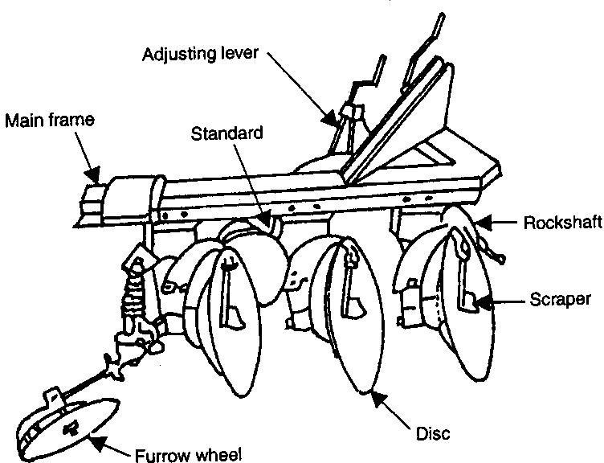

Fig. 23. Standard disc plough
Harrowing
It is secondary tillage operation which pulverizes, smoothens and packs the soil in seed bed preparation and/or to control weeds.

Harrow
A harrow is a implement that cuts the soil to a shallow depth for smoothening and pulverizing the soil as well as to cut the weeds and to mix materials with soil. It is an implement used to break the clods after ploughing, to collect trash from the ploughed land and to level the seed bed.There are several types of harrows used in India are mentioned below:

Disc harrow
It is harrow which performs the harrowing operations by means of a set (or a number of sets) of rotating steel discs, each set being mounted on a common shaft. Disc harrows are of two types depending upon the sources of power:
- Tractor drawn
- Animal drawn.
Tractor drawn disc harrow: Disc harrow is found very suitable for hard ground, full of stalks and grasses. It cuts the lumps of soil, clods and roots. Discs are mounted on one, two or more axles which may be set at a variable angle to the line of motion. As the harrow is pulled ahead, the discs rotate on the ground. Depending upon the disc arrangements, disc harrows are divided into two classes (Fig.25): (i) single action, and (ii) double action.

Single action disc harrow
It is a harrow with two gangs placed end to end, which throw the soil in opposite directions. The discs are arranged in such a way that right side gang throws the soil towards right, and left side gang throws the soil towards left.

Double action disc harrow
A disc harrow consisting of two or more gangs, in which a set of one or two gangs follow behind the set of the other one or two, arranged in such a way that the front and back gangs throw the soil in opposite directions. Thus the entire field is worked twice in each trip. It may be of two types:
- Tandem, and
- Off-set.

Tandem disc harrow
It is a disc harrow comprising of four gangs in which each gang can be angled in opposite direction.

Off-set disc harrow
It is a disc harrow with two gangs in tandem, capable of being off-set to either side of the centre line of pull. Two gangs are fitted one behind the other. The soil is thrown in both directions because discs of both gangs face in opposite directions. It is very useful for orchards and gardens. It travels left or right of the tractor. The line of pull is not in the middle, that‟s why it is called off-set disc harrow (Fig.25).

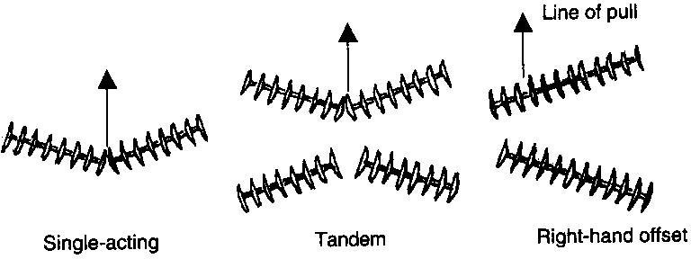

Tractor drawn disc harrows

Components of disc harrow
A disc harrow mainly consists of: (i) disc, (ii) gang, (iii) gang bolt or arbor bolt, (iv) gang angle, (v) gang control lever, (vi) spools or spacer, (vii) bearings, (viii) transport wheels, (ix) scraper and (x) weight box.
- Disc: It is a circular, concave revolving steel plate used for cutting and inverting the soil. Disc is made of high grade heat treated hardened steel. Tractor drawn disc harrows have concave discs of size varying from 35 to 70 cm diameter. Concavity of the disc affects penetration and pulverization of soil. Usually two types of disc are used in disc harrows: (a) Plain disc and
(b) Cut-away disc.
Plain discs have plain edges and they are used for all normal works. Most of the harrows are fitted with plain discs only. Cut-away discs have serrated edges and they cut stalks, grasses and other vegetative matter better than plain discs. Cut-away discs are not very effective for pulverization of soil but it is very useful for pudding the field especially for paddy cultivation.
- Gang: It is an assembly of concave discs mounted on a common shaft with spools in between.
- Gang axle or arbor axle: It is a shaft on which a set of discs are mounted. The spacing between the discs on the gang bolt ranges from 15cm to 23cm for light duty harrows and 25 to 30 cm for heavy duty harrows.
- Gang angle: The angle between the axis of the gang and the line perpendicular to the direction of travel is called Gang angle.
- Gang control lever: A lever which operates the angling mechanism of disc harrow is called Gang control lever.
- Spool or Spacer: The flanged tube, mounted on the gang axle between every two discs to retain them at fixed position laterally on the shaft is called spool or spacer. It is just a device for keeping the discs at equal spacing on the axle. It is usually cast in special shapes and sizes and is generally made of cast iron.
- Bearing: Bearing is essential to counteract the end thrust of the gangs due to soil thrust. Disc harrow bearings are subjected to heavy radial and thrust loads. Chilled cast iron bearings, ball bearings or tapered roller bearings may be used on disc harrows. Oil soaked wooden bearings are very common for disc harrows, because they are cheaply available. Chilled cast iron bearings are also used due to their durability.
- Cultivator with spring loaded tines
A tine hinged to the frame and loaded with a spring so that it swings back when an obstacle is encountered, is called spring loaded tine. Each tine of this cultivator is provided with two heavy coil springs, tensioned to ensure minimum movement except when an obstacle is encountered. The springs operate, when the points strike roots or large stones by allowing the tines to ride over the obstruction, thus preventing damage. On passing over the obstruction, the tines are automatically reset and work continues without interruption. The tines are made of high carbon steel and are held in proper alignment on the main frame members.

