AM335 Functional block overview

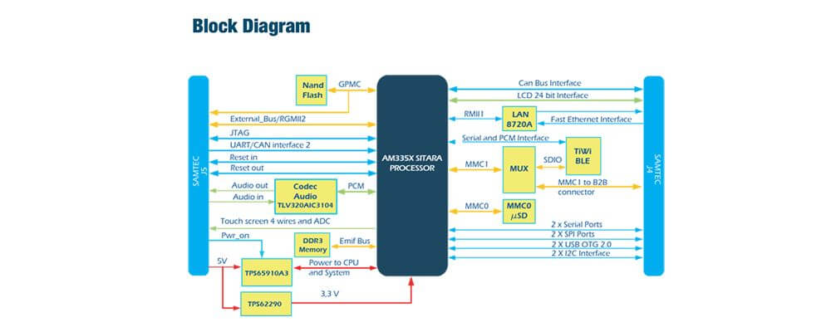

The AM335 functional block diagram provides an overview of the major functional components integrated into the Texas Instruments Sitara AM335x System-on-a-Chip (SOC). Here's a high-level overview of the functional blocks found in the AM335 SOC:
ARM Cortex-A8 CPU:
The central processing unit (CPU) is based on the ARM Cortex-A8 architecture and operates at up to 1 GHz. It is responsible for executing instructions and running software applications.
L1 Caches:
The L1 instruction cache and L1 data cache are small, high-speed memory caches that provide faster access to frequently used instructions and data.
PRU Subsystem:
The Programmable Real-Time Unit (PRU) subsystem consists of two independent 32-bit RISC microcontrollers, PRU0 and PRU1. These PRU cores can be programmed to perform real-time tasks and control peripheral interfaces.

Graphics:

The PowerVR SGX530 graphics accelerator provides hardware acceleration for 2D and 3D graphics rendering.System Control Module (SCM):
The SCM handles system-level control and configuration, including clock generation and control, power management, and reset control.
Memory:
The AM335 SOC supports external memory interfaces, including DDR3 memory, NAND flash memory, and NOR flash memory.
Peripherals and Interfaces:
The SOC integrates various peripheral interfaces, such as multiple UARTs, SPI (Serial Peripheral Interface), I2C (Inter-Integrated Circuit), CAN (Controller Area Network), USB (Universal Serial Bus), Ethernet MAC, and MMC/SD/SDIO (MultiMediaCard/Secure Digital/Secure Digital Input/Output).
Timers and Watchdog:
The SOC includes multiple general-purpose timers, real-time clocks (RTCs), and a watchdog timer for timing, scheduling, and system monitoring purposes.
Analog-to-Digital Converter (ADC):
The integrated ADC provides analog-to-digital conversion capabilities for acquiring analog sensor data.
Debug and Trace:
The AM335 SOC features debug and trace support, including JTAG (Joint Test Action Group) and ETM (Embedded Trace Macrocell) interfaces for debugging and profiling applications.
External Memory Interfaces:
The SOC supports various external memory interfaces, including DDR3 memory, NAND flash memory, and NOR flash memory, allowing for extended storage capabilities.
These functional blocks represent the major components integrated into the Sitara AM335 SOC, providing a comprehensive set of features and capabilities for embedded systems and IoT applications. The specific configuration and capabilities may vary based on the specific variant of the AM335 SOC used.

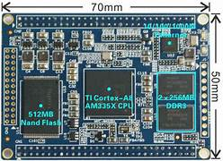

Here are some additional notes on the functional block overview of the AM335 SOC:
System Control Module (SCM):
The SCM handles power management functions, including voltage regulation, power sequencing, and thermal management.
It provides clock generation and control for various subsystems and peripherals in the SOC.
The SCM also controls system-level reset signals, allowing for system initialization and recovery.
DMA Controller:
The DMA (Direct Memory Access) controller facilitates data transfers between peripherals and memory without CPU intervention.
It enables efficient data movement, offloading the CPU and improving overall system performance.
GPIO (General-Purpose Input/Output):
The AM335 SOC offers a large number of GPIO pins for general-purpose input and output operations.
GPIO pins can be used to connect and control various external devices and sensors.
Ethernet MAC (Media Access Controller):
The integrated Ethernet MAC supports Ethernet communication, enabling connectivity for network-based applications.
It supports multiple Ethernet standards and provides interfaces for wired network connections.
USB (Universal Serial Bus):
The SOC integrates USB interfaces, including USB host and USB device functionality.
USB interfaces enable connectivity with a wide range of USB peripherals, such as keyboards, mice, storage devices, and more.
PRU Subsystem
The PRU subsystem consists of two programmable real-time units (PRU0 and PRU1) with their own dedicated memory and I/O capabilities.
PRUs are intended for real-time tasks and can interface with various peripherals and control external devices.
Video and Display:
The SOC provides display and video capabilities, including support for LCD displays, touchscreens, and video input/output interfaces.
It enables the integration of graphical user interfaces and multimedia applications.
Real-Time Clock (RTC):
The integrated RTC provides accurate timekeeping functions, including the ability to maintain the time even in low-power or battery-backed scenarios.
Security and Cryptography:
The SOC incorporates security features and cryptographic accelerators to enhance system security and protect sensitive data.
It supports various encryption algorithms and provides secure key storage capabilities.
Power Management:
The AM335 SOC includes power management features to optimize power consumption and extend battery life in portable and energy-efficient devices.
Power domains and clock gating techniques are employed to minimize power usage during idle or low-power operation.
These additional notes provide further insights into the functional block overview of the AM335 SOC, highlighting its extensive set of features for embedded systems development, IoT applications, and more. The integration of various peripherals, interfaces, and control modules on a single chip allows for compact and powerful system designs.

