Embedded Linux Toolchain

An Embedded Linux Toolchain is a set of tools and libraries used for developing software applications targeting embedded systems running Linux. It provides a complete development environment to compile, build, and debug software specifically tailored for embedded devices.

Typically, an Embedded Linux Toolchain consists of the following components:

1)Cross Compiler:

The cross compiler is the primary component of the toolchain. It is a compiler that runs on the development host machine but generates executable code for the target embedded system architecture.
The cross compiler understands the target system's instruction set and generates machine code compatible with the embedded device.
It allows developers to write and compile software on a more powerful development machine and then deploy it to the embedded target.
2)Libraries and Headers:

The toolchain includes precompiled libraries and header files specifically designed for the target system architecture and Linux environment.
These libraries provide the necessary functionality to develop applications for embedded systems, such as networking, file I/O, graphics, and device drivers.
3)Build System Tools:

The toolchain often includes build system tools like make, cmake, or autotools. These tools automate the process of compiling and linking the source code into executable binaries.
Build system tools manage dependencies, handle the compilation and linking process, and generate the final executables for the target system.

4)Debugging and Profiling Tools:
Embedded Linux toolchains may also include debugging and profiling tools for diagnosing and optimizing software running on the target device.
Common tools like GDB (GNU Debugger) and Valgrind are often part of the toolchain to assist with debugging and performance analysis.
Embedded Linux toolchains are essential for cross-compiling software applications for resource-constrained embedded systems. They provide an environment for developers to write code on a more convenient and powerful development machine while targeting specific hardware platforms running Linux.

Toolchains can be obtained from various sources, including embedded Linux distributions, chip manufacturers, and open-source projects. They are typically customized for specific embedded platforms, offering optimized compiler settings and libraries to maximize performance and minimize resource usage on the target device.
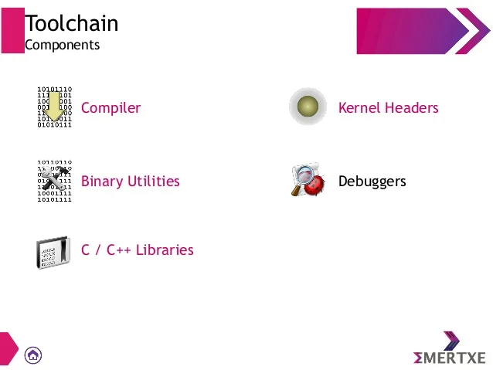

Usage:

To use an Embedded Linux Toolchain, you typically set up the toolchain on your development machine.
You specify the target architecture and platform-specific settings, including the location of the cross compiler, libraries, and headers.
You write or obtain the source code for your embedded application and compile it using the cross compiler provided by the toolchain.
The build system tools assist in automating the compilation, linking, and packaging of the application.
You can then deploy the resulting executable binaries to the target embedded system for testing and execution.
Embedded Linux Toolchains are designed to simplify the development process for embedded systems. They provide an efficient and streamlined workflow by enabling cross-compilation, offering prebuilt libraries, managing dependencies, and facilitating debugging and profiling tasks. Toolchains can be customized to specific hardware platforms, enabling developers to optimize software performance for resource-constrained embedded devices.

how to build an embedded linux system?

Building an embedded Linux system involves several steps and requires expertise in system administration, Linux configuration, and cross-compilation. Here's a high-level overview of the process:

1.Target Hardware Selection:
Choose the hardware platform that suits your embedded system requirements. Consider factors such as processor architecture, memory, storage, and I/O interfaces.
2.Select a Linux Distribution:

Choose a Linux distribution suitable for embedded systems. Popular choices include Yocto Project, Buildroot, OpenEmbedded, and Debian-based distributions like Debian and Ubuntu.

3.Configuration and Customization:
Configure the Linux distribution to meet your specific requirements.
Customize the kernel configuration to include necessary device drivers, file systems, and other components needed for your target hardware.
Customize the root file system by adding or removing packages, setting up network configurations, user accounts, and other system-specific settings.

4.Cross-Compile Toolchain Setup:
Set up a cross-compilation toolchain on your development machine. The toolchain should consist of a cross compiler, libraries, and headers compatible with your target hardware.
The toolchain allows you to compile software on the development machine for the target embedded system.

5.Build Process:
Use the selected Linux distribution's build system (e.g., Yocto Project, Buildroot) to build the embedded Linux system.
The build system typically involves configuring build settings, selecting desired components and packages, and specifying hardware-specific configurations.
The build process will compile the kernel, build the root file system, and generate the necessary boot files.

6.Flashing and Booting:
Flash the compiled kernel image and root file system onto the target hardware's storage medium (e.g., SD card, NAND flash, eMMC).
Configure the bootloader (e.g., U-Boot) to load the kernel and boot the system from the flashed storage medium.
Power on the embedded device and verify that the system boots up successfully.

7.Testing and Debugging:
Test the functionality of your embedded Linux system to ensure it meets your requirements.
Debug any issues that arise during the boot process or system operation using tools like serial console, remote debugging, or log analysis.

8.System Maintenance and Updates:
Implement a mechanism for system maintenance, such as updating the kernel, packages, and configurations.
Plan for ongoing maintenance and updates, including security patches, bug fixes, and feature enhancements.

Building an embedded Linux system can be a complex process, and the specific steps and tools may vary depending on the chosen Linux distribution and build system. It is essential to refer to the documentation and resources provided by the selected Linux distribution and build system for detailed instructions and guidelines specific to your setup.

