Busybox:

BusyBox is a software suite that provides lightweight versions of common Unix utilities and command-line tools. It is designed for embedded systems and resource-constrained environments where a full-featured operating system may not be feasible due to limited storage, memory, or processing power.
BusyBox combines multiple core utilities into a single executable, reducing the overall size and memory footprint. It includes a variety of common Unix commands such as ls, cp, mv, cat, grep, tar, sed, awk, and many more. These utilities are often found in standard Linux distributions but are individually provided as separate binaries.
BusyBox is often used in embedded Linux systems, routers, network appliances, and other devices that require a minimalistic yet functional set of command-line tools. It aims to provide a complete environment that is compatible with the traditional GNU command-line utilities while being highly optimized for size and performance.
BusyBox is typically used as the default shell or as a component of the root file system in embedded Linux systems. It can be customized to include or exclude specific utilities based on the requirements of the target system. Additionally, it supports command-line options and features to enhance compatibility with existing shell scripts and command-line interfaces.
To use BusyBox, you can download the source code from the official website (https://www.busybox.net) and compile it for your specific platform. Alternatively, BusyBox is often pre-installed or available through package managers in many Linux-based embedded systems and distributions.

Examples:
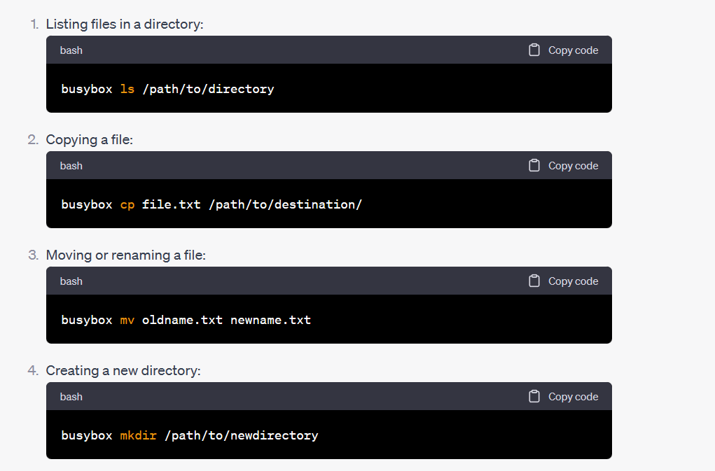

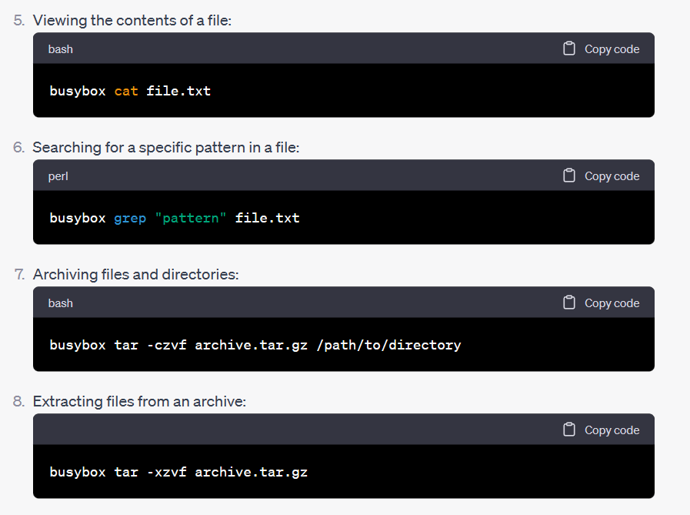

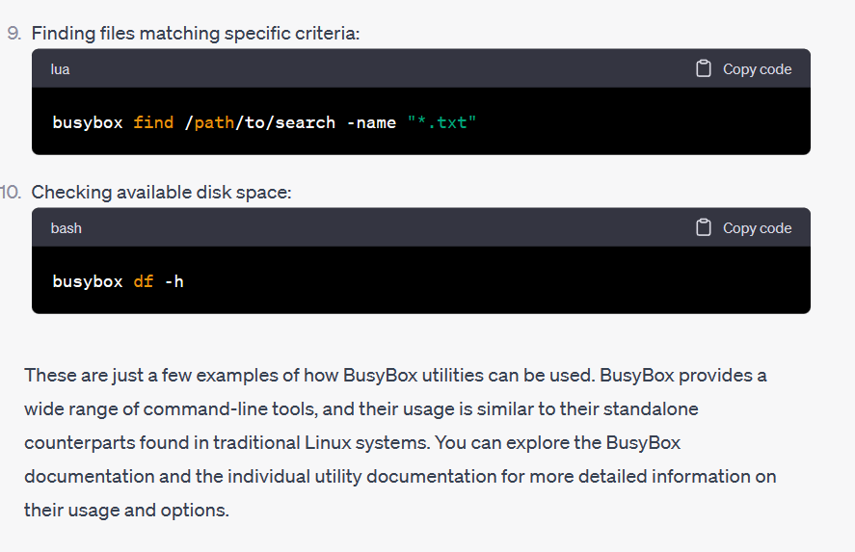
Code
To provide a complete BusyBox code implementation would be beyond the scope of a single response, as BusyBox is a comprehensive software suite comprising multiple utilities. However, I can provide you with a simple example that demonstrates the usage of BusyBox utilities within a script.
#!/bin/sh

# Print current date and time
busybox date

# List files in the current directory
busybox ls

# Create a new directory
busybox mkdir new_directory

# Copy a file to the new directory
busybox cp file.txt new_directory/

# Move to the new directory
cd new_directory

# Display the contents of the copied file
busybox cat file.txt

# Remove the copied file
busybox rm file.txt

# Remove the directory
cd ..
busybox rmdir new_directory

Save the above script to a file, such as busybox_example.sh, make it executable (chmod +x busybox_example.sh), and then run it (./busybox_example.sh). It demonstrates the usage of various BusyBox commands such as date, ls, mkdir, cp, cat, rm, and rmdir. Feel free to modify the script and include additional BusyBox commands as needed.
Remember to have BusyBox installed on your system and accessible in the command-line path. The actual implementation and usage of BusyBox utilities will depend on your specific environment and requirements.

