Buildroot
Buildroot is an open-source build system and collection of tools used to generate embedded Linux systems. It provides a simplified and customizable approach to create a complete Linux-based operating system tailored for embedded devices, such as routers, set-top boxes, industrial controllers, and more. Buildroot automates the process of building cross-compilation toolchains, configuring the Linux kernel, building root filesystems, and integrating user-space applications.
Buildroot enables developers to define the components and configuration of their embedded Linux system through a configuration file. This file specifies the target architecture, selected software packages, kernel configuration, system libraries, device drivers, bootloaders, and various system settings. Based on this configuration, Buildroot fetches the necessary source code, compiles it, and generates the complete embedded Linux system.
Some key features of Buildroot include:
1. Customizability: Buildroot allows fine-grained control over the selection and configuration of software components. It supports a wide range of packages and lets you easily enable or disable features, customize kernel options, and manage dependencies.
2. Cross-compilation: Buildroot provides a cross-compilation environment that enables building software for different target architectures. It automatically handles the complexities of building and linking software for embedded systems.
3. Package management: Buildroot includes a package management system that simplifies the process of adding, removing, or updating software packages in the embedded Linux system. It manages the dependencies between packages and resolves conflicts.
4. Build optimization: Buildroot optimizes the build process by enabling build-time options like parallel builds, caching of downloaded packages, and reuse of build artifacts, leading to faster and more efficient builds.
5. Buildroot community: Buildroot has an active and vibrant community of developers who contribute to its continuous development. The community provides support, shares knowledge, and contributes new features and package updates.
Buildroot generates a complete embedded Linux system that includes a cross-compilation toolchain, a Linux kernel, a root filesystem, and a bootloader. The resulting system can be deployed on the target device, providing a minimal, customized, and optimized Linux environment specifically tailored for embedded applications.
Buildroot is highly flexible and extensively documented, allowing developers to adapt it to their specific needs. It offers a powerful and efficient solution for building embedded Linux systems from scratch, enabling the creation of lightweight, optimized, and tailored operating systems for embedded devices.
Fetures:

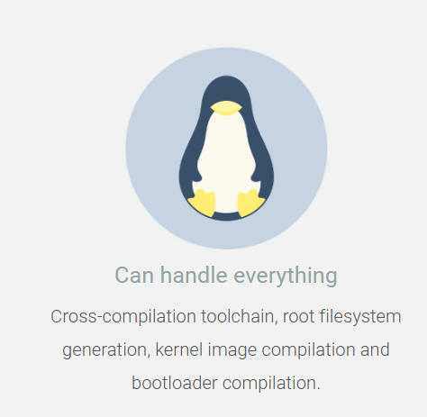

2. 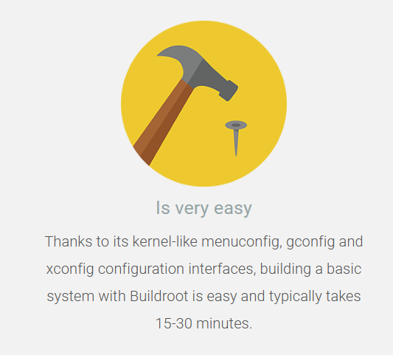

3. 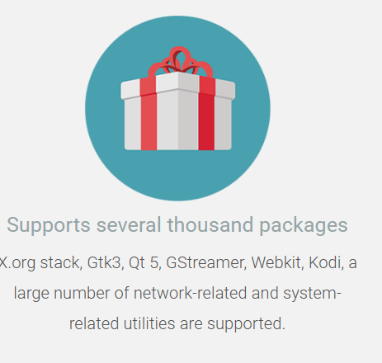

Advantages and disdvantages of buildroot:
Buildroot, like any tool or software, has its own set of advantages and disadvantages. Here are some of the advantages and disadvantages of using Buildroot to build embedded Linux systems:
Advantages:
- Customizability: Buildroot offers a high level of customization, allowing developers to select and configure the components of their embedded Linux system. It provides fine-grained control over software packages, kernel configuration, and system settings, enabling tailored and optimized builds.
- Efficiency: Buildroot optimizes the build process by providing features like parallel builds, caching of downloaded packages, and reusing build artifacts. This improves build times and reduces resource usage, making it efficient for repetitive builds and development iterations.
- Package Management: Buildroot includes a package management system that simplifies the management of software components. It handles package dependencies, conflict resolution, and allows easy addition, removal, or update of packages, ensuring a manageable and maintainable embedded Linux system.
- Cross-Compilation: Buildroot supports cross-compilation, enabling the development of software for different target architectures. It provides a consistent and controlled environment for building software, which is essential in embedded systems where resources are often limited.
- Active Community: Buildroot has a strong and active community of developers who contribute to its development and provide support. The community forums, mailing lists, and regular updates ensure that users have access to resources, knowledge sharing, and assistance.
Disadvantages:
- Learning Curve: Buildroot has a learning curve, especially for newcomers to embedded Linux development. Understanding the build system, configuration options, and integrating custom packages may require some initial effort and familiarity with Linux development concepts.
- Limited Hardware Support: Buildroot's primary focus is on providing a lightweight and customizable build system. While it supports a wide range of hardware architectures, specific hardware support might not be as extensive as in larger and more general-purpose Linux distributions.
- Manual Maintenance: As Buildroot allows customization at a granular level, maintaining the build system and keeping it up to date with security patches and software updates may require manual effort and vigilance.
- Lack of GUI: Buildroot is primarily a command-line-based tool and does not provide a graphical user interface (GUI) for system configuration. Configuration is done through text-based configuration files, which might not be as intuitive for users accustomed to GUI-based tools.
- Limited Ecosystem: Buildroot has its own ecosystem of packages and community support, which might not be as extensive as larger Linux distributions. Some software packages or specific features might not be readily available or require additional manual effort to integrate into the build system.
Overall, Buildroot provides a powerful and flexible solution for building embedded Linux systems, but it requires a certain level of expertise and familiarity with Linux development. It is best suited for projects where customization, efficiency, and lightweight systems are key requirements.

Buildroot is a versatile build system used for creating embedded Linux systems. It finds application in a wide range of industries and projects where customized, optimized, and tailored Linux environments are required. Here are some common uses of Buildroot:
Uses of buildroot:
- Embedded Systems: Buildroot is extensively used for building embedded Linux systems. It enables developers to create lightweight, minimalistic, and optimized operating systems for various embedded devices such as routers, set-top boxes, IoT devices, industrial controllers, automotive systems, and more.
- Prototyping and Development: Buildroot is often employed during the prototyping and development stages of embedded systems. It allows developers to quickly build and iterate on their Linux-based software stack, enabling faster development cycles and reducing time-to-market.
- Education and Learning: Buildroot serves as an excellent tool for teaching and learning about embedded Linux systems. It provides hands-on experience with customizing and building Linux distributions, understanding the build process, configuring kernel options, managing packages, and exploring various aspects of embedded systems development.
- Research and Experimentation: Researchers and hobbyists use Buildroot to experiment with new hardware platforms, explore specific features or optimizations, or develop proof-of-concept projects. Buildroot's flexibility and customizability make it suitable for adapting to unique requirements and conducting research in the embedded Linux domain.
- Open-Source Projects: Many open-source projects and initiatives leverage Buildroot as their build system. It helps in streamlining the build process, ensuring consistent and reproducible builds across different environments, and simplifying the distribution and deployment of software on various embedded platforms.
- Production Systems: Buildroot can be used to build Linux systems for production use in embedded devices. By customizing and optimizing the software stack, developers can create efficient and secure systems tailored to the specific needs of their target devices, resulting in robust and reliable solutions.
- System Maintenance and Updates: Buildroot simplifies system maintenance by providing package management capabilities. It allows easy addition, removal, or update of software packages in the embedded Linux system, making it convenient to keep the system up to date with security patches and software updates.
- Building Virtual Machine Images: Buildroot can also be used to create custom Linux images for virtual machines, enabling the generation of lightweight and customized virtual environments for various purposes, including testing, development, and deployment.
These are just a few examples of the many uses of Buildroot. Its flexibility, customizability, and efficiency make it a popular choice for creating embedded Linux systems across various industries and project types

Extra study material:
Buildroot: a nice, simple and efficient embedded Linux build system (elinux.org)

