Eclipse setup for BBB: 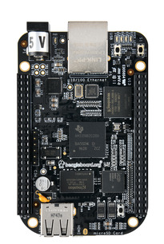 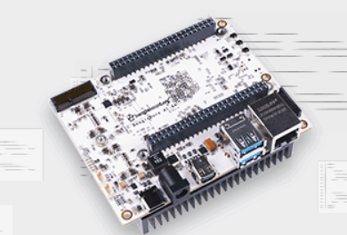
WHAT IS BeagleBone Black (BBB)?
BeagleBone Black is a low-cost, community-supported development platform for developers and hobbyists. Boot Linux in under 10 seconds and get started on development in less than 5 minutes with just a single USB cable.
Eclipse setup for BBB:
Setting up Eclipse for BeagleBone Black (BBB) development involves configuring Eclipse IDE, installing the necessary plugins, and configuring the toolchain to build and deploy applications for the BBB. Here's a step-by-step guide to setting up Eclipse for BBB development:

Install Eclipse IDE: Download and install Eclipse IDE for C/C++ Developers from the official Eclipse website (https://www.eclipse.org/downloads/). Choose the appropriate version for your operating system.

Install the Eclipse CDT Plugin: Launch Eclipse and navigate to "Help" -> "Eclipse Marketplace". Search for "CDT" (C/C++ Development Tooling) and install the Eclipse CDT plugin.

Install the Remote System Explorer (RSE) Plugin: In Eclipse, go to "Help" -> "Eclipse Marketplace" again. Search for "Remote System Explorer" and install the "Remote System Explorer End-User Runtime" plugin. This plugin enables remote file system browsing and SSH connection capabilities.

Install the Yocto Project SDK: The Yocto Project provides a cross-compilation toolchain and libraries for building software for the BBB. Follow the Yocto Project documentation to install the SDK for the desired BBB Linux distribution. Make sure to set up the necessary environment variables.

Create a New C/C++ Project: In Eclipse, go to "File" -> "New" -> "C Project". Select "C++ Managed Build" and give your project a name. Choose the appropriate toolchain and select "Empty Project".

Configure the Toolchain: Right-click on the project name in the "Project Explorer" view and select "Properties". Under "C/C++ Build" -> "Tool Chain Editor", select the toolchain you installed with the Yocto Project SDK.

Configure Remote Connection: In the "Remote Systems" view, right-click and select "New Connection". Choose "SSH Only" and provide the BBB's IP address, username, and password. This allows Eclipse to connect to the BBB for remote development.

Build and Run Configuration: In the "Project Explorer" view, right-click on your project and select "Properties". Under "C/C++ Build", configure the necessary build settings like include paths, compiler flags, and linker settings.

Build and Deploy: Build your project by selecting "Project" -> "Build All". Once built, right-click on the project and select "Run As" -> "Remote C/C++ Application". Choose the executable to deploy and the remote connection to the BBB.

With these steps, Eclipse should be set up for BBB development. You can now write, build, and deploy your C/C++ applications for the BBB using Eclipse's integrated development environment. Remember to configure the project settings and build options according to your specific requirements and the Yocto Project SDK.

advantages and dis advantages of BBB:
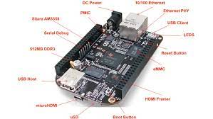
BeagleBone Black (BBB) is a popular development board with its own set of advantages and disadvantages. Here are some of the key advantages and disadvantages of using BBB:

Advantages:

Cost-effective: BBB offers a cost-effective solution for embedded system development. It provides a powerful set of features at a relatively low price point compared to other development boards.

Ample Connectivity: BBB comes with a wide range of connectivity options, including Ethernet, USB, HDMI, UART, SPI, I2C, and more. This makes it versatile and suitable for a variety of applications requiring connectivity.

Open-Source and Community Support: BBB is built on open-source hardware and software, allowing for customization and modification. It has an active community of developers who provide support, share knowledge, and contribute to the improvement of software and documentation.

Expandability and Cape Support: BBB supports "capes," which are expansion boards that extend the functionality of the board. There is a wide range of available capes that provide additional capabilities, such as LCD displays, sensors, motor control, and wireless connectivity.

Linux-based Operating System: BBB is compatible with Linux-based operating systems, providing a familiar and robust software environment for development. It allows developers to leverage the extensive Linux ecosystem and utilize various software libraries and tools.

Disadvantages:

Limited Processing Power: Compared to more advanced development boards, BBB has relatively limited processing power. It features a 1GHz single-core processor, which may not be suitable for computationally intensive applications or real-time tasks.

Limited Memory: BBB has limited onboard memory, with 512MB of RAM. This could impose restrictions on resource-intensive applications that require more memory for processing or storage.

Lack of Built-in Wi-Fi and Bluetooth: The basic BBB model does not have built-in Wi-Fi or Bluetooth capabilities. If wireless connectivity is a requirement, additional hardware or external adapters are necessary.

Power Consumption: BBB's power consumption may be relatively higher compared to some other low-power development boards. This can be a consideration for battery-powered or energy-efficient applications.

Documentation: While BBB has an active community and decent documentation, some users may find that the available documentation and resources are not as extensive or comprehensive as other development boards.

It's important to consider these advantages and disadvantages in the context of your specific project requirements and constraints. BBB can be a suitable choice for many embedded system development scenarios, but it's essential to evaluate its features and limitations against your project's needs.

Uses of BBB;
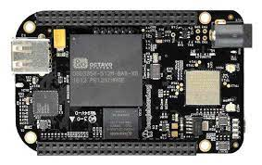
BeagleBone Black (BBB) is a versatile development board that finds applications in various domains. Here are some common uses of BBB:

Prototyping and DIY Projects: BBB is popular among hobbyists, makers, and electronics enthusiasts for prototyping and building DIY projects. It provides a flexible and affordable platform for experimenting with electronics, sensors, actuators, and various hardware components.

Embedded Systems Development: BBB is widely used for embedded systems development. Its powerful processor, ample connectivity options, and support for Linux-based operating systems make it suitable for developing embedded applications such as home automation systems, robotics, data loggers, and Internet of Things (IoT) devices.

Education and Learning: BBB is utilized in educational institutions and workshops to teach concepts of embedded systems, electronics, programming, and Linux. Its accessible price, extensive documentation, and active community support make it an ideal tool for hands-on learning and experimentation.

Home Automation and IoT: BBB's connectivity options, GPIO pins, and support for Linux distributions make it well-suited for home automation projects. It can be used as a central controller to integrate and automate various devices and systems within a smart home or IoT setup.

Industrial Control Systems: BBB is employed in industrial automation and control systems. It can serve as a reliable and cost-effective platform for monitoring and controlling processes, collecting data, and interfacing with industrial equipment and sensors.

Research and Development: BBB is utilized in research projects and academic studies across various disciplines, including robotics, computer vision, machine learning, and signal processing. Its processing power and versatility make it suitable for developing and testing new algorithms and technologies.

Internet-connected Appliances: BBB's connectivity options and Linux support make it suitable for creating internet-connected appliances and devices. It can be used to develop prototypes or commercial products like smart thermostats, environmental monitors, and remote monitoring systems.

Audio/Video Applications: BBB can be used in audio and video applications. With its HDMI output and support for multimedia libraries, it can serve as a media player, video streaming device, or audio processing platform.

These are just a few examples of the many uses of BeagleBone Black. Its versatility, expandability, and community support make it a popular choice for a wide range of projects and applications in the fields of electronics, embedded systems, IoT, and beyond

