Device Drivers are a set of programs that act as an intermediary between the operating system of the computer and the hardware components. In this article, one gets an introduction to such device drivers, their purpose, types, how they work, interaction with hardware, and their role in keeping up a smooth-running computer system.

What is Device Driver?
Device Driver in computing refers to a special kind of software program or a specific type of software application that controls a specific hardware device that enables different hardware devices to communicate with the computer's Operating System. A device driver communicates with the computer hardware by computer subsystem or computer bus connected to the hardware.
Device Drivers are essential for a computer system to work properly because, without a device driver, the particular hardware fails to work accordingly, which means it fails in doing the function/action it was created to do. Most use the term Driver, but some may say Hardware Driver, which also refers to the Device Driver.
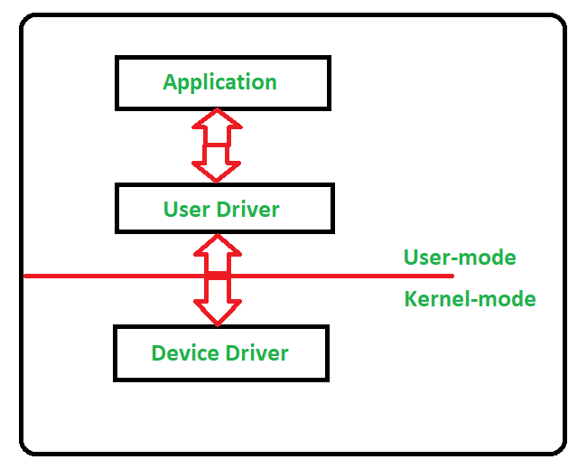

Working of Device Driver
Device Drivers depend upon the Operating System's instruction to access the device and perform any particular action. After the action, they also show their reactions by delivering output or status/message from the hardware device to the Operating system. For example, a printer driver tells the printer in which format to print after getting instruction from OS, similarly, A sound card driver is there due to which 1's and 0's data of the MP3 file is converted to audio signals and you enjoy the music. Card reader, controller, modem, network card, sound card, printer, video card, USB devices, RAM, Speakers, etc need Device Drivers to operate.
The following figure illustrates the interaction between the user, OS, Device driver, and the devices:
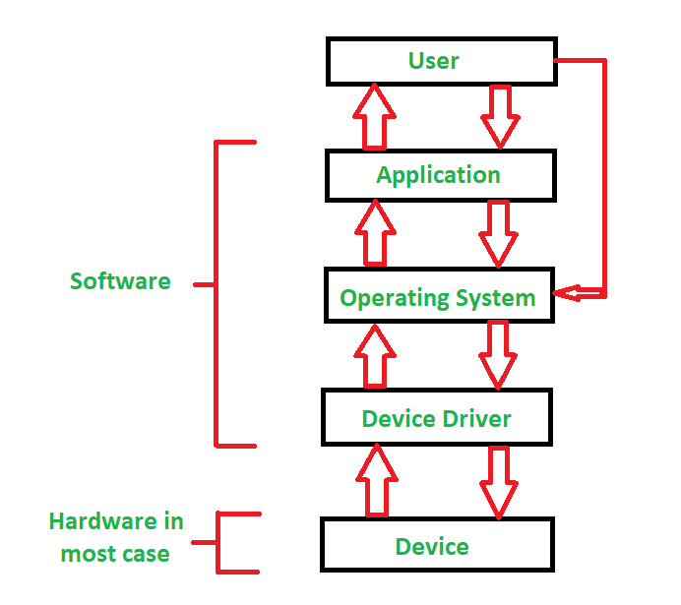

Types of Device Driver
For almost every device associated with the computer system there exist a Device Driver for the particular hardware. But it can be broadly classified into two types i.e.,
- Kernel-mode Device Driver
This Kernel-mode device driver includes some generic hardware that loads with the operating system as part of the OS these are BIOS, motherboard, processor, and some other hardware that are part of kernel software. These include the minimum system requirement device drivers for each operating system.
- User-mode Device Driver
Other than the devices which are brought by the kernel for working the system the user also brings some devices for use during the using of a system that devices need device drivers to function those drivers fall under User mode device driver. For example, the user needs any plug-and-play action that comes under this.

How Do Device Drivers Interact With Hardware?
For device drivers to interact with hardware, Virtual Device Driver can be used. There are also virtual device drivers (VxD), which manage the virtual device. Sometimes we use the same hardware virtually at that time virtual driver controls/manages the data flow from the different applications used by different users to the same hardware.
It is essential for a computer to have the required device drivers for all its parts to keep the system running efficiently. Many device drivers are provided by manufacturers from the beginning and also we can later include any required device driver for our system.

How Does Web-Based Technology Use Device Drivers?
Web-based technology does not normally use device drivers. Normally, it depends on an operating system and web browsers for controlling hardware. The device drivers are low-level software interacting directly with the operating system. The OS talks directly to the hardware devices. The browser brings abstraction of hardware to the web application. This way, when a web application wants to access some of the devices, it uses APIs provided by the browser. These APIs talk to the Operating System, which, in turn, speaks to the hardware via appropriate device drivers. This layering allows web applications to run across devices without concern about the specifics of the driver.

How do I Install Device Drivers?

To install device drivers, following steps can be followed:
Step 1: Identify the device needing a driver (e.g., printer, graphics card).
Step 2: Check if Windows has automatically installed a driver.
Step 3: If not, visit the manufacturer's website.
Step 4: Find the "Support" or "Downloads" section.
Step 5: Enter your device model number.
Step 6: Download the latest compatible driver for your operating system.
Step 7: Once downloaded, run the installer file (usually .exe).
Step 8: Follow the on-screen instructions to complete installation.
Step 9: Restart your computer if prompted.
Step 10: Check Device Manager to confirm successful installation.
Step 11: Test the device to ensure it's working properly.

Examples of Device Driver

Some examples of Device Driver are as follows:

Printer Driver
Software used by a computer to 'talk' to the printer. It acts like a translator of print jobs into some form of language the printer understands, mediates instructions like paper size or quality of print for the print job, and also communicates status messages from the printer back to the computer. The various printer driver versions can be model and operating system-specific.

Graphics Card Driver
It Controls the interaction of the operating system with the GPU. It takes responsibility for display output, 3D acceleration, video decoding, and includes power management. Graphics drivers optimize game performance and graphics-intense applications and mostly include a control panel used to adjust display settings.

Network Interface Card (NIC) Driver
It enables the OS to communicate with the network adapter. It configures data packets for transmission and receipt over the network, configures network properties such as speed and duplex mode, and installs protocols to be used on a wired or wireless connection. NIC drivers also include features such as Wake-on-LAN and packet filtering.

Audio Driver
Develops the interaction of an operating system with a sound card or chip of audio. It regulates audio input/output, multiple audio stream management, and audio effects. It is also in charge of volume control. Many audio drivers also include utilities for setting an equalizer, surround sound, and improving your microphone.

USB Controller Driver
It allows the operating systems to operably communicate with the USB ports by detecting the devices, managing the data flow protocols, managing power control for the USB devices, and enabling a wide array of USB standards, such as 2.0 and 3.0, among others. This sort of functioning is important for enabling the detection and usability of the USB devices-for instance, mice, keyboards, and external drives.

Conclusion
The device driver is the indispensable software that enables the operating system to interact with specific hardware devices. It facilitates interfacing the operating system's instructions to the hardware, or vice versa. Basically, a driver is software that helps in translating operating system instructions with the compatible hardware, or vice versa, which enables the working of the device to take place without any hitch, like printing of documents or playing audio.
Generally, it is classified into two categories: kernel-mode drivers, which form part of the OS, and user-mode drivers for user-added devices. Virtual device drivers allow hardware devices to be shared by multiple applications. Installing device drivers is important for the effective and efficient functioning of a system and for compatibility to have all the hardware components work properly.

