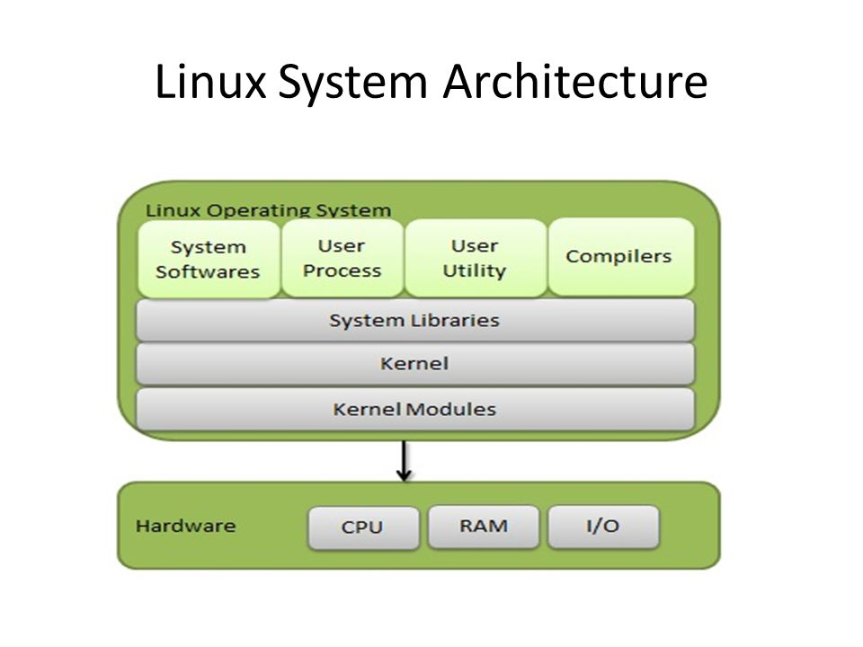

The Linux operating system follows a modular and layered architecture, commonly known as the Linux Kernel Architecture. Here is an overview of the Linux architecture:
Kernel:
The Linux kernel is the core component of the operating system. It interacts directly with the hardware and provides essential services and abstractions to the rest of the system.
Key responsibilities of the kernel include process management, memory management, device drivers, filesystems, networking, and security.
System Libraries:
Above the kernel, there are system libraries that provide additional functionalities and abstractions for application development.
The GNU C Library (glibc) is one of the main libraries used in Linux systems. It provides functions and APIs that applications can use for various operations.
System Utilities:
Linux offers a wide range of system utilities and commands for managing and configuring the system. These utilities are usually available through the command-line interface (CLI).
Examples include shell interpreters (such as Bash), package managers (such as apt or yum), text editors (such as vi or nano), and various system administration tools.
Graphical User Interface (GUI):
Linux can provide a graphical user interface (GUI) environment for users.
X Window System (X11 or Xorg) is a commonly used display server protocol that handles GUI-related tasks such as window management, input handling, and graphics rendering.
Desktop environments (e.g., GNOME, KDE, Xfce) and window managers (e.g., Openbox, i3) provide user-friendly interfaces and manage the appearance and behavior of windows and applications.
Applications:
On top of the system libraries and utilities, users and developers can run various applications on Linux.
Linux supports a wide range of applications, including web browsers, office suites, media players, development tools, and more.
Applications can be developed using programming languages like C, C++, Python, Java, and others.
Filesystem Hierarchy:
Linux follows a standardized filesystem hierarchy, which defines the organization and structure of files and directories.
Common directories include /bin for essential binaries, /etc for system configuration files, /home for user home directories, /usr for user programs and data, and /var for variable data (logs, spool, etc.).
The root directory ("/") is the top-level directory from which the entire filesystem hierarchy branches out.
It's important to note that the Linux kernel is modular and can be customized by adding or removing features through kernel configuration. Additionally, there are various distributions (e.g., Ubuntu, Fedora, Debian) that package the Linux kernel along with different sets of utilities, libraries, and applications to provide complete operating system packages.
Kernel Space vs. User Space:

Linux implements a separation between kernel space and user space.
Kernel space refers to the privileged mode of operation where the kernel code executes. It has direct access to the hardware and provides low-level system services.
User space is where user applications run. Applications interact with the kernel by making system calls, which provide a controlled interface to access kernel services.
Process Management:

Linux employs a multitasking model where multiple processes run concurrently.
The kernel manages processes, including process creation, termination, scheduling, and context switching.
Each process has its own virtual address space, which provides memory isolation and protection.
Memory Management:

Linux provides virtual memory management to abstract the physical memory and provide a larger virtual address space for each process.
Memory management includes memory allocation, deallocation, and protection mechanisms to ensure proper memory usage and security.
The kernel uses techniques such as demand paging, memory mapping, and swapping to efficiently manage memory resources.
Device Drivers:

Device drivers enable the communication between the kernel and hardware devices.
The Linux kernel includes a wide range of built-in device drivers for common hardware components such as storage devices, network interfaces, input/output devices, and more.
Device drivers provide a consistent interface for accessing and controlling hardware devices.
Filesystem and Storage:

Linux supports various filesystems, including ext4, Btrfs, XFS, and more. Filesystems handle the organization, storage, and retrieval of files and directories on storage devices.
Virtual filesystem (VFS) layer provides a unified interface to access different filesystem types, allowing applications to work with files regardless of the underlying filesystem.
Networking:

Linux has extensive networking capabilities, supporting various protocols such as TCP/IP, UDP, ICMP, and more.
The networking stack handles network communication, including network device drivers, network protocols, and socket APIs for application-level network programming.
Interprocess Communication (IPC):

Linux provides mechanisms for IPC, allowing processes to communicate with each other.
Common IPC mechanisms include pipes, named pipes (FIFOs), sockets (for network communication and local inter-process communication), shared memory, and message queues.
Security:

Linux includes various security features, such as access control lists (ACLs), file permissions, user and group management, and secure communication protocols.
Security modules, such as SELinux (Security-Enhanced Linux), provide additional access control and policy enforcement mechanisms.
Modular Architecture:

The Linux kernel follows a modular design, where functionality can be dynamically added or removed through loadable kernel modules.
Kernel modules allow for flexibility and customization by adding or removing specific features without rebuilding the entire kernel.
These additional details provide a deeper understanding of the Linux architecture, highlighting its key components and functionalities. The modular and layered design of Linux enables flexibility, extensibility, and customization, making it a versatile operating system used in various domains, from servers and embedded systems to mobile devices and IoT applications.
The Linux architecture provides flexibility, modularity, and the ability to customize the system according to specific needs, making it a popular choice for a wide range of devices and applications.

