Kernel Modules Vs Applications:
Kernel Modules and Applications are two distinct types of software in a Linux system, each serving different purposes. Here's a brief explanation of Kernel Modules and Applications:

Kernel Modules:
Kernel modules (also known as device drivers or loadable kernel modules) are pieces of software that extend the functionality of the Linux kernel.
Modules are dynamically loaded and unloaded into the kernel at runtime, allowing them to be added or removed without rebooting the system.
Kernel modules provide low-level access to hardware devices, file systems, network protocols, and other kernel services.
They handle tasks such as managing hardware interrupts, handling device I/O, implementing file systems, and enabling support for various peripherals.

Applications:
Applications, also called user-space applications or user-level programs, run in the user-space environment of the operating system.
Applications are executed outside the kernel and rely on the kernel for accessing system resources and services.
They are typically developed to perform specific tasks, provide user interfaces, and interact with users.
Examples of applications include web browsers, text editors, media players, development tools, and any other software that runs on top of the operating system.
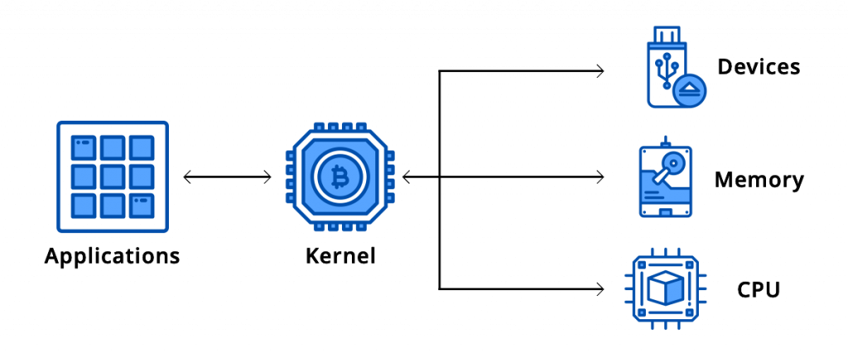
Key Differences:
Kernel modules operate at the kernel level, providing low-level functionality and direct access to hardware, while applications run in the user-space, utilizing the services and resources provided by the kernel.
Kernel modules are part of the kernel itself and are loaded and unloaded as needed, while applications are standalone programs executed by the user.
Kernel modules are typically developed in C or C++, require special knowledge of kernel internals, and undergo rigorous testing and verification. Applications can be developed in various programming languages and follow different development practices.
Kernel modules have privileged access to system resources and operate in a more controlled and restricted environment. Applications, on the other hand, have limited access to system resources and operate in a more isolated and secure manner.
In summary, kernel modules extend the functionality of the Linux kernel and provide low-level system services, while applications are user-level programs that utilize the kernel services to perform specific tasks in the user-space environment.

dependencies of Kernel Modules and Applications:
Kernel Modules and Applications in a Linux system may have different dependencies based on their specific requirements and functionalities. Here are some common dependencies for both Kernel Modules and Applications:

Dependencies for Kernel Modules:
1.Kernel Headers: Kernel modules typically depend on the availability of the corresponding kernel headers for the target Linux kernel version. These headers provide necessary definitions, structures, and function prototypes required for module compilation and interaction with the kernel.

2.Compiler and Build Tools: Building kernel modules requires a compatible compiler toolchain, such as GCC (GNU Compiler Collection), along with associated build tools like make. These tools are necessary to compile the module source code into loadable binary modules.

3.Kernel Configuration: Kernel modules may have dependencies on specific kernel configuration options. For example, a module designed to support a particular hardware device requires the corresponding device driver option to be enabled in the kernel configuration.

4.Module Utilities: Certain module-related utilities, like insmod (module insertion), rmmod (module removal), and modprobe (automatic module loading with dependency resolution), are used to manage the lifecycle of kernel modules. These utilities are usually provided by the Linux distribution or come as part of the system's package management.

Dependencies for Applications:

1.Libraries: Applications often rely on various libraries for accessing system services, performing specific functions, or providing additional features. Common libraries include C runtime libraries (libc), networking libraries (libcurl), graphical libraries (Qt, GTK), database libraries (SQLite, MySQL), and many others. These libraries need to be present on the system and available during the application's compilation and execution.

2.External Tools and Utilities: Applications may depend on external tools or utilities for specific tasks. For instance, an application that processes images may require tools like ImageMagick or OpenCV. These tools need to be installed on the system for the application to function correctly.

3.Development Frameworks: Some applications rely on specific development frameworks or platforms. For example, applications developed using Java may require a Java Runtime Environment (JRE) or Java Development Kit (JDK). Web applications may rely on web server software like Apache or Nginx.

4.Configuration Files and Data: Applications may depend on configuration files, data files, or databases for proper operation. These files provide settings, parameters, or content required by the application at runtime.
It's important to note that the actual dependencies can vary significantly depending on the specific application or kernel module and the Linux distribution being used. It's crucial to consult the documentation or specific requirements of each component to determine their exact dependencies and ensure they are fulfilled in the target system.

