Course Name: PRINCIPLES OF CYTOGENETICS (2+1)
Course Code: MAGP 1102

Plant Cytogenetics: Rediscovery of Mendelian Laws of Inheritance generated interest in understanding chromosomal basis of inheritance. Therefore, experimental procedures and techniques were developed to elucidate structure of chromosomes and understand their behavior to underscore genetic principles. The hybrid discipline that combines cytology and genetics is termed as cytogenetics. Plant cytogenetics serves to integrate molecular biology, plant biotechnology and genetics with cytogenetics and also provide a conceptual foundation for modern genomics such as structural and functional genomics and comparative evolutionary genomics.
UNlT l:
Architecture of Prokaryotic Chromosomes: In many bacteria, the chromosome is a single covalently closed (circular) double-stranded DNA molecule that encodes the genetic information in a haploid form. The size of the DNA varies from 500,000 to several million base-pairs (bp) encoding from 500 to several thousand genes depending on the organism. The chromosomal DNA is present in cells in a highly condensed, organized form called nucleoid (nucleus-like), which is not encased by a nuclear membrane as in eukaryotic cells. The isolated nucleoid contains 80% DNA, 10% protein, and 10% RNA by weight. There are two essential aspects of nucleoid formation; condensation of a large DNA into a small cellular space and functional organization of DNA in a three-dimensional form. The haploid circular chromosome in E. coli consists of ~ 4.6 x 10⁶ bp. The essential aspect of nucleoid formation is the functional arrangement of DNA. Chromosomal DNA is not only condensed but The DNA in the chromosome appears to have a condition-dependent 3-D structure that is linked to gene expression so that the nucleoid architecture and gene transcription are tightly interdependent, influencing each other reciprocally. Almost five decades of research beginning in 1971, has shown that the final form of the nucleoid arises from a hierarchical organization of DNA. At the smallest scale (1 -kb or less), nucleoid-associated DNA architectural proteins condense and organize DNA by bending, looping, bridging or wrapping DNA. At a larger scale (10 -kb or larger), DNA forms plectonemic loops, a braided form of DNA induced by supercoiling. At the megabase scale, the plectonemic loops coalesce into six spatially organized domains (macrodomains), which are defined by more frequent physical interactions among DNA sites within the same macrodomain than between different macrodomains. Long- and short-range DNA-DNA connections formed within and between the macrodomains contribute to condensation and functional organization. Finally, the nucleoid is a helical ellipsoid with regions of highly condensed DNA at the longitudinal axis.

Bacterial Chromosome Structure
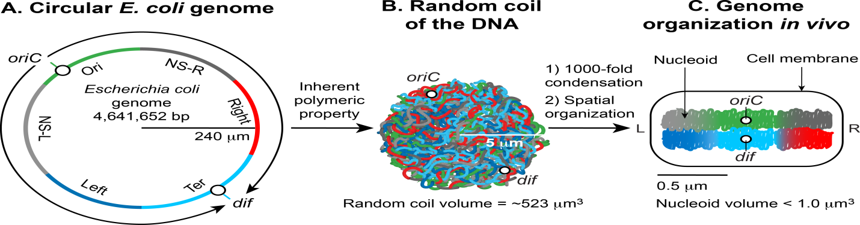
Fig 1. Formation of the Escherichia coli nucleoid. A. An illustration of an open conformation of the circular genome of E. coli. Arrows represent bi-directional DNA replication. The genetic position of the origin of bi-directional DNA replication (oriC) and the site of chromosome decatenation (dif) in the replication termination region (ter) are marked. Colors represent specific segments of DNA as discussed in C. B. An illustration of a random coil form adopted by the pure circular DNA of E. coli at thermal equilibrium without supercoils and additional stabilizing factors [5, 6]. C. A cartoon of the chromosome of a newly born E. coli cell. The genomic DNA is not only condensed by 1000-fold compared to its pure random coil form but is also spatially organized. oriC and dif are localized in the mid-cell, and specific regions of the DNA indicated by colors in A organize into spatially distinct domains. Six spatial domains have been identified in E. coli. Four domains (Ori, Ter, Left, and Right) are structured and two (NS-right and NS-left) are non-structured (See section 4 of the main text for details). The condensed and organized form of the DNA together with its associated proteins and RNAs is called nucleoid. Drawings are not in scale with each other.
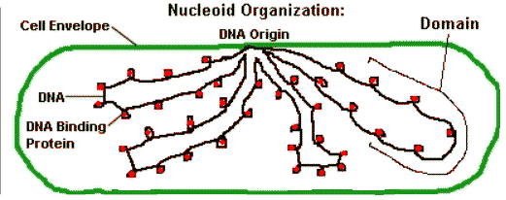

Eukaryotic Chromosome Structure
Eukaryotic cells contain their DNA within the nuclear membrane.
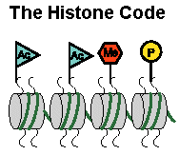 | - Methylation of histone or of DNA usually turns a gene off.  - Acetylation of histone usually turns a gene on.  - Phosphorylation -- we're not sure what that does.
Nucleosome – solenoid model: This model was proposed by Kornberg and Thomas in 1974. Chromatin is composed of DNA, RNA, histones and other proteins. Histones are basic proteins rich in lysine and arginine and lacks tryptophan. The nucleosomes are basic sub units of chromatin and have bead like appearance. Each nucleosome is a disc-shaped particle
containing 2 copies of each type of histones–H2A, H2B, H3 and H4. This histone octamer forms a protein core [(H2A-H2B) (H3-H4)₂(H2A-H2B)] around which the double-stranded DNA helix makes 1.7 turns left-handed superhelix that corresponds to 146 bp. Each nucleosome bead is separated from the next by a region of linker DNA which is generally 54 base pair long and contains single H1 histone protein molecule.
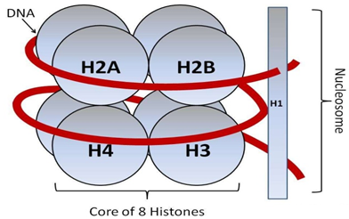
1. The 10-nm fibre: This is the first level of packing in chromatin is called nucleosome. The repeating nucleosomes with intervening "linker" DNA form a 10-nm-fiber, described as "beads on a string", and have a packing ratio of about five to ten i.e., five to ten times more compact than free DNA.
2. The 30-nm fibre (solenoid): The second level of packing is called solenoid. In the second level of packing, histone H1 molecules are found responsible for packing of nucleosomes into the 30-nm thick chromatin fibre called solenoid. In the 30-nm fibre, nucleosomes are closely packed (about six nucleosomes per turn) with a packing ratio of ~50 and is known as solenoid. Hence, Solenoid is a compacted structure with a packing ratio of ~50 and whose formation is dependent on the presence of the H1 histone. This model is universally accepted as a model of chromatin fibre organization. The packaging of DNA into a 30-nm chromatin fibre leaves a human chromosome about 0.1 cm long, so there must be several higher orders of folding. Inside the nucleus, this 30 nm solenoid structure undergoes further coiling to produce a chromatin fibre of 300 nm thick. 300 nm thick chromatin filaments are condensed into the 700 nm thick chromatid and is seen at metaphase stage of cell division. During cell division a 1,400 nm thick metaphase chromosome is produced containing two chromatids, each chromatid being 700 nm.

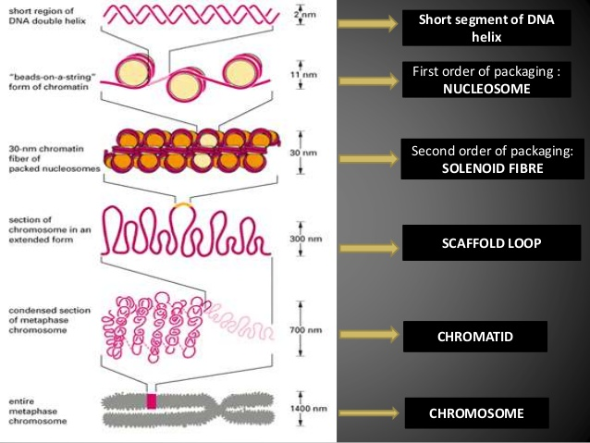
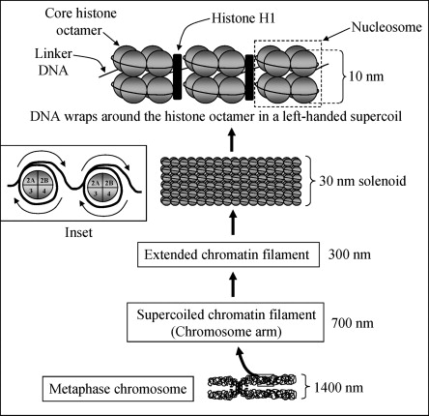
Figure: The nucleosomes (10 nm each) are condensed into 30 nm solenoid fiber structure; 30 nm solenoids are condensed into 300 nm filament; 300 nm filaments are condensed into the 700 nm chromosome. During cell division, when the chromosomes duplicate, a 1,400 nm metaphase chromosome is produced containing two chromatids, each chromatid being 700 nm. The inset shows the position of individual histones with respect to each other as viewed from the top, and the left-handed wrapping of the DNA around each histone octamer core.
DNA→ nucleosome → solenoid → chromatin fibre → chromatid → chromosome
(2 nm dia) (10 nm dia) (30 nm diameter) (300 nm diameter) (700 nm diameter) (1400 nm diameter)

At some places chromatin is densely packed to form darkly staining heterochromatin. At other places chromatin is loosely packed. It is called euchromatin. Euchromatin is lightly stained. It is transcriptionally active chromatin whereas heterochromatin is transcriptionally inactive and late replicating or heteropycnotic.

In mitosis, the chromosomes appear as the thick rod-shaped bodies which can be stained and visualized under light microscopy.  The modern way to visualize condensed chromosomes is by FISH -- fluorescence in situ hybridization. In this method, fluorescent antibody-tagged DNA probes hybridize to their complementary sequences in the chromosomes. By using FISH probes with different colored fluorophores, one can color each human chromosome independently, and thus identify all 23 chromosomes. This is called chromosome painting. | 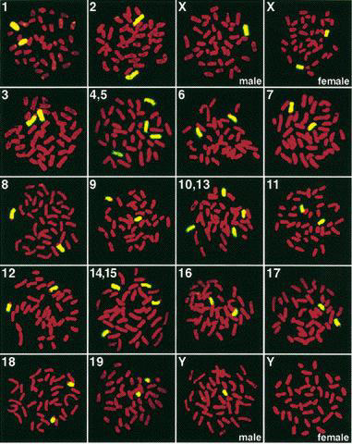
Architecture of Eukaryotic Chromosomes
E. Strasburger in 1875 first discovered thread-like structures which appeared during cell division. These thread like structures were called chromosomes due to their affinity for basic dyes. The term chromosome is derived from two Greek words; chrom = colour, soma=body. This term was first used by Waldeyer in 1888. Chromosomes contributed to the division of cells and they are of prime importance as they carry the genes which are the hereditary material.
Chromosome number: The number of chromosomes in a given species is generally constant. All the members of the species ordinarily have definite and generally a constant somatic and gametic chromosome number. Generally somatic cells contain two copies of each chromosome except the sex chromosomes. Both the copies are ordinarily identical in morphology, gene content and gene order and hence known as homologous chromosomes. Somatic chromosome number is the number of chromosomes found in somatic cells of a species and is represented by 2n. Gametic chromosome number is exactly half of somatic chromosome number and is represented by n. It denotes the number of chromosomes found in gametes of a species. The number of chromosomes varies greatly from 2n = 4 (n = 2) in Haplopappus gracilis (Compositae) to 2n = > 1200 in some pteridophytes. Among animals Aulacantha (a radiolarian) the diploid chromosome number is 1600. For actual chromosome numbers, x should be used as follows: x, 2x, 3x, 4x, 5x, 6x represent chromosome number for haploids, diploids, and a variety of polyploids.
Name of the organism Chromosome number (2n)
Rice 24
Tomato 24
Wheat 42
Onion 16
Maize 20
Garden pea 14
Upland cotton 52
Human beings 46
Evening primrose (Oenothera) 14
Drosophila 8
Size: The size of the chromosome shows a remarkable variation depending upon the stage of cell division. The chromosomes are the longest and thinnest during interphase (resting stage) and hence not visible under light microscope. Chromosomes are the smallest and thickest during mitotic metaphase. In general, plants have longer chromosomes than animals and species having lower chromosome number have longer chromosomes than those having a higher chromosome number. Among plants, dicots in general have shorter and higher number of chromosomes than monocots. Among the higher plants, the longest mitotic chromosomes are those of Trillium sps., which may reach 32 µ in size. In most fungi all chromosomes are extremely minute. Chromosome size is not proportional to the number of genes present on the chromosome.
Morphology: The outer covering or sheath of a chromosome is known as pellicle, which encloses the matrix. Within the matrix lies the chromatin. Flemming introduced the term chromatin in 1879. The term chromatin refers to the Feulgen positive materials observed in interphase nucleus and later during nuclear division. Chromatin readily stains with basic dyes especially Basic Fuchsin, which is specific for DNA which in turn is a major constituent of chromosomes. The chromosome morphology changes during cell division and mitotic metaphase is the most suitable stage for studies on chromosome morphology. In mitotic metaphase chromosomes, the following structural features can be seen under the light microscope.
1. Chromatid: Each metaphase chromosome appears to be longitudinally divided into two identical parts each of which is called chromatid. Both the chromatids of a chromosome appear to be joined together at a point known as centromere. The two chromatids of chromosome separate from each other during mitotic anaphase (and during anaphase II of meiosis) and move towards opposite poles. Since the two chromatids making up a chromosome are produced through replication of a single chromatid during synthesis (S) phase of interphase, they are referred to as sister chromatids. In contrast, the chromatids of homologous chromosomes are known as non-sister chromatids.
2. Centromere: Centromere and telomere are the most stable parts of chromosomes. The region where two sister chromatids appear to be joined during mitotic metaphase is known as centromere. It generally appears as constriction and hence called primary constriction. Centromere is a localized and easily detectable morphological region of the chromosomes which helps in the movement of the chromosomes to opposite poles during anaphase of cell division. The centromere divides the chromosomes into two transverse parts called arms. The centromere consists of two disk shaped bodies called kinetochores. The kinetochores do not form part of the chromatid but lie one on each side of the chromosome such that each chromatid is having its own kinetochore. One kinetochore is attached to the spindle fibres towards one pole and the other similarly towards the other pole. Depending on position of the centromeres, chromosomes can be grouped as:
a) Metacentric: Centromere is located exactly at the centre of chromosome, i.e. both arms are equal in size. Such chromosomes assume ‘V’ shape at anaphase.
b) Submetacentric: The centromere is located on one side of the centre point such that one arm is longer than the other. These chromosomes become ‘J’ or ‘L’ shaped at anaphase.
c) Acrocentric: Centromere is located close to one end of the chromosome and thus giving a very short arm and a very long arm. These chromosomes acquire ‘ J’ shape or rod shape during anaphase.
d) Telocentric: Centromere is located at one end of the chromosome so that the chromosome has only one arm. These chromosomes are ‘I” shaped or rod shaped.
Normally chromosomes are monocentric having one centromere each. Acentric (without centromere) and dicentric (with two centromeres) chromosomes, if produced due to chromosomal aberrations, cannot orient properly on the equatorial plate and lag behind other chromosomes during anaphase movements. In certain organisms, centromere does not occupy a specific position, but is diffused through out the body of chromosome. Such chromosomes having diffused centromere, are found in Luzula sps. and insects belonging to the order Hemiptera.
3. Telomere: The two ends of chromosomes are known as telomeres. They are highly stable and do not fuse or unite with telomeres of other chromosomes due to polarity effect. The telomeres impart stability to the chromosome and hence confer identity and individuality to chromosomes through cell cycle and for many cell generations.
4. Secondary constriction: The constricted or narrow region other than that of centromere is called secondary constriction and the chromosomes having secondary constriction are known as satellite chromosomes or sat chromosomes. Chromosome may possess secondary constriction in one or both arms of it. Chromosomal end distal to the secondary constriction is known as satellite. Production of nucleolus is associated with secondary constriction and therefore it is also called nucleolus organizer region and satellite chromosomes are often referred to as nucleolus organizer chromosomes.
5. Chromonema (plural chromonemata) is the thread-like coiled filament are found in the chromosomes of early prophase. These extend the entire length of a chromosome and are the gene bearing portion of chromosomes. The term chromonema was coined by Vejdovsky in 1912.
6. Chromomere: The serially aligned beads or granules over the chromonema of a eukaryotic chromosome, resulting from tight coiling of DNA and appear as dark staining bands in the giant salivary gland chromosomes. These represent heterochromatic regions. It is visible on a chromosome during the prophase of meiosis (pachytene stage) and mitosis. These are invisible in mitotic metaphase chromosomes
7. Matrix: The mass of acromatic material which surrounds the chromonemata is called matrix. The matrix is enclosed in a sheath which is known as pellicle. Both matrix and pellicle are non genetic materials and appear only at metaphase, when the nucleolus disappears.
Composition of chromosomes: The material of which chromosomes are composed is called chromatin. N.Fleming introduced the term chromatin in 1879. Chromatin = DNA + Histone proteins. The basic unit of chromatin is Nucleosome. Chromatin was classified into two groups by cytologists when chromosomes are stained with stains such as basic dyes like acetocarmine or feulgen (basic fuchsin) reagent at prophase. The darkly stained regions were called heterochromatin, while lightly stained regions were called euchromatin. This differential staining capacity of different parts of chromosomes is known as ‘heteropycnosis’. In general heterochromatin is found in centromeric and telomeric regions and these regions of chromosome generally replicate later than the euchromatic regions of chromosomes. The genes within the heterochromatic regions are usually inactive. Most of the genome of an active cell is euchromatic and the genes with in this euchromatic region are expressed. Heterochromatin is further classified into two groups:
a) Constitutive and b) Facultative
a) Constitutive heterochromatin: It is present in all cells at identical positions on both homologous chromosomes of a pair.
b) Facultative heterochromatin: It varies in state in different cell types, at different stages or sometimes, from one homologous chromosome to another. A well known example of facultative heterochromatin is the Barr body, an inactivated X chromosome in somatic cells of mammalian female(XX).
Differences between Heterochromatin and euchromatin:
 | Heterochromatin | Euchromatin
1. | Represent darkly stained regions of the chromatin due to tight coiled DNA | Lightly stained regions of the chromatin due to loosely coiled DNA
2. | Usually found near centromere and telomere | Found in the middle of chromosome between centromere and telomere
3. | Genes in heterochromatin are transcriptionally inactive due to tightly coiled DNA | Contains lot of active genes and plays active role in transcription
4 | Two types – Constitutive and facultative | Only one type
5 | Examples are chromomeres, chromocentre (occur near centromere of giant polytene chromosomes) and Knobs of maize (spherical heterochromatin bodies seen in pachytene stage that serve as valuable chromosome markers for distinguishing related species and races)

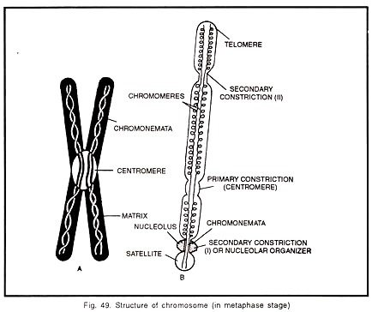

Characteristic Features of Chromosomes:

i. Karyotype:
Karyotype refers to the characteristic morphological features of chromosomes of a species such as chromosome Number, Size, Position of centromere, Position of satellite, and degree and distribution of heterochromatin. Generally, karyotype is represented by arranging the haploid set of chromosomes an organism in descending order of size, keeping their centromeres in the same line. Thus the largest chromosome is placed on extreme left and the shortest on extreme right. The diagrammatic representation of karyotype of a species is known as ideogram or ideotype (Fig. 4.2). Hence, the karyotype represents haploid (gametic) chromosome number in a given

species.
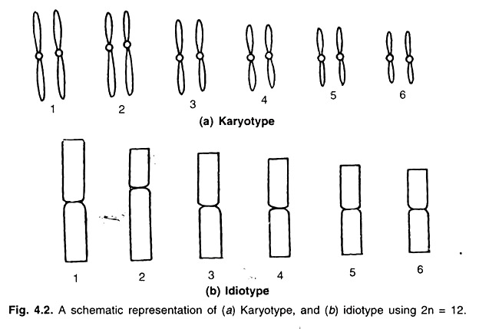
Importance of karyotype study:
- The karyotype is generally identical for a species, but it differs from species to species. Hence karyotype represents evolutionary relationships.
- KARYOTYPE suggest primitive and advanced feature of an organism. Karyotype is of two types, viz., symmetrical and asymmetrical. In the symmetrical karyotype, all the chromosomes are mostly Meta centric chromosomes and less variation in the size of chromosomes. Plant species with this type of karyotype are considered as primitive ones. In case of asymmetrical karyotype, the chromosomes show large differences between the size of the smallest and the longest chromosome and have fewer metacentric chromosomes. Plant species with asymmetrical karyotype are considered advanced from evolution point of view. Flowering plants having specialized zygomorphic flowers show asymmetrical karyotype. Thus, study of karyotype helps in understanding the evolutionary process.

“Banding pattern for identification of Chromososmes
A Band is defined as a part of a chromosome that is clearly distinguishable from its adjacent segments by appearing darker or lighter. Each chromosome has a unique banding pattern that is specific to each chromosome and are reproducible landmarks of chromosomes.

Uses of Chromosome Banding
- Once karyotype is constructed, chromosome aberrations such as partial deletions and translocations in genetic diseases can be identified by banding techniques. Secondly specific chromosomes and also small chromosome fragments can be identified. This is because the chromosome banding pattern is constant and highly specific for each chromosome that allow distinction of s
- imilar sized chromosomes in a karyotype.

Quinacrine banding (Q-banding) (caspersson et al.,) is obtained when chromosomes are stained with quinacrine mustard (QM) dye, a fluorochrome. The chromosomes display bright and dark bands when viewed under UV light and every chromosome pair can be identified by this fluorescence characteristics. The banding pattern is specific for each pair of chromosomes. Q-banding is most commonly used in plants.
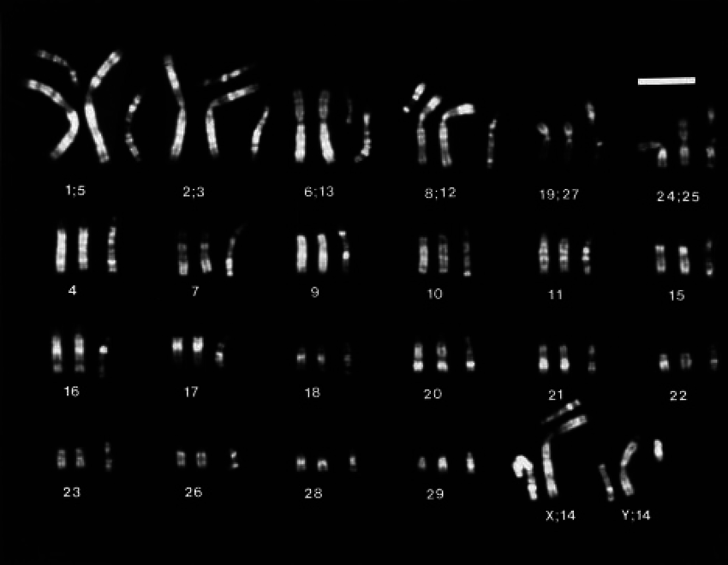

Q-band karyotype

Giemsa banding (G-banding): It involves pre-treatment of the condensed metaphase chromosomes with trypsin (to partially digest the chromosomes), followed by staining with Giemsa. Giemsa is Romanowsky type dye mixture consisting of various dyes such as methylene blue, Azure A, B & C, Eosin and thionin. These dye components binds only to DNA that are rich in the base pairs Adenine (A) and Thymine (T) producing a dark band. Heterochromatic regions that are rich in A-T, replicates late and relatively gene poor stain more darkly in G-banding. G-banding shows alternate regions of heavy staining (called G bands) and light staining (interbands). The pattern of bands are numbered on each arm of the chromosome starting from centromere to the telomere, G-banding is most commonly used in analyzing vertebrate chromosomes but not plant chromosomes as plant chromosomes contain more DNA than vertebrates. The region where a transition occurs between a dark and light band is known as isochore. Q-banding and G- banding are similar in terms of preference to bind DNA regions that are heterochromatic (rich in A-T base pair) and therefore, Q-bands coincide with G-bands while R-banding creates the reverse banding pattern. That is, positively stained G and Q bands correspond to negatively stained R-bands and vice-versa.
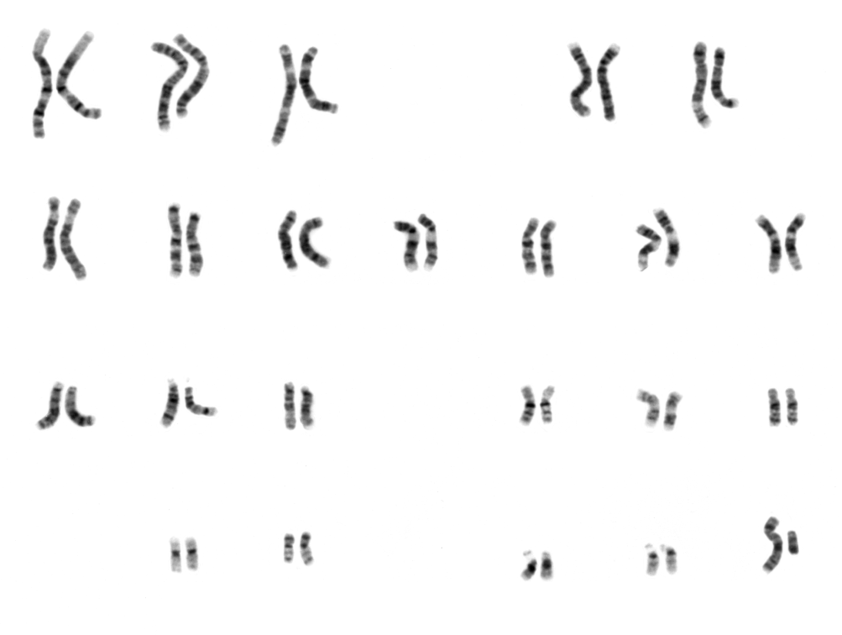
Giemsa Banding
R (reverse)-banding: R-banding is just the reverse of G-banding pattern in that the lightly stained G-bands become darkly stained in R-banding and vice-versa. Here the chromosomes are incubated in phosphate (1M) buffer at 86-87⁰C at pH of 6.5 for 10 minutes, rinsed in water and stained with Giemsa stain. R band DNA is relatively G:C rich and contain more transcriptionally active genes.
G-bands and Q-bands have less number of active genes due to less histone acetylation and are more heterochromatic than R-bands. R-bands have more transcriptionally active genes (euchromatic) due to histone acetylation.
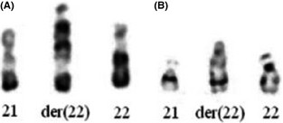

R-banding (A) and G-banding (B) of chromosomes 21, 22, and the derivative chromosome 22

Constitutive heterochromatin banding (C-banding): a modification of in situ hybridization technique. It generally stains all constitutive heterochromatic regions such as centromere region, NOR region and Telomeres. Heterochromatic regions are condensed throughout cell cycle with genes remain in inactive state and contains highly repetitive DNA. In C-banding technique the chromosomes are treated with hot alkali, or hot saline followed by staining with Geimsa. 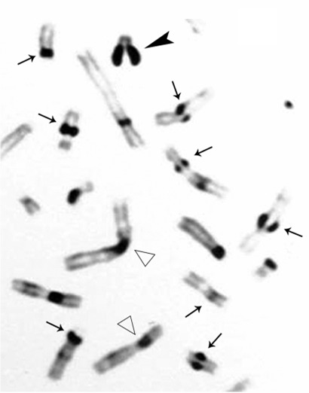
C-banding of metaphase chromosomes. Arrows show selected chromosomes with premature centromere separation. Large arrowhead points to "splitting" of the Y chromosome heterochromatic region. Open arrows show selected chromosomes with normal C-banded regions.

N-banding: Unlike C-banding that stains all herechromatic regions, N-banding stains specifically nucleolus organizers (NORs) in chromosomes. These nucleolus organizer region have rRNA genes.
Miscellaneous Bands
T-banding: Giemsa staining at higher temperatures such as 87⁰C and at pH of 6.7 will r
esult in staining of terminal regions of chromosomes (that is, telomeres).

Chromosomal DNA content and C value Paradox
Nuclear DNA content is usually determined by Vicker’s integrating microdensitometer. This machine determines nuclear DNA automatically through the use of Feulgen stained squashed root tip cells. In recent years flow cytometry has been successfully used to determine nuclear DNA content using an appropriate fluorescent dye like ethidium bromide and olivomycin. In flow cytometer, DNA from several hundred nuclei can be measured within a second. The data obtained is subjected to statistical analysis using a computer device in order to obtain correct nuclear DNA measurements.
C-value: the amount of DNA (in pico grams) carried in haploid cells. C-values may show large differences in related eukaryotic species. For example, the haploid DNA content in man is 3.2 picogram DNA per haploid genome; Protozoa (Tetrahymena pyriformis): 13.6 pg DNA per haploid genome; Maize: 7.5 picogram DNA per haploid genome, Tobacco: 1.2 picogram DNA per haploid genome. Substantial variation in the nuclear DNA content also exists even between closely related species. For instance Bacteria: 0.0016 to 0.011pgDNAper haploid genome; Phages: 2.8 to 46.7 pg DNA per haploid genome10⁻⁶pg to 10⁻⁵pg DNA per haploid genome; yeast: 0.245 pg DNA per haploid genome.
The genome size does not uniformly increase with respect to perceived complexity of organisms, for example some Amphibians have more than 10-fold more DNA than do Mammals, including humans. There exists a large variation in C-values between related eukaryotic species and also among closely related species. Moreover, the amount of genomic DNA in complex eukaryotes is much greater than the amount needed to encode proteins. This is termed as C-value paradox. C-value paradox probably arises from varying amounts of noncoding DNA such as constitutive heterochromatic regions (repetitive DNA), introns in genes, regulatory elements of genes, pseudogenes, multiple copies of genes (gene duplication), polyploidy in amphibians, intergenic sequences.
.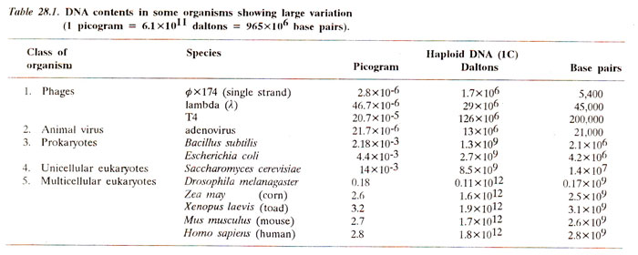DNA content (Genome size) and Adaptability
Correlations of nuclear DNA content with either the altitude or the latitude have been worked out. For instance adaptation to higher altitude has been shown be correlated with higher DNA content in maize. Similarly in maize, a negative correlation of nuclear DNA content with latitude (lower DNA content at higher latitudes) has been observed. In terms of latitude, the 4C DNA in maize varies about 40% at intraspecific level. At higher latitude 4C DNA content in maize is 9.9 pg and at lower latitude the 4C DNA content it is 13.5 pg, a variation of about 40% in DNA content with latitude.
Note:DNA is measure in PICOGRAM (pg). 4C refers to two homolog chromosomes (diploid) consisting each of two sister chromatids as seen in S-phase of interphase. 2C refers to two homolog chromosomes that are un-replicated and hence each chromosome with single chromatid as seen in Telophase of mitosis.

Split genes: Genes in eukaryotes such as mammals, birds and amphibians has intervening sequences (non-coding) which are not represented in mRNA transcribed from the gene. Such genes (that is, bit of genomic DNA) with intervening sequences were called split genes. Philip Sharp and Richard Roberts won Nobel Prize for medicine for their work on split genes. They analysed the hybrids of mRNA with corresponding genomic DNA in adenovirus. When mRNA-DNA hybrids were analyzed in electron microscope, mRNA was found to hybridize with discontinuous stretches of genomic DNA of adenovirus. The intervening sequences called introns were observed as loop and the phenomenon was later described as R-looping. The number of loops correspond to number of introns.
In a given gene, mRNA that is transcribed first is called primary transcript or heterogenous nuclear RNA (hnRNA). The primary transcript has both coding sequences (Exons) and non-coding intervening sequences (Introns). Later introns from the primary transcript were removed by a process called splicing and only exon sequences were joined together in correct order to give the ultimate product called mRNA (messanger RNA). The term introns and exons were used by Gilbert for the first time. Later Chambon proposed GT-AG rule that denote sequences at the boundaries of introns (that is at intron-exon junctions). GT always seen at 5’ side of the intron (left splice junction) and AG at 3’ side (right splice junction).

Structure of chicken ovalbumin split gene
The structure of ovalbumin gene in chicken has been studied in considerable detail and it has been found that in the split gene of ovalbumin there are eight exons and seven introns (Figs. 29.7 and 29.8). The size of ovalbumin gene has been shown to be 7,700 base pairs although the mature mRNA for ovalbumin is only 1,872 nucleotides. It has also been shown, that entire ovalbumin gene having 7,700 base pairs is first transcribed to a precursor RNA to which a cap consisting of 7mG (7 methyl guanosine) is added at the 5' end and poly A tail is added at 3' end. After the addition of cap and tail, the introns are excised, perhaps in two instalments, five introns being excised in the first step and the remaining two in second step. The exons produced due to splicing are then joined with the help of enzyme ligase to produce the mature mRNA of ovalbumin gene.
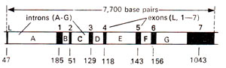
Fig. 29.8. Schematic representation of ovalbumin gene showing 7 introns (A-G) and 8 exons (L, 1-7); number of base pairs in each exon are also given.

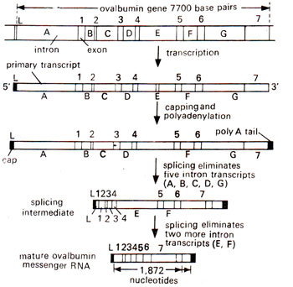
Fig. 29.9. Steps involved in the production of ovalbumin mRNA (1872 nucleotides long) from ovalbumin gene (7700 base pairs long); introns (A-G) and exons (L, 1-7).

When mRNA from chicken ovalbumin gene was hybridized with single stranded genomic DNA, seven distinct loops of DNA at specific sites were observed under electron microscope. This DNA forming loop was missing in mRNA suggesting genomic DNA but not mRNA had intervening sequences. These loops correspond to Introns in genomic DNA and are not represented in mRNA.
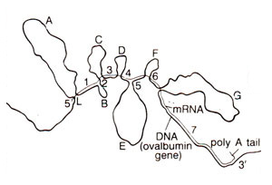
Fig. 29.7. The map of electron micrograph prepared after hybridizing mRNA (thin line) of the ovalbumin gene with its single stranded DNA (thick line). The loops A-G represent 7 different introns and segments L and 1-7 represent 8 exons.

R-loop mapping of interrupted genes
R-loop mapping is a technique in which mRNA is hybridized with double stranded DNA under conditions in which RNA-DNA hybrid is more stable than the DNA duplex. When ds DNA segment belonging to an interrupted gene is used for hybridization with mRNA, the intervening sequence or intron region loops out as double stranded DNA and the exon region loops out as single stranded DNA loops as shown in Figure 29.3. The double stranded DNA loop will appear at the junction of two single stranded loops produced due to displacement by mRNA. These loops can be observed under the electron microscope as has been done for mouse minor β-globin gene showing single intron. This technique is comparable to the hybridization of mRNA with single stranded DNA described earlier.
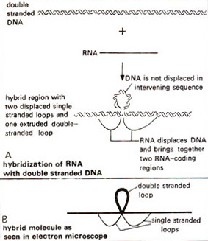

Fig. 29.3. R-looping, where mRNA is hybridized with double stranded DNA (note the double stranded thick loop showing intron region and single stranded thin loops representing the exons).

SPECIAL TYPES OF CHROMOSOMES
Some tissues of certain organisms contain chromosomes which differ significantly from normal chromosomes in terms of either morphology or function. Such chromosomes are referred to as special chromosomes. The following are included under this category:
1. Giant chromosomes or polytene chromosomes: These were first discovered by E. G. Balbiani in 1882 in Dipteran salivary glands and hence commonly called salivary gland
chromosomes. The giant chromosomes represent bundle of fibrils which arise by repeated cycles of endo-reduplication of single chromatids. These chromosomes replicate repeatedly without cell division and the number of chromonemata (fibrils) keeps on increasing. This phenomenon is known as endomitosis or endoreduplication. Endoreduplication results in the formation of many stranded giant chromosomes known as polytene chromosomes and the condition is known as polyteny. Their size is 200 times or more than the normal somatic chromosomes (autosomes) and very thick. Hence they are known as giant chromosomes. The homologous chromosomes are continuously paired in the somatic cells.
The polytene chromosome contains two types of bands, dark bands and interbands. The dark bands are darkly stained as it contain more DNA and the inter bands are lightly stained with nuclear stains. The dark bands also called chromomeres. The uncoiling of individual chromomeres in a band causes swelling of bands at certain times to form puffs and exceptionally large puffs are known as balbiani rings. Puffs are the sites of active RNA synthesis. The formation of puffs is called puffing.

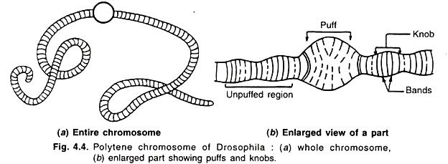

2. Lamp brush chromosomes: These were first observed by W. Flemming in 1882 and were described in detail in oocytes of sharks by Rukert in 1892. They occur at diplotene stage of meiotic prophase in oocytes of all animal species. Since they are found in meiotic prophase, they are present in the form of bivalents in which the maternal and paternal chromosomes are held together by chiasmata at those sites where crossing over has previously occurred. Each bivalent has four chromatids, two in each homologue. The axis of each homologue consists of a row of granules or chromomeres, each of which have two loop like lateral extensions, one for each chromatid. Thus each loop represents one chromatid of a chromosome and is composed of one DNA double helix. One end of each loop is thinner than the other which is known as thick end. There is extensive RNA synthesis at thin ends of the loop while there is little or no RNA synthesis at the thick ends.
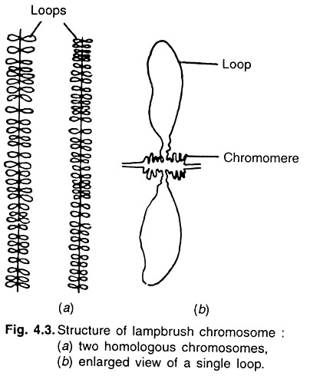
3. Accessory chromosomes: The normal members of chromosome complements are known as A chromosomes. Some species possess extra chromosomes which are not members of normal chromosome complements. These are called as B chromosomes or supernumerary chromosomes or accessory or extra chromosomes. The following are the characteristics of B-Chromoosmes:
1. These chromosomes are generally smaller in size than the normal somatic complement. B chromosomes are believed to originate from A chromosomes.
2. Breakage of A chromosome and subsequent hetero chromatization leads to formation of B chromosomes. However they are genetically inert, but may not be completely devoid of genes.
3. They are non-homologous with any of the basic A chromosomes.
4. When present in high number, they reduce vigour and fertility.
5. Their inheritance is non-mandelian.
Effects of B-Chromosomes:
In maize, B chromosomes lead to:
(i) Reduction in vigour,
(ii) Production of defective seeds with partially developed endosperm, and
(iii) Increase in the percentage of abortive pollens.
The B chromosomes were first reported in maize and later on in some other species.

4. Isochromosomes: An isochromosome is the one in which two arms are identical with each other in gene content and morphology. In other words, both the arms are mirror images of one another. Every isochromosome is metacentric. The attached ‘x’ chromosome of Drosophila is a classical example of an isochromosome. Isochromosomes can be created in meiosis and mitosis by misdivision of centromere.

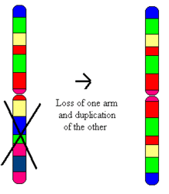
Fig: Isochromosome in which the arms are mirror copies of each other.

5. Allosomes / sex chromosomes: Chromosomes differing in morphology and number in male and female are called allosomes. They are responsible for determination of sex. Eg: X and Y chromosomes in human beings and Drosophila. Chromosomes which have no relation with determination of sex and contain genes which determine somatic characters of individuals are
called autosomes and are represented by letter ‘A’.

UNIT ll

Cell cycle (Interphase and Mitosis) can be defined as the entire sequence of events happening from the end of one nuclear division to the beginning of the next. Howard and Pelc (1953) have divided cell cycle into four phases or stages : G1, S, G2 and M
phase. The G1 phase, S phase and G2 phase are combined to from the classical interphase.

The cell cycle
(Interphase and the mitotic phase)
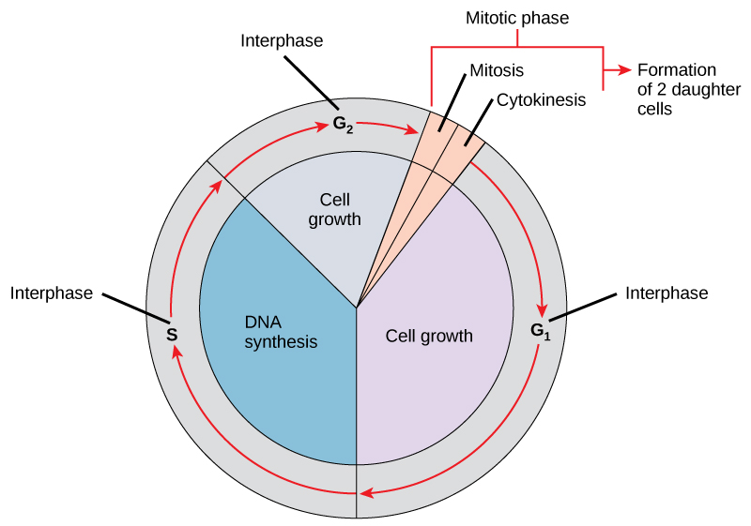
1. G1 Phase. After the M phase of previous cell cycle, the daughter cells begin G1 of interphase of new cell cycle. G1 is a First gap phase or resting phase. It is called first gap phase, since no DNA synthesis takes place during this stage; currently, G1 is also called first growth phase, since it involves synthesis of RNA, proteins and membranes which leads to the growth of nucleus and cytoplasm of each daughter cell towards their mature size. Thus, G1 involves transcription of three types of RNAs, namely rRNA, tRNA and mRNA ; rRNA synthesis is indicated by the appearance of nucleolus in the interphase (G1 phase) nucleus. Proteins synthesized during G1 phase (1) regulatory proteins which control various events of mitosis ; (2) enzymes (e.g., DNA polymerase) necessary for DNA synthesis of the next stage ; and (3) tubulin and other mitotic apparatus proteins.

2. S phase. During the S phase or synthetic phase of interphase, replication of DNA and synthesis of histone proteins occur. New histones are required in massive amounts immediately at the beginning of the S period of DNA synthesis to provide the new DNA with nucleosomes. Thus, at the end of S phase, each chromosome has two DNA molecules and a duplicate set of genes.

3. G2 phase. This is a second gap or growth phase or resting phase of interphase. During G2 phase, synthesis of RNA and proteins continues which is required for cell growth. As the G2 phase draws to a close, the cell enters the M phase.

Division of nucleus is called as karyokinesis and division of cytoplasm is called cytokinesis.
The cell division is of two types. 1) Mitosis and 2) Meiosis
MITOSIS: The term mitosis was coined by Flemming in 1882. Mitosis occurs in somatic organs like root tip, stem tip and leaf base etc. Hence it is also known as somatic cell division. The daughter cells are similar to the mother cell in shape, size and chromosome complement. Since the chromosome number is same in the daughter cells as compared to that of mother cell, this is also known as homotypic or equational division. Mitotic cell cycle includes the following stages: Interphase: This is the period between two successive divisions. Cells in interphase are characterized by deeply stained nucleus that shows a definite number of nucleoli. The chromosomes are not individually distinguishable but appear as extremely thin coiled threads forming a faintly staining network. The cell is quite active metabolically during interphase.
Mitosis consist of four stage, viz.,
(a) Prophase, (b) Metaphase, (c) Anaphase and (d) Telophase
a) Prophase: This is the longest phase in mitosis. The nucleus takes a dark colour with nuclear specific stains and also with acetocarmine / orcein. The size of the nucleus is comparatively big and the chromosomes that are thin thread and uncoiled in the initial stages slowly thicken and shorten by a specific process of coiling called relational coiling. An important feature of prophase is that the two chromatids of each chromosome are held at centromere and can be seen under light microscope. The nuclear membrane and nucleolus disintegrates at the end of prophase and before the cell enters into metaphase.
b) Metaphase: After the disintegration of nuclear membrane in prophase, the sphindle fibres are formed and the centromere of each chromosome is arranged on the equatorial plate. The chromosomes remain attached to sphindle fibres at the centromere. This type of orientation of centromeres on the equator is known as auto- orientation. The chromosomes at this stage are shortest and thickest. Hence, chromosomes are clearly visible in metaphase. The chromatids of a chromosome are held together at the point of centromeres and the relational coils are at its minimum.
c) Anaphase: The centromere of each chromosome separates first and the sister chromatids or daughter chromosomes of each chromosome moves towards opposite poles due to contraction of sphindle fibres. Depending on the position of the centromeres (metacentric, acrocentric and telocentric), the chromosomes show ` V `, ` L ` and ` I ` shapes respectively as the anaphase progresses. The chromosome number is constant but the quantity of each chromosome is reduced to half.
d) Telophase: spindle fibres disintegrate. Chromosomes loose their identity and become a mass of chromatin. The nucleus along with nucleoli will be re-organized at each pole. The division of one nucleus into two is known as Karyokinesis. Karyokinesis is followed by cytokinesis. Cytokinesis: It is the division of cytoplasm that usually occurs between late anaphase and end of telophase. In plants, cytokinesis takes place through the formation of cell plate by golgi apparatus, which begins in the centre of the cell and moves towards the periphery in both sides dividing the cytoplasm into two daughter cells. In animal cells, cytokinesis occurs by furrowing of plasmalemma in the equatorial region.
Significance of Mitosis: Mitosis plays an important role in the life of living organisms in various ways as given below:
1. Mitosis is responsible for development of a zygote into adult organism after the fusion of male and female gametes.
2. Mitosis is essential for normal growth and development of living organisms. It gives a definite shape to a specific organism.
3. In plants, mitosis leads to formation of new organs like roots, leaves, stems and branches. It also helps in repairing of damaged parts.
4. In animals, mitosis acts as a repair mechanism wherein old, dead and decayed cells are replaced with new ones, such as gut epithelium and blood cells
6. Mitosis is useful in maintaining the genetic purity because it does not allow segregation and recombination to occur. Hence daughter cells are genetically identical to parental ones. This concept forms the basis in asexual propagation of vegetatively propagated crops like sugarcane, banana, sweet potato, potato, etc. as mitosis leads to production of identical progeny in such crops.
Note: In plectonemic coiling as seen in mitotic prophase only, the two sister chromatids are wrapped around each other in a helix. The two chromatids cannot separate until uncoiling is completed. In paranemic coiling (as in parallel) of meiotic prophase the two strands simply lie alongside one another, making them easier to pull apart.
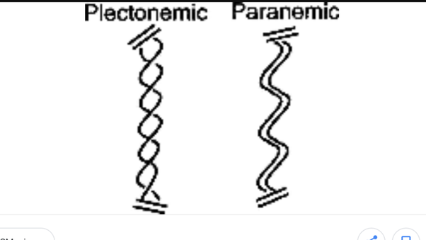
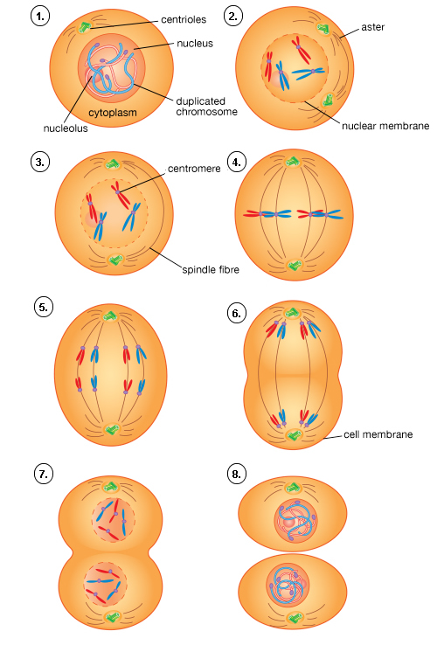
Mitosis
1.Interphase
2: Early Prophase
3. Late Prophase
4. Metapahase
5. Early Anaphase
6. Late Anaphase
7. Telophase
8. Daughter cell Identical
1.Interphase 2: Early Prophase 3. Late Prophase 4. Metapahase
5. Early Anaphase 6. Late Anaphase 7. Telophase 8. Daughter cell Identical

MEIOSIS
The term meiosis was coined by J.B. Farmer in 1905. This type of division is found in organisms in which there is sexual reproduction. The term has been derived from Greek word; Meioum = diminish or reduce. The cells that undergo meiosis are called meiocytes. Three important processes that occur during meiosis are:
1. Pairing of homologous chromosomes (synapsis) at Zygotene of Prophase-I
2. Formation of chiasmata and crossing over at Pachytene of Prophase-I
3. Segregation of homologous chromosomes (or separation of alleles) at Anapahse-I
Both crossing over and segregation contribute to genetic recombination (that is, new gene combination). The first division of meiosis results in reduction of chromosome number to half and is called reduction division. The first meiotic division is also called heterotypic division. Two haploid cells are produced at the end of first meiotic division and in the second meiotic division, the haploid cells divide mitotically and results in the production of four daughter cells (tetrad), each with haploid number of chromosomes. In a tetrad, two daughter cells will be of parental types and the remaining two will be recombinant types. The second meiotic division is also known as homotypic division. Both the meiotic divisions occur continuously and each includes the usual stages viz., prophase, metaphase, anaphase and telophase. Meiotic cell cycle involves the following stages: Interphase: Meiosis starts after an interphase which is not very different from that of an intermitotic interphase. During the premeiotic interphase DNA duplication occurs during the S phase I.
Meiosis-I:
(1) Prophase-I: It is of a very long duration and is also very complex. It has been divided into the following sub-stages:
a) Leptotene or Leptonema: Chromosomes at this stage appear as thin thread like structures that are loosely interwoven like a loose ball of wool. In some species, on these chromosomes, bead-like structures called chromomeres are found all along the length of the chromosomes.
b) Zygotene or Zygonema: It is characterized by pairing of homologous chromosomes (synapsis), which form bivalents. Pairing of homologous chromosomes takes place at one region only but not throughout their length and this pairing occurs in a zipper-like fashion. The paired homologous chromosomes are joined by a protein containing frame work known as synaptonemal complex.
c) Pachytene or Pachynema: The chromosomes appear as bivalents. Each bivalent consists of four chromatids and is called a tetrad. At this stage, exchange of segments between non-sister chromatids of homologous chromosomes known as crossing over occurs. During crossing over, only one chromatid from each of the two homologous chromosomes takes part. The nucleolus still persists.
d) Diplotene or Diplonema: At this stage further thickening and shortening of chromosomes takes place. Homologous chromosomes start separating from one another. Separation starts at the centromere and travels towards the ends (terminalization). Homologous chromosomes are held together only at certain points along the length. Such points of contact are known as chiasmata and are the resultant of crossing over. The process of terminalization is completed at this stage.
e) Diakinesis: Chromosomes continue to undergo further contraction or condensation. Due to further contraction, the bivalents appear as round darkly stained bodies (with acetocarmine) and they are evenly distributed throughout the cell. The nuclear membrane and nucleolus disappear.
2) Metaphase-I: The sphindle apparatus gradually organizes. The bivalent are attached to the spindle fibres through the centromeres. The centromeres of the bivalents are arranged on either side of the equator and this type of orientation is called co-orientation.
3) Anaphase-I: From each bivalent, one chromosome (having two sister chromatids) move to opposite poles (disjunction). The centromere is the first to move to the pole. Since the two sister chromatids in a bivalent move to same pole, meiosis is called reductional division. Each pole now has a haploid number of chromosomes. Hence separation of homologous chromosomes (separation of alleles) occurs in this phase.
4) Telophase-I: Nuclear membranes are formed around the groups of chromosomes at the two poles. The nucleus and nucleolus are re- organized. First meiotic division is followed by second meiotic division (Meiosis-II is essentially mitosis) with or without an intervening interphase. Hence each meiotic division involves two karyokinesis and one cytokinesis.
II. Meiosis-II: The second meiotic division is similar to the mitotic division and it includes the following four stages:
1) Prophase-II: The chromosomes having two sister chromatids condense again. The nucleolus and nuclear membrane disappear.
2) Metaphase-II: Spindle fibres appear and the chromosomes get arranged on the equatorial plane (auto-orientation). This plane is at right angle to the equatorial plane of the first meiotic division.
3) Anaphase-II: Each centromere divides longitudinally and the two sister chromtids or daughter chromosomes moves towards the opposite poles.
4) Telophase-II: The chromatids move to the opposite poles The nuclear envelope and the nucleolus reappears. Thus at each pole, there is re- organization of haploid nucleus. Cytokinesis: The division of cytoplasm takes place by cell plate method in plants and by furrow method in animals. The cytokinesis may take place after meiosis I and meiosis II separately or sometimes may take place at the end of meiosis II only.
Significance of Meiosis: Meiosis plays a very important role in the biological populations in various ways as given below:
1. Meiosis results in production of gametes with haploid (half) chromosome number. Union of male and female gametes leads to formation of zygote which receives half chromosome number from male gamete and half from the female gamete and thus the original somatic chromosome number (diploid condition) is restored. Thus meiosis helps in maintaining constant chromosome number from one generation to another in a given species.
2. Meiosis facilitates segregation and independent assortment of chromosomes and genes.
3. It provides an opportunity for the exchange of genes through the process of crossing over. Recombination of genes results in generation of variability in a biological population which is important from evolution points of view.
4. In sexually reproducing species, meiosis is essential for alternation of generation. Because meiosis results in the formation of male and female gametes that are haploid and union of such haploid gametes leads to the development of diploid zygote and thereby new individual. This haploid phase is followed by diploid phase and is also called as.

Differences between Mitosis and Meiosis

Mitosis | Meiosis
1. Consists of one nuclear division and one cytokinesis | 1. Consists of two nuclear divisions and one cytokinesis.
2. One cell cycle results in production of two daughter cells that are identical with parent cell in structure and chromosome composition | 2. One cell cycle results in production of four daughter cells. Daughter cells are different from parent mother cell in chromosome number and composition
3. The chromosome number of daughter cells is the same as that of Parent cell (2n) | 3. Daughter cells contain half the  chromosome number of parent cell (n)
5. It occurs in somatic cells | 5. It occurs in reproductive cells
6. Total DNA of nucleus replicates  during S phase | 6. About 0.3% of the DNA is not  replicated during S phase and it occurs  during the zygotene stage.
7. The prophase is not divided into sub stages | 7. The prophase I is divided into five sub  stages
8. There is no pairing between  homologous chromosomes | 8. Homologous chromosomes pair during pachytene (Synapsis)
9. Segregation and recombination do  not occur | 9. Crossing over takes place during  pachytene
10. Chromosomes are in the form of dyad at metaphase | 10. Chromosomes are in the form of tetrad at metaphase-I
11. The centromeres of all the  chromosomes lie on the equatorial  plate (auto orientation) during  metaphase | 11. The centromeres of all the  chromosomes lie on either side of the  equatorial plate (co-orientation) during  metaphase I
12. At metaphase, centromere of each  chromosome divides longitudinally | 12. The centromere does not divide at  metaphase I
13. Sister chromatids of each chromosome separate and move to opposite pole during  anaphase | 13. Sister chromatids of each chromosome donot separate and goes move to the same pole during during the anaphase I
14. Maintains genetic purity due to lack of  segregation and recombination as observed in asexual method of reproduction. | 14. Generates variability due to  segregation and recombination as seen in sexual method of reproduction.
15. Helps in multiplication of cells | 15. Helps in alternation of generation

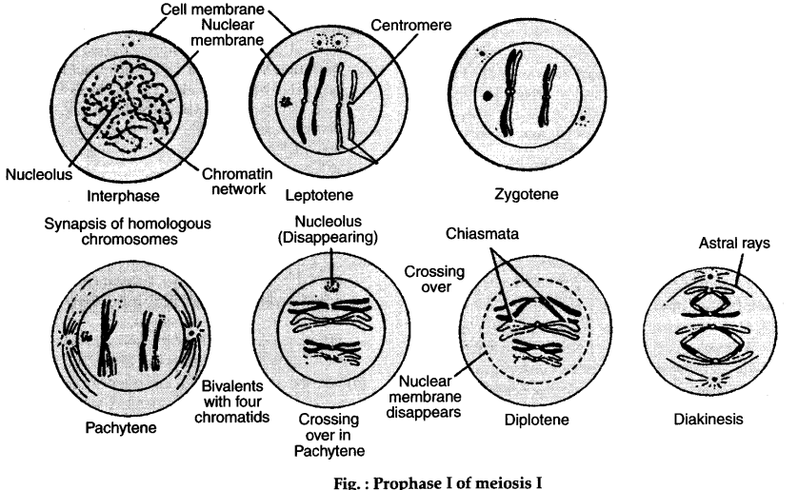

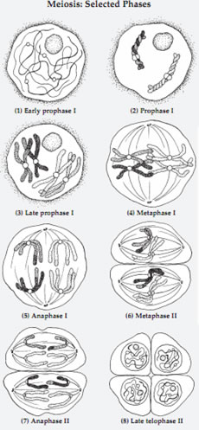

Crossing Over on the Chromosomes: Mechanisms and Theories
Crossing over is the process of exchange of genetic material or segments between non-sister chromatids of two homologous chromosomes. Crossing over occurs due to the interchange of sections of homologous chromosomes in pachytene stage of prophase-1. Crossing over takes place at the four-chromatid or tetrad stage of meiosis. Crossing over was described, in theory, by Thomas Hunt Morgan.
Mechanisms of Crossing Over on the Chromosomes

Stages-Mechanism of Crossing-Over
Mechanism or process of crossing-over includes following stages.
- Synapsis
- Duplication of Chromosomes
- Actual Crossing Over (Break and Exchange)
- Terminalization
(i) Synapsis: The homologous chromosomes pair lengthwise due to a force of mutual attraction in zygotine of prophase-I in meiosis. The pairing starts at one or more points and proceeds along the whole length in a zipper fashion. The process of pairing is called synapsis. The paired homologous chromosomes are called bivalents. During synapsis, a molecular scaffold called synaptonemal complex aligns the DNA molecule of two homologous chromosomes side by side. The synaptonemal complex (SC) is a protein structure that forms between homologous chromosomes (two pairs of sister chromatids) during meiosis and is thought to mediate chromosome pairing (synapsis), and crossing over. The synaptonemal complex is a tripartite structure consisting of two parallel lateral regions and a central element.
Three specific components of the synaptonemal complex have been characterized: SC protein-1 (SYCP1), SC protein-2 (SYCP2), and SC protein-3 (SYCP3). The synaptonemal complex was described by Montrose J. Moses in 1956 in primary spermatocytes of crayfish and by D. Fawcett in spermatocytes of pigeon, cat and man.
(ii) Duplication of chromosomes:
Synapsis is followed by the duplication of chromosomes which changes the bivalent nature of chromosome to four- stranded stage or tetrad. Four stranded stage (Fig. 5.48) of chromatids occurs due to splitting of homologous chromosomes into sister chromatids attached with un-splitted centromeres.
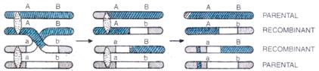
5.48. Crossing over at 4-stranded stage results in 50% recombinant and 50% parental types of gametes.
(iii) Crossing-over: Basic principle is breakage and union. During pachytene stage, recombination nodule becomes visible. The two non-sister chromatids first break at corresponding points. Enzyme endonuclease facilitates the process. Segment on one side of each break connect with a segment on the opposite side of the break, such that two chromatids cross each other. Replication of the remaining 0.3% DNA occurs at this stage, to fill the gap. Ligase is the enzyme for fusion process. The non-sister chromatids get connected with each other at points known as chiasmata. More the physical distance between genes situated on chromosome, greater the probability of chaisma to occur between them. Important to note, in a species, each chromosome has a characteristic number of chaismata.
During diakinesis of prophase-I chiasmata move towards the end of bivalent by a process called terminalization. At the end of terminalization homologous chromosomes are separated completely and move to opposite poles in Anaphase I. The crossing over thus brings about alteration of the linear sequence of gene in chromosomes and thus add new gene combination (recombination) in progeny. Out of 4 gametes formed in meiosis, two will be of recombinant types and two will be of parental types. This is because only two out of four non-sister chromatids in a tetrad participates in crossing over. Hence, Maximum frequency of crossing over is 50%.
Theories about mechanism of Crossing Over

The following points highlight the four main theories proposed for the mechanism of crossing over. The theories or hypothesis are:

1 Partial Chiasma Type Theory

2. Belling’s Hypothesis

3. Copy-Choice Hypothesis.

4. Breakage and reunion theory

Theory # 1.Partial Chiasma Type Theory:
This theory was originally proposed by Janssens is 1909 and 1924 and was elaborated upon and supported by Darlington in 1934, 1935 and by other workers. According to this theory, first, breakage occurs which is then followed by reciprocal reunion of the segments of non-sister chromatids; this results in exchange of chromatid segments or crossing over.
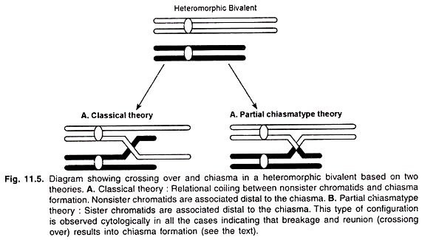
At the diplotene, the homologues are associated by the chiasmata which are the direct result of crossing over and are formed exactly at the points where the exchanges of non-sister chromatids have taken place (Fig. 11.4), At any given point, crossing over occurs between two of the four chromatids, but 3- and 4-strand double crossing overs are also possible in any given region.
The partial chiasma type theory was strengthened by the work of Brown and Zohary in 1955. They used a special stock of Liliumformosanum in which one arm of a chromosome had a large deficiency, while its homologue was normal; pairing of these homologues during meiosis formed a heteromorphic bivalent.
In this bivalent, the arm having the large deficiency never formed more than one chiasma; the sister chromatids were also associated distal to the chiasma and such a configuration indicates breakage and reunion between non sister chromatids.
In chiasmatype theory, each chiasmata represents one prior genetic crossing over, there would be one to one relationship between the chiasmata and crossing over. There was a close correspondence between the frequencies of observed chiasmata and the frequencies of crossing over.

Theory # 2. Belling’s Hypothesis: This theory was proposed by Belling in 1931 and 1933. This hypothesis assumes that chromosome replication takes place during pachytene. According to this theory, crossing over is the result of an exchange between new chromatids while they are being synthesized. He considered that the synthesis of new chromomeres occured first alongside the preexisting chromomeres and that the inter-chromomeric regions were synthesized subsequently.

If during the synthesis of inter-chromomeric region relational coil existed between the

homologues, the inter-chromomeric fibres could join non sister chromomeres (Fig. 11.6). Such a joining would produce crossing over/crossover chromatids. This theory rules out 3- and 4-strand double crossing over.
However, this theory is not completely satisfactory because:
(i) There is no evidence of chromosome replication in two phases,
(ii) The genetic material (DNA) has a continuous linear organization,
iii) DNA synthesis (replication) occurs in interphase. A very small amount of DNA is synthesized during zygotene-pachytene at the time of crossing over,
(iv) Chromosomes at pachytene already consist of two sister chromatids which were synthesized during the interphase.

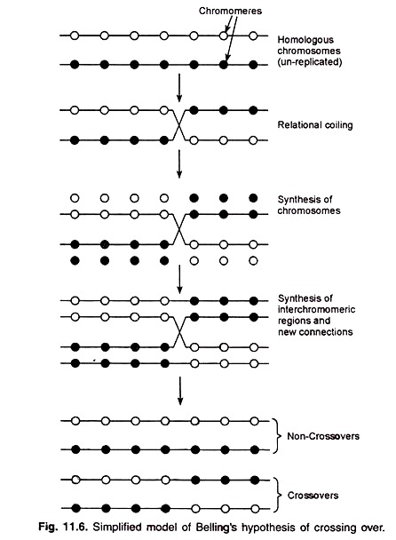

Theory # 3.Copy-Choice Hypothesis:This hypothesis was formulated by Lederberg in 1955; it assumes that recombination occurs during chromosome (DNA) replication. It is postulated that during DNA replication, the new strand is synthesized using one chromosome as template up to some point at which the homologous chromosome begins to be used as template.
This hypothesis is also known as the complete-copy- choice theory. Thus the entire recombinant chromatid arises from newly synthesized sections. For instance, if two linked genes, say a and b, are present in one chromosome and their alleles, A and B, are in its homologue they could be recombined as Ab and aB through complete copy choice (Fig. 11.7).
The complete copy choice also explains some aberrant microbial recombination data, such as, “nonreciprocal recombination.”
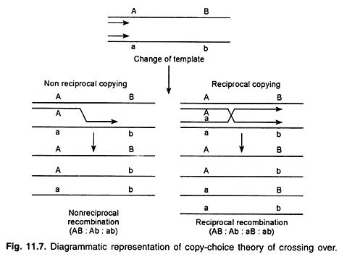
The copy-choice hypothesis holds that crossing over occurs as synthetic error during S phase (DNA replication phase). But there are reports where recombination occurs in the absence of DNA replication, e.g., in the virus Lambda (A.) of E. coli. Similarly, it has been found that crossing over occurs more than one week after the completion of DNA replication in Schistocerca.
This theory has two objections:
1. According to this theory breakage and reunion does not occur, while it has been observed cytological.
2. Generally crossing over takes place after DNA replication but here it takes place at the same time.
ii. Breakage and Reunion Theory: Most accepted theory. Proposed by Darlington. Prior to crossing over each chromosome of each bivalent get duplicated to form tetrad.This theory states that crossing over takes place due to breakage and reunion of non-sister chromatids in pachytene stage. Crossing over involves the mechanical breaks in non-sister chromatids due to twisting around each other and reunion of chromatids takes place. According to this theory first of all, chromatids break and then form chiasmata. Chiasmata results in crossing over.
If the union takes place between sisters chromatid parts (i.e., paternal to paternal and maternal to maternal) no genetic consequence is anticipated. However, if the break and reunion occur between non- sister chromatids (i.e., paternal to maternal or vice versa) recombinants would result. This hypothesis represents the best explanation to date to account for the formation of recombinants. Diagrams showing the stages involved in this hypothesis are given in (Fig. 16.5).
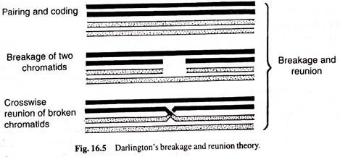

UNIT III

Holliday model- a general model of recombinationm
Holliday model explains the general mechanism of recombination. The key features of the Holliday model are the formation of heteroduplexDNA; the creation of a cross bridge; its migration along the two heteroduplex strands, termed branch migration; the occurrence of mismatch repair; and the subsequent resolution, or splicing, of the intermediate structure to yield different types of recombinant molecules. The model is depicted in the figure below.
- Enzymatic cleavage and the creation of heteroduplex DNA:Looking at the figure, we can see that two homologous double helices are aligned, althoughthe bottom strand of the first helix has the same polarity as the top strand of the second helix (5′ → 3′ in this case). Then a nuclease cleaves the two strands that have the same polarity (Figure). The free ends leave their original complementary strands and the nicked ends dissociate from their complementary strands and each single strand invades the other duplex. This occurs in a reciprocal manner to produce a heteroduplex region derived from one strand from each parental duplex. DNA ligase seals the nicks. The result is a stable joint molecule, in which one strand of each parental duplex crosses over into the other duplex.This X-shaped joint is called a Holliday intermediate or Chi structure.

2) Branch migration: The Holliday structure creates a cross bridge, or branch, that can move, or migrate, along the twoheteroduplex strands (Figure). This phenomenon of branch migration is a distinctive property of the Holliday structure.
- Resolution of the Holliday structure: The Holliday structure after branch migration can be resolved by cutting and ligating the two originally exchanged strands generating a pair of duplexes that are parental, except for a stretch in the middle containing one strand from each parent(Figure, left after resolution step). If the two parents had different alleles in this stretch, as indicated here, then the DNA will be heteroduplex. In another instance the originally unexchanged strands (Figure, right) after resolution generates two duplexes that are recombinant, with a stretch of heteroduplex DNA. The Holliday model also postulated that the heteroduplex DNA mismatches can be repaired by an enzymatic correction system that recognizes mismatches and excises the mismatched base from one of the two strands, filling in the excised base with the correct complementary base. The resulting molecules will carry either the wild-type or the mutant allele, depending on which allele is excised.

Application of the Holliday model to genetic crosses: The Holliday model nicely explained the heteroduplex formation and Gene conversion during recombination.
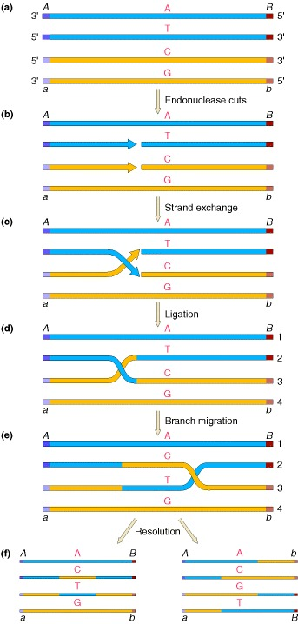

Figure: A prototype mechanism for genetic recombination.

Meselson-Radding model
The model proposed by Meselson and Radding (shown in Figure) generates the Holliday structure with one single-strand cut in only one chromosome (Figure), in contrast with the Holliday model, in which a nick is made in one strand in each of the two homologous chromososmes. This single-strand cut is followed by DNA synthesis (Figure). After the nick, the displaced single strand invades the second duplex (Figure), generating a loop, which is excised (Figure). After ligation to produce a Holliday structure, followed by branch migration(Figure), a heteroduplex is generated in each chromosome.

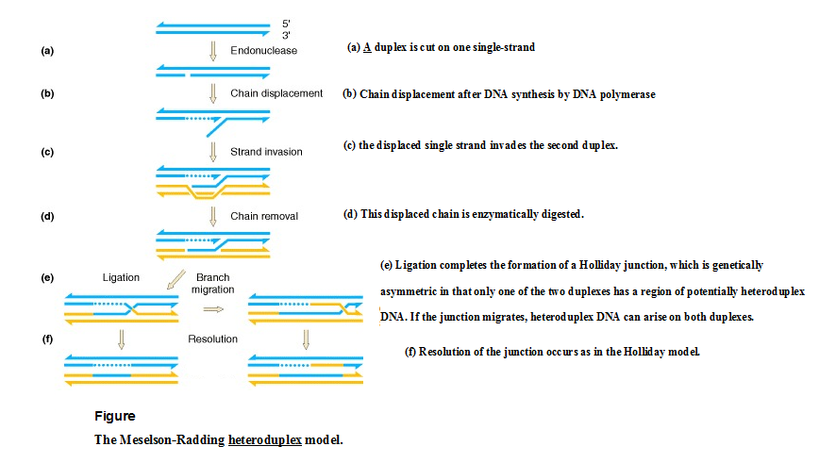
Double-Strand Break Repair Model (Szostak Model) for Recombination:In the Holliday and Meselson-Radding models for genetic recombination, the initiation events for recombination are single-strand nicks that result in the generation of heteroduplex DNA. However, the finding that yeast transformationis stimulated 1000-fold when a double-strand break is introduced into a circular donor plasmid provided the impetus for an additional model, the double-strand-break The key features of this model are diagrammed in the steps in Figure.
- An endonuclease cleaves both strands of one of the homologous DNA duplexes, shown as thin blue lines in Figure 8.9. This is the aggressor duplex, since it initiates the recombination.
- The cut is enlarged by an exonuclease to generate a gap with 3' single-stranded termini on the strands.
- One of the free 3' ends invades a homologous region on the other duplex (shown as thick red lines), called the donor duplex. The formation of heteroduplex also generates a D-loop(a displacement loop), in which one strand of the donor duplex is displaced.
- The D-loop is extended as a result of repair synthesis primed by the invading 3' end. The D-loop eventually gets large enough to cover the entire gap on the aggressor duplex, i.e. the one initially cleaved by the endonuclease.
- When the displaced strand from the donor (red) extends as far as the other side of the gap on the recipient (thin blue), it will anneal with the other 3' single stranded end at that end of the gap. The displaced strand has now filled the gap on the aggressor duplex, donating its sequence to the duplex that was initially cleaved. Repair synthesiscatalyzed by DNA polymerase converts the donor D-loop to duplex DNA. During steps 4 and 5, the duplex that was initially invaded serves as the donorduplex; i.e. it provides genetic information during this phase of repair synthesis. Conversely, the aggressor duplex is the recipient of genetic information.
- DNA ligase will seal the nicks, one on the left side of the diagram in Figure 8.9 and the other on the right side. In both cases, sealing the nick forms a Holliday junction.

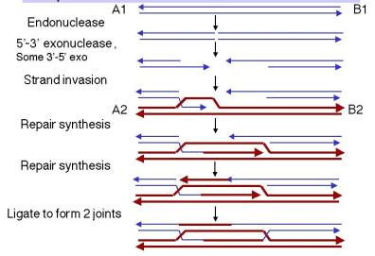

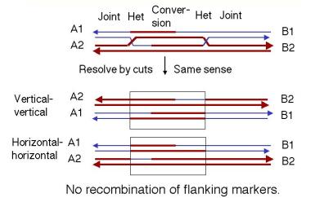

Cytogenetics is branch of biology devoted to the study of chromosomes and their
implications in genetics.
CHROMOSOMAL ABERRATIONS: Occasionally, spontaneous (without any known causal factor, Natural occurence) variations in the structure and number of chromosomes have been observed in nature. These variations are called chromosomal aberrations and can be due to either
(a) structural changes or (b) numerical changes.
Origin of structural aberration
Chromosomes are structures with definite organization. However, through various means they may be broken and their normal structure disrupted. X-rays, atomic radiations and various chemicals are among the agents that can cause breaks in chromosomes. Breaks also sometimes occur under natural conditions, where in most instances the reason for breakage is not known.
Structural chromosomal aberrations: Structural chromosomal changes include those
chromosomal aberrations which alter the chromosome structure i.e. the number of genes,
the sequence or kind of genes present in the chromosome(s) and do not involve a
change in chromosome number.
Types of structural chromosomal aberrations: These aberrations may be confined to
a single chromosome or more than one chromosome. Hence they are of two types.
1. Intra-chromosomal aberrations
2. Inter-chromosomal aberrations
I. Intra -chromosomal aberrations: When aberrations remain confined to a single chromosome of a homologous pair, they are called intra -chromosomal aberrations. Includes deletions, deficiency and inversions.
II. Inter-chromosomal aberrations: When aberrations occur in non-homologous chromosomes and the resulting fragments are inter-changed by both the nonhomologous chromosomes, they are known as inter-chromosomal aberrations. Ex: Translocations.
I. Intra-chromosomal aberrations: They may be of the following types :
1. Deletions or deficiencies: Deletion is due to the loss of a part of a chromosome. In a deletion, a chromosome lacks either a terminal or an interstitial segment which may include only a single gene or a part of a gene. Hence it is of two types.
i) Terminal deletion: If a break occurs near the end of chromosome and a small piece of terminal chromosome is lost, it is called terminal deletion.
ii) Interstitial or intercalary deletion: Sometimes two breaks may occur at any two points and the broken ends of the original chromosome get fused or reunited and as a result, an interstitial deletion is formed. The deleted fragment is acentric. Consequently the acentric fragment is immobile and will be lost during cell division.
Both types of deletions can be observed during pachytene stage of meiosis or in the polytene chromosomes. However, in majority of the cases, terminal deficiencies are more frequent than intercalary deletion because single breaks are required whereas intercalary deletions require two breaks.
Origin and occurrence of Deletions
- Production of deletions through irradiation (X rays and neutrons): Deficiencies can be artificially induced using radiations such as X-rays or fast neutrons. An effective way for artificial induction of deficiencies is achieved by irradiation of pollen used for pollination (as in tomato and Maize) or irradiation of developing seeds after pollination (as in Maize). Irradiation is an effective method because the deleted segment remains in the pollen or cell so that viability is not affected. X-rays mainly induce breaks in the heterochromatin region while fast neutrons induce breaks in the euchromatin region.
- Production of deficiency due to a gametocidal chromosome: Endo developed a genetic system for isolation of several deletion lines in common wheat. A monosomic alien addition lines in wheat were produced by backcross programme involving Aegilops cylindrica that provides a gametocidal chromosome. This Aegilops cylindrica chromosome induces terminal deletions of chromosomes in wheat as identified by C-banding. These deletions are used to map genes on chromosomes. Monosomic addition lines can be defined as the original diploid plants or plants having normal somatic complement plus a single alien chromosome of another species (2n + 1 where the extra one chromosome is a gametocidal chromosome of Aegilops cylindrica).
Meiosis and Breeding behavior of deficiency heterozygote
Organisms with homozygous deletion do not survive to an adult stage because a complete set of genes is lacking (lethal effect). Small deficiencies, if present in heterozygous condition (deficiency heterozygote) can be tolerated by the organism. In such individuals during pachytene stage of meiosis the unpaired segment of the normal chromosome of an intercalary deletion heterozygote produces a characteristic loop in a bivalent as seen in maize and tomato. In Drosophila loops or characteristic buckling and missing bands can be easily observed in salivary gland chromosomes which are found in a permanent state of pairing. Therefore even small deficiencies could be detected in these chromosomes. In case of terminal deletion heterozygotes, the segment towards one end of the normal chromosome appears as unpaired segment or univalent portion. Sometimes this univalent portion may fold back and pair non-homologously with the recipient chromosome. Generally deficiencies are usually lethal to pollen and ovules. If a deficiency is transmitted only through female gametes, a 1: 1 ratio of normal to deficiency heterozygote is observed in the progeny. The deficiency heterozygote is identified by loops seen at pachytene stage of meiosis.
Genetics of deficiency: Deficiencies have an effect on the inheritance also. In presence of deficiency a recessive allele will behave like a dominant allele. When an organism heterozygous for a pair of alleles Aa loses a portion of the chromosome bearing the dominant allele ‘A’, the recessive allele being in the hemizygous condition will be expressed phenotypically. This phenomenon is known as pseudo-dominance. Pseudo –dominance technique has been utilized for location of genes on specific chromosomes in Drosophila, maize, tomato and other organisms (that is, chromosome mapping).
In Drosophila, deletions are used for chromosome mapping (that is, locating genes on specific chromosome). If a female Drosophila heterozygous for a deficiency and carries a dominant marker is crossed to male fly having recessive marker, then the progeny will be 50% females having recessive phenotype instead of 100% dominant. This would mean that the concerned gene falls within the region of deficiency, so that the location of deficiency will determine the location of genes on that particular chromosome.
In maize, when pollen are irradiated with X rays they function normally and transmission of deleted segment will not be impaired. When such pollen is used as male source and crossed to females having recessive marker, the F1 seeds will express female recessive markers genes in case deletions are induced in the irradiated pollen. Here the technique of pseudodominance is exploited for locating genes in the broken segment cytologically. G. S. Khush and Rick carried out extensive studies using pseudodominance technique in tomato to locate genes on chromosome arms. Here the irrdaited pollen carrying dominant alleles from RED CHERRY variety of tomato is crossed to female parent having recessive marker allele at corresponding locus. Only the recessive pseudodominant stocks were retained for pachytene chromosome analysis and discarded dominant plants. Khush and Rick could able to assign 35 genes on 18 of the 24 arms of the chromosome complement. When this pseudodominance technique combined with aneuploidy, 1) almost all the genes can be located on chromosomes, 2) orientation of linkage groups are prepared 3) establish position of centromere on chromosomes.
2. Duplications or Repeats: Duplication occurs when a segment of chromosome is represented two or more times in a chromosome of a homologous pair. The extra segment may be a free fragment with a centromere or a chromosomal segment of the normal complement. As a result, in one chromosome of the homologous pair, there will be deletion, while in other there will be a duplication. Duplication was first reported in Drosophila by C.B. Bridges in 1919. Duplications generally result due to unequal crossing over at pachytene stage.
Duplications are of four types:
1. Tandem or repeat duplication: The extra chromosome segment may be located immediately after the normal segment in precisely the same gene sequence.
2. Reverse tandem or reverse repeat: The gene sequence in the extra segment of tandem duplication is in the reverse order i.e. is inverted. (eg . cb in place of bc)
3. Displaced: The extra segment may be located in the same chromosome but away from the normal segment and with same sequence.
4. Reverse displaced: The gene sequence in the extra segment of a displaced duplication is in the reverse order i.e. is inverted (eg. ed in place of de)
Duplication in one of the two homologous chromosomes can be seen at pachytene stage of meiosis, cytological observations characteristic of deficiency will be obtained in duplication also.
Origin, occurrence and production of duplications
1) Duplications can originate naturally or spontaneously as seen in dominant phenotypic marker called Bar locus in Drososphila (first reported by Tice in 1914). One of the classical examples of duplication in Drosophila is that of bar eye. Bar eye is a character where the eyes are narrower as compared to normal eye shape. This phenotypic character is due to the duplication for a part of chromosome. By the study of giant salivary gland chromosomes of Drosophila melanogaster, it could be demonstrated that ‘Bar’ character was due to duplication in the region 16A of x chromosome. Barred individuals (16A 16A) gave rise to ultra bar (16A 16A 16A) and normal wild type (16A) due to unequal crossing over.
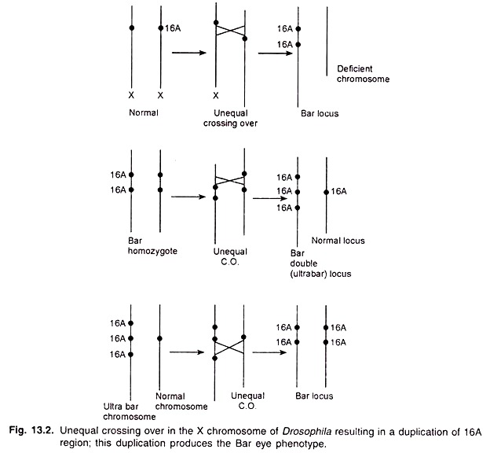
2) Crossing over within inversion: Crossing over within an inversion produces chromosomes showing deficiency-duplication.
3) Translocation heterozygote: Deficiency-duplication gametes are produced by translocation heterozygotes, but these gametes are sterile.
3) In minor cases Irradition treatments also cause duplications.

Chromosome Pairing at meiosis in duplication heterozygote:
The duplicated segment forms a loop during pachytene in duplication heterozygotes (Fig. 13.3). Unequal crossing over may occur in duplication heterozygotes leading further duplications of the concerned segment. For example, Bar eye locus of Drosophila gives rise to the double-Bar (ultra bar) eye following unequal crossing over (Fig. 13.2).

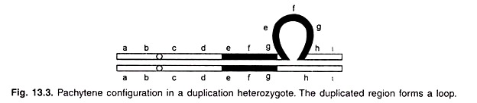
If the duplication is carried on the other arm of the same chromosome, the two arms of a chromosome pair to form ring univalents. Duplications can be identified by molecular markers such as RFLP to distinguish loops of deletions and duplications. RFLPs give more than one fragments in case of duplications and one fragment in deletions.

Breakage-fusion-bridge Cycle: Extensive studies on broken chromosome-9 in corn have been made by Barbara Mc Clintock. In the gametophyte (pollen) and endosperm of corn, ends of chromosome that are recently broken tend to be “sticky,” as is shown by their tendency to adhere to one another. She found that following reduplication of a broken chromosome the two sister chromatids may fuse at the point of previous breakage. The fused sister chromatids would be unable to separate readily. In effect, they constitute a single chromatid with two centromeres, a dicentric chromatid. As the centromeres move to opposite poles at anaphase 1 or anaphase-II, the dicentric chromatid stretches out, forming a chromatin bridge from one pole toward the other. This bridge eventually breaks, but the break does not always occur at the point of previous fusion. The break usually occurs near one of the two poles resulting two daughter cell with one cell having duplication and the other cell has deletion. Therefore, chromosomes may be formed that show structural aberrations such as duplications and deficiencies if compared with an original type.
Thus, if the original chromosome is C B A
the type C B A A
is a duplication type, since region A is represented twice.
The type C B
is a deficiency, since region A is absent.
Now two new broken ends of chromosomes are also sticky and these sticky broken ends do not heal in gametophyte or endosperm B. This situation permits repetition of more similar events as described above, in cyclic series. Spontaneous production of chromosome aberrations through breakage-fusion-bridge cycle may occur in this manner for some time. But when a broken chromosome is introduced into the sporophytic generation such cycles cease, as the broken ends heal in the zygote. Breakage-fusion-bridge cycle has phenotypic effects on maize endosperm such as colourless spots in the seed due to deletion of genes.
3. Inversions: Inversions would involve two breaks followed by reunion of interstitial segment in a reverse order i. e., the segment rotates by 180⁰. Gene sequence in an inverted segment is exactly the opposite of that in its normal homologous pair.
(Let us imagine that a chromosome 1-2-3-4-5-6-7-8 gives rise to another chromosome having the order 1-2-6-5-4-3-7-8. the segment 3-4-5-6 has rotated here at 180⁰ giving an inverted order of genes 6-5-4-3). Even though gene order is changed in an inversion, many inversions do not cause abnormal phenotypes.

Inversions can be of two types depending upon whether centromere is involved or not in
inversions.
(a) Paracentric inversions and (b) Pericentric inversions.
- Differentiate between paracentric inversion and pericentric inversion
Paracentric inversion | Pericentric inversion
- Inverted segment do not include centromere and hence involves only one arm of the chromosome | - Inverted segment include centromere. Since centromere is involved, both arms of the chromosome are involved in this type of inversion (pericentric means surrounding the centromere).
- Crossing over within the inversion loop results in the formation of a dicentric bridge (chromatids having two centromeres) and acentric fragment at anaphase-1 | No dicentric bridge (chromatids having two centromeres) and acentric fragment are formed at anaphase-1
- The crossover products (meiotic products or gametes) are non viable due to chromosomal deletions | The crossover products (meiotic products or gametes) are non viable due to chromosomal deletions and duplications
- Paracentric inversions do not alter the arm ratio and karyotype of chromosomes are not changed | Pericentric inversions alter the arm ratio of chromosomes and hence karyotype is changed.

Why paracentric inversions are called crossover suppressors?

The products of single crossing over will not function and the only crossover products recovered will be double cross overs, the observed frequency of recombination between any two genes of interest will be considerably reduced. Due to this reason, inversions (especially paracentric inversions) are often called crossover suppressors. This reduction in crossing over is not the actual reduction in cytological crossing over, but is the result of lack of recovery of the products of single cross overs (that is gametes of single cross overs are non-viable). This property of inversion has been utilized in the production of ClB stock used by Muller for the detection of sex-linked lethal mutations in Drosophila melanogaster.

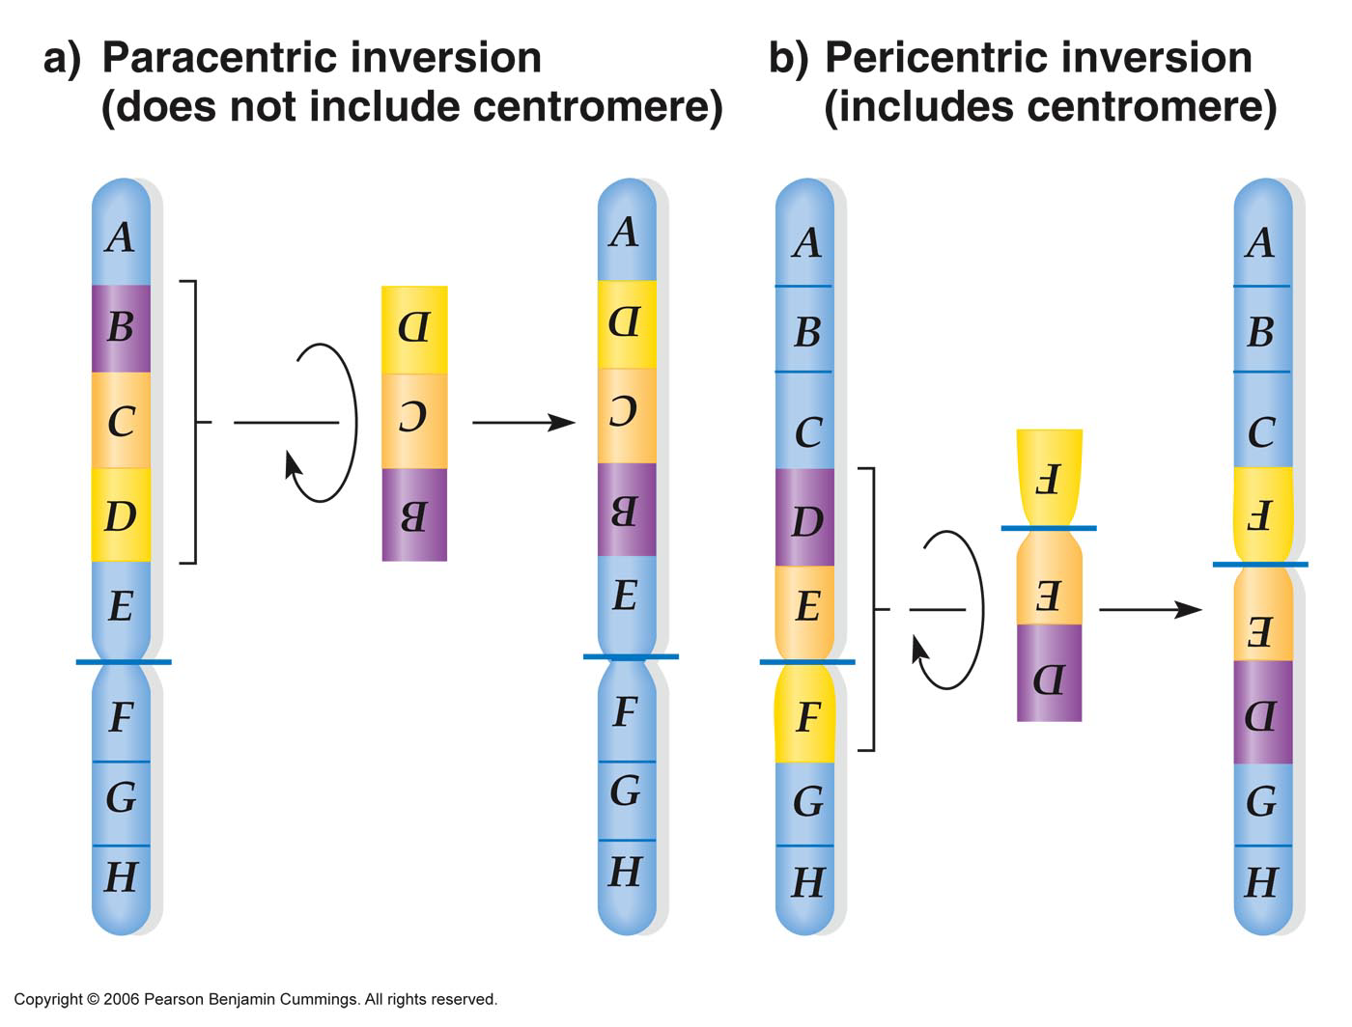

Origin and production of inversions: Inversions can originate spontaneously and can also be produced artificially. Due to their spontaneous origin, inversions are found abundantly in wild populations of certain organisms such as salivary glands of Drosophila. There is some evidence that inversions are produced naturally through the activity of transposable elements (unusual DNA sequences capable of moving from one chromosomal position to the other). During their movement, these elements break a chromosome into pieces. The broken pieces then reattach in an aberrant way, producing an inversion. Chromosome breakage can also occur by mechanical shear or as a result of chromosome entanglement at interphase or during replication. Inversions can also be induced artificially using X-rays or gamma rays or chemical mutagens. These mutagens have the ability to induce breaks in the chromosome. The broken segments sometimes turn around or rotate at 180⁰ and then reattach resulting into an inversion.
Meiotic pairing in inversion heterozygote: during pairing of homologous chromosomes in an inversion heterozygote, the inverted segment must pair with its counterpart with the help of a loop formation at pachytene stage of meiotic prophase. Sometimes the characteristic inversion loop may be absent due to lack of synapsis in the inverted region or due to due to non-homologous association in the inverted region leading to formation of rod bivalent (McClintock).
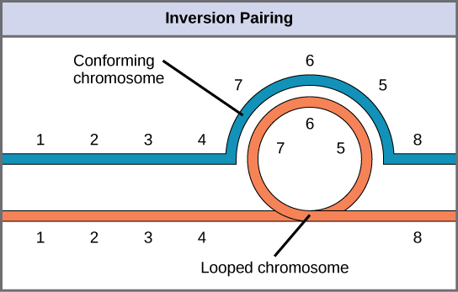
Cytological crossing over and its consequences in inversion Heterozygote: Paracentric Inversion: Crossing-over within the inversion loop of a paracentric inversion produces a dicentric bridge (the two centromeres remain linked by the bridge) and acentric fragment—a fragment without a centromere. As the chromosomes separate in anaphase I, tension eventually breaks the bridge, forming two chromosomes with terminal deletions. The acentric fragment cannot align itself or move and is, consequently, lost (Figure below). The gametes containing such deleted chromosomes are inviable and the zygotes that they eventually form are inviable. Hence, a crossover event, which normally generates the recombinant class of meiotic products, instead produces inviable gametes.

Paricentric Inversion: In a pericentric inversion, because the centromeres are contained within the inverted region, the chromosomes do not form dicentric bridge and acentric fragment. However, the crossover produces chromatids that contain a duplication and a deficiency for different parts of the chromosome (Figure below). Since gametes (cross-over products) having such chromosmes are inviable and the zygote dies. Therefore in higher plants both pollen and ovule abortion are expected due to crossing over in the inverted region.

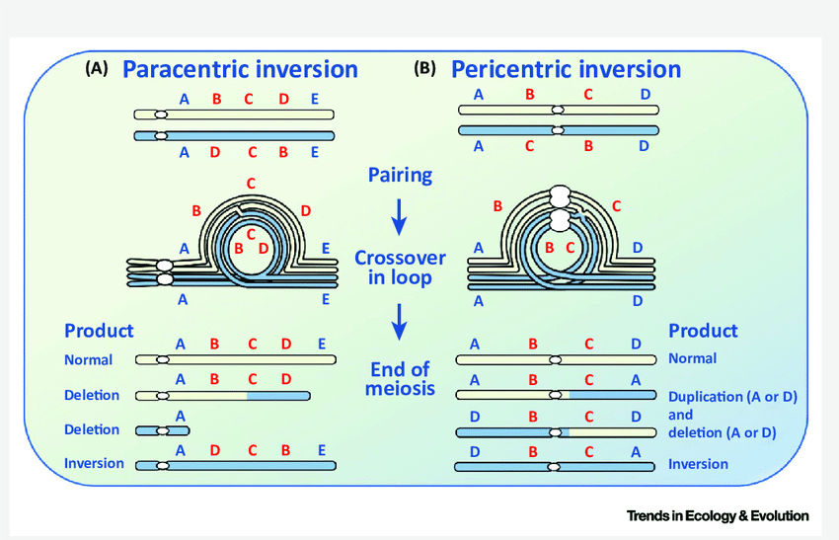

Detection of inversions
- Genetic analysis and meiotic chromosome cytology are both good ways of detecting inversions. A paracentric inversion in anaphase-I normally produces a dicentric bridge (the two centromeres remain linked by the bridge) and acentric fragment—a fragment without a centromere. If the same chromosomes are always involved in bridge and the fragment and if the acentric fragment size is constant, it is a strong evidence for the presence of paracentric inversion.
- If the frequencies of chromosomal configurations such as BF (bridghe-fragment), BBFF (two bridge-two fragment), LF (loop-fragment), LLFF (twoloop-two fragment) are similar in Anapahase I and Anaphase II, this will another evidence for the presence of paracentric inversion.
- Inversions can be detected through mitotic chromosome analysis. A key operational feature is to look for new arm ratios. Due to pericentric inversions, ratio of the long arm to the short arm has been changed from about 4:1 to about 1:1. Paracentric inversions do not alter the arm ratio, but they may be detected microscopically if chromosome banding or other chromosome landmarks are available.

Uses of para and pericentric inversions

1) Inversions can be used to study the behavior of chromosomes during meiosis such as chromosome pairing, cytological crossing over, formation of dicentric bridges and acentric fragments as seen in paracentric inversions, deletions and duplications in pericentric inversions etc.,

2) A combination of cytological location of inversion breakpoints and genetic linkage can be used for physical location of genes in the chromosome.

3) Inversions can be used to study the Position effect: due to inversions euchromatic segment of a chromosome may become located in the vicinity of a heterochromaticregion. In such a condition, the euchromatic region may become heterochromatinized. This would cause suppression of gene expression. One of the main effects of inversion is that it changes the position of the gene. Any change in the phenotype due to change in position of the gene is called position effect. Due to position effect, the expression of the gene may be blocked if, e.g. the gene is separated from its regulatory sequences or is placed next to constitutive heterochromatin due to inversion. The normal expression of the gene is also affected due to absence of various kinds of allelic and nonallelic interactions at its new position.

4) Inversions act as cross over suppressors: absence of crossing over within the inverted segment maintains that particular gene combinations intact. That is, complete linkage for the concerned genes and such inversions are designated as cross over suppressors. Muller used ClB stock to detect lethal mutations induced by X-rays. In CIB, ‘C’ represents crossover suppressor gene (inverted chromosome segment).

5) Inversions played an important role of in evolution such as formation of different races in drosophila. By studying overlapping inversions, the phylogentic relation of different species can be studied.

6) Asymmetrical Inversion breakpoints on the two sides of a centromere in pericentric inversion changes the karyotype of the chromosome. A metacentric chromosome may become a submetacentric or acrocentric depending on the break positions in the two arma. Thus karyotype polymorphism may be generated.

7) inversions in combination with other chromosomal changes can be used to control insects Ex: yellow fever mosquito (Aedesaegypti).

8) Inversions are used to create duplications in specific chromosome regions for various experimental purposes.

Role of inversions in evolution
- Spontaneous inversion observed in drosophila. In Drosophila pseudoobscura, a species which inhabits western North America, spontaneous inversion led to formation of different races. These Inversion races are restricted to specific localities and were named according to the localities they inhabited, such as Pike’s Peak, Estes Park, Cuernavaca etc.
- By studying overlapping inversions, the phylogentic relation of different species can be studied. Overlapping inversions can be identified by banding patterns and chromosome pairing in F1 hybrids as seen in salivary gland chromosomes.
- Because of evolutionary benefit, paracentric inversions are more common in drososphila races than pericentric inversions. Paracentric inversions do not show male or female sterility. Sterility is absent in male drososphila as crossing over is absent. Female sterility is absent due to formation of dicentric bridge in meiosis that causes a chromatid tie. In pericentric inversion sterility on female side is observed due to absence of bridge.

Role of inversion in the evolution of Karyotyope

- In paracentric inversion karyotype changes are not observed. In case of pericentric inversions, asymmetrical inversion breakpoints on the two sides of a centromere changes the karyotype of the chromosome. A metacentric chromosome may become a submetacentric or acrocentric depending on the break positions in the two arma. Thus karyotype polymorphism may be generated.
- Inversions, specifically pericentric inversions can lead to increase or decrease in chromosome number. Tsuchiya in barley observed in the selfed progeny of a trisomic type for chromosome 6, a 16-chromosome type was obtained which had a pair of new metacentric chromosome 6 in excess. The new metacentric chromosome 6 was shorter than any of the 14 chromosomes of normal barley complement and showed a heteropycnotic nature at late prophase in somatic mitosis. The 16-chromosome plants were observed to exhibit8_{II}or 7_{II}+2_{I}at meiosis.

Breeding behaviour of translocation heterozygotes:

The presence of translocation heterozygosity can be detected by the presence of semisterility and low seed set. This can in turn be confirmed by cytological analysis, where a characteristic translocation ring is observed at diakinesis or metaphase stages of meiosis. We have already seen that only alternate disjunction results in the formation of functional gametes. During selfing of a translocation heterozygote, two types of gametes are formed on male and female side, one carrying normal chromosomes, and the other type carrying translocated chromosomes. Random fertilization between these gametes will produce a progeny of normal, translocation heterozygotes and translocation homozygotes in the ratio of 1:2:1, respectively.

Fig. Breeding behaviour of translocation heterozygote (Drawn from Genetics by PK Gupta)

Rarely, however, an interchange ring may undergo 3:1 disjunction at anaphase, resulting in the formation of n+1 and n-1 gametes. Although the deficient gamete is non functional, but the gamete with n+1 condition on fertilization with normal gamete will lead to the production of variety of trisomics.
Types of translocations

Different types of translocations exist in nature, as given below:
1. Simple translocations
In this case a single break occurs in a chromosome releasing a terminal acentric fragment. This is followed by transfer of this acentric fragment to the end of a non-homologous chromosome. This type of translocation was first reported by Muller and Painter in 1929. Simple translocations actually do not exist in nature.
2. Shifts or intercalary translocations: This type of translocation is commonly found in nature and involves atleat three breaks – two breaks in one chromosome releasing an acentric fragmnet and one break in another non-homologous chromosome. The released acentric fragment is then inserted at the intercalary position near the break produced in the non-homologous chromosome. This type of translocation was first reported by Bridges in 1923. Both simple type and intercalary translocations are also called as non-reciprocal translocations.
3. Reciprocal translocations: This is the most frequently found and best studied type of translocation. When chromosomal segments are exchanged between two non-homologous chromosomes without any net loss of genetic material, the event is referred to as a reciprocal translocation. In reciprocal translocation, atleast a single break occurs in each non-homologous chromosome, releasing a terminal telomeric fragment. This is followed by mutual exchange of these fragments between the two non-homologous chromosomes, e.g. a part of chromosome-1is detached and becomes attached to chromosome 2. At the same time, a part of chromosome 2 is detached and becomes attached to chromosome 1. Such translocations are also called interchanges. The net result of this translocation is that genes from one chromosome are transferred to the other, and vice-versa.

Types of translocations (Drawn from Genetics by Strickberger)

Permanent translocation hybrids in oenothera: The plant genus Oenothera (evening primrose, Onagraceae, 2n = 2x = 14) due to reciprocal chromosomal translocations, forms extensively multichromosomal rings at meiosis. Meiotic configurations can range from a single ring, where all the 14 chromosomes are involved in catenation, through intermediate forms with rings and bivalents, to solely bivalents. Hence in Oenothera, chromosomal end-segments are the only sites throughout the genome where chiasmata are formed. The terminal chiasmata are obligatory for proper and regular meiosis I segregation. However, techniques of classical and molecular genetics show unusually low levels of crossovers, allowing Oenotheragenomes to be regarded as essentially nonrecombining.
In a translocation heterozygote two distinct pairs of homologous chromosomes have reciprocally exchanged nonhomologous segments between one member of each pair. As a result each of the affected chromosome pairs contain both homologous and nonhomologous segments. Put another way, each such pair has one translocated chromosome, and one normal (untranslocated) chromosome. More than two chromosome pairs can be altered in this way so that some or all of the chromosome pairs are composed of a translocated and an untranslocated member.Organisms having all the chromosomes rearranged the form of a ring (sometimes a ring of 12 chromosomes and a bivalent) with genes close to centromere of different chromosmes are linked are said to bepermanent translocation heterozygotes(permanent hybridity). Due to the way reciprocal translocations are processed during meiosis, all the translocated chromosomes pass to one gamete and all the normal chromosomes pass to the other. As a result, only two types of gametes are produced. One has all the translocated chromosomes and the other has all the normal ones (here "translocated" and "normal" are relative terms since in naturally occurring organisms it is usually unknown which of the two types was original). These two sets of chromosomes ("normal" and "translocated") or linkage groups are known as Renner complexes. PTH are always stable because when these complexes meet in the hybrid, they always experience regular meiotic segregation.In well-studied organisms of this type, the various Renner complexes have been assigned formal names.
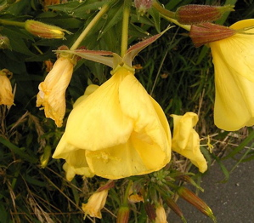
Oenotheralamarckiana
In one of the best-known permanent translocation heterozygotes, the evening primrose Oenotheralamarckiana, the two Renner complexes are called velans and gaudens. So the karyotype of O. lamarckiana is designated as "velans/gaudens." Genetic interchange (crossing-over) between Renner complexes is very rare (Renner x Velans).
Aneuploidization is a common stabilization process among permanent translocation heterozygotes because there is an enhanced tendency to produce aneuploid gametes. The result is the production of numerous trisomic forms. But the most common stabilization process seen in organisms of this type occurs when forms with distinct Renner complexes hybridize to produce new forms. For example, hybridization of O. lamarckiana with another evening primrose, O. strigosa, which has the Renner complexes deprimens and strigens, yields four different types,
- velans/deprimens,
- velans/strigens,
- gaudens/deprimens,
- gaudens/strigens
Since chromosomes in distinct complexes differ genetically in many respects, some hybrids produced by such recombinations of Renner complexes are reproductively stable and others are not. By this means new stable types can be produced in a single generation. Therefore, a certain level of outbreeding is needed to create new stable PTH forms. O. lamarckiana itself arose by such a process via hybridization between O. biennis and O. hookeri. This event occurred within the last two or three centuries in Europe where the two parental forms, both native to North America, were introduced. In fact, most of the 18 forms of European Oenothera that Renner (1942) treated as species arose in this way.

An explanation for maintenance of permanent hybridity ("velans/gaudens”) in stable manner in Oenothera was given by Muller using Balance Lethal Systemin Drososphila. In Balance Lethals the dominant alleles of two traits, each with a recessive lethal effect, are present in heterozygous repulsion phase. Homozygotes do not survive and permanent hybridity is maintained. There are two balance lethal mechanisms, one involving zygotic lethality and the other involving gametic lethality. There are two gametic complexes in oenothera, alpha (α) in functional egg and beta (β) in functional pollen. The full ovule fertility or seed set is due to the fact that only the megaspore that carries alpha (α) complex. Since alpha (α) complex unite with beta (β) complex in pollen, plants breed true for heterozygous condition.
Robersonian translocation
A Robertsonian translocation is one that combines the long arms of two acrocentric chromosomes resulting in large metacentric chromosome and a small chromosome, as shown in Figure 17-27. A small chromosome composed of the two short arms also forms; however, this small chromosome may be devoid of genes and may be lost. It is also called centric fusion as the two acrocentric chromosomes fuse at centromere. Such translocations mostly occur in the acrocentric chromosomes such as D group (chromosomes 13,14, and 15) and G group (chromosomes 21 and 22) of human chromosomes. Translocation Down syndrome is caused by a Robertsonian fusion between chromosomes 21 and 14. The translocated chromosome passes down through the generations in unaffected carriers. However, meiotic segregation in the translocation carriers can result in offspring that carry three copies of most of chromosome 21, as shown in Figure 17-27, and these offspring have Down syndrome.
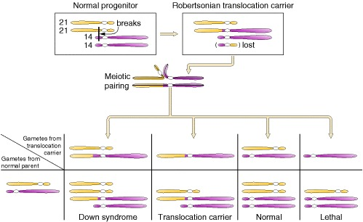

Figure 17-27: How Down syndrome arises in the children of an unaffected carrier of a special type of translocation, called a Robertsonian translocation, in which the long arms of two acrocentric chromosomes have fused. The specific Robertsonian translocation in translocation Down syndrome is between the Down syndrome chromosome 21 and chromosome 14. Translocation Down syndrome accounts for less than 5% of cases.

Effect of Robertsonian translocation:
- Due to loss of small chromosome due to translocation, chromosome number is reduced to 45 in humans. Meiotic cells show association of three chromosomes: i.e., two normal and one large metacentric translocated chromosome.
- The translocated chromosome passes down through the generations in unaffected carriers. However, meiotic segregation in the translocation carriers can result in offspring that carry three copies of most of chromosome 21, as shown in Figure 17-27, and these offspring have Down syndrome.
- Keith jones emphasized the role of robertsonian trabslocation in the evolution of some members of family commelinaceae.
Classification of Haploids
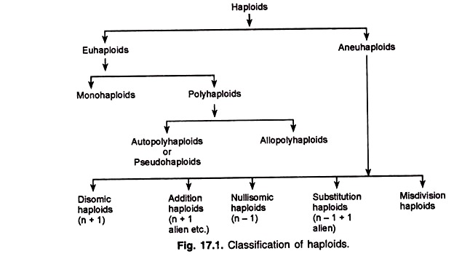

Haploids: Plants (or the sporophyte) having gametic chromosome number are called haploids.

Classification of Haploids:
According to their cytological features, haploids have been classified into different types (Fig. 17.1), a brief description of which is given below.

I. Euhaploid:
The chromosome number of such a haploid is an exact multiple of one of the basic numbers of the group. Euhaploids are of two types:
i) Mono-haploid or monoploid:
It arises from a diploid species (2x) and possesses the gametic chromosome number of the species; it is designated as “x”.
(ii) Polyhaploid:
Haploid individuals arising from a polyploid species (4x (autotetraploid), 6x (autohexaploid), etc.,) are called polyhaploids; they may be di-haploids (with 2x), tri-haploids (3x) and so on. Based on their auto- or allo-ploid condition, polyhaploids have been divided into two groups:
(a) Auto-polyhaploid : Autopolyploid species give rise to auto-polyhaploids. For example,
Autotetraploid (Ax = AAAA)———-> Auto-di-haploid (2n = AA)
Auto-hexaploid (6x = AAAAAA)———–> Auto-tri-haploid (3x = AAA)
(b) Allopolyhaploid : Such individuals arise from allopolyploid species. For example,
Allotetraploid {Ax = AABB)———-> Allodihaploid (2x = AB)
Allohexaploid (6x = AABBDD)———–> Allotrihaploid (3x = ABD)

II. Aneuhaploid:
The chromosome number of such a haploid is not an exact multiple of the basic number of the group.
Aneuhaploids have been classified into five types:
(i) Disomic haploids (n + 1): Such haploids have one chromosome in disomic condition, i.e., there is one extra chromosome belonging to the genome involved.
(ii) Addition haploids (n + few alien): The extra chromosome(s) in the haploid is an alien chromosome.
(iii) Nullisomic haploids (n-1): In such haploids, one chromosomes is missing from the haploid complement.
(iv) Substitution haploids (n-1 + 1 alien): One or more chromosomes of the haploid complement are substituted by alien chromosomes.
(V) misdivision haploids: such haploids contain telocentric or isochromosomes resulting from misdivision of centromeres.

Origin and occurrence of haploids

Origin of Haploids:
Haploids arise spontaneously, and haploidy can be artificially induced by modified pollination methods in vivo such as delayed pollination, or by in vitro culture of immature male (pollen culture) or female gametophytes (cells in the embryosac). In nature, they arise through the development of egg cells without fertilization (parthenogenesis) or through pseudogamy.
The rate of haploid production increased up to 20/1000 in interspecific pollination and up to 200/1000 when combined with delayed pollination.
The first report of induced haploidy in plant was that by Blakeslee et al. in 1922, through cold treatment of young buds of Datura stramonium.
Production of Haploids
In general, there are three main Methods of Haploid Production:
(1) Parthenogenesis and apogamy,
(2) Somatic reduction and chromosome elimination, and
3) Anther, pollen and ovule culture.
- Parthenogenesis and Apogamy: In plants, parthenogenesis is the development of embryo from egg cell without fertilization In this case, no fertilization is needed. In apogamy, embryo is developed from a cells of the embryosac without fertization. The haploids arising from the maternal cell in the embryosac are called ‘gynogenetic haploids’ whereas those arising from male nucleus in the embyosac is called ‘androgenetic haploids’.
The various methods used to produce parthenogentic haploids are:
- Temperature treatment: treatment of young flower buds with high or low temperature generate haploids.
- Pollination with Irradiated pollen grain with x-rays: This method inactivates the pollen but can stimulate the egg to develop into embryo parthenogenetically.
- Chemical treatment with nitrous oxide stimulate embryogenesis in the cells of embyosac and thereby resulting in haploid production.
- Delayed pollination: It induces parthenogentic development of egg into a haploid embryo. The success of delayed pollination will actually depend on the viability of stigma and ovules.
- Alien cytoplasm:
- Haploid inducing genes: Certain inducing genes such as ‘indeterminate gametophyte (ig) gene’ induces both androgenetic as well as gynogenetic haploids in maize. Haploid initiator (hap) gene induces haploids of female origin in barley. The function of this gene is to prevent fertilization of the egg cell, while not affecting fertilization of the polar nuclei and development of the endosperm.
- Selection of twin seedlings: twin seedlings arise due to polyembryony. One embryo develops from an egg cell and the other from the synergid resulting in the production of twin embryos.
- Semigamy: a genetically controlled production of chimeric haploids. Here sperm nucleus enters the egg cell but fusion of male and female nuclei does not occur. Instead they both divide simultaneously, giving rise to a chimaeric embryo with both male and female components. Semigamous plants in cotton produce elevated frequencies of maternal haploids, paternal haploids, as well as chimaeric maternal/paternal haploids. Thus semigamy falls between the two extremes, the syngamy (fusion of male and female gametes) and pseudogamy (development of embryo after pollination without involvement of male gamete).
- Haploid production through Chromosome Elimination following wide hybridization (interspecific and intergeneric hybridization)
The barley example:. Bulbosum method is more efficient than microspore culture in producing haploid barley. In this method, haploid plantlets of Hordeum vulgare with seven chromosomes are produced as a result of gradual elimination of H. bulbosum chromosomes. This is achieved by an interspecific cross between barley (Hordeum vulgare ; 2n = 2x = 14, female) x Hordeum bulbosum (wild relative; 2n = 2x = 14, male). The method was started with the fertilization of Hordeum vulgare by Hordeum bulbosum followed by gradual elimination of the H. bulbosum genome in the early stages of embryo development (few days after fertilization).
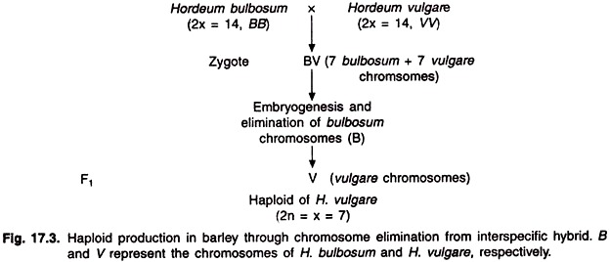
F1 obtained above will be left with 7 vulgare chromosomes after elimination of 7 chromosomes from H. bulbosum (Kasha and Kao). In a similar way, a cross between T. aestivum and H. bulbosum generates wheat haploids (2n=3x=21) with elimination of all 7 chromosomes of H. bulbosum.
- Somatic reduction: various chemicals such as chloramphenicol, colchicines, fluorophenyalanine are mutagenic and induce somatic chromosome reduction.
- Anther, pollen and ovule culture: Haploids have been produced by using anther, pollen and ovule culture. Development of haploids from pollen grains was first reported in datura innoxia by Guha and Maheshwari. Anthers of most species are cultured at binucleate stage. The best stage of pollen culture lies between the quartet stage and stage just past the first pollen mitosis. In ovule culture, unfertized ovaries are cultured to get haploids. Haploids obtained from callus cells (caulogenesis).

Detection of Haploids: Haploids can be identified by the following

Morphological Approach:
The vegetative and floral parts and the cell sizes of haploid plants are relatively reduced when compared to diploid plants. By this way haploids can be detected in a population of diploids. Morphological approach, however, is not as effective as genetic approach.

Genetic Approach:
Genetic markers are widely used for the specific identification of haploids. Several markers are in use to screen at seedling stage.
i. ‘a₁’ marker for brown coloured aleurone and their corresponding dominant marker being ‘A’ marker for purple colour.
iii. ‘lg’ marker for liguleless and its corresponding dominant marker being ‘Lg’ marker for liguled character.
If the female parent carries ‘a’ or ‘lg’, then the monoploids are will be recognized by lack of purple colour or ligule character when crossed with male parent carrying ‘A’ or ‘Lg’. The above markers have been used for the development of haploids of maize. Maize haploids can be used to develop inbrelines in hybridization programme. The other markers are
3. Chromosomal Counting: Haploids have gametic chromosome number of that species.
Phenotypic effects of Haploidy:
- Monohaploid plants are weaker, smaller and less vigorous than the diploids. However in Pepper, haploids may be comparable in size and vigour to its diploids
- Their leaves, flowers and other parts are smaller compared to those of diploids.
- Their stomatal size is smaller bur the number of stomata per unit area is higher than that of diploids.

Meiosis and breeding behavior in haploids (x)
- In a monoploid, all the chromosomes present in a nucleus are non-homologous. Therefore, only univalents are expected at MI. These univalents are distributed throughout metaphase-I and Anaphase-I because of univalents inability to localize at equatorial plane. Sometimes bivalents due to non-homologous pairing along with univalents are seen resulting in non viable gametes and thus there is a complete sterility.
- Non-homologous chromosome pairing (of small chromosomal segments) has been assigned to small duplication and genetic redundancy. In 1983, Kasha and Seguin-Swartz made the following three main observations regarding chromosome pairing and chiasma formation in barley monoploids.
- Chiasma formation is mainly dependent on duplication of chromosomes segments and their location on the chromosomes rather than on the large content of highly repetitive DNA sequences (over 70%) in the barley genome.
(iii) The very low frequency of association, e.g., 0.03-0.05 bivalent per PMC, could be due to random breakage and crossing over.
3) In some species, all the chromosomes present at MI and AI may be included in a single restitution nucleus following the telophase I; this nucleus undergoes a normal second meiotic division to produce two normal haploid spores. Therefore, after pollination by a diploid plant the monoploid may produce diploid progeny.
4) Chromosome pairing and crossing over in the duplicated region of non-homologous chromosomes of the monoploid will lead to the diploid progeny carrying a heterozygous translocation. Studies in Zea mays revealed occurrence of repeated interchanges (translocations) due to crossing overs in the duplicated segments.

Breeding behaviouir in Polyhaploids:
In auto-polyhaploids, homologous chromosome pairing is a common feature. In auto-di-haploids, mostly bivalents with very few univalents are observed. However, fertility and vigour of these auto-polyhaploids are often lower than those of their polyploid counterparts, possibly due to inbreeding.
In case of allopolyploids such as wheat (T. aestivum), there should be no chromosome pairing since the chromosomes are not homologous. But a low frequency of chromosome pairing occurs in the same homoeologous group (A,B,D) due to the absence of chromosome 5B. This is expected since the gene ph present in 5B is known to suppress homoeologous chromosomes pairing. Secondary association: Secondary association of univalents is also observed in haploids; the association may be side-to side, end-to-end or end-to-side. The reasons for secondary association may be duplication, homoeology and the presence of highly repetitive DNA sequences.
Uses of Haploids in plant breeding:
- Rapid production of homozygous lines in the shortest possible time: This is achieved by treating haploids with colchicines and subsequent chromosome doubling of such haploids to generate doubled haploids or homodiploids. These doubled haploids can be used directly as cultivars or as inbred lines in breeding programmes (maize). Hap gene in barley is used for both production of haploids as well as spontaneous doubled haplods (SDH). In SDH, the doubling of chromosomes occurred naturally without colchicines treatment.
- Use of haploids in species with polysomic inheritance such as potato. The dihaploids in potatao can be used for chromosome doubling to increase tuber size. This is known as analytical breeding.
- Mutation breeding: mutation breeding can be effectively carried out at haploid level as both dominant and recessive mutations are expressed in the M1 generation itself. Desirable mutations can be selected from among haploid cells cultured in vitro or from haploid plants and from them fertile doubled haploids with all desirable muataions can be obtained through chromosome doubling.
- In cytogenetic studies haploids are used as sources of aneuploids: In wheat, haploids as female when pollinated with hexaploid wheat, chine spring variety gave rise to monosomics and selfing of monosomics gave nullisomics and trisomics. Selfing of trisomics gave tetrasomics. Thus E. R. Sears developed aneuploid stocks as well as translocation stocks from wheat haploids.
- Haploids are used in evolutionary studies: Homoeologous chromosome pairing in the haploids of different allopolyploid species provide information on ancestry of the species and evolution of different genomes in these allopolyploids.
- High yielding heterotic hybrids are generated in Asparagus officinalis: Asparagus has XX-XY system of sex determination where XX is female and XY is male. Androgenetic haploids obtained through anther culture of asparagus male plant (XY) produced super males with YY line and homozygous female (XX). When super males (YY) were crossed to its female XX, all F1 are male population that are commercially superior in yielding abilities than the conventional “50% male + 50% female populations”.
- Haploids can be used in genetic studies. Haploids used to study chromosome behavior during meiosis. Pairing in monohaploids indicates presence of duplications in the chromosome complement.Ex: potato.

UNIT IV
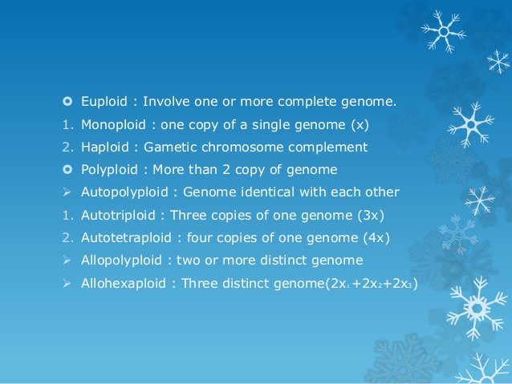
When all the genomes present in a polyploid species are identical, it is known as 'autopolyploid'. In case of allopolyploids, two or more distinct genomes.
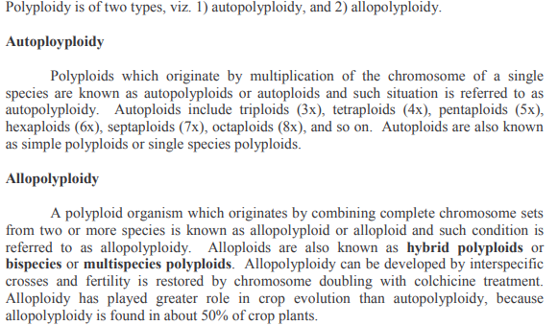
AUTOPOLYPLOIDY: In autopolyploidy are included triploidy, tetraploidy and higher levels of ploidy. Autopolyploids are produced directly or indirectly through chromosome doubling, which is briefly considered as follows.
Origin and production of Doubled Chromosome Numbers Cells/ individuals having doubled chromosome numbers may originate in one of the following several ways:
(1) Spontaneous,
(2) Due to treatment with physical agents,
(3) Regeneration in vitro,
(4) Colchicine treatment,
and (5) Other chemical agents.
(1) Spontaneous – Chromosome doubling occurs occasionally in somatic tissues and unreduced gametes are also produce in low frequencies.
(2) Physical Agents – Heat or cold treatments, and X–ray or gamma-ray irradiation may produce polyploids in low frequencies. Tetraploid branches were produced in Datura in response to cold treatment. Exposure of maize (Z.mays) plants or ears to a temperature of 38-45OC at the time of the first division of zygote produces 2-5 per cent tetraploid progeny. Heat treatment has been successfully used in barley (H.vulgare), wheat (T.aestivum), rye (S.cereale) and some other crop species.
(3) Regeneration in vitro – Polyploidy is a common feature of the cells cultured in vitro. Some of the plants regenerated from callus and suspension cultures may be polyploids. Plants of various ploidy have been regenerated from callus cultures of Nicotiana, Datura, rice (O. sativa) and several other species.
(4) Colchicine treatment – Colchincine treatment is the most effective and the most widely used treatment for chromosome doubling. It has been used with great success in a large number of crop species belonging to both dicot and monocot groups. Pure colchicine is C22H25O6N. It blocks spindle formation and thus inhibits the movement of sister chromatids to the opposite poles. The resulting restitution nucleus includes all the chromatids; as a result, the chromosome number of the cell is doubled.
(5) Other chemical agents – several other chemical have polyploidizying effect. Notable among them are, 8- hydroxyquinoline and nitrous oxide. These chemicals are much less effective than colchicine and are not commonly used.
Meiotic behaviour in autopolyploids-Autotriploids and autotetraloids:
Cytology of autopolyploids.
In an autopolyploid, there will be more than two sets of homologous chromosomes. This leads to formation of multivalents instead of bivalents as found in diploids. An important difference exists even between autotriploids and autotetraploids, because while in the latter normal disjunction is possible giving rise to diploid gametes, in triploids it is not possible. In an autotriploid, there are three sets of homologous chromosomes. If these three sets are normally paired, trivalents can not disjoin normally and will either disjoin 2 : 1 chromosomes to two poles or will disjoin 1 : 1 leaving one chromosome as a laggard. The number of chromosomes in gametes of triploid organism, therefore, will vary from n to 2n. Most of these gametes are unbalanced leading to high degree of sterility.
In autotetraploids, since there are four sets of chromosomes, quadrivalents are formed, which disjoin in a normal 2 : 2 manner giving diploid gametes. Rarely however, a quadrivalent may disjoin 3 : 1 or may leave a chromosome as a laggard at anaphase I. Therefore autotetraploids also have a certain degree of sterility, although it will not be as high as in autotriploids.
Genetics of autopolyploids (trisomic and tetrasomic inheritance).
The segregation pattern in polyploids is quite different than what we find in diploids. In a polyploid there are more than one kind of heterozygotes, because there are more than two homologous chromosomes. The different possible genotypes and expected ratios in autotetraploids are given in Table 20.4. Similar ratios for triploids are given in Table 20.1. The ratios are based on the assumption that either the gene is close to centromere leading to what we call chromosome segregation or the gene is away from centromere so that crossing over between gene and centromere will take place and ratios will be modified. In the latter case it will be called chromatid segregation, because segregation is taking place not at chromosome level, but at chromatid level due to crossing over.
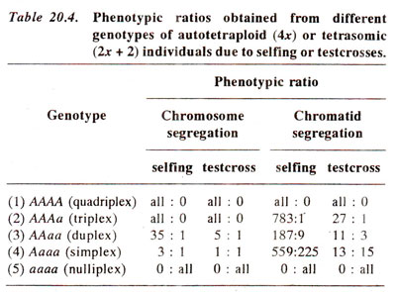
It can be seen from Table 20.4 that main effect of autopolyploidy on segregation, when compared with that of diploids is the reduction in frequency of genotype homozygous at a particular locus. The result is that recessive phenotype is much less frequent as shown by a ratio 35 : 1 as against a disomic ratio of 3 : 1 and so on (Table 20.4). Tetrasomic inheritance and trisomic inheritance are useful criteria to differentiate between autopolyploids and allopolyploids and for locating genes on specific chromosomes.

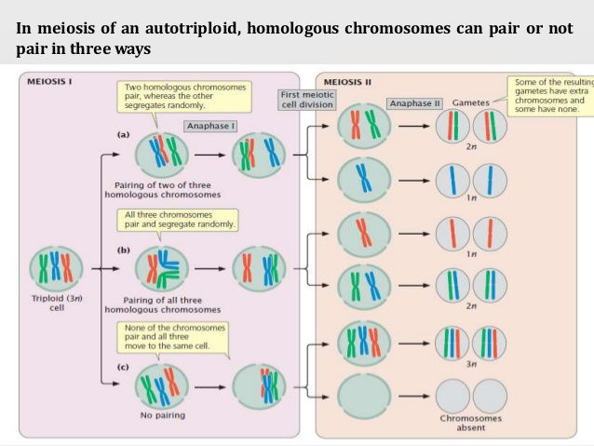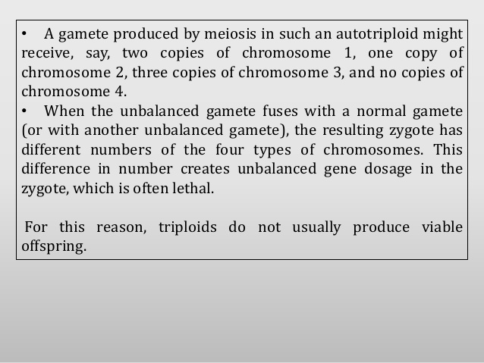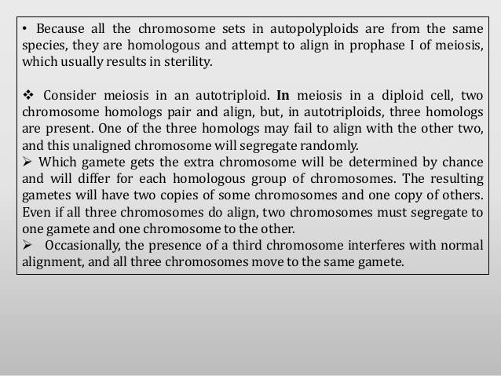
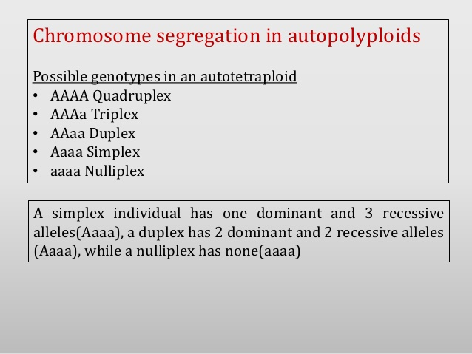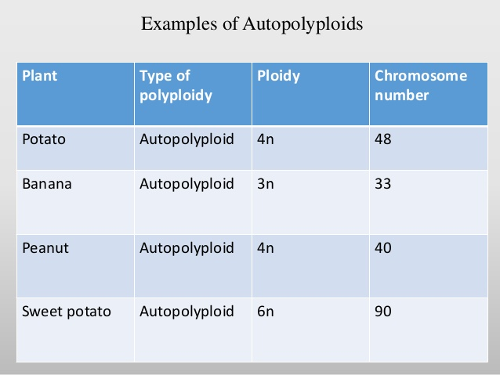
ALLOPOLYPLOIDY Allopolyploids have genomes from two or more species. Several of our crop plants are allopolyploids. The productions of allopolyploids involve two steps.
- Production of F1 distant hybrid
- Chromosome doubling
Production of allopolyploids has attracted considerable attention; the aim almost always was the creation of new species. Some success has been obtained as is evident from the emergence of Triticale as a new crop species in some areas, and the promise shown by some other allopolyploids, e.g., Raphanobrassica and some allopolyploids of forage grasses. Some genera, which contain allopolyploid species, and one or more crop species. The crop species themselves may be allopolyploid or diploid. Genera like Triticum, Brassica and Gossypium have both diploid and allopolyploid crop spices.
Role of polyploidy in evolution of crops – Wheat, Cotton, Tobacco and Brassica Role of Allopolyploidy in Evolution: It is estimated that about one-third of the Angiosperms are polyploids, and by far the vast majority of them are allopolyploids. The identification of parental diploid species is primarily based on pairing between the chromosomes of the diploid and the allopolyploid species. When the chromosomes of a diploid species pair with some of those of the allopolyploid species, homology between chromosomes of the two species is apparent. This homology suggests that the diploid species may be one of the parental species of the allopolyploid. We shall briefly consider the possible evolutionary history of some important allopolyploid crop species, viz., wheat, tobacco, cotton and Brassica. Evolution of Bread Wheat (Triticum aestivum). Evolutionary history of wheat has been the most extensively investigated, and is perhaps the least understood. Identity of the diploid species contributing the three genomes (A, B, and D genomes) of T. aestivum has been investigated by many workers, more notably by Sears, Kihara and others.
Common cultivated wheat is another important example of allopolyploidy, although its allopolyploid nature has now been questioned. There are three different chromosome numbers in the genus Triticum, namely 2n = 14, 2n = 28 and 2n = 42. The common wheat is hexaploid with 2n = 42, and is derived from three diploid species : (i) AA = Triticum aegilopoides (2n = 14), (ii) BB = Aegilops speltoides ? (2n = 14) (in the past evidence was made available, showing that Ae. speltoides may not be the donor of B genome; it is also believed that the donor of B genome may never be discovered) and (iii) DD = Aegilops squarrosq (2n = 14). The hexaploid wheat, therefore, is designated as AABBDD, the tetraploid (2n = 28) as AABB and diploid (2n = 14) as AA. There is, however, evidence available now which suggests that A, B and D genomes from three diploid species mentioned above are not much different from one another, so that it is believed that the three diploid progenitors of common hexaploid wheat were derived from a common ancestor. For this reason, the common hexaploid wheat is now considered an autopolyploid rather than an allopolyploid. At best, it may be a segmental allopolyploid.
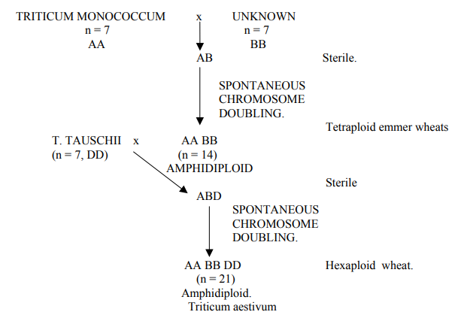
Evolution of Nicotiana tabacum. N. tabacum (n = 24) is most likely an amphidiploid from the cross N. sylvestris x N. tomentosa; both the species are diploid with n = 12. The amphidiploid from the cross N. sylvestris x N. tomentosa is similar to N. tabacum in many characteristics, which further supports the above conclusion. The species N. tabacum has undergone considerable differentiation during its evolutionary history, mostly due to the accumulation of gene mutations and, to some extent, due to the loss of some duplicated segments of the two genomes.
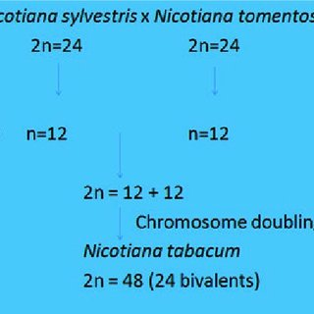
Evolution of Gossypium hirsutum: Gossypium hirsutum, popularly known as upland cotton, is another interesting example of amphidiploidy. Old World cotton has 13 pairs of large chromosomes, while American or upland cotton has 13 pairs of smaller chromosomes. The New World cotton, the cultivated long-staple type has 26 paris of chromosomes, 13 large and 13 small. J.O. Beasley crossed the American and Old World cottons and doubled the chromosome number in the F₁ hybrids (Fig. 20.12). The amphidiploid thus produced resembled the cultivated New World cotton and when crossed with it gave fertile F₁ hybrids. The evidence presented in Figure 20.12, thus showed that New World cotton, the cultivated Gossypium hirsutum (tetraploid) originated from two diploid species, namely G. herbaceum (2n = 26) and G. raimondii (2n = 26). 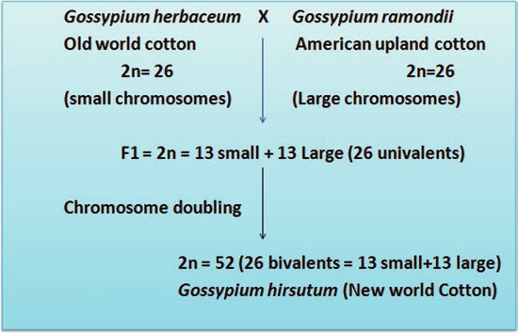
Evolution of Amphidiploid Brassica Species: The origin of amphidiploid Brassica species is presented based on the famous U’s Triangle proposed by N. U in 1935. According to this scheme, B. juncea (n = 18) is an amphidiploid from B. nigra (n =8) x B. campestris (n = 10), B. napus (n = 19) is an amphidiploid from the cross B. oleracea (n = 9) x B. campestris (n = 10), and B. carinata (n = 17) is an amphidiploid from the cross B. nigra (n = 8) x B. oleracea (n = 9). The synthetic allopolyploids produced according to the above scheme resemble the natural amphidiploids, cross easily with them, and the hybrids between the synthetic and natural amphidiploids are reasonably fertile.
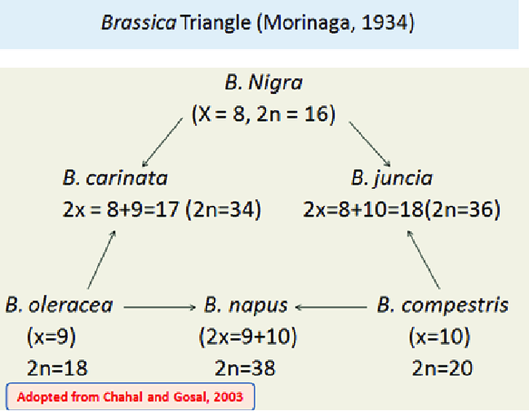
Segmental allopolyploids.
In some allopolyploids, the different genomes which are present are not quite different from one another. Consequently, in these polyploids chromosomes from different genomes do pair together to some extent and multivalents are formed. This mearts that segments of chromosomes and not the whole chromosomes are homologous. Therefore, such allopolyploids are called segmenta! allopolyploids according to Stebbins (1943, 1950). These segmental allopolyploids are intermediate between autopolyploids and allopolyploids and can be identified by their meiotic behaviour.
It is also believed that most of the naturally occurring polyploids are neither true autopolyploids nor true allopolyploids but are rather segmental allopolyploids. Our common hexaploid bread wheat is also regarded to be a segmental allopolyploid, because the three diploid genomes (A, B and D) are related (homoeologous) to each other.
Aneuploids can have a chromosome number either greater or smaller than that of the wild type. Hypo-ploidy may be due to loss of a single chromosome – monosomy (2n – 1), or due to loss of one pair of chromosomes – nullisomy (2n – 2). Similarly, hyper-ploidy may involve addition of either a single chromosome-trisomy (2n + 1) or a pair of chromosomes (2n + 2) – tetrasomy (Fig. 11.1).
Nondisjunction in mitosis or meiosis is the cause of most aneuploids. Disjunction is the normal separation of homologous chromosomes or chromatids to opposite poles at nuclear division. Nondisjunction is a failure of this disjoining process, and two chromosomes (or chromatids) go to one pole and none to the other. Nondisjunction occurs spontaneously; it is another example of a chance failure of a basic cellular process.
In meiotic nondisjunction, the chromosomes may fail to disjoin at either the first or second division. Either way, n + 1 and n − 1 gametes are produced. If an n − 1 gamete is fertilized by an n gamete, a monosomic(2 n − 1) zygote is produced. The fusion of an n + 1 and an n gamete yields a trisomic 2n + 1
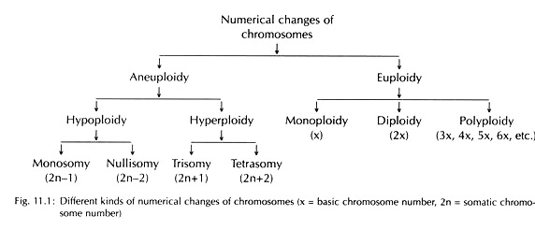
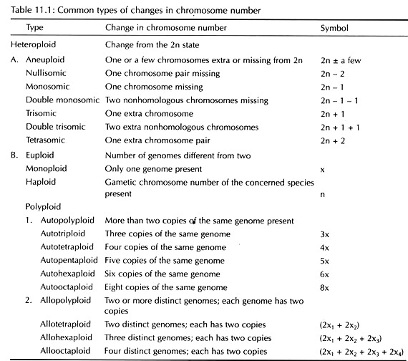

Balanced Tertiary Trisomics (BTT)
Balanced Tertiary Trisomics (BTT) described by Ramage in 1965 provide an alternative method for the continuous availability of male sterile line to be used as female parent for commercial hybrid seed production in Barley. A Balanced Tertiary Trisomic (BTT) is a heterozygous tertiary trisomic has genotype aaA with dominant male fertile allele A or Msthat is located on the extra translocated chromosome while the recessive allele ‘a’, also called male sterile allele ‘ms’ on the two normal chromosomes). BTT produces three types of functional female gametes and only one type of male gamete. This is because male gametes having extrachromosome are inviable and hence cannot be transmitted through pollen, but only by egg.
Selfing of BTT produces three kinds of progeny:
1) 70% homozygous recessive (aa or msms) diploids that are used as female parents in hybrid production.
2) 30% heterozygous (aaA or msmsMs) balanced tertiary trisomic. These are vigorous, male fertile and produce abundant pollen for effective wind or insect pollination.
3) 1.0% homozygous recessive primary trisomic. These are in less in proportion.
Using BTT, the first hybrid variety named “Hembar” was produced by Ramage and Weibe in 1969. Hembar was produced by crossing a commercial inbred cultivar ‘Arivat’ onto GENETICRECESSIVE MALE STERILE DIPLOID PLANTS. Because of problems of cross-fertilization, susceptibility of hybrid to ergot infection and the complexity of the system, BTT have not proved practical for implementing hybrid barley on a commercial scale.
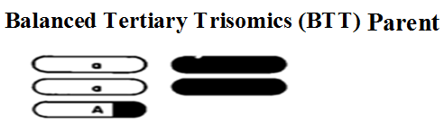
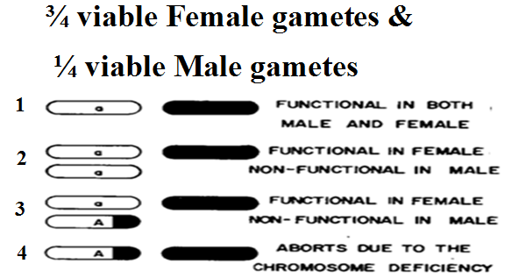
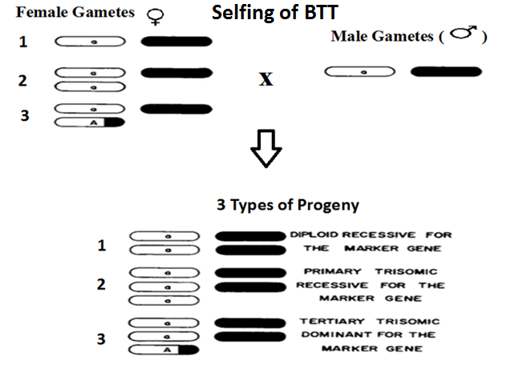

Trisomy
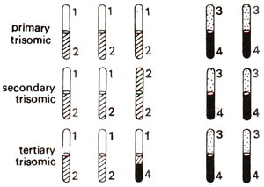
Fig. 20.2.Three kinds of trisomics.

One of the most extensively studied trisomic series is that produced and studied by T. Tsuchiya (who died in May, 1992) in barley. Trisomics are also known in Homo sapiens (human beings). Trisomy for certain chromosomes causes definite morphological abnormalities in human beings.
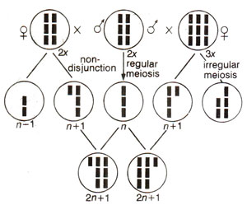
Fig. 20.4.Trisomic conditions associated with changes in fruit morphology in Datura stramonium.
Mongolism (Down's syndrome) is one such feature, which is common in children and is characterized by mental retardation, a short body, swollen tongue and eyelid folds resembling those of Mongolian races (for details, seeHuman Genetics). Other cases of trisomy are also known in a number of different plant and animal species.
Production of trisomics. Trisomics may originate spontaneously due to production of n + 1 type of gametes (Fig. 20.4) due to rare non-disjunction of a bivalent. However more often trisomics are produced artificially either by selfing triploids (triploids are produced by crossing diploids and autotetraploids) or by crossing these Triploids as females with diploids as male (3x x 2x). In either case trisomics are obtained in large number and can be identified through phenotypic effects of individual chromosomes.
Cytology of trisomics.
A trisomic has an extra chromosome which is homologous to one of the chromosomes of the complement. Therefore, it forms a trivalent. This trivalent may take a variety of shapes in primary and secondary trisomics as shown in Figure 20.5. In a tertiary trisomic a characteristic pentavalent is observed.
Trisomic analysis.
Trisomics are also used for locating genes on specific chromosomes. If a particular gene is located on the chromosome involved in trisomy, segregation in the progeny of this trisomic will not follow a Mendelian pattern, but the ratio will deviate from normal 3 : 1 F₂ and 1 : 1 test cross ratios. The expected ratios in trisomics can be worked out, and are given in Table 20.1. In Table 20.1, ratios based on chromosome segregation as well as those based on chromatid segregation are given. Chromosome segregation will hold good, when the gene is located very close to centromere permitting no crossing over between the gene and the centromere, so that both sister chromatids will be similar. In chromatid segregation, gene is located away from centromere permitting crossing over between gene and centromere.
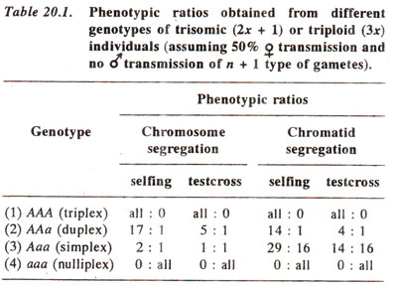

More in this section
Trisomics are those organisms, which have an extra chromosome (2n + 1). Since the extra chromosome may belong to any one of the different chromosomes of a haploid complement, the number of possible trisomics in an organism will be equal to its haploid chromosome number. For instance, we know that haploid chromosome number in barley is n = 7, consequently, seven trisomics are possible. Trisomics, where extra chromosome is identical to twohomologues, are called primary trisomics. Besides these, there are secondary and tertiary trisomics. While a secondary trisomic means that extra chromosome should be an isochromosome (both arms genetically similar), a tertiary trisomic would mean that extra chromosome should be a translocated one (Fig. 20.2). Trisomics were obtained for the first time in Datura stramonium (jimson weed) by A.F. Blakeslee and his co-workers. Since haploid chromosome number in this species is n = 12, 12 primary trisomics, 24 secondary trisomics and a large number of tertiary trisomics are possible. Most of the trisomics were identified by size, shape and other morphological features of the fruit (Fig. 20.3).
Fig. 20.2.Three kinds of trisomics.

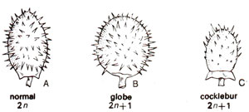
Fig. 20.3.Trisomic conditions associated with changes in fruit morphology in Datura stramonium.

Meiotic behavior of trisomics

The most characteristic feature of primary trisomics is the formation of a trivalent at metaphase-1 of meiosis. Secondary trisomics at metaphase-I forms mostly ring trivalents while tertiary trisomics form dumbbell shaped pentavalents.

Primary Trisomics: the trivalents in primary trisomics assumes different configurations such as chain, fry pan, triple arc and Y-shaped. The most common configuration in primary trisomic is chain trivalent. Based on the extent of pairing of chromosome and number of chiasmata formed at pachytene stage. For longer chromosomes that can form two chiasmata, frypan trivalents are frequently formed and for smaller chromoosmes which cannot form two chiasmata, the most frequent trivalent configuration is chain type.

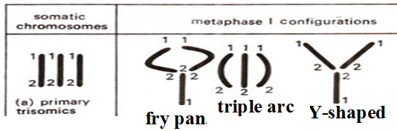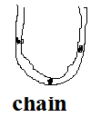
Secondary Trisomics:When the extra chromosome is an iso-chromosome, the aneuploid is called secondary trisomic; its formula is “2n + iso”. One chromosome arm is represented four times in the secondary trisomic.In secondary trisomics, chromosome configuration based on chromosome pairing may be a trivalent (1^{III}) or “bivalent + univalent” (1^{II} + 1^{I})and 3^{I}

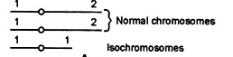

The most frequent trivalent configuration in secondary trisomics is ring trivalent (1^{III})
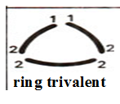
Sometimes both the normal homologues pair to form a bivalent, while both arms of the iso-chromosome pair together to form a U-shaped univalent(1^{II} + 1^{I}).

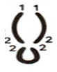

Tertiary Trisomic: A dumbbell shaped pentavalent configuration is formed at metaphase-I

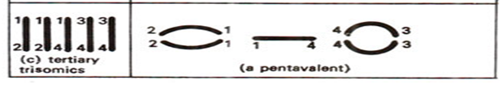

Uses of Trisomics
1. Secondary trisomics can be used to locate genes on specific chromosomesand finding out distance of these genes from centromere, a technique calledchromosome mapping.
2. They may be used to know the method of action of certain genes.
3. Primary trisomics are used in assigning linkage groups to specific chromosomes.

3. Tertiary Trisomics are used to produce female parent for hybrid seed production.
Trisomics in polyploids: trisomics have been produced in crops such as wheat (Triticumaestivum 2n = 6x = 42), oars (Avena sativa 2n = 6x = 42), tobacco (Nicotianatabacum 2n =4x = 48) and cotton (Gossypiumhirsutum 2n = 4x = 52). These trisomics in polyploids were resulted due to non-disjunction of homologous chromosomes. Sears produced complete set of trisomics only in ‘chinese spring’ variety of wheat by pollinating a haploid plant with the pollen from a normal wheat. These trisomicsressembled in morphology to hexaploid wheat.However more often trisomics are produced artificially either by selfing triploids or by crossing these Triploids as females with diploids as male (3x x 2x). In either case trisomics are obtained in large number. In wheat trisomics are used to obtain tetrasomics and the ‘compensating nullisomoc-tetrasomic’ lines which proved useful for establishing homeologous relationships.
In cotton trisomics, amphidiploids are first produced using diploid parents. The amphidiploids are then backcrossed to tetraploid cotton to isolate trisomics with 2n = 4x + 1 = 53 chromosomes. These trisomics are better called as alien addition lines or interspecific trisomics and resembled the characteristics of diploid species.
Tetrasomics in plants:Tetrasomics are individuals having an extra pair of homologous chromosomes.In diplods these will be represented as 2x + 2 and in tetraploid as 4x + 2 and in hexaploid as 6x+2. Tetrasomics have a particular chromosome represented in four doses (2n+2). The types of possible tetrasomics are equal to the haploid chromosome number of an organism. All 21 possible tetrasomics are available in wheat.Tetrasomicshave been originated in polyploid plants such as wheat, oat and cotton by selfing of trisomics. In wheat tetrasomics are used to obtain ‘compensating nullisomic-tetrasomic’ lines which proved useful for establishing homeologous relationships. However tetrasomics are not useful for chromosome mapping. Meiotic Behaviour of tetrasomics:During meiosis, the four homologues of the tetrasomic set tend to form a quadrivalent.
Wheat is unique in that it can tolerate a high degree of aneuploidy (abnormal chromosome number) because of its polyploid buffering capacity. Some of the most important and useful genetics stocks ever developed in wheat are the nullisomic–tetrasomic (NT) lines and the ditelosomic (dt) lines. NT lines are lacking one pair of chromosomes and the absence of the pair is compensated for by an extra pair of homoeologous chromosomes. Ditelosomic lines are lacking one pair of chromosome arms. For example, the line dt1AS has the complete normal chromosome constitution except that the long arms of the pair of 1A chromosomes are missing. Homeologous chromosomes (Partially homologous chromosomes) include chromosomes of different ‘genomes’ which pair occasionally in many interspecific hybrids or allopolyploids. R.L. Knight defines homoeologous chromosomes as ‘chromosomes that are homologous in parts of their length but are not homologous along their entire length as seen in homologous chromosomes.
Nullisomics
The cell, tissue or organism in which both the homologues of a chromosome are missing from the somatic chromosome complement is called nullisomic (2n-2), and the condition is called nullisomy. If two pairs of homologous chromosomes are absent, the cell, tissue or organism is known as double nullisomic (2n-2-2). Normally, nullisomics do not survive in diploids; but they survive in polyploid species.
Origin:
Nullisomics are obtained in the selfed progeny of monosomics where “n-1” type male and female gametes fuse to form “2n-2” zygote. Monosomic plants produce two types of gametes, (n) and (n-1).
Phenotype:
Nullisomics are weaker and less vigorous as compared to normal disomic plants. They show reduced size, vigour and fertility. All the 21 possible nullisomics in wheat were developed by Sears.
Uses of Nullisomics:
1. Nullisomics can be used to identify the groups of homoeologous chromosomes. In allopolyploid species like wheat {In ~6x = 42) the effects of nullisomy for particular chromosome may be compensated by tetrasomy for a specific chromosome of the complement.
For example, effects of nullisomy for chromosome 20 (= 2D) in the variety Chinese Spring were compensated by the tetrasomy for chromosome 2 (= 2B) or chromosome 13 (= 2A), while effects of nullisomy for chromosome 17 (= ID) was compensated by chromosome 1 = IB) or 14 (= 1A).
By making all possible combinations of nullisomics and tetrasomics, and selecting those where compensation occurred, Sears in 1954 and Sears and Okamoto in 1957 could classify all the homoeologous chromosomes in the three genomes (A, B and D), viz., (i) 1A to 7A, (ii) IB to 7B and (iii) ID to 7D.
2. Nullisomics are used to locate genes on particular chromosomes.
3. Production of substitution lines:
The production of substitution lines using nullisomics requires a good fertility and reasonable vigour in the nullisomic for the chromosome to be substituted. In wheat, nullisomic-7B and nullisomic-7D have reasonable fertility, while nullisomics for the other chromosomes are very low in vigour and fertility. The following is a generalised procedure for the production of substitution lines.
(i) The nullisomic line is crossed to the donor variety. The F₁ progeny will be monosomic, and the monosomic will be contributed by the donor variety.
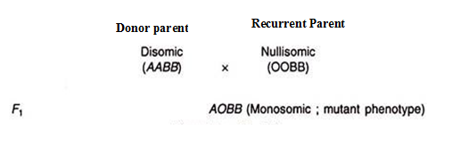
(ii) The F₁ (monosomic) is back crossed to the nullisomic line (used as female). Monosomic plants are selected from the back cross progeny and are back crossed to the nullisomic lines; this is repeated till 5-6 back crosses have been made. In the 6th backcross generation, the genotype of the recurrent parent would be almost completely recovered (Figure below).
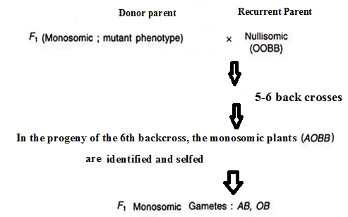
(iii) In the progeny of the 6th backcross, the monosomic plants are identified and selfed, and disomic plants (AABB) are selected from the F2 progeny as shown below.These plants will possess the substituted chromosome from the donor variety in the background of the nullisomic variety.
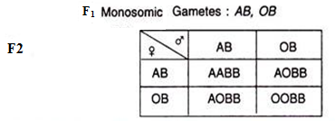

Use of nullisomics in locating genes on chromosomes
Nullisomics are used to assign genes to particular chromosomes. If the dominant mutant gene (A) to be located is present in the chromosome of a disomic parent, then a cross between this disomic line (AABB) and nullisomic line for gene (B) but disomic for gene A will produce allmonosomicF₁ plants. The F₁monosomic plants are selfed and the segregation for the concerned gene (A) is studied in F₂.
If the concerned gene (A) is located in the chromosome of anullisomic parent (in other words, if the nullisomic parent is disomic for the concerned mutant gene), then in F2 both (Fig. 16.8) mutant and nonmutant phenotypes will appear in all the types of F₂ plants, viz., disomic, monosomic and nullisomic plants. In case of nullisomics, the frequency of mutant and nonmutant phenotypes will be 3: 1.

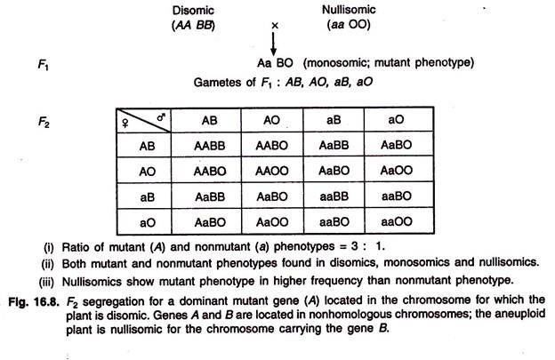
On the other hand, if the dominant mutant gene is located in the chromosome of a disomic parent when crossed toparentnullisomicfor the concerned gene (A) (That is, the nullisomic line lack the concerned dominant gene but disomic for the other gene) (Fig. 16.9), all the nullisomics will show the non-mutant phenotype in the F₂, while all the other types of plants, viz., disomics and monosomics will exhibit the mutant phenotype.

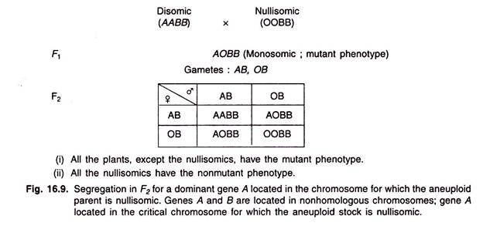

A monosomic maize plant contains one copy of one chromosome and two copies of each of the other nine chromosomes (2n - 1 = 2x - 1 = 19 chromosomes). There is a genetic system in maize, the r-Xl system that generates a high frequency of monosomic andtrisomic plants.
The r-Xl Deficiency: The r-Xl deficiency, a deficiency that includes the R locus on chromosome 10 in maize, was X-ray induced by L. J. Stadler (unpublished). The dominant allele of the R locus is necessary for anthocyanin production. Plants germinated from colorless kernels (that contain the r-Xl deficiency) include monosomics and trisomics along with diploids. Clearly, a factor on chromosome 10 that is necessary for normal chromosome disjunction is deleted in the r-Xl deficiency. Nearly all of the monosomics produced by the r-Xl system have a chromosome missing from the entire plant. Each of the monosomic types is distinctively smaller but remarkably vigorousthan its diploid siblings. Using r-Xl system several thousand maize monosomics that include monosomies for each of the 10 chromosomes were generated.
Some Characteristics of the r-Xl System:Some of the characteristics of the r-Xl deficiency are as follows:
(1) It is submicroscopic (too small to be detected using the light microscope).
(2) It is transmitted with a high efficiency through female gametes; however, pollen grains containing it do not function even though they appear to be morphologically normal.
(3) It is due tonondisjunctionat the second mitosis of the three embryo sac divisions (during embryo sac development).
(4) The genetic background influences the activity of the r-Xl system.
Application of r-Xl System
It has also been used successfully to assign a biochemical marker (the benzoxazinless locus), a histone electrophoretic variant, and an isozyme locus of peroxidase to the respective chromosomes. Monosomics have been compared with diploid sibling plants in studies of gene dosage effects on factors controlling the level and composition of embryo lipids, the free fatty acid composition in leaves, and recombination. The system also can be an efficient and economical means for assigning cloned DNA fragments to specific chromosomes.

Alien-gene transfer through chromosome manipulations
The success of introducing alien variation into crop species from related species depends on the cytogenetic relations between the species. If there are no restrictions on chromosome pairing and recombination in species hybrids, a backcrossing programme can be used to obtain the desired gene transfers. However, when there is a failure of adequate chromosome pairing in species hybrids, techniques of chromosome manipulation have to be used to obtain alien gene transfers. In polyploid crop species it is possible to introduce appropriate single chromosomes of the alien species into the genotype of the recipient species, but the failure of the alien chromosome to become integrated into the genotype of the recipient species often leads to meiotic instability. The introduction of segments of alien chromosomes has been successful through the use of irradiation-induced translocations. The deletions/duplications that are a consequence of such translocations do limit the usefulness of this approach. In a number of allopolyploid crop species, regular bivalent pairing behaviour has been shown to be genetically controlled. By interfering with the genetic system controlling the diploid-like pairing it is possible to induce pairing between the alien chromosomes and its corresponding chromosomes in the crop species. Gene transfers based on this method involve exchanges between chromosomes of similar gene sequences.
Genetic-induced gene transfers
The failure of alien chromosomes to pair with their corresponding chromosomes in the cultivated species is not always associated with structural differentiation of the chromosomes but with the genetic control of chromosome pairing. In wheat, regular bivalent pairing is controlled by the Ph gene on the long arm of chromosome 5B. The Ph gene restricts pairing to homologous chromosomes and the homoeologues of the three constituent genomes synapse and form chiasmata associations only when chromosome 5B is deleted. The presence of such a genetic system in natural allopolyploids is also responsible for minimizing pairing between alien chromosomes and their homoeologues in the crop species. The relaxation of the control mechanism leads to pairing between alien chromosomes and the corresponding wheat chromosomes. By manipulating the control mechanism to allow homoeologous chromosomes to pair have been able to induce alien chromosomes to pair with their homoeologues in wheat and isolate recombinants including genes located on the alien chromosome. Riley etal.(1968) used genotypes of Aegilops speltoides, which suppresses the activity of the Ph gene, while Sears (1973), using the appropriate aneuploid lines, deleted chromosome 5B to induce pairing between alien chromosomes and their homoeologues in wheat.
Irradiation -induced translocations:
Sears (1956) was the first to use irradiation-induced translocations to transfer resistance to brown rust from Aegilops umbellulata to bread wheat. The technique relies on chromosomes rejoining in novel combinations after chromosome breakage induced by the irradiation treatment. Sears (1956) irradiated spikes, just before anthesis, of plants with additions of isochromosomes of Aegilops umbellulata carrying a gene for resistance to brown rust, and isolated gene transfers in subsequent progeny. Irradiation of dry seeds of the disomic alien addition can also be successfully used to induce translocations (Driscoll & Jensen 1963). In gene transfers based on irradiation-induced translocations there is a deletion of part of the genome of the recipient species and a duplication arising from the alien segment introduced. The usefulness of the gene transfers will depend on the ability of the genotype to tolerate such deletions and duplications.

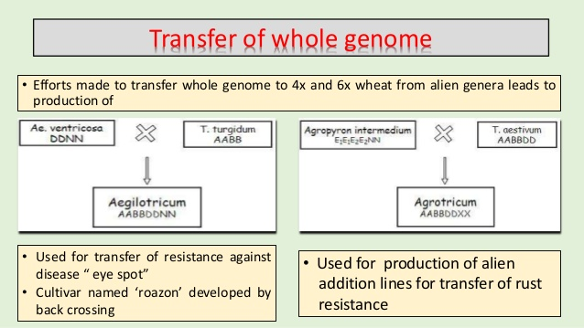
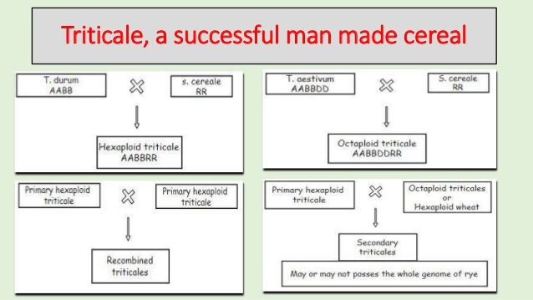
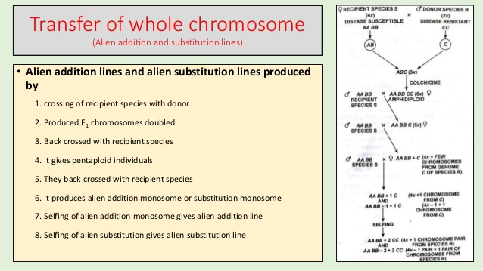
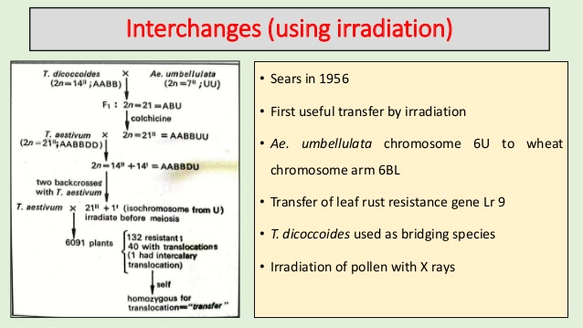

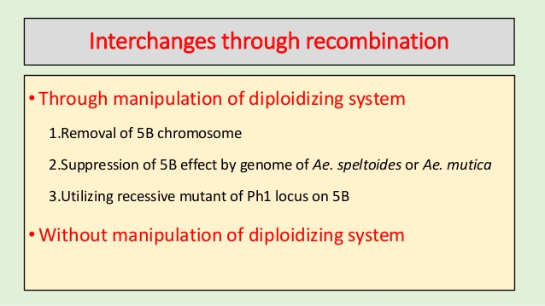
Transfer of genome in the genus Arachis
Cultivated peanut is an allotetraploid (2n = 4× = 40 chromosomes) with two genome types, A and B, which are found separately in the wild species of the Arachis section. The A-genome species are diploids characterized by the presence of a so-called A chromosome pair, of reduced size and with a lower level of euchromatin condensation in comparison to the other chromosomes. Diploid species of the section Arachis with 2n = 20 and lacking the A chromosome pair are usually considered to share the B-type genome, although they are much more heterogeneous and may present variant forms of this B-genome. Cultivated allotetraploid peanut Arachis hypogaea was originated via hybridization of two diploid wild species, probably A. duranensis (A-genome) and A. ipaënsis (B-genome), followed by a rare spontaneous duplication of chromosomes. The resulting tetraploid plant would have been reproductively isolated from its wild diploid relatives. This isolation, coupled with the origin through a probably single hybridization event, leads to a limited genetic diversity of peanut, as observed in different studies using molecular markers. In contrast, wild diploid Arachis species are genetically more diverse providing a rich source of variation for agronomical traits, and DNA polymorphisms for genetic and genomic studies.
Although the cultivated germplasm contains a large amount of genetic variability for various traits, it lacks sources of resistance to several important pests and pathogens. Nevertheless, wild Arachis species with genes conferring high levels of resistance to these diseases have been identified. The development of strategies to utilize wild species has become extremely important in the genetic improvement of groundnut. utotetraploids of wild peanut species have either AAAA or BBBB genomes, so crosses with cultivated peanut (AABB genomes) are partially sterile. The method of crossing A. hypogaea with autotetraploids does not work well with peanut.
Crossing AABB synthetic polyploids derived from A‐ and B‐genome diploid species with cultivated peanut is the preferred method to introgress wild species germplasm, although several generations of selection are still required to stabilize genomes and obtain highly fertile progenies. The method of choice for peanut is to first produce A‐genome × B‐genome species crosses and then double the chromosome number of the sterile AB genome F₁ hybrid. Seeds obtained from the colchine‐treated cuttings will all be semifertile AABB genome amphidiploids that can then be used as a male parent in crosses with A. hypogaea.
Using the approach of making AABB genome synthetic polyploids, the species A. duranensis and A. ipaënsis were hybridized, the chromosome number was doubled, and the hybrid was crossed to the cultivar Fleur 11 to study genomewide segment introgression of peanut species into the cultivated genome (Foncéka et al., 2009). Marker‐assisted selection was used in the BC₁F₁ and BC₂F₁ generations to select lines with donor segments and the highest percentage of the cultivated genome. Their work is leading to broadening of the genetic base of the cultivated peanut and has provided a proof of concept for introgressing genes in a systematic approach from diploid species into cultivated peanut.
An example of success with producing synthetic amphiploids are TxAg‐6 and Tx Ag‐7 (Simpson et al., 1993), which originated from the complex hybrid {A. batizocoi (B genome) × [A. cardenasii (A genome) × A. diogoi (A genome)]}^{4x}. TxAG‐6 has very good nematode resistance, but also significant linkage drag, which resulted in low yields and poor pod and seed quality. The RFLP markers linked to the nematode gene conferring resistan

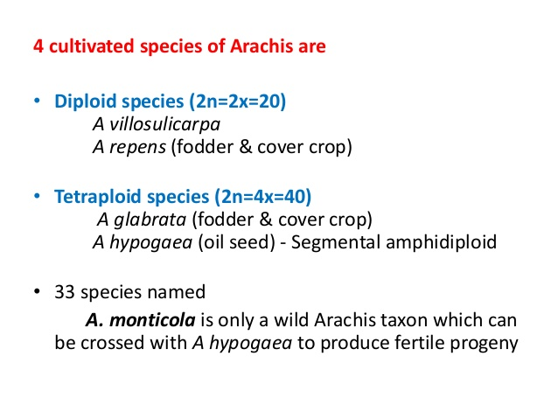
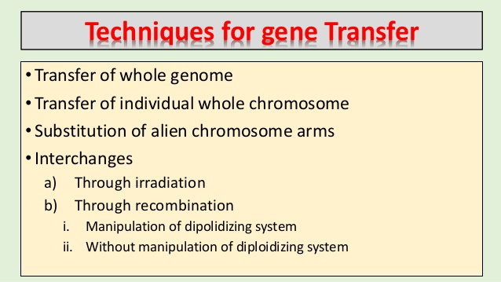
UNIT V
Transfer of individual whole chromosome -alien addition lines-alien substitution lines; Apomixis:
1. Alien addition lines: Carries one chromosome pair from a different species in addition to somatic chromosome complement. For Eg. Disease resistance in Wheat, oats, tobacco
2. Alien substitution lines:replacement of one chromosome pair of cultivated species with the chromosome pair of wild donor species.
3. Introgression of genes: Transfer of small chromosome segments with desirable genes from wild species into cultivated species. Introgression of genes from one species into another species by back cross method is known as introgressive hybridization.
Eg. Disease resistance, improving qulaity and Wide adaptation.

Alien addition Lines:
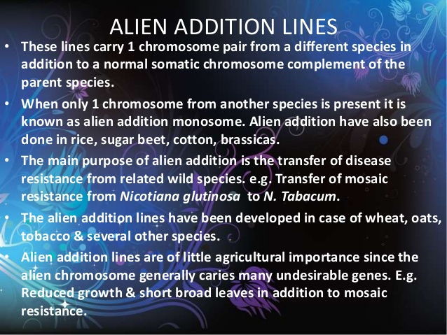
Interspecies hybridization and backcrossing is a means to transfer desirable genes from one species to another in breeding programs of higher plants. Monosomic alien addition lines (MAALs) can be produced via addition of single chromosome of an alien donor species to the entire chromosome complement of the recipient species. Monosomic alien addition lines (MAALs) are valuable for elucidating the genome structure and transferring the useful genes and traits in plant breeding. Backcrossing of MAALs to the recipient parent results in plants containing short overlapping introgressions, which cover the entire donor genome. These introgression lines can be used as vectors of alien genomic libraries in a recipient genetic background. In addition, a complete set of MAALs also serves as a library of the donor genome dissected into individual chromosome entities, which facilitates high-throughput marker allocation to individual donor chromosomes, and marker assignments and syntenic relationships can be compared between the donor chromosomes and the respective orthologous recipient chromosomes. Meanwhile, MAALs can be used to study the introgression mechanism and the pairing status of homologous chromosomes.

Alien substitution lines: Alien Substitution takes place when chromosome(s) of another species replace the own chromosome(s) of a species. Alien substitutions may be obtained from alien addition lines. However, monosomic lines are used most commonly. Monosomic lines can be maintained without too many difficulties in polyploids, because the genomes are better balanced. Monosomic plants produce some eggs that are nullisomic. These recipients are then crossed with a donor species. In the F₁ the chromosome absent in the parent nullisomic will appear as a monosome of the donor. These monosomic individuals are repeatedly backcrossed (6–8 times) with the recipient, until in some individuals all the chromosomes of the donor are eliminated, except that particular monosome. Selfing this monosomic substitution line results in a disomic substitution that has the same chromosome number as the euploid line from which the nullisomic arose, but one pair of the chromosomes will represent the donor. Alien substitution lines have been developed in wheat, cotton tobacco, oats, etc • In case of tobacco, mosaic resistant gene N was transferred from N. glutinosa to N. tabacum line had 24 pairs of N. tabacum chromosomes & 1 pair of N. glutinosa chromosomes. • The alien substitution show more undesirable effects than alien addition & as a consequence are of no direct use in agriculture.
Chromosome Painting:
The term chromosome painting was first used by Pinkel et al. in 1988 that describes direct visualization, using in situ hybridization, of specific chromosomes in metaphase spreads and in interphase nuclei. Chromosome painting, coupled with fluorescence in situ hybridisation (FISH), is now used routinely to enhance the identification of chromosomal rearrangements such as chromosomal translocations, the assignment of breakpoints/deletions, and the determination of the origin of extra chromosomal material. In short chromosome painting helps in the identification of both numerical and structural chromosomal aberrations in human pathology with high sensitivity and specificity. As a result, chromosome painting has rapidly become an established routine procedure in cytogenetic investigations.
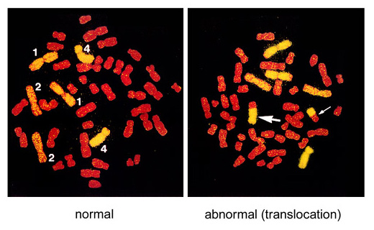
Figure. An example of FISH-treated metaphase chromosomes. Here, chromosomes 1, 2, and 4 were labeled yellow with FISH and the other chromosomes were stained red. Translocations between yellow and red chromosomes are detected. The left picture represents a normal cell (the numbers in the figure indicate chromosome numbers) and the right picture is an example of reciprocal translocation with two bi-color chromosomes (indicated by two arrows).
In this way, if a part of a painted chromosome (yellow, for example) had undergone an exchange with another, non-painted chromosomes (stained red), it is possible to detect the aberration (termed a reciprocal translocation) because the aberrant chromosome contains both yellow and red segments. Usually, a pair of bi-colored chromosomes can be detected in one metaphase because two chromosomes typically exchange a part of their DNA.
Procedure of chromosome painting:
- The usual starting material for the production of a chromosome paint is to isolate each human chromosome.
- DNA from these chromosomes was amplified either by polymerase chain reaction (PCR) or enzymatic digestion and molecular cloning into a bacterial vector.
- These amplified DNA fragments are labeled with appropriate fluorescent (light-emitting) dyes such as fluorochrome (fluorescein isothiocyanate (FITC-dUTP) or biotin-dUTP and allowed to hybridize (attach) to metaphase chromosomes or interphase nuclei. The fluorescent-labeled DNAs will attach to the analogous chromosomes from which they were derived. (DNA fragments with the same base sequences have the characteristic of attaching to each other.)
- Confocal laser scanning microscopy: Visualisation of the labelled DNA with a rabbit anti-FITC antibody followed by a goat anti-rabbit FITC conjugated antibody or enzyme conjugated affinity reagent systems such as streptavidin-HRP (horse radish peroxidase) results in the painted chromosome being strikingly identified in metaphase spreads and interphase nuclei.
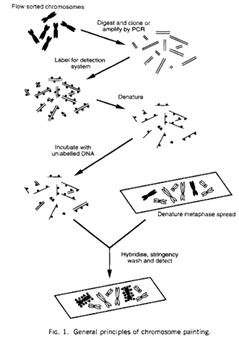
Chromosome Walking: Chromosome walking is a technique used to clone a gene (e.g., disease gene) from its known closest markers (e.g., known gene) and hence is used in moderate modifications in cloning and sequencing projects in plants, fungi, and animals. In another words, it is used to identify, isolate, and clone a particular sequence present in close vicinity of the gene to be mapped. Libraries of large fragments, mainly bacterial artificial chromosome libraries, are mostly used in genomic projects. Primer walking is a method to determine the sequence of DNA up to the 1.3–7.0 kb range whereas chromosome walking is used to produce the clones of already known sequences of the gene. To identify the desired colony and to select a particular clone the library is screened first with a desired probe. After screening, the clone is overlapped with the probe and overlapping fragments are mapped. These fragments are then used as a new probe (short DNA fragments obtained from the 3′ or 5′ ends of clones) to identify other clones. A library approximately consists of 96 clones and each clone contains a different insert. Probe one identifies λ1 and λ2 as it overlaps them (Fig. 4.5). Probe two derived from λ2 clones is used to identify λ3, and so on. Orientation of the clones is determined by restriction mapping of the clones. Thus, new chromosomal regions present in the vicinity of a gene could be identified. Protocol for chromosomal walking of DNA is described in Fig. 4.7.
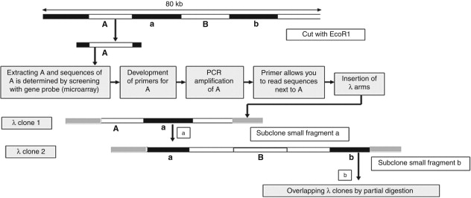
Fig: Procedure for chromosome walking of DNA
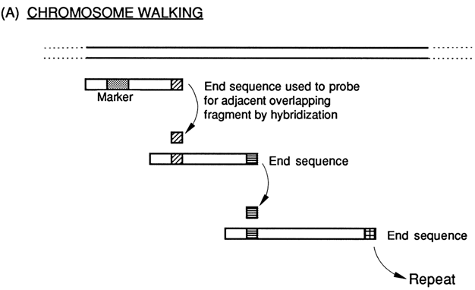

Chromosome jumping is a tool of molecular biology that is used in the physical mapping of genomes. It is related to several other tools used for the same purpose, including chromosome walking. Chromosome jumping is used to bypass regions difficult to clone, such as those containing repetitive DNA, that cannot be easily mapped by chromosome walking, and is useful in moving along a chromosome rapidly in search of a particular gene.
Chromosome jumping allows more rapid movement through the genome compared to other techniques, such as chromosome walking, and can be used to generate genomic markers with known chromosomal locations. Chromosome jumping enables two ends of a DNA sequence to be cloned without the middle section. Genomic DNA may be partially digested using restriction endonucleases and with the aid of DNA ligase, the fragments are circularized.^{[2]} From a known sequence, a primer is designed to sequence across the circularised junction. This primer is used to jump 100 kb-300 kb intervals: a sequence 100 kb away would have come near the known sequence on circularisation. Thus, sequences not reachable by chromosome walking can be sequenced.
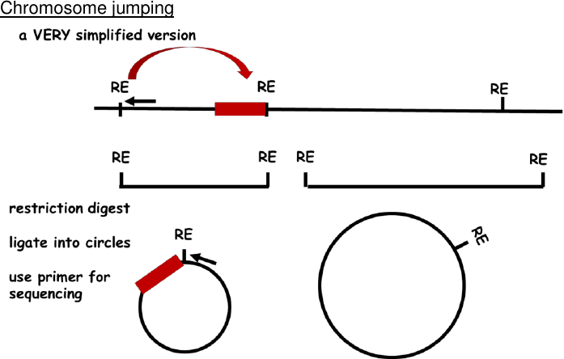
Artificial chromosome construction and its uses: For many years, plasmids were used to clone DNA fragments of 1–30 kb. Larger DNA fragments (inserts) are difficult to clone. Then researchers began to use artificial chromosomes— a large DNA vectors such as P1 artificial chromosomes (PACs), bacterial artificial chromosomes (BACs) and yeast artificial chromosomes (YACs) listed in order of size from small to large. Similar to endogenous chromosomes, Artificial Chromosomes can replicate and segregate autonomously without integration into the host chromosome. ACs can broadly be classified into two groups: linear ACs (YACs) and circular ACs (BACs and PACs). However, YACs are linear and requires a number of cis-acting elements for successful maintenance in vivo. It consists of 1) yeast centromeric repeat, used for maintaining stability during the cell cycle and mitotic segregation 2) a replication origin, to maintain faithful DNA replication 3) telomere sequence, to maintain linearity. YACs are able to maintain large fragments of DNA, hundreds of kilobases in size (100-1000 kb), making them useful for sequencing and mapping experiments. As a result, YACs were first used to create physical maps of human DNA, and were subsequently used as part of the Human Genome Project. While YACs have proven useful for mapping and sequencing projects, there are some limitations. For instance, there have been reports that a large fraction of YAC clones are often unstable, exhibiting chimerism, deletions, and rearrangements of inserts. Chimerism means a single clone may contain inserts from multiple genomic locations. As a result clones must be screened before they can be used, an expensive and time-consuming process. In addition, constructs must be grown in yeast, which are generally slower growing than E. coli. Lastly, there is nothing preventing a cell from harboring multiple YACs, which could potentially complicate further studies.
As the Human Genome Project was beginning in the early 1990s, researchers were seeking an alternative to YACs for creating libraries To accomplish this, Circular ACs were created with an origin of replication and an episomal maintenance element or a method of chromosome integration. The BAC was created based on the F-factor (the naturally occurring sex factor plasmids of E. coli) for episomal maintainenace, which allows stable maintenance of 300 kb of DNA fragments in E. coli. Due to their presence in E. coli, BACs can be maintained in a circular form. Due to the F-factor, BACs can only be maintained as single copy, which, contrary to the YAC system, means that it is not possible to have different inserts in the same cell. The BAC system has been shown to be able to stably maintain DNA fragments of 150–350 kb and can be easily extracted from cells through an alkaline lysis protocol. As a result of their ease of production and purification, BACs quickly served as the go-to method for construction of genomic libraries, with libraries of Arabidopsis, rice, and of complex organisms—including those representing the human and mouse genomes. It was found that BACs could be used to create transgenics through pronuclear injection in mice, and microinjection in zebrafish. In plants, BACs have also been used for transformation of large DNA fragments via particle bombardment.
In contrast to YAC clones, P1 artificial chromosomes (PACs) and bacterial artificial chromosomes (BACs) are generally stable and not typically chimeric. Because average insert sizes range from 90 to 300 Kb, a typical gene and its flanking regulatory sequences are often encompassed within a single clone. The basic elements of the P1 artificial chromosomes PAC vectors are derived from P1, a temperate phage with a genome that is approximately 100 kb long. Both cloning systems (PACs and BACs) are relatively new.
Uses of Artificial Chromosomes
- YACs and BACs were used to create physical maps of human DNA, and were subsequently used as for genome sequencing as a part of the Human Genome Project.
- BACs could be used to create transgenics in mice, zebrafish and plants.
- Sequencing the candidate gene to look for mutations or creating a targeted mutation in a candidate gene.
- Rescuing the phenotype by over-expressing the wild-type allele in a transgenic mouse. For example, the use of a YAC or BAC carrying the entire frataxin gene has rescued frataxin knock-out mice from embryonic lethality.
- Artificial chromosomes are said to be a better candidates as vectors for gene therapy.
- To understand chromosome function.
Note: you tube https://www.genome.gov/genetics-glossary/Bacterial-Artificial-Chromosome
Unit VI: Fertilization barriers in crop plants at pre-and post -fertilization levels; In vitro techniques to overcome the fertilization barriers in crops; chromosome manipulations in wide hybridization; case studies-Production and use of haploids, dihaploids and doubled haploids in genetics and breeding.

Introduction: When individuals from two different species of the same genera are crossed, it is known as inter specific hybridization. Such hybrids vary from completely sterile to completely fertile and hence used in crop improvement. Eg. Inter specific hybridization :Eg. Oryzasativa x O. perennis. When individuals being crossed belong to two different genera, it is referred to as inter generic hybridization. Intergeneric hybrids are always sterile and cannot be commonly used in crop improvement. Eg. Triticale (Wheat x rye).
Hybridization between individuals from different species belonging to the same genus or two different genera, is termed as distant hybridization or wide hybridization, and such crosses are known as distant crosses or wide crosses.
History
1.The first distant hybridization; hybrid between carnation (Dianthus caryophyllus) and sweet william (Dianthus barbatus) by Thomas Fairchild in 1717 and the hybrid is called as fairchilds mule.
2. Most of the interspecific hybrids were of no agricultural value many interspecific hybrids particularly in case ornamentals, served as commercial varieties.
3. An interesting inter generic hybrid Raphano brassica was an amphidiploid cross between radish and cabbage but it was useless.
4. The first inter generic hybrid with a great potential was TRITICALE
Objectives:
1. To transfer some desirable character from wild relatives that are not available in cultivated varieties. Eg. Many disease resistance and, insect resistance genes, Wide adaptability : (i.e. drought-resistance, cold tolerance etc.), Quality improvement (Eg. Cotton (fibre) Tobacco (leaf), Yield improvement (Eg. Oats, Tobacco, Maize, S. cane) Other characters (Eg. CMS, Earliness, dwarfness morphological characters)
2. Exploitation of luxuriance (heterosis) in vegetatively propagated / ornamental crops. Prolonged vegetative period, Prolonged blooming period.
3. Creation of Novel genotypes: New species or F1 hybrids hither to non – existent in nature.
BARRIERS TO THE PRODUCTION OF DISTANT HYBRIDS
1. Failure of zygote formation / Cross incompatibility
2. Failure of zygote development / Hybrid inviability
3. Failure of F1 seedling development / Hybrid sterility
4. Hybrid Breakdown: F1 is fertile and vigorous but F₂ is weak and sterile.
A variety of mechanisms may be responsible for each of these three difficulties :
1. Failure of zygote formation / cross incompatibility: Inability of the functional pollens of one species or genera to effect fertilization of the female gametes of another species or genera is referred to as cross incompatibility. It may be due to – 1. failure of fertilization, because the pollen may not germinate. 2. Pollen tube is unable to reach to embryo sac and hence sperms are not available for fertilization. 3. Pollen tube may burst in the style of another species Eg. Datura. 4. The style of the female parent may be longer than the usual length of the pollen tube growth therefore the pollen does not reach the embryo sac. Eg. Zea mays and Tripsacum sp. 5. Pollen tubes of polyploidy species are usually thicker than those of diploid species. 6. When a diploid is used as female and a polyploidy as male, the polyploidy pollen tube grows at a slower rate in the diploid style than it would be in a polyploid style.
These barriers are known as pre-fertilization barriers.
2. Failure of zygote Development / Hybrid inviability: The inability of a hybrid zygote to grow into a normal embryo under the usual conditions of development is referred to as hybrid inviability. This may be due to: Lethal genes: some species carry a lethal gene, which causes death of the interspecific hybrid zygote during early embryonic development. Eg. 1. Aegilopsumbellulata carries a lethal gene with 3 alleles against diploid wheats.
2. unfavourable interaction between the two parental genomes.
3. Chromosome elimination: In somecases of distant hybridization, chromosomes are gradually eliminated from the zygote. In a cross between Hordeumbulbosum x H. vulgareChromosomes from one species (H. bulbosum) are successively eliminated from zygote due to mitotic irregularities. This bulbosum technique results in generation of haploids.
4. Incompatible cytoplasm: Embryo development may be blocked by an incompatibility between cytoplasm of the species used as female and the nuclear genes of the species used as male. Such an interaction, more generally, leads to hybrid weakness and male sterility in the hybrids or may some times leads to failure of embryo developments.
5. Endosperm Abortion: Seeds from a large number of distant crosses are not fully developed and are Shrunken due to poorly developed endosperm. Such seeds show poor germination, and may often fail to germinate. When the endosperm development is poor or is blocked, the condition is generally known as endosperm abortion.
Eg. 1. Triticum x secale – Triticale. In this case the endosperm aborts at a much later stage so that a small frequency of viable seed is obtained. 2. Hordiumbulbosum x H. vulgare – the endosperm aborts at an early stage so that viable seeds are not produced. In case of endosperm abortion - embryo rescue culture is practiced.
3. Failure of Hybrid seedling development / Hybrid sterility:Hybrid sterility refers to the inability of a hybrid to produce viable off spring. Some distant hybrids die during seedling development or even after initiation of flowering. The mechanisms involved in the failure of seedling development most likely involve complementary lethal genes. Eg. 1. In cotton-certain interspecific hybrids appear normal, but die in various stages of seedling growth; some plants die at flowering. The main cause of hybrid sterility is lack of structural homology between the chromosomes of two species. Sometimes, sterility is due to small structural changes that cannot be detected during meisosis. Stebbins termed it as criptic structural hybridity.
In vitro techniques to overcome the fertilization barriers in crops
Wild species are an important reservoir of useful genes for resistance to major diseases and pests, tolerance to abiotic stresses and cytoplasmic male sterility. However, several problems occur when transferring useful genes from wild species to cultivated rice. The barrier most commonly encountered is lack of crossability resulting from chromosomal and genic differences.
- Protoplast fusion: The wide crosses can be obtained through protoplast fusion, when it is not possible to produce such crosses through sexual fusion.
- Embryo rescue: This technique is being used widely to obtain viable interspecific or intergeneric hybrids. This is used when hybrid embryo is unable to develop due to endosperm degeneration. H. Vulgare x Secale cereale. In this technique proembryo is dissected 3-5 days after pollination, cultured on solid agar medium to get plantlets. The drawbacks are high cost of obtaining new plantlets, induction of new mutations in the invitro phase, requirement of sophisticated equipment and green house facilities, requirement of specialized skills in in vitro operation.

CHROMOSOME MANIPULATION IN DISTANT HYBRIDIZATION
- Chromosome manipulation - The term chromosome manipulation or chromosome engineering describes process or technologies in which chromosomes are manipulated to change their mode of genetic inheritance.
- Distant hybridization - a cross of two individuals belonging to different species (interspecific hybridization) or genera , it is called as intergeneric hybridization
TYPES OF CHROMOSOMES MANIPULATION
- Incorporation of a single or fragments of chromosome from a wild into the existing crops to enhance the genetic diversity
- Incorporation of an alien chromosome by chromosomes doubling in order to produce amphidiploids
- Elimination of an alien chromosome in order to induce haploids.
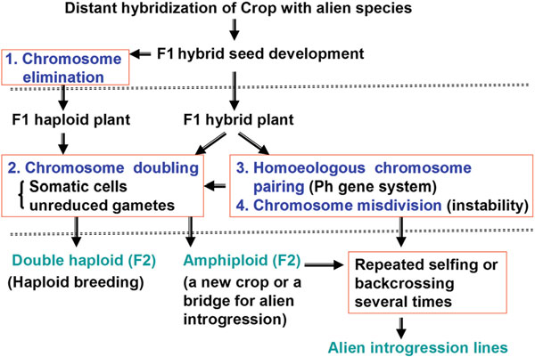
Fig. 1. Chromosome manipulation based on chromosome behaviors in F 1 hybrids
Chromosomes elimination and haploid crops: Chromosomes elimination mediated techniques are the method of choice for haploid production, for gene mapping and other breeding studies in cereals. Chromosome elimination is the degeration of one parental chromosome in F1 hybrid due to inactivation of kinetochore function. After chromosome doubling by colchicines treatment results in production of doubled haploids. For example, the generated F1 plants from the cross between wheat x job`s tears carries 21 chromosomes indicating the complete elimination of chromosomes of job`s tears. Colchicine treated F1 plants showed to carry 42 chromosomes (doubled haploid) i.e. the normal chromosomes of common wheat. Here Job`s tears can be used as a suitable pollen donor plant for haploid wheat production. In barley, haploid production termed bublbosum technique is the result of wide hybridization between cultivated barley (Hordeum vulgare, 2n=2x=14) as the female and wild H. bulbosum (2n=2x=14) as the male. After fertilization, a hybrid embryo containing the chromosomes of both parents is produced. During early embryogenesis, chromosomes of the wild relative (H.bulbosum) are preferentially eliminated from the cells of developing embryo, leading to the formation of a haploid embryo, which is due to the failure of endosperm development. A haploid embryo is later extracted and grown in vitro. The ‘bulbosum’ method was the first haploid induction method to produce large numbers of haploids across most genotypes and quickly entered into breeding programs. Pollination with maize pollen could also be used for the production of haploid barley plants, but at lower frequencies. Paternal chromosome elimination has also been observed after interspecific crosses between wheat (Triticum aestivum) and maize. After pollination, a hybrid embryo between wheat and maize develops but, in the further process, the maize chromosomes are eliminated so that haploid wheat plantlets can be obtained. Such haploid wheat embryos usually cannot develop further when left on the plant, because the endosperm fails to develop in such seeds. By applying growth regulator 2,4-dichlorophenoxyacetic acid in planta, embryo growth is maintained to the stage suitable for embryo isolation and further in vitro culture. The maize chromosome elimination system in wheat enables the production of large Haploids and Doubled Haploids in Plant Breeding. This ‘bulbosum’ method developed by Kasha and Kao in 1970 was first haploid induction method to produce large numbers of haploids across most genotypes and quickly adapted into breeding programs. The tetraploid female S. tuberosum (Solanum tuberosum L. ssp. tuberosum, 2n=4x) produces an embryo sac containing one egg cell and two endosperm nuclei, all with the genetic constitution n=2x. After pollination with S. phurea (2n=2x), dihaploid (2n=2x) embryos can develop from un-fertilized egg cells. The frequency of dihaploid seeds is low. Dihaploid potatoes can be used for breeding purposes, including alien germplasm introgression or selection at the diploid level, but such plants are not homozygous.
- Chromosomes doubling and amphidiploids: Chromosome doubling can be carried out through the treatment with antimicrotubule drugs, Colchicine (originally extracted from autumn crocus ( Colchicum autumnale ).
- Homeologous chromosomes pairing: Bread wheat (Triticum aestivum) contains three closely related genomes: A, B and D. Chromosome pairing during meiosis in this allohexaploid is confined to strict homologues, despite the co‐existence in the genome of homoeologous chromosomes. Diploid‐like behaviour results in 21 bivalents at meiotic metaphase I. In polyploid wheat, the diploid-like chromosome pairing is principally controlled by the pairing homoeologous1 (Ph1) gene on the long arm of chromosome 5B via preventing homeologous chromosome pairing (HECP). The manipulation of this gene can be used to induce recombination between chromosomes that will not normally pair at meiosis. This has application in the introduction of new genetic information into wheat. That is, improving the efficiency of alien introgression development.
Advantages of chromosomes manipulation
- Increase genetic diversity
- Produce variability and varieties
- Production of gene introgression lines
- Overcoming barriers of distant hybridization
Limitation
- Limited knowledge on process of gene expression and intremediary metabolism
- Complex nature of DNA

Production and Use of haploids, dihaploids and doubled haploids in Genetics and Plant Breeding

Some Definitions:
Haploid pertains to a condition, a cell, or an organism that has half of the usual complete set of chromosomes in somatic cells.
Doubled haploid (DH) is a genotype formed when haploid cells undergo chromosome doubling.
Dihaploid refers to a haploid cell in which its nucleus contains two copies of the set of chromosomes. For instance, haploids of tetraploid species are called dihaploid.
Androgenesis can be defined as the set of biological processes leading to an individual genetically coming exclusively from a male nucleus. In tissue culture, the term androgenesis refers to plant regeneration directly from microspore culture under in vitro conditions.
In vitro gynogenesis, a parallel term to "androgenesis", means the process of plant regeneration from the unfertilised egg cells (in broad sense also including the other haploid cells of the female gametophyte) in the cultures of unpollinated ovaries or ovules.
Introduction: Haploids are plants (sporophytes) that contain a gametic chromosome number (n). They can originate spontaneously in nature or as a result of various induction techniques. Spontaneous development of haploid plants has been known since 1922, when Blakeslee first described this phenomenon in Datura stramonium (Blakeslee et al., 1922); this was subsequently followed by similar reports in tobacco (Nicotiana tabacum), wheat (Triticum aestivum) and several other species (Forster et al., 2007). However, spontaneous occurrence is a rare event and therefore of limited practical value. The potential of haploidy for plant breeding arose in 1964 with the achievement of haploid embryo formation from in vitro culture of Datura anthers (Guha and Maheshwari, 1964, 1966), which was followed by successful in vitro haploid production in tobacco (Nitsch and Nitsch, 1969).
Production of haploids and doubled haploids Haploids produced from diploid species (2n=2x), known as monoploids, contain only one set of chromosomes in the sporophytic phase (2n=x). They are smaller and exhibit a lower plant vigor compared to donor plants and are sterile due to the inability of their chromosomes to pair during meiosis. In order to propagate them through seed and to include them in breeding programs, their fertility has to be restored with spontaneous or induced chromosome doubling. The obtained doubled haploids (DHs) are homozygous at all loci and can represent a new variety (self-pollinated crops) or parental inbred line for the production of hybrid varieties (cross-pollinated crops). In fact, cross pollinated species often express a high degree of inbreeding depression. For these species, the induction process per se can serve not only as a fast method for the production of homozygous lines but also as a selection tool for
the elimination of genotypes expressing strong inbreeding depression. Selection can be expected for traits caused by recessive deleterious genes that are associated with vegetative growth. Traits associated with flower fertility might not be related and should be eliminated by recurrent selection among DH lines. The production of pure lines using doubled haploids has several advantages over conventional methods. Using DH production systems, homozygosity is achieved in one generation, eliminating the need for several generations of self-pollination. The time saving is substantial, particularly in biennial crops and in crops with a long juvenile period. For self incompatible species, dioecious species and species that suffer from inbreeding depression due to self-pollination, haploidy may be the only way to develop inbred lines. The induction of DH lines in dioecious plants, in which sex is determined by a regulating gene, has an additional advantage. Such a case is well studied in asparagus, in which sex dimorphism is determined by a dominant gene M. Female plants are homozygous for the recessive alleles (mm), while male plants are heterozygous (Mm). Androgenically produced DH lines are therefore female (mm) or 'supermale' (MM). An advantage of supermales is that, when used as the pollinating line, all hybrid progeny are male. Haploids from polyploid species have more than one set of chromosomes and are polyhaploids; for example dihaploids (2n=2x) from tetraploid potato (Solanum tuberosum ssp. tuberosum, 2n=4x), trihaploids (2n=3x) from heksaploid kiwifruit (Actinidia deliciosa, 2n=6x) etc. Dihaploids and trihaploids are not homozygous like doubled haploids, because they contain more than one set of chromosomes. They cannot be used as true-breeding lines but they enable the breeding of polyploid species at the diploid level and crossings with related cultivated or wild diploid species carrying genes of interest.
Anther and microspore culture (Androgenesis)
The impact of haploid production in genetics and plant breeding has long been realised. However, their exploitation remained restricted because of the extremely low frequency with which they occur in nature. the artificial production of haploids was attempted through distant hybridization, delayed pollination, application of irradiated pollen, hormone treatments and temperature shocks. However, none of these methods are efficient. The development of numerous pollen plantlets in anther culture of Datura innoxia, first reported by two Indian Scientists (Guha and Maheswari, 1964) was a major breakthrough in haploid breeding of higher plants.
This technique of haploid production through anther culture (anther androgenesis or simply androgenesis) has been extended to numerous plant species including cereals, vegetables, oil and tree species. The anthers may be taken from plants grown in the field or in pots, but ideally these plants should be grown under controlled temperature, light and humidity. Often the capacity for haploid production declines with age of donor plants. Flower buds of the appropriate developmental stage are collected, surface sterilised and their anthers are excised and placed horizontally on 2 culture medium. Care should be taken to avoid injury to anthers since it may
induce callus formation from anther walls. Alternatively, pollen grains can be separated from anthers and cultured on a suitable medium.
In vitro induction of maternal haploids – gynogenesis
Spontaneous production of haploids usually occurs through the process of parthenogenesis (embryo development from unfertilised egg). In vivo occurrence of androgenic haploids has been reported in Antirrhinum, Nicotiana etc. In vitro induction of maternal haploids, so-called gynogenesis, is another pathway to the production of haploid embryos exclusively from a female gametophyte. It can be achieved with the in vitro culture of various un-pollinated flower parts, such as ovules, placenta attached ovules, ovaries or whole flower buds. Gynogenetic regenerants show higher genetic stability and a lower rate of albino plants compared to androgenetic ones. This technique is used mainly in plants in which other induction techniques, such as androgenesis and the pollination methods above described, have failed. Gynogenic induction using un-pollinated flower parts has been successful in several species, such as onion, cucumber, squash, sunflower, wheat, barley, etc. but its application in breeding is mainly restricted to onion and sugar beet.
Wide hybridization: Wide hybridization between species has been shown to be a very effective method for haploid induction and has been used successfully in several cultivated species. It exploits haploidy from the female gametic line and involves both interspecific and inter-generic pollinations. The fertilization of polar nuclei and production of functional endosperm can trigger the parthenogenetic development of haploid embryos, which mature normally and are propagated through seeds (e.g., potato). In other cases, fertilization of ovules is followed by paternal chromosome elimination in hybrid embryos. The endosperms are absent or poorly developed, so embryo rescue and further in vitro culture of embryos are needed (e.g., barley). In barley, haploid production termed bublbosum technique is the result of wide hybridization between cultivated barley (Hordeum vulgare, 2n=2x=14) as the female and wild H. bulbosum (2n=2x=14) as the male. After fertilization, a hybrid embryo containing the chromosomes of both parents is produced. During early embryogenesis, chromosomes of the wild relative (H.bulbosum) are preferentially eliminated from the cells of developing embryo, leading to the formation of a haploid embryo, which is due to the failure of endosperm development. A haploid embryo is later extracted and grown in vitro. The ‘bulbosum’ method was the first haploid induction method to produce large numbers of haploids across most genotypes and quickly entered into breeding programs. Pollination with maize pollen could also be used for the production of haploid barley plants, but at lower frequencies. Paternal chromosome elimination has also been observed after interspecific crosses between wheat (Triticum aestivum) and maize. After pollination, a hybrid embryo between wheat and maize develops but, in the further process, the maize chromosomes are eliminated so that haploid wheat plantlets can be obtained. Such haploid wheat embryos usually cannot develop further when left on the plant, because the endosperm fails to develop in such seeds. By applying growth regulator 2,4-dichlorophenoxyacetic acid in planta, embryo growth is maintained to the stage suitable for embryo isolation and further in vitro culture. The maize chromosome elimination system in wheat enables the production of large Haploids and Doubled Haploids in Plant Breeding. Pollination with maize is also effective for inducing haploid embryos in several other cereals, such as barley, triticale (x Triticosecale), rye (Secale cereale) and oats (Avena sativa) (Wędzony, 2009). Similar processes of paternal chromosome elimination occur after the pollination of wheat with wild barley (H. bulbosum), sorghum (Sorghum bicolour L. Moench) and pearl millet (Pennisetum glaucum L.R.Br.; Inagaki, 2003). Haploid production in cultivated potato can be achieved by inter-generic pollination with selected haploid inducer clones. The tetraploid female S. tuberosum (Solanum tuberosum L. ssp. tuberosum, 2n=4x) produces an embryo sac containing one egg cell and two endosperm nuclei, all with the genetic constitution n=2x, while the diploid pollinator S. phurea (2n=2x) produces two sperms of the genetic constitution n=x or 2x. After pollination, dihaploid (2n=2x) embryos can develop from un-fertilized egg cells, which are supported by a 6x endosperm formed by the fusion of polar nuclei with both reduced sperm cells. The frequency of dihaploid seeds is low. Dihaploid potatoes can be used for breeding purposes, including alien germplasm introgression or selection at the diploid level, but such plants are not homozygous.
This ‘bulbosum’ method developed by Kasha and Kao in 1970 was first haploid induction method to produce large numbers of haploids across most genotypes and quickly adapted into breeding programs.
Pollination with irradiated pollen: This is another possibility for inducing the formation of maternal haploids using intra-specific pollination. Embryo development is stimulated by pollen germination on the stigma and growth of the pollen tube within the style, although irradiated pollen is unable to fertilize the egg cell. It has been used successfully in several species.
The production of maternal haploids stimulated by irradiated pollen requires efficient emasculation, which has in some cases been shown to limit its use because the method is too laborious. To overcome such an obstacle in onion, for instance, only male sterile donor plants were used as donor plants, but such lines, possessing cytoplasmically inherited male sterility, are of very limited practical use.
Diploidization of haploid plants
Haploids plants are sterile as these plants contain only one set of chromosomes. By doubling their chromosomes number, the plants can be made fertile and resultant plants will be homozygous diploid or isogenic diploid. The fertile homozygous diploid plants are more important than the sterile haploid plants and can be used as pure lines in breeding programme. Haploids plants can be diplodized by following methods:
i) Colchicine Treatment: Colchicine has been utilised widely as spindle inhibitor to induce chromosome duplication and to produce polyploid plants. The young plantlets are treated with 0.5% colchicine solution for 24-48 hrs. Treated plantlets after thorough washing.
ii) Endomitosis: Haploids cells are unstable in culture and have tendency to undergo endomitosis. i.e chromosome duplication without nuclear division. This property can be used for obtaining homozygous diploid plants.
iii) Fusion of Pollen Nuclei: Homozygous diploid callus or embryoids may arise from the spontaneous fusion of two similar nuclei of the cultured pollen after first division. In Brassica, the frequency of spontaneous nuclear fusion in microspore is high in culture.
Genetics of DH population
In DH method only two types of genotypes occur for a pair of alleles, A and a, with the frequency of ½ AA and ½ aa, while in diploid method three genotypes occur with the frequency of ¼ AA, ½ Aa, ¼ aa. Thus, if AA is desirable genotype, the probability of obtaining this genotype is higher in haploid method than in diploid method. If n loci are segregating, the probability of getting the desirable genotype is (1/2)^{n} by the haploid method and (1/4)^{n} by the diploid method. Hence the efficiency of the haploid method is high when the number of genes concerned is large.
Studies were conducted comparing DH method and other conventional breeding methods and it was concluded that adoption of doubled haploidy does not lead to any bias of genotypes in populations, and random DHs were even found to be compatible to selected line produced by conventional pedigree method. Using DH technology, completely homozygous plants can be established in one generation thus saving several generations of selfing comparing to conventional methods, by which also only partial homozygosity is obtained. Another feature that should be considered is the breeding strategy. Within the breeding process, DH lines can be induced as soon as from F1 generation (note that gametes on F1 plants represent the F2 generation), although some breeders prefer to induce Doubled Haploids lines from later generations. Induction in the F2 generation was proposed as an option because lines originated from F3 generation gametes had passed through another recombination cycle. The role of DH in the breeding process largely depends on the plant mode of reproduction. In self-pollinated species, they can represent final cultivars or they can be used as parental lines in hybrid production or test-crosses of cross-pollinated species.
Use of haploids, dihaploids and doubled haploids
Haploids may be utilised for various investigations of both fundamental and applied
importance as briefly described below:
(1) Haploids are used to study the chromosome behaviour during meiosis. Study of chromosome pairing in mono-haploids indicates the presence of duplications in the chromosomes.
(2) Study of chromosome pairing in haploids indicates the origin of different species of a plant. For example, in Brassica, chromosome pairing in haploids indicated that the basic chromosome number in the genus is x = 6, and different species originated through dysploidy.
(3) Information on the ancestry of species can be obtained through the study of homoeologous chromosome pairing in the haploids of different allopolyploid species.
(4) One of the most important uses of mono-haploids and polyhaploids is the production of homozygous lines in the shortest possible time. This is achieved by extracting haploids from heterozygous plants, followed by chromosomes doubling of such haploids; the resulting plants/lines are called doubled haploids or homodiploids. Chromosome doubling may occur naturally or may be induced using colchicine or some other suitable treatment. Doubled haploids may be used directly as cultivars. Cultivars derived from haploid systems have been produced in various crops such as wheat, rice, rapeseed, barley and tobacco.
(5) In cross-pollinated species, haploidy is an effective method for selecting viable combinations of genes which are then used as inbreeds after chromosome doubling.
(6) There is no segregation of genes in the homodiploids and therefore, it permits selection for quantitative characters; thus selection efficiency increases.
(7) In cases of self-incompatibility, inbred lines are readily produced by doubling the chromosome number of haploids.
(8) Haploid tissues can be maintained in vitro in undifferentiated condition and they provide a source of suspension of haploid cells. Like micro-organisms, these haploid cells of higher plants can also be used to carry out new genetic researches such as mutational studies at physiological levels and biochemical analyses.
(9) Monoploids can be used efficiently in mutational studies because they possess only a single set of genes. Therefore, both the dominant and recessive mutations are expressed in the M1 generation itself. Desirable mutants can be selected from among haploid cells cultured in vitro or from haploid plants and fertile homodiploids with all desirable mutations can be obtained through chromosome doubling.
(10) New genotypes can be incorporated into alien cytoplasm through androgenetic haploidy (androgenetic haploids may be produced by semi gamy and disruption of egg nucleus by irradiation). This method enables the transfer of a new genotype into the cytoplasm possessing factors for male sterility.
(11) Transfer of genes from wild diploid species to cultivated species can be done through dihaploids of polyploid species.
(12) Haploidy can be used in specific breeding schemes for dioecious plants, such as, Asparagus officinalis. Asparagus has the XX-XY system of sex determination, the male (XY) being more valuable commercially as they produce spears with a lower fibre content. An inbred population produced through sib-mating between pistillate (XX) and staminate (XY) plants consists of 50% males and 50% female plants.
Androgenetic haploids, derived especially through anther culture, are used to produce homozygous female (XX) and super-male (YY) lines; crossing of such female and super-male plants yields an all male population, which is commercially superior to the conventional “50% male + 50% female” populations.
(13) Monoploids obtained from dihaploids through parthenogenesis of androgenesis can be used to select and evaluate various genomes to be put together through protoplast fusion in asexually propagated crop like potato.
(14)Dihaploids may be used in selection or crossing at diploid level before chromosome doubling (autotetraploid) as suggested by Chase in 1963 in the “analytical breeding” scheme for potato (Solatium tuberosum).
(15) Through chromosome doubling in haploids, homozygous lines can be produced for various climatic regions in one laboratory.
(16) Haploids may be used to produce translocation stocks and aneuploid stocks which are of cytogenetic importance and can be used in improvement of crop plants.
(17) Most of the economic traits are controlled by genes with small but cumulative effects. Although the potential of DH populations in quantitative genetics has been understood for some time, it was the advent of molecular marker maps that provided the impetus for their use in identifying loci controlling quantitative traits. As the quantitative trait loci (QTL) effects are small and highly influenced by environmental factors, accurate replicated trials is needed. This is possible with doubled haploidy organisms because of their true breeding nature and because they can conveniently be produced in large numbers. Using DH populations, 130 quantitative traits have been mapped in nine crop species.[5] In total, 56 DH populations were used for QTL detection.
(18) Genetic maps are very important to understand the structure and organisation of genomes from which evolution patterns and syntenic relationships between species can be deduced. Genetic maps also provide a framework for the mapping of genes of interest and estimating the magnitude of their effects and aid our understanding of genotype/phenotype associations. DH populations have become standard resources in genetic mapping for species in which DHs are readily available.
Doubled haploid populations are ideal for genetic mapping. It is possible to produce a genetic map within two years of the initial cross regardless of the species. Map construction is relatively easy using a DH population derived from a hybrid of two homozygous parents as the expected segregation ratio is simple, i.e. 1:1. DH populations have now been used to produce genetic maps of barley, rapeseed, rice, wheat, and pepper. DH populations played a major role in facilitating the generation of the molecular marker maps in eight crop species.
(19) In bulked segregant analysis, a population is screened for a trait of interest and the genotypes at the two extreme ends form two bulks. Then the two bulks are tested for the presence or absence of molecular markers. Since the bulks are supposed to contrast in the alleles that contribute positive and negative effects, any marker polymorphism between the two bulks indicates the linkage between the marker and trait of interest. BSA is dependent on accurate phenotyping and the DH population has particular advantage in that they are true breeding and can be tested repeatedly. DH populations are commonly used in bulked segregant analysis, which is a popular method in marker assisted breeding. This method has been applied
mostly to rapeseed and barley.
(20) QTL analysis has generated a vast amount of information on gene locations and the magnitude of effects on many traits, the identification of the genes involved has remained elusive. This is due to poor resolution of QTL analysis. The solution for this problem would be production of recombinant chromosome substitution line, or stepped aligned recombinant inbred lines. Here, backcrossing is carried out until a desired level of recombination has occurred and genetic markers are used to detect desired recombinant chromosome substitution lines in the target region, which can be fixed by doubled haploidy. In rice, molecular markers have been found to be linked with major genes and QTLs for resistance to rice blast, bacterial blight, and
sheath blight in a map produced from DH population.
(21) Genetic transformation at haploid level has been studied in several ways. The most common approach has been for haploid plants to be transformed using established transformation methods. To give just one example, transformed haploid bread wheat with an HVA1 gene to obtain drought tolerance. Chromosome doubling thus enabled stable fixation of the integrated gene, and this feature can be tested for 14 generations. Another approach has been for haploid cells themselves, mainly microspores, to be targets of transformation prior to haploid induction.
It should again be mentioned that, in addition to breeding, haploids and doubled haploids have been extensively used in genetic studies, such as gene mapping, marker/trait association studies, location of QTLs, genomics and as targets for transformations. Furthermore the haploid induction technique can nowadays be efficiently combined with several other plant biotechnological techniques, enabling several novel breeding achievements, such as improved mutation breeding, backcrossing, hybrid breeding and genetic transformation.
Conclusion Doubled haploidy is and will continue to be a very efficient tool for the production of completely homozygous lines from heterozygous donor plants in a single step. Since the first discovery of haploid plants in 1920 and in particular after the discovery of in vitro androgenesis in 1964, techniques have been gradually developed and constantly improved. The method has already been used in breeding programs for several decades and is currently the method of choice in all species for which the technique is sufficiently elaborated. Species for which well-established protocols exist predominantly belong to field crops or vegetables, but the technique is gradually also being developed for other plant species, including fruit and ornamental plants and other perennials. It should be mentioned that, in addition to breeding, haploids and doubled haploids have been extensively used in genetic studies, such as gene mapping, marker/trait association studies, location of QTLs, genomics and as targets for transformations. Furthermore the haploid induction technique can nowadays be efficiently combined with several other plant biotechnological techniques, enabling several novel breeding achievements, such as improved mutation breeding, backcrossing, hybrid breeding and genetic transformation.

