-Phase Locked Loop (PLL)
- LPC214x has two PLLs: PLL0 and PLL1
- PLL0 is used to generate clock for CPU (CCLK) & peripherals (PCLK)
- PLL1 is used for USB
- It uses crystal oscillator input frequency (FOSC) 10–25 MHz and generates output up to 60 MHz
- Parameters m & p determine output frequency, CCLK = m x FOSC
- In the feedback path of PLL there is current controlled osc (CCO) whose frequency should be kept within 156 – 320 MHz.
Computing m and p values for generating CCLK of 60 MHz from FOSC 12 MHz
- m = CCLK/FOSC = 60/12 = 5
- If p is chosen to be 2, CCO (= 2 x p x 60) is within 156 – 320 MHz.
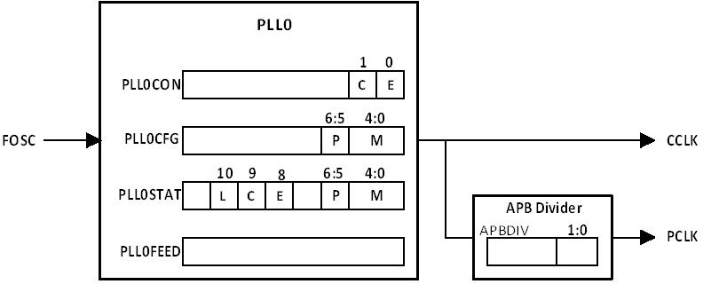

PLL Registers
- PLLxCON – Controls PLL activation; used to enable and connect PLL
- PLLxCFG – Multiplier value (bits [4:0]) and divider value (bits [6:5] are configured
- PLLxSTAT – Shows current enable & connect status, m & p values, lock status
- PLLxFEED – Writing feed sequence, i.e. ‘0xAA’ and ‘0x55’ in sequence, to this register– It enables changes made to PLLCON, PLLCFG registers to take effect APBDIV – Sets PCLK freq to 1/4, same or 1/2 of CCLK (by writing 0x00, 0x01, 0x02)

PLL configuration sequence
- Determine m and p values for desired CCLK and PCLK from FOSC
- Enter (m-1) in bits [4:0] and enter 00/01/10/11 for p values 1/2/4/8 in bits [6:5] of PLLCFG register.
- Enable PLL using PLLCON register (by setting bit[0]).
- Issue feed sequence, i.e. write constants 0xAA, 0x55 into PLLFEED reg
- Wait for PLL to lock (by checking bit[10],
- Connect & enable PLL using PLLCON reg. (by setting bits[1:0])
Issue again feed sequence Examples
- Configuring PLL0 for generating 60 MHz CCLK from 12 MHz FOSC multiplier = CCLK / FOSC = 60 / 12 = 5; (m-1) = 4 is placed in bits [4:0]
- ‘p’ is chosen as 2, since CCO (= 2 x p x 60) is to be within 156 – 300 MHz
Enabling but not connecting PLL0, enabling and connecting:
- Bit [0] of PLL0CON register is set for only enabling and bits[1:0] are set for enabling and connecting.
- PLL0CON = 0x01; // enable PLL but not connect
- PLL0CON = 0x03; // enable PLL and connect
Issue of PLL feed sequence:
- PLL0FEED = 0xAA; // first fixed value
- PLL0FEED = 0x55; // second fixed value
Checking PLL0 lock status & waiting till PLL0 locks onto the target frequency:
PLOCK, the bit [10] of PLL0STAT register, is polled and checked for lock status.
PLOCK = 0x40;
while(!(PLLSTAT & PLOCK)); // poll lock status & wait till PLL0 locks

VPB Divider
Programming APB divider for desired PCLK frequency:
Value 0x00, 0x01 or 0x02 in APBDIV register sets the PCLK frequency to one-fourth, same as or half of CCLK frequency.
APBDIV = 0x02 // set PCLK frequency to (CCLK/2)

