Experiment No-1: Identification of physical problems of soils

Theory:

- Acid soil

Poor yields of more sensitive crops may indicate acidic soil problems. Soil sampling and analysis are the first steps to correctly diagnose and confirm a soil acidity problem. Fields of concern must be carefully soil sampled.. Fields should be divided into areas based on soil type, topography and differences in crop growth. Each area must be sampled separately. Often, soil pH will vary with topography; so on land with more rolling topography, the lower, mid and upper slope areas should be sampled separately.
- Collected sample using spade and shovel.
- Dig 15 cm of soil and collect it labeled container.
- Uniquely different areas of a field should be sampled separately

- Saline soil
Visual symptoms can be used to identify these problems, but ultimately a soil test is the best way for an accurate diagnosis. When salinity is suspected from a high water table, you may be able to measure groundwater depth by boring holes with an auger. If free water collects in holes less than 4 to 5 feet deep, a drainage problem is indicated. Plants growing in saline soils may appear water stressed. This is because the high salt content of the soil hampers the ability of plants to take up water from the soil. Plants growing in these soils sometimes give clues about the problem.
- Collect a soil sample from the top 15 to 30 cm of soil,
- Concentrating on the areas that appear most impacted. High pH, salt or sodium levels are rarely uniformly distributed across fields.
- Area of the field suspected of these problems should be mapped and sampled separately to fully understand the severity of the problem.

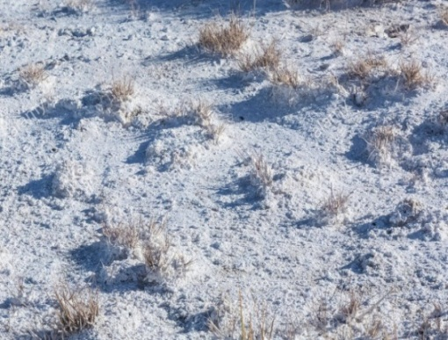
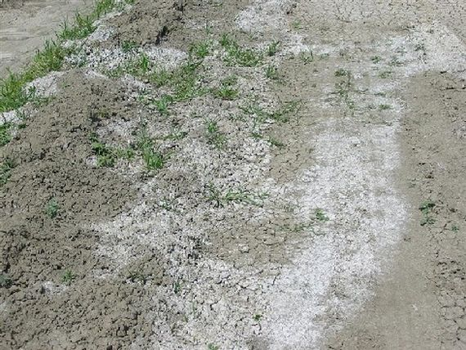
Pic 1.1: White Alkali soil Pic1.2: Saline soil

Observation: Students must follow physical characteristics of soil in field itself and identify different kind of problem soil. The observed result write below.

Sample No Remark

1.

2.

3.

4.

Signature of Faculty In-charge

References:

  - Biswas, T.D. and S.K. Mukherjee .1995.Text book of Soil Science. Tata McGraw- Hill Publishing Company Limited, New Delhi.
  - Das, D.K. 1997. Introductory Soil Science. Kalyani Publishers

Experiment No 2: Determination of soil pH

Theory
The soil pH is the negative logarithm of the active hydrogen ion (H⁺) conc. in the soil solution. It is the measure of soil salinity, acidity or neutrality. It is a very crucial estimation for soils, since soil pH influences to a great extent on the availability of nutrients to crops. It also influences microbial population in soils. Most nutrients are available to the plants in the pH range of 5.5 to 6.5.

Apparatus
- pH meter
- Beaker
- Glass rod

Reagent
- Buffer solutions of pH 4, 7 and 9.2

Procedure
- Calibrate the pH meter, using 3 buffer solutions, one should be the buffer with neutral pH (7.0) and the other should be chosen based on the range of pH in the soil. Take the buffer solution in the beaker. Insert the electrode alternately in the beakers containing 2 buffer solutions and adjust the pH. The instrument indicating pH as per the buffers is ready to test the samples.
- Weigh 10.0g of soil sample into 50 or beaker; add 25 ml of distilled water.
- Thoroughly stir for 10 second using a glass rod.
- Record the pH on the calibrated pH meter.

Table 2.1: Based on soil pH values, following types of soil reactions are distinguished:
PH Range Soil Reaction Rating
<3.5 Extremely acid

3.5-4.0 Very strongly acid

4.0-5.0 Strongly acid

5.0-6.0 Moderately acid

6.0-6.5 Slightly acid

6.6-7.4 Neutral (comfortable for most crops)

7.5-8.0 Slightly alkaline

8.0-8.5 Moderately alkaline

>8.5 Strongly alkaline

The acidic soils need to be limed before they can be put to normal agricultural production. The alkali soils need to be treated with gypsum to remove the excessive content of sodium.

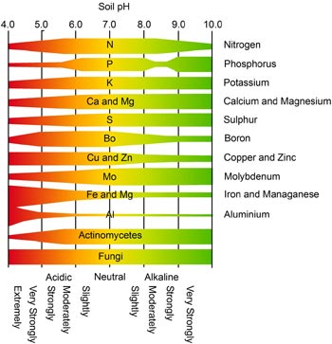

Pics2.1: Soil pH and nutrient availability

Observation: Students must compare your results with above charts and write proper conclusion in remark area like pH value and nutrient availability.

Sample No pH value Remark

1.

2.

3.

4.

Signature of Faculty In-charge

References:

  - Jackson,M.L. 1973. Soil chemical analysis, Prentice Hall of India Private Limited, New Delhi.

Experiment No-3: Determination of EC of saline soils

Theory:
The electrical conductivity (EC) is a measure of the ionic transport in a solution between the anode and cathode. This means, the EC is normally considered to be a measurement of the dissolved salts in a solution. Like a metallic conductor, they obey Ohm’s law. Since the EC depends on the total number of ions in the solution. The EC of a soil is conventionally based on the measurement of the EC in the soil solution extract from a saturated soil paste, as it has been found that the ratio of the soil solution in saturated soil paste is approximately two-thirds times higher than that at field capacity. Generally a 1:2.5 soil/water suspension is used.

Apparatus
- EC meter
- Beakers (25 ml)
- Conical flask
- Filter paper (whatman No.1)

Reagent
- 0.01M Potassium chloride solution: Dry a small quantity of AR grade potassium chloride at 60⁰C for two hours. Weight 0.7456 g of it and dissolve in freshly prepared distilled water and make the volume to one liter. This solution gives an electrical conductivity of 1411.8x10-3 i.e. 1.412 dS/m at 25⁰C. For best result, select a conductivity standard (KCl solution) close to the sample value.
Procedure
- Take 40 g soil into 250 ml conical flask, add 100 ml of distilled water, stopper the flask and shake on reciprocating shaker for one hour. Filter through Whatman No.1 filter paper. The filtrate is ready for measurement of conductivity.
- Wash the conductivity electrode with distilled water and rinse with standard KCl solution.
- Pour some KCl solution into a 25 ml beaker and dip the electrode in the solution Adjust the conductivity meter to read 1.412 dS/m, corrected to 25⁰C.
- Wash the electrode and dip it in the soil extract.
- Record the digital display corrected to 25⁰C. The reading in dS/m of electrical conductivity is a measure of the soluble salt content in the extract, and an indication of salinity status of this soil (Table 3.1). The conductivity can also be expressed as dS/m.

Table no 3.1 General interpretation of EC values

Soil | EC  (dS/m) | Crop reaction
1. Salt free | 0-2 | Salinity effect negligible,
2.Negligiable salt | 2-4 | Except for more sensitive crops
2. Slightly saline | 4-8 | Yield of many crops restricted
3.Moderately saline | 8-15 | Only tolerant crops yield satisfactorily
4. Highly saline | >15 | Only very tolerant crops yield Satisfactorily

Note: 1mS/cm =1dS/m.

Observation: Students must compare your results with above chart and write proper conclusion. Example, EC at dS/m at 25ºC using temperature correction factor.

Sample No EC (dS/m ) Remark

1.

2.

3.

Signature of Faculty In-charge

References:

1.Jackson,M.L. 1973. Soil chemical analysis, Prentice Hall of India Private Limited, New Delhi.

Experiment No-4: Determination of lime requirement of acid soils
(Shoemaker et al.)

Theory

While a slightly acidic condition is often favorable for crop growth but a higher degree of soil acidity mostly exerts an adverse effect on crop growth and hence such acid soils need lime application to improve the productivity. The quantity of lime required to bring the pH to the desired level will vary according to the nature of the soil. The procedure given by Shoemaker et al. (1961) is being widely followed for determining the lime requirement of acid soils of pH less than 6.0.

Reagent

Extractant buffer: 1.8g nitrophenol, 2.5 mL triethanolanine, 3.0 g potassium chromate, 2.0g calcium acetate and 53.1 g calcium chloride dehydrate (all chemically pure) are dissolved in a liter of water and the pH adjusted to 7.5 with dilute NaOH solution.
Instrument
A glass electrode pH meter.
Beaker, Glass rod

Procedure
To 5g of air-dry soil taken in a dry 50 mL beaker, 5 mL distilled water and 10mL of the extracting buffer are added and stirred continuously for 10 minutes or intermittently for 20 minutes. The pH of the suspension is determined on the basis of which the requirement of lime is read from the following table. The values are given in tons of pure calcium carbonate per acre required to bring the soil to the pH indicated and are to be converted to their equivalents of the form of agricultural lime to be used.

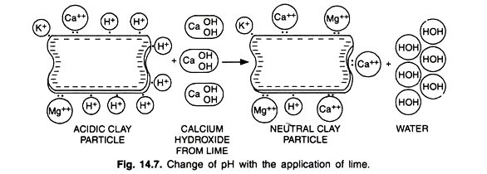
Table no 4.1: Lime requirement to bring the soil to the desired pH level according to pH value of the soil buffer suspension

pH of soil Buffer Suspension | Lime required to bring the soil to indicated pH (in tons/acre of pure calcium carbonate)
 | pH 6.0 | pH 6.4 | pH 6.8
6.7  6.6  6.5  6.4  6.3  6.2  6.1  6.0  5.9  5.8  5.7  5.6  5.5  5.4  5.3  5.2  5.1  5.0  4.9  4.8 | 1.0  1.4  1.8  2.3  2.7  3.1  3.5  3.9  4.4  4.8  5.2  5.6  6.0  6.5  6.9  7.4  7.8  8.2  8.6  9.1 | 1.2  1.7  2.2  2.7  3.2  3.7  4.2  4.7  5.2  5.7  6.2  6.7  7.2  7.7  8.2  8.6  9.1  9.6  10.1  10.6 | 1.4  1.9  2.5  3.1  3.7  4.2  4.8  5.4  6.0  6.5  7.1  7.7  8.3  8.9  9.4  10.0  10.6  11.2  11.8  12.

Observation: Students must compare your results with above chart and write proper conclusion in tons per acre.

Sample No Lime requirement (t acre⁻¹)

1.

2.

Signature of Faculty In-charge

References:
    - Wilcox, L.V., G.Y. Blair and C.A. Bower 1954. Effect of bicarbonate in irrigation water for irrigation, Soil Science 77:259-265.
    - Das, D.K. 2011. Introductory Soil Science. Kalyani Publishers, 218-238

Experiment No 5: Determination of gypsum requirement of alkali soils (Schoonover 1952)

Theory

The reclamation of alkali soil (pH in water suspension exceeding 8.5) requires gypsum treatment for replacement of sodium ions from the exchange complex. The sodium so released has to be leached out by flooding. The gypsum requirement can be determined by adding a known excess of saturated solution of gypsum (CaSO₄.2H₂O) to soil and estimating its un reacted amount by EDTA (versenate) titration.
Reagents
- Saturated calcium sulphate solution: About 5g of pure CaSO₄.2H₂O taken in one liter of distilled water shake mechanically for 10 minutes and filtered it through ordinary filter paper.
- Ammonium chloride-ammonium hydroxide buffer of pH 10 : 67.5 g pure ammonium chloride dissolved in 570 mL of concentrated ammonia solution (sp. Gr. 0.88) and diluted to one liter with distilled water and adjusted to pH 10 (Caution : Liquid ammonia should be refrigerated before opening the bottle).
- Eriochrome black T indicator: 0.5 g of eriochrome black T (EBT) and 4.5 g of hydroxylamine hydrochloride (AR) dissolved in 100 mL of 95% ethyl alcohol.
- 0.01 N calcium chloride solutions: 0.500 g of AR grade calcium carbonate taken in little excess of AR HCl (about 10 mL of dil. acid) and the solution made up to one liter with distilled water.
- Standard versenate (EDTA) solution 0.01 N : 2.0 g of ethylene diamine- tetra acetic acid disodium salt and 0.05 g of MgCl₂ (AR) dissolved in water and diluted to 1 liter; the solution to be standardized against 0.01 N calcium chloride.
Procedure
5g of soil is taken in a 250 mL conical flask to which 100 mL of the saturated CaSO₄ solution is poured in, shaken for 5 minutes and filtered through Whatman No.1 filter paper. After rejecting first few mL, 5mL of the extract is pipetted into a 100 mL flask or porcelein dish and diluted to about 25 mL with distilled water. One mL of NH₄Cl – NH₄OH buffer and 3 to 4 drops of Eriochrome black T indicator are added and titrated with the standard EDTA solution until the colour changes from wine red to blue. Similarly, 5 mL of the saturated CaSO4 solution is titrated separately to determine the Ca concentration.

Observations table 5.1
- Ca + Mg in soil extract

Sl.No. | Vol. of EDTA taken (mL) | Burette reading |  | Vol. of EDTA used (mL) (Final- Initial)
 |  | Initial | Final
1
2
3

- Ca in saturated gypsum solution
Sl. No. | Vol. of EDTA taken (mL) | Burette reading |  | Vol. of EDTA used (mL) (Final-Initial)
 |  | Initial | Final
1
2
3

Calculation:
normality of the EDTA X mL of the EDTA X 1000
Ca (meL⁻¹) = -------------------------------------------------------------------
mL of saturated CaSO4 Solution taken

= --------------------------------------

normality of the EDTA X mL of the EDTA X 1000 Ca + Mg (meL⁻¹) --------------------------------------------------
mL of soil extract (filtrate) taken

= ------------------------------------------

Gypsum requirement in meL⁻¹ 100 g = [(Ca concentration in saturated gypsum
solution (meL⁻¹) minus Ca – Mg concentration in filtrate (meL⁻¹)] x 2

= -----------------------------------------

Gypsum requirement in metric tons (tonnes) per hectare (15 cm soil depth)

= 1.72 x G.R. (meL-1 100 g of soil) x 2.24

= -----------------------------------

Observation: Students must complete your calculation with above formula and write proper conclusion.

Sample No Gypsum Requirement (t ha⁻¹) Conclusion

1.

2.

Signature of Faculty In-charge

References:

- Jackson,M.L. 1973. Soil chemical analysis, Prentice Hall of India Private Limited, New Delhi.
- Richards, L.A. et al. 1954. Diagnosis and Improvement of Saline and Alkali soils. USDA Hand book 60, Oxford & IBH Publishing Co, New Delhi.

Experiment No-6: Determination of calcium carbonate content in calcareous soils

Theory
Percentage of calcium carbonate, CaCO₃ (%), is defined as the total carbonates which is contained in 100 g of dry soil. We express total carbonates, (CaCO₃, MgCO₃ etc) as CaCO₃
.

Principle
The determination of CaCO₃ (%) is based on the volumetric analysis of the carbon dioxide CO₂, which is liberated during the application of hydrochloric acid solution HCl₄ N in soil’s carbonates and is described with the following reaction:
CaCO₃ + MgCO₃ + 2 HCl → CaCl₂ + MgCl₂ + H₂O + CO₂ ↑
During the application of the acid into the soil sample a foaming is observed, evidence of carbon dioxide’s liberation and the existence of carbonate salts consequently.

Reagents :
Methyl orange indicator: Dissolve 50 mg methyl orange sodium salt in 100 ml H₂O, which contain 15, 2 ml of HCl 0,01 Ν solution. Mild heat the solution, and when it gets cold an infiltration follows.
Calcimeter Bernard filling solution: Dissolve 200 g CaCl₂ .6H₂O in 100 ml distilled water, add 3 drops methyl orange indicator and some drops of non-concentrated solution of hydrochloric acid till the solution becomes red-orange.
Solution of HCl₄ Ν: Dilute 340 ml concentrated HCl with distilled water up to 1000 ml.
Instrument- Calcimeter Bernard

Procedure:
- Weigh 200 g of prepared soil sample and transfers it into the Bernard apparatus conical flask.
- Afterwards fill the glass of the apparatus till the ¾ of its height with HCl 4 Ν solution and place it into the conical flask attentively. Pay attention, that the tubule stays upright with the acid (Solution of HCl₄ Ν) inside.
- Cap the conical flask with its particular plug and then make zero the level of the filling solution. With the left hand bring the pear shaped glass container next to the graduated column for the fluids both in the pear shaped container and in the graduated tube stand in the same level.

- With the right hand, shake gently the conical flask, so, the HCl 4Ν solution comes in contact with the prepared soil sample.
- Then CO₂ liberated. The filling solution of graduated column descends due to the pressure of liberated CO₂.
- At the same time, we lower the pear shaped container for its fluid level to remain in the same level with the fluid of the column. This way the hydrostatic pressure equalizes.
- When the liberation of the CO₂ is finished, stop the agitation and note the column’s reading.

In case the carbonate content is too high and the liberated gas displaces all the fluid from the graduated column repeat the process, decreasing the quantity of the prepared soil sample into 100 gm. Although in this case the same happens, repeat the process with 50 gm of prepared sample.

Calibration
The determination of the correction factor f of the instrument is as follow: Weigh about 0.10 g CaCO₃, which has been dried at 104ºC, transfer it into the Bernard apparatus conical flask and follow the same process as described above
f =W x T/1.22 x V
Where : W = g weighted CaCO₃
T = temperature of measurement, in K V = ml produced CO₂

Observation: Students must complete your calculation with above formula and write proper conclusion

Sample No CaCO₃ content (%) Remark

1.

2.

3.

Signature of Faculty In-charge

References:

  - Cheng, K.L. and R.H. Bray 1951. Determination of calcium and magnesium in soil and plant material. Soil Science 72:449-458.

Experiment No-7: Determination of infiltration rates of light soils.

Theory

The infiltration rate is the velocity or speed at which water enters into the soil. It is usually measured by the depth (in mm) of the water layer that can enter the soil in one hour. An infiltration rate of 15 mm/hour means that a water layer of 15 mm on the soil surface, will take one hour to infiltrate.
In dry soil, water infiltrates rapidly. This is called the initial infiltration rate. As more water replaces the air in the pores, the water from the soil surface infiltrates more slowly and eventually reaches a steady rate. This is called the basic infiltration rate.
The most common method to measure the infiltration rate is by a field test using a cylinder or ring infiltrometer.

Table no 7.1 Basic infiltration rates for various soil types

Soil type | Basic infiltration rate (mm/hour)
sand | less than 30
sandy loam | 20 - 30
loam | 10 - 20
clay loam | 5 - 10
clay | 1 - 5

Equipment required

- Watchor clock
- Shovel/ hoe
- Hammer
4. 5 liter bucket
5. Timber (75x75x400)
6. Hessian (300x300)or jute cloth
7. At least 100 liters of water

Method

Step1: | Hammer the 30 cm diameter ring at least 15 cm into the soil. Use the timber to protect the ring from damage during hammering. Keep the side of the ring vertical and drive the measuring rod into the soil so that approximately 12 cm is left above  the ground.

Step 2: |  | Hammer the 60 cm ring into the soil or construct an earth bund around the 30 cm  ring to the same height as the ring and place the hessian inside the infiltrometer to protect the soil surface when pouring in the water.
Step 3: |  | Start the test by pouring water into the ring until the depth is approximately 70-100

Ring infiltrometer of 30 cm diameter and 60 cm diameter. Instead of the outer cylinder a bund could be made to prevent lateral water flow.

Measuring rod graduated in mm (e.g. 300 mm ruler)

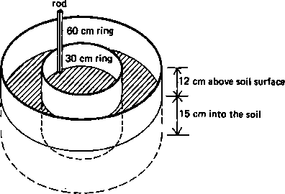

Figure 7.1 Set-up of field test

mm. At the same time, add water to the space between the two rings or the ring and
the bund to the same depth. Do this quickly.
 | The water in the bund or within the two rings is to prevent a lateral spread of water from the infiltrometer.
Step 4: | Record the clock time when the test begins and note the water level on the measuring rod.
Step 5: | After 1-2 minutes, record the drop in water level in the inner ring on the measuring rod and add water to bring the level back to approximately the original level at the start of the test. Record the water level. Maintain the water level outside the ring  similar to that inside.
Step 6: | Continue the test until the drop in water level is the same over the same time interval. Take readings frequently (e.g. every 1-2 minutes) at the beginning of the test, but extend the interval between readings as the time goes on (e.g. every 20-30  minutes).

Note that at least two infiltration tests should be carried out at a site to make sure that the correct results are obtained.

Table no 7.2 Data sheet and information sheet

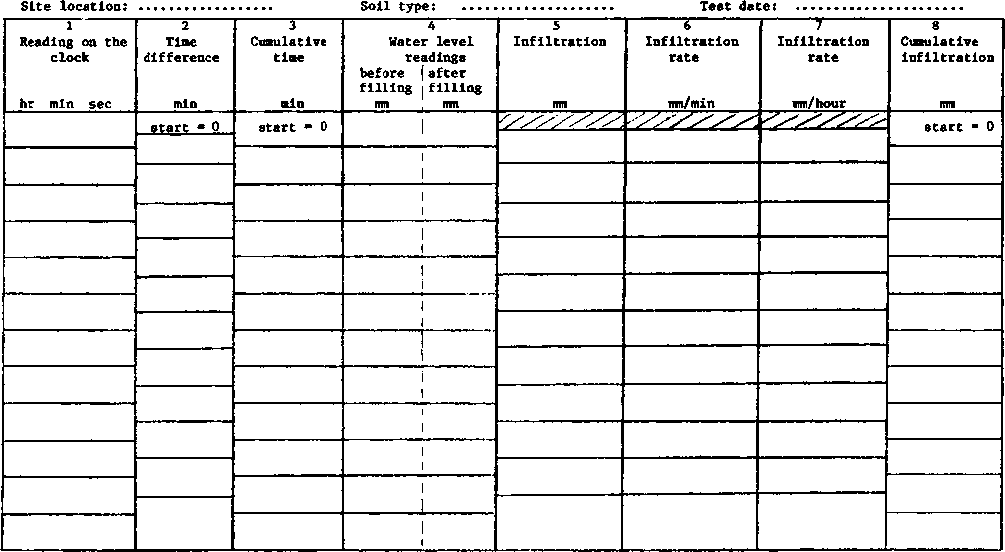

Observation: Students must complete your calculation with above formula and write proper conclusion from data sheet.

Sample No Infiltration rate (mm/hr) Remark

1.

2.

3.

Signature of Faculty In-charge

References:

1. Jackson,M.L. 1973. Soil chemical analysis, Prentice Hall of India Private Limited, New Delhi.

Experiment No-8: Water quality assessment (pH, EC, alkalinity)

Theory
- pH
pH is the measure of the acidity of a solution of water. The pH scale commonly ranges from 0 to 14. The scale is not linear but rather it is logarithmic. For example, a solution with a pH of 6 is ten times more acidic than a solution with a pH of 7. Pure water is said to be neutral, with a pH of 7. Water with a pH below 7.0 is considered acidic while water with pH greater than 7.0 is considered basic or alkaline.

Conductivity
Conductivity is a numerical expression of an aqueous solution's capacity to carry an electric current. This ability depends on the presence of ions, their total concentration, mobility, valence and relative concentrations, and on the temperature of the liquid. Solutions of most inorganic acids, bases, and salts are relatively good conductors. In contrast, the conductivity of distilled water is less than 1 μmhos/cm. Because conductivity is the inverse of resistance, the unit of conductance is the mho (ohm spelled backwards), or in low-conductivity natural waters.

Alkalinity
Alkalinity is the sum total of components in the water that tend to elevate the pH to the alkaline side of neutrality. It is measured by titration with standardized acid to a pH value of
4.5 and is expressed commonly as milligrams per liter as calcium carbonate (mg/L as CaCO₃). Alkalinity is a measure of the buffering capacity (ability to resist changes in pH) of the water, and since pH has a direct effect on organisms as well as an indirect effect on the toxicity of certain other pollutants in the water, the buffering capacity is important to water quality. Commonly occurring materials in water that increase alkalinity are carbonates, bicarbonates, phosphates and hydroxides. Limestone bedrock and thick deposits of glacial till are good sources of carbonate buffering. Lakes within such areas are usually well- buffered.

Observation: Students must compare your result with above definitions and write proper conclusion.

Sample No. Conclusion

1.

2.

Signature of Faculty In-charge

References:

- Biswas, T.D. and S.K. Mukherjee .1995.Text book of Soil Science. Tata McGraw- Hill Publishing Company Limited, New Delhi.
- Das, D.K. 2011. Introductory Soil Science. Kalyani Publishers

Experiment No-9. Determination of Carbonate and Bicarbonate in irrigation water (Richards, 1954)
Theory:
Titration of definite quantity of water against a standard acid using phenolphthalein & Methyl orange as indicators. Firstly phenolphthalein is added as an indicator. On adding the slandered acid drop – wise, the pink colour disappears when all the carbonate in the sample water are converted to bicarbonates. At this stage methyl orange is added as an indicator. Now the colour of the sample water is yellow. Titrate further against the same slandered acid. Colour changes to orange when the end – point is reached.

Comparison of the stage wise reading indicates the following.
- If the first stage reading (phenolphthalein indicator) is half the total reading, we may say the alkalinity was due to carbonates along and hence the amount of carbonates can be calculated directly.
- If the first stage reading is zero, the reading shows that the alkalinity is due to bicarbonates along and hence the amount can be calculated directly.
- If the second stage reading is zero, the alkalinity is due to hydroxides alone and hence can be calculated directly,
- If the first stage reading is greater than half the total reading the alkalinity is due to both carbonates and hydroxides.
- If the first stage reading is less than half the total reading, the alkalinity is due to both carbonates & bicarbonates. The equations of the reactions in this case are.

2Na₂CO₃ + H₂SO₄ 2NaHCO₃ + Na₂SO₄
2NaHCO₃ + H₂SO₄ Na₂SO₄ + H₂O + XO₂

Requirements
0.05M H₂SO₄, 100 ml, Sample water, Conical flasks, Burette, Pipette 25 ml, Phenolphthalein & Methyl orange indicator.

Procedure
Pipette out 25 ml, of sample water into a clean dry flask. Add 5 drops of phenolphthalein. The solution turns pink showing the presence of carbonates. Add the acid from the burette drop wise till the solution becomes colour less. Note the reading; now to the same bulk of

solution add 3 drops of methyl orange. The solution turns yellow. Titrate further adding the acid from the burette drop wise till the colour change to orange. Note the reading. This procedure should be repeated a number of times with fresh quantity of sample water each time till constant reading are obtained.

Calculation:
If X ml. of 0.05 M H₂SO₄ is required to convert the quantity of carbonates present in 25 ml. sample water to bicarbonate (phenolphthalein reading) then 2X ml. of 0.05 M H₂SO₄ will be required to neutralize the total amount of carbonates.
If Y ml. of 0.05 M H₂SO₄ are required to neutralize bicarbonates (Methyl orange reading) then Y-X ml. of 0.05 M H₂SO₄ will be required to neutralize the bicarbonates present in 25 ml of the sample water because X ml. are required to neutralize the bicarbonates obtained from carbonates.

1 Mole of H H₂SO₄120 gm of 2CO₃⁻²
So 1 ml. of 0.05 M H₂SO₄ = 0.006 gm CO₃⁻²
So 2X *25*0.006 *10⁶ = ppm Carbonates.
1 Mole of H₂SO₄ = 122g HCO₃-
So 1 ml. of 0.052 M H₂SO₄= 0.0061 g HCO₃-
So (Y-X) *25*0.0061*10⁶= ppm bicarbonates.

Observation: Students must complete your calculation with above formula and write proper result.

Sample No Carbonates (ppm) Bicarbonates (ppm)

1.

2.

3.

Signature of Faculty In-charge

References:

- Wilcox, L.V., G.Y. Blair and C.A. Bower 1954. Effect of bicarbonate in irrigation water for irrigation, Soil Science 77:259-265.
- Eaton, F.M. 1950. Significance of carbonates in irrigation water. Soil Science 69:123-133.

Experiment No-10: Determination the total hardness (Permanent & Temporary) of the given irrigation water.
Theory:
Determination the total hardness (Permanent & Temporary) of the given irrigation water

Requirement
500 ml. of water, burette, Pipette, Flask, buffer solution pH = 10, 0.01 M EDTA & Eriochrome black T indicator.

Procedure

Pipette out 50 ml. of sample water in a dry clean conical flask. Add 5 ml. of the buffer solution and five drops of indicator to it. Then titrate against the given EDTA solution from the burette till the red color changes to the permanent purple blue. See that no reddish tinge remains in the solution.

Hints: To get a sharp end point add a few drops of dilute HCl boil, cool and neutralize with just sufficient dilute NaOH before adding the buffer solution.

Calculation: 1 ml. 0.01 M EDTA 1 mg. of CaCO₃ 0.001 gm of CaCO₃

So Constant reading * 10⁶ * 0.001 = ppmCaCO₃
50mL
The total hardness is to be expressed in terms of CaCO₃.

Observation: Students must complete your calculation with above formula and write proper result.

Result: Total hardness in terms of CaCO₃ = ppm.

Signature of Faculty In-charge

References:

Wilcox, L.V., G.Y. Blair and C.A. Bower 1954. Effect of bicarbonate in irrigation water for irrigation, Soil Science 77:259-265

Experiment No-11: Determination the amount of Chloride in irrigation water.

Principle:
Mohr’s titration method is most commonly used for chloride estimation. It depends upon the formation of a sparingly soluble brick-red silver chromate (AgCrO₄) precipitate at the end point when the sample is titrated against standard silver nitrate (AgNO₃) solution in the presence of potassium chromate (K₂CrO₄) as indicator.

Initially the Cl ions are precipitated as AgCl and dark brick-red precipitate of Ag₂CrO₄ starts just after the precipitation of AgCl is over.

Apparatus
- Beakers/porcelain dish
- Burette

Reagents
- Potassium chromate (K₂CrO₄) indicator (5%) solution: Dissolve 5 g of K₂CrO₄ in about 75 ml distilled water and add drop by drop saturated solution of AgNO₃ until a slight permanent red precipitate is formed. Filter and dilute to 100 ml. With high purity analytical reagent, the indicator solution can be prepared directly.
- Standard silver nitrate solution (0.05M): Dissolve 8.494 g of silver nitrate (AgNO₃) in distilled water and make the volume to one liter. Standardize it against standard NaCl solution and keep in amber coloured bottle away from light.

Procedure
- Take 5 ml of the sample in a 100 ml beaker or a porcelain dish and diluted to about 25 ml with distilled water.
- Add 5-6 drops of K₂CrO₄ indicator (making it dark yellow), and titrate against the standard AgNO₃ solution with continuous stirring till the first brick-red tinge appears.
- Run a blank to avoid error due to any impurity in chemicals.

Calculation:
Cl (mg/liter of water) = Xx1.775x ml of sample x 1000

Where, ml of water sample taken = 5
X = ml of 0.05M AgNO₃ consumed in titration
1.775 = factor representing mg of Cl in aliquot/sample as calculated below: 1 ml of 1M AgNO₃ = 1 me of Cl
1 ml of 0.05M AgNO₃ = 0.05 me of Cl = 35.5 x 0.05 = 1.775 mg of Cl (in aliquot).

Observation: Students must complete your calculation with above formula and write proper result.

Sample No Chloride content (ppm) Remark

1.

2.

3.

Signature of Faculty In-charge

References:

- Subramoney, H.S. and Y.S. Verma 1969. Analysis of irrigation water samples and its interpretation. Directorate of Extension, Krishi Bhavan, New Delhi.

Experiment No-12: Determination of Ca and Mg content in
irrigation water
Aim: To determine the amount of calcium & magnesium in the given sample of water.

Requirement:
500 ml sample water, calcium precipitating buffer solution, buffer solution pH 10, Eriochrome black T indicator, burette, pipette, flask beaker, 0.01 M EDTA solution, funnels etc.
(To prepare calcium precipitating buffer solution, dissolve 6.0 g. of A.R. ammonium oxalate
in 100 ml. distilled water and add 144.0 g. of A.R. grade NH₄Cl and 13-ml. conc. NH₃– solution to it. Then dilute the bulk to 1.0 liter).

Procedure

Pipette out 100-ml. of the sample water into dry clean conical flask. Add 30.0 ml of the calcium precipitating buffer solution to it. Stir vigorously Allow it to stand for 1.5 hrs. Then filter this through two filter papers (Whatmann No.42 ) into dry clean beaker. Now, from the filtrate pipette out 50 mL add 25 mL of distilled water and 50 mL of buffer solution pH 10 add 10 drops of the indicator and titrate again the EDTA solution from the burette till the colour change from wine red to blue. Prepare five sets of such titration. Get a constant reading. Tabulate your observation.

Calculation:

Constant reading in Exp.10 is the reading for total hardness i.e. due to Ca⁺² & Mg⁺² (Say X ml) Constant reading in this Exp.11 is the reading for Mg⁺² only (Say Y ml).

(X-Y) ml, 0.01 M EDTA required for Ca⁺² only Now 1 ml. of 0.01 M EDTA 0.0004008g Ca⁺² And 1 ml. of 0.01 M EDTA 0.0002432 g Mg⁺²
(X - Y)*0.0004008*10⁶ = ppm Ca⁺² 50

And Y * 0.0002432 *10⁶ = ppm Mg⁺² 50

Observation: Students must complete your calculation with above formula and write proper result.

Sample No Ca⁺² content (ppm) Mg⁺² content(ppm) Remark

1.

2.

3.

4.

Signature of Faculty In-charge

References:

1. Cheng, K.L. and R.H. Bray 1951. Determination of calcium and magnesium in soil and plant material. Soil Science 72:449-458.

Experiment No-13: Determination of Na and K content in
irrigation water Determination of Na content in irrigation water
Principle

The Sodium Adsorption Ratio is a ratio of Na concentration in meq/l to the square root of half the concentration of Ca + Mg in meq/l.

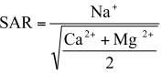

Reagents
Sodium solution -0, 5, 10, 15 and 20 ppm

Procedure
Adjust flame photometer reading to 0 by atomizing 0 ppm Na after placing Na filter opposite air-propane blue flame, and then atomize 20 ppm Na solution and adjust flame photometer reading to 100. Repeat atomization of 0 and 20 ppm Na solution, and check the flame photometer reading
If necessary again adjust the flame photometer reading. Then atomize the intermediate Na standards. Thereafter, atomize to spray water sample diluted 50 to 500 times. If flame photometer reading is found in the range of 0 to 100, note down the flame photometer reading and the corresponding dilution.

Calculation:

Determine Na concentration (ppm), in diluted water sample by the following equation meq Na/lt in water sample = (ppm Na in diluted sample x times of dilution)/23

Determination of K content in irrigation water

Principle

Water sample is diluted and is then atomized to spray in air- propane blue flame of a flame photometer. K ions on gaining energy from the flame begin to dissipate energy in the form of 767 mill micron wave length which is directly proportional to the concentration of
- The emission from K is made to pass through K. filter before striking a photocell connected to a galvanometer. The photocell converts light energy into electrical energy which is measured by the galvanometer. The instrument is first calibrated by atomizing K standards and then water sample atomized and K in water sample is determined by reference to a calibration curve.

Reagents

  - Standard potassium solution, 1.0 g K/A. Dissolve 1.9066 g pure dry KCI (AR) in distilled water and dilute it to 1000 ml mark with distilled water. The Concentration of K in this solution is 1000 ppm. Store the solution in polythene bottle.
  - Standard potassium solution, 0 to 20 ppm. To obtain 0, 5, 10, 15 and 20 ppm K solution, transfer 0 25 50 75 and 10.0 ml of 1000 ppm K solution into Separate 500 ml volumetric flask. Add distilled water to make the volume to 500 ml.
If internal lithium standard is specified by the manufacturer the estimated amount of lithium/500 ml K standard be added to each flask before making the volume to 500 ml mark with distilled water
If interference from metallic cations is anticipated the interfering cations be also added to the K standards in amounts equal to their concentration in the diluted sample test solution prior to making the volume of K standard to 500 ml. Store each standards in 500 ml polythene bottles.

Procedure

- Operation of the flame photometer. Place K-filter against the burner by rotating the filter disc and then operate the flame photometer as described in Na determination in water sample.

- Calibration of the instrument. Atomize 0 and 20 ppm K solution and adjust the flame photometer reading to 0 and 100 respectively. Then atomize the intermediate K standards, and note down the corresponding flame photometer reading.
- Preparation of calibration curve for K. On a linear scale graph paper, set flame photometer reading scale on the ordinate and K concentration scale on the abscissa Then plot flame photometer reading on the ordinate corresponding to K concentration in ppm on the abscissa Connect flame photometer reading for 0 and Solution by a straight line to obtain the calibration curve for K.
- K determination in diluted water sample. Dilute water sample by transferring 4.0,
2.0 & 1.0 ml of water sample into separate 100 ml volumetric flask and dilute each to 100 ml to obtain water sample diluted 25, 50 and 100 times
Atomize to spray 0 and 20 ppm K solution into the flame of the flame photometer, and set the flame photometer reading to 0 and 100. Then atomize diluted water sample. As diluted water sample give flame photometer reading within the range of 0 and 100, note down the flame photometer reading and times of dilution.
Estimate K concentration in diluted water sample by reference to the calibration curve or else divide flame photometer reading by 5 to obtain K concentration in ppm.

Calculation:

ppm K in water sample = ppm K in diluted water by reference to calibration curve *
dilution times

Meq K/lt in water sample = ppm K in undiluted water sample / Equivalent weight of K i.e.
39.102

K supply from irrigation water in kg K/ha.= meq K/1 irrigation water * 3.91 * Depth of irrigation in cm.

Observation: Students must complete your calculation with above formula and write proper result.

Sample No Na⁺ content (ppm) K⁺content (ppm) Remark

1.

2.

3.

4.

Signature of Faculty In-charge

References:

1. Standford, S. & L. English 1949. Use of the flame photometer in rapid soil tests for K & Ca. Agron. J.4:446-447.

Experiment No-14: Computation of RSC and SAR of irrigation water.

Richards (1954) and Eaton (1950)

Principle

The Sodium Adsorption Ratio is a ratio of Na concentration in meq/l to the square root of half the concentration of Ca + Mg in meq/l.

The Residual Sodium Carbonate is the sum of concentration of carbonate plus bicarbonate in meq/ minus the concentration of calcium plus magnesium in meq/l
i.e. RSC = (CO⁻⁻ + HCO⁻) - (Ca⁺⁺ + Mg⁺⁺)

The water sample has to be analysed for the determination of the concentration of Na. Ca + Mg and CO₃⁻⁻ + HCO₃⁻⁻ in meq/l to estimate SAR and RSC by way of assessing sodicity hazard.

Reagents
- for Na determination

Sodium solution -0, 5, 10, 15 and 20 ppm

- For Ca + Mg determination

EDTA solution, 0.01N Heavy metal complexing reagents Calcium chloride solution, 0.01N 1% KCN solution
Magnesium chloride solution, 0.01N 4% Na. K ferrocyanide solution Ammonium Chloride-Ammonium 5%Hydroxylamine hydrochloride Hydroxide Buffer (1 1) Triethanol amine
Eriochrome Black T indicator

- for CO₃ + HCO₃ determination

0.1% Sulphuric acid,
05 N Phenolphthalein indicator,
0.5% Sodium carbonates solution,
0.1N Methyl orange,
The preparation of reagents are described in experiment no 11.

Procedure
- Na determination in water sample. Adjust flame photometer reading to 0 by atomizing o ppm Na after placing Na filter opposite air-propane blue flame, and then atomize 20 ppm Na solution and adjust flame photometer reading to 100. Repeat atomization of 0 and 20 ppm Na solution, and check the flame photometer reading
If necessary again adjust the flame photometer reading. Then atomize the intermediate Na standards. Thereafter, atomize to spray water sample diluted 50 to 500 times. If flame photometer reading is found in the range of 0 to 100, note down the flame photometer reading and the corresponding dilution. Determine Na concentration (ppm), in diluted water sample by the following equation:
meg Na/lt in water sample = (ppm Na in diluted sample x times
of dilution)/23

- Ca + Mg determination in water sample. Transfer 5.0 ml aliquot of water sample and 20 ml of distilled water into 150 ml Erlenmeyer flask. Then add I drop MgCl₃ (0.01 N), 5 drops each of four heavy metal complexing reagent, 2 ml of NH₄Cl⁻
NH₄OH buffer and 2 drops of EBT indicator Titrate with 0.01N EDTA until the reaction mixture colour changes from pink to purple and then from purple to clear blue or green with 1 drop of EDTA. Similarly run a blank taking distilled water instead of sample aliquot.
meq Ca +Mg / lt in water sample = {EDTA titre (sample-blank) x 0.01 x1000}/5

- CO₃-- and HCO₃-- determination in water sample. Transfer 50.0 ml aliquot of filtered
water sample into a 150 ml Erlenmeyer flask. Add 3 drops of 0.5% phenolphthalein indicator and titrate with 0.05 N H₂SO₄ until the solution colour changes from purple to colourless. Note down the acid titre and designate it as "P".
Then add 2 drops or 0.1% methyl orange indicator, and titration with 0.05 N H₂SO₄ without refilling the burette untills the colour changes from yellow to orange.

Heat the contents to boil gently for 1 minute. If the orange colour turn yellow on heating, and it does not turn orange on cooling add few drops of 0.05N H₂SO₄ till the solution turn orange. Note down the total acid titre, and designate it as "T”.

Calculation

meq CO₃⁻⁻ / lt in water sample = (2P x .05 x 1000)/50 When P<0.5 T or when P=T
meq CO₃— /lt in water sample= {2(T-P) x .05 x1000 when P>0.5T

meq HCO₃⁻⁻ /lt in water sample = (T x .05 x 1000)/50 when P = 0

meq HCO₃⁻⁻ /lt in water sample = {(T – 2P) x .05 x 1000}/50 when P<0.5 T

where P is acid titre for phenolphthalein end point and T is total acid titre ke, 'p plus acid titre to methyl orange end point.
Sodium Adsorption Ratio = Na⁺ / √ (Ca⁺⁺ + Mg⁺⁺/2)

Residual Sodium Carbonate = (CO₃⁻⁻ + HCO₃⁻⁻ ) - (Ca⁺⁺ + Mg⁺⁺) where the concentration of each ion is expressed in meq/l

Observation: Students must complete your calculation with above formula and write proper result.

Sample No SAR (meq/lt) RSC(meq/lt) Remark

1.

2.

3.

4.

Table no 13.1

Class | S₁ | S₂ | S₃ | S₄
SAR | <10 | 10-18 | 18-26 | >26
Sodium  Hazard | Low | Medium | High | Very High

Signature of Faculty In-charge

References:

  - Subramoney, H.S. and Y.S. Verma 1969. Analysis of irrigation water samples and its interpretation. Directorate of Extension, Krishi Bhavan, New Delhi.
  - Standford, S. & L. English 1949. Use of the flame photometer in rapid soil tests for K & Ca. Agron. J.4:446-447.

