A typical block diagram of an embedded system includes various components that work together to perform specific functions. While the specific components and their arrangement can vary depending on the system's requirements, here are some common components found in embedded systems:
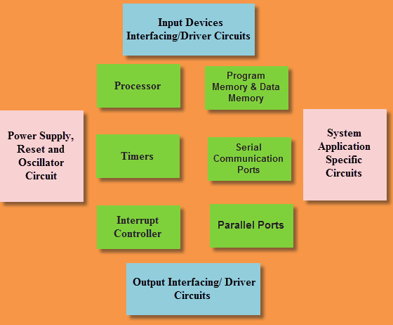

Microcontroller/Microprocessor:
The microcontroller or microprocessor is the central processing unit of the embedded system. It executes the program instructions, controls the system operation, and interacts with other components.

Memory:
Embedded systems include various types of memory to store data and program instructions. This can include ROM (Read-Only Memory) for firmware or program code storage, RAM (Random Access Memory) for data storage, and non-volatile memory for persistent storage, such as EEPROM or flash memory.

Input/Output (I/O) Devices:
These devices enable communication between the embedded system and the external world. Common I/O devices include buttons, switches, sensors, displays (LCD or LED), keyboards, touchscreens, serial ports, Ethernet interfaces, USB ports, and wireless communication modules (such as Wi-Fi, Bluetooth, or RFID).

Analog-to-Digital Converter (ADC) and Digital-to-Analog Converter (DAC):
Embedded systems often need to interface with analog signals. ADCs convert analog signals (e.g., from sensors) into digital values that can be processed by the microcontroller. DACs, on the other hand, convert digital values into analog signals (e.g., for outputting audio or controlling analog systems).

Timers/Counters:
Timers and counters are used to measure time intervals, generate precise timing signals, or count events. They are commonly used for tasks such as scheduling tasks, generating PWM signals, or controlling real-time operations.

Communication Interfaces:
Embedded systems may require communication with other systems or devices. This can involve interfaces such as UART (Universal Asynchronous Receiver/Transmitter), SPI (Serial Peripheral Interface), I2C (Inter-Integrated Circuit), CAN (Controller Area Network), Ethernet, or wireless protocols like Wi-Fi, Bluetooth, or Zigbee.

Power Management:
Embedded systems require efficient power management to control power consumption and ensure reliable operation. This includes voltage regulators, power monitoring circuits, battery management circuits, and power-saving features.

Interrupt Controller:
Interrupts allow the microcontroller to respond to external events or signals in a timely manner. The interrupt controller manages and prioritizes interrupts from various sources, enabling the microcontroller to handle critical events promptly.

Real-Time Clock (RTC):
An RTC provides an accurate timekeeping function for time-sensitive applications. It can include a dedicated hardware clock or utilize the microcontroller's internal timers.

Operating System (OS):
Depending on the complexity and requirements of the embedded system, an operating system may be employed to manage tasks, memory, and resources. Examples include real-time operating systems (RTOS) or lightweight kernels.

These are just some of the key components that can be found in an embedded system. The specific configuration and components depend on the system's intended application, requirements, and constraints.

