Practical Manual

B.Sc. (Hons.) Agriculture
Crop Production Technology-I: Kharif Crops
Course No.: ASAG2103
Credit: 3(2+1)
Semester: 3rd
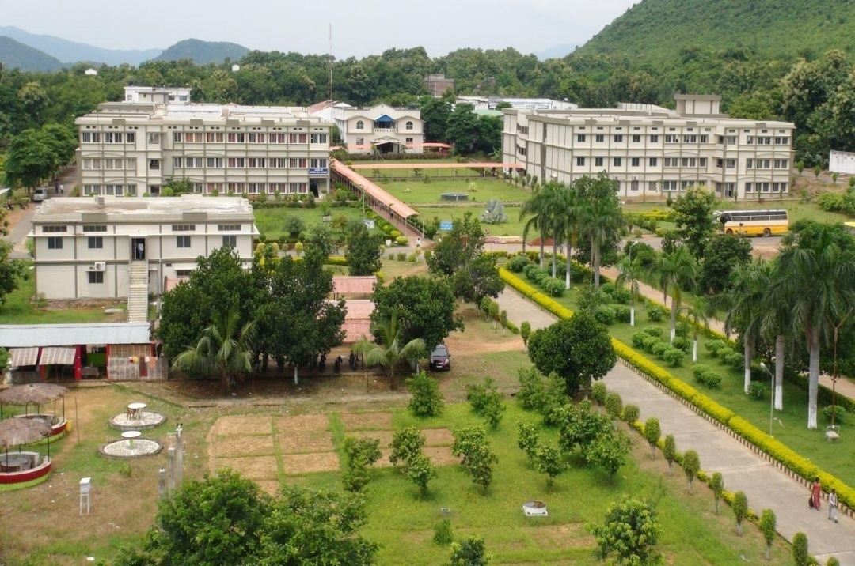

Department of Agronomy and Agroforestry

M. S. Swaminathan School of Agriculture

Centurion University of Technology and Management, Paralakhemundi
www.cutm.ac.in
August, 2022

Practical Manual

B.Sc. (Hons.) Agriculture
Crop Production Technology-I: Kharif Crops
Course No.: ASAG2103
Credit: 3(2+1)
Semester: 3rd

Department of Agronomy and Agroforestry

M. S. Swaminathan School of Agriculture

Centurion University of Technology and Management, Paralakhemundi
www.cutm.ac.in
August, 2022

Department of Agronomy and Agroforestry

M. S. Swaminathan School of Agriculture
Centurion University of Technology and Management

Paralakhemundi

Certificate

Certified that this is a bonafide record of practical work done by
Mr./ Ms. ________________________________________________
Regd. No. _______________________in B. Sc. (Hons.) Agriculture degree programme, Course No. ASAG2103 entitled “Crop Production Technology-I” during 3rd semester of the academic year 2019-20.

Date: Faculty In charge

Evaluation System
Crop Production Technology-I: Kharif Crops
Course No.: ASAG2103

Sl. No. | Marks distribution* | Total marks (25) | Marks obtained
1 | Record | 5
2 | Attendance | 5
3 | Field work | 10
4 | Viva | 5
Total (25 marks)

Signature of Faculty In-charge

List of Experiments

Exp. No. | Date  of Exp. | Date of Submission | Title | Page No. | Signature | Remark
1 |  |  | Rice nursery preparation and transplanting of rice
2 |  |  | Sowing of soybean, pigeonpea, mungbean, maize, groundnut and cotton
3 |  |  | Effect of seed size on germination and seedling vigour
4 |  |  | Effect of sowing depth on germination of kharif crops
5 |  |  | Identification of weeds in kharif season crops
6 |  |  | Top dressing and foliar feeding of nutrients
7 |  |  | Study of yield contributing characters and yield calculation of kharif season crops
8 |  |  | Study of forage experiments
9 |  |  | Morphological description of kharif season crops
10 |  |  | Visit to research centre of related crops

Experiment No. 1 Date------------
Rice Nursery Preparation and Transplanting of Rice
1.1 Aim
To study about rice nursery preparation and transplanting of rice
1.2 Materials required
Tractor, ladder/plank, hand hoe, rake, measuring tape, seed, fertilizers and water etc.

1.3 Advantage of nursery raising
- Sufficient time for main field preparation or we can increase the cropping intensity or manipulate cropping pattern by excluding the seedling stage in main field.
- Disease pest management will be easier.
- Weed growth also be less due to high density of seed.
- It is easier to manage under unfavorable weather condition.

Types of paddy nursery:
- Wet nursery
- Dry nursery
- Dapog nursery
1.4 Write steps of all the 3 types of rice nursery preparation

1.5 Transplanting
Transplanting of healthy seedlings may be done in puddled soil at 4-5 leaf stage or when they are about 20-25 cm in height @ 2-3 seedlings not deeper than 2-4 cm.

Type of rice nursery | Age of seedling for transplanting (days)

1.6 Write advantages and disadvantages of transplanted rice.

1.7 Conclusion

Signature of Faculty In-charge

Experiment No. 2 Date-------------
Sowing of Soybean, Pigeon pea, Mung bean, Maize, Groundnut and Cotton
2.1 Aim
To study about sowing of soybean, pigeon pea, mung bean, maize, groundnut and cotton
2.2 Materials required
Tractor, ladder/plank, Spade, hand hoe, rake, measuring tape, seed, fertilizers and water etc.
2.3 Observation
Sl no. | Crop | Seed rate | Spacing | Depth of sowing | Method of sowing

Stage of crops | Plant height | No. of plants per m²

2.4 Steps of sowing methods for your own crop

2.5 Conclusion

Signature of Faculty In-charge

Experiment No. 3 Date-------------
Effect of Seed Size on Germination and Seedling Vigour
3.1 Aim
To study effect of seed size on germination and seedling vigour
3.2 Seed germination
Germination is the process by which the embryo wakes up from the state of dormancy and takes to active life. Supply of water, favourable temperature, adequate supply of oxygen are main external conditions essential for germination, but, the seeds concerned must be viable, i.e. they must retain the power of germination. Light also has influence on germination of some seeds, but in most cases light regards germination at the early stages.
3.3 Seedling vigour
It is the sum of those properties that determine the activity and performance of seed lots of acceptable germination in a wide range of environments’ (ISTA, 2015). As part of this definition they point out that it is not a single measurable property, but a concept associated with aspects of seed performance that include: rate and uniformity of seed germination and seedling growth; emergence ability of seeds under unfavourable environmental conditions; and performance after storage, particularly the retention of the ability to germinate. Vigour can therefore be considered as the potential performance of viable seeds in agricultural practice and this is determined by the complex interaction between genetic and environmental component.
3.4 Observation
Table 3.1 Effect of seed size on germination and seedling vigour
crop | Seed size (diameter in mm) | Germination % | Seedling vigour
  - Conclusion

Signature of Faculty In-charge

Experiment No. 4 Date-------------
Effect of Sowing Depth on Germination of Kharif Crops
4.1 Aim
To study effect of sowing depth on germination of kharif crop
4.2 Depth of sowing
Depth of sowing is another important aspect for establishing a good crop stand. Uneven depth of sowing results in uneven crop stand. Plants will be of different sizes and ages and finally harvesting is a problem as there is no uniformity in maturity. Shallow or deep sowing results in lesser plant as all seeds do not germinate. The crop appears with uneven spread of plants with large number of gaps. Weed problem becomes serious under these conditions. It is therefore essential to sow the crop at optimum depth for obtaining good stand of the crop. The optimum depth of sowing depends on size of seed, seed reserve, coleoptile length and soil moisture. The thumb rule is to sow seeds to a depth approximately 3 to 4 times their diameter.
4.3 Observation table
Table 4.1 Effect of sowing depth for germination
Crop | Depth of sowing | Days taken for emergence
4.4 Conclusion

Signature of Faculty In-charge

Experiment No. 5 Date-------------
Identification of weeds in kharif season crops

5.1 Aim
To identify the weed species found in different kharif season corps
5.2 Materials
Quadrant, Books on Botany, Taxonomy, Pencil

5.3 Procedure
After locating different types of weeds, study their habitat, morphology and mode of propagation. Help of books, manuals, herbarium, exhibits and other references may be taken for correct and scientific reporting of weed specimen. As you get a weed plant, make a visual observation and understand it’s basic characteristics.

5.4 Observations
Table 5.1 Make a list of all weeds and note down the salient characteristics given below

S.No. | Crop | Name of weed  (Local/English) | Botanical  name | Family | Control method | Population (m²)
1
2
3
4
5
5.5 Conclusion

Signature of Faculty In-charge

Experiment No. 6 Date-------------
Top Dressing and Foliar Feeding of Nutrients
6.1 Aim
To study about top dressing and foliar feeding of nutrients

6.2 Materials
Note book, pen , fertilizers and weighing balance

6.3Top-dressing
Spreading of fertilizer in standing crops is termed as top dressing without considering the crop rows but when the crop rows are taken into account and the fertilizer is dropped on the ground surface near the crop rows, then it is called as side dressing.

Recommended dose of nutrient (kg/ha)
Amount of fertilizers (kg/ha) = ---------------------------------------------------------×100
Nutrient content in fertilizers (%)

6.4 Foliar spraying of nutrient solutions
In this method of fertilizer application, urea, micro-nutrients and other required materials are dissolved in water, filtered and sprayed over the crop foliage by the help of a suitable sprayer. This method is preferred to other methods because it needs very little quantity of materials, the crop plants respond within 24 hours of application, soil reaction, topography and soil textures have no adverse effect on the nutrient availability and fertility status of the soil, however, uneven spraying and improper concentration of the solution may lead to hazardous effect over the crop.

Amount of fertilizers (g/ lt of water) = Fertilizer solution (%) for spray × 10

Problem
- Calculate the amount of Urea, SSP and MOP required to apply in 25 m² area for rice if the RDF is N:P₂O₅:K₂O :: 80:40:40 kg/ha. If nitrogen is split in two different stage of rice.

- How much zinc sulphate would be required, if 2 % ZnSo₄ is to be sprayed on 500 m² maize crop and spray volume is 1000 lt/ha

6.5 Observation
After application of nutrients
Stage | Growth  (15 days intervals)
 | Plant height (cm) | Dry weight/plants (g)
6.6 Conclusion

Signature of Faculty In-charge

Experiment No. 7 Date-------------
Study of Yield Contributing Characters and Yield Calculation of Kharif Season Crops
7.1 Aim
To study of yield contributing characters and yield calculation of kharif season crops
7.2 Materials Required
Polythene bags, harvesting equipment like sickle, knife, balance, gunny bags or baskets, pans, etc.
7.3 Yield attributes Observations

1. Rice
No. of tillers / unit area -
No. of panicles / unit area-
Average no. of grains / panicles-
% of filled grains -
Test weight of 1000 grains-

2. Maize
Average no. of cobs/plant-
Average no. of grain rows/cob-
Average no. of seeds/grain row-
Seed index of maize-

3.Sorghum
No. of earhead / plant-
No. grains / earhead-
Test weight (1000 grains)-
4.Bajra
Total no. of tillers / unit area-
No. of productive tillers / unit area-
Length of ear head-
No .of filled grains / ear head-
Test weight (1000 grains)-
5.Ragi
No. of productive tillers / unit area-
No. of fingers / ear head-
No. of filled grains/ ear head-
Test weight -

6.Red gram
No. of plants/ unit area-
No. of pods/ plant-
No. of seeds/pod-
Test weight-
7.Blackgram
No. of plants/ unit area-
No. of pods/plant-
No. of grains /pod-
Test weight-
9.Groundnut
Average no. of matured pods/plant-
No. of kernels/pod-
Test weight of kernels-(g)-
Shelling percentage-
10.Cotton
Average no. of sympodial branches/plant-
Average no. of bolls/branch -
No. of locules/boll -
Average no. of seeds/locule-
Seed to lint ratio -
Test weight of cotton seed in g.-
Yield per hectare through the single plant yield method and yield per unit area method can be calculated by using the following formula Yield per ha = Wt. of seeds per plant x No. of plants per ha. Or Yield per ha = Yield per plot of 1.0 sq. m x 10,000
Problem 1: Calculate yield/ha of allotted crop adopting the above procedures.

7.4 Conclusion

Signature of Faculty In-charge

Experiment No. 8 Date-------------
Study of Forage Crops
8.1 Aim
To know about kharif forage crop.

8.2 Materials Required
Notebook and Ball point pen

8.3 Observations
Field experiments were conducted during ----------------------

Experimental site--------------------------

Crop details

Crop name
Variety name
Crop duration
Yield characteristics

Yield
Other details

8.4 Conclusion

Signature of Faculty In-charge

Experiment No. 9 Date-------------
Morphological Description of Kharif Season Crops
9.1 Aim
To study about the morphological description of kharif season crops.
9.2 Materials Required
Notebook and Ball point pen

9.3 Morphology characteristics
(i) Leaf: Colour, size, shape, arrangement
(ii) Stem: Colour, size, nature (erect, prostrate, angular trailing etc.); nodes and internodes- solid/ hollow; woody, tender
(iii) Branches: Branched, unbranched, pattern and arrangement
(iv) Flowers: Colour, size, type of inflorescence
(v) Roots: Shallow, deep, tap root, adventitious etc.
(vi) Juncture points: Note the plant part like hair, ligule, auricle, glands etc.
(vii) Fruits / seeds: Colour, size, shape and type of fruit
(viii) Special points: Nature of plant sap (milky, juicy, gum etc.) and its colour, special modification on the plant etc.

9.4 Observation
Table 9.1 Record the following observations in the table given below
S.No. | Name of the crop | Root | Stem | Leaf | Inflorescence | Height | Fruit/grain
1
2
3
4
5
9.5 Conclusion

Signature of Faculty In-charge

Experiment No.10 Date-------------
Visit to Research Centre of Related Crops
10.1 Aim
A field trip provides an opportunity to students to acquaint themselves with the important crops of the locality. They are able to know the climate, soil type, irrigation methods, farm and field operations, implements, latest varieties under cultivation, improved and indigenous implements, etc. Similarly, they can observe other activities going on at the farm.

10.2 Materials Required
(i) Notebook
(ii) Ball point pen or pencil
10.3 Procedure
- Carry all the necessary things and reach the college in time.
- Get briefing on the visit from the teacher and leave the institution at the scheduled time so that you arrive well within time at the farm.
- After arrival at the site, contact the Farm Manager or Incharge of the farm or the person deputed for the purpose.
- Introduce yourself and discuss the purpose of your visit.
- Note down special facilities available at the farm.
- Seek clarification on any aspects or doubts, if required.
10.4 Observations
(i) Area of the farm _________________ ha
(a) Under cultivation _______________ ha
(b) Single crop area _________________ha
(c) Double crop area _________________ha
(d)Under building, roads, channels, threshing floor etc ___________________________ ha
(ii)Characteristics of the soil __________________________________________________
(a)Texture ________________________________________________________
(b) pH ____________________________________
(c)N Content ______________________________________________________________
(d) P₂O₅ Content ____________________________________________________________
(e) K₂O Content _________________________________________________________
(ii) Source of irrigation ___________________________________
(iv) Area under irrigation ____________________ha
(v) Crop rotations followed ________________________________.
(vi) List of equipment/farm machinery________________________________.
(vii) Area under rainfed crop________________________________.
Crop details

(a) ___________________________________________________

(b) __________________________________________________

(c) __________________________________________________

(d) __________________________________________________

(e) __________________________________________________

10.5 Conclusion

Signature of Faculty In-charge

References
1. Chandrasekaran B., Annadurai K and Somasundaram V. A Textbook on Agronomy, New
Age International Publishers.
2. Das N.R., (2013) Principles manual on basic agronomy of Agronomy, Scientific Publishers.
3. Prasad R., (2013) Text book of field crop production , Indian Council of Agriculture Research
4. Reddy S.R., (2013) Agronomy of field crops, Kalyani Publishers
5. Singh S.S and Singh R., (2013) Principles & Practices of Agronomy, Kalyani Publishers.
6. Sarma Abhijit(2015) Numerical Agronomy, Kalyani Publishers
7.www.tnau.agriportal.

