  - Tools in Microbiology Laboratory
The most common equipment are inoculation needle, inoculation/transfer loop, Bunsen burner, autoclave (or pressure cooker), incubator, hot air oven, refrigerator, centrifuge, spectrophotometer, magnetic stirrer, orbital shaker, hot plate, Distillation water still, UV- lamp, water-bath, carbon dioxide cylinder, single-pan balance with weights (for rough use), chemical balance, pH meter, colony counter, laminar air flow, electrophoretic apparatus, microscopes etc.

- Inoculation Needle & Inoculation Loop
  - These are the most commonly used tools.
  - Inoculation needle/loop is made up of a long platinum wire fixed into a metallic rod.
  - A wire loop has a handle with steel screw shaft in which nichrome or platinum wire is to be fitted.
  - The straight wire needle is used for transferring culture from solid medium. Even smaller amount of liquid culture can be manipulated by using straight needle.
  - The loop and wire are also used for picking small quantities of solid materials from a microbial colony and can be used to inoculate either a liquid or a solid medium. Both the loop and straight wire must be flamed immediately after use to avoid contamination.

- Bunsen Burner
  - Sterilization of tools by using spirit lamp is called incineration.
  - Gas enters the burner at the base, and its supply is regulated externally by the gas cock.
  - The amount of air can be controlled by rotating a sleeve that fits over the holes in the body of the burner.
  - To keep the flame from blowing out special tips are frequently used to fit over the top end of the barrel.
  - The proper method of lighting the burner is to close off the air supply, turn on the gas and light. The flame will be large and yellow. Gradually open the air intake until the flame takes a blue colour.

- Water Bath
  - Water bath is an instrument that is used to provide constant temperature to a sample.
  - It consists of an insulating box made up of steel fitted with electrode heating coil.
  - The temperature is controlled through a thermostat.
  - In some of the water baths, plate form rotates, then it is called water bath shaker. It is more useful to microbiologists because it provides a uniform heat to the sample material meant for incubation.
  - The main use of water bath is the incubation of samples at a desired and constant temperature.

- Laminar Air Flow Chamber
  - Laminar air flow is an apparatus consists of an air blower in the rear side of the chamber which can produce air flow with uniform velocity along parallel flow lines. There is a special filter system of high efficiency particulate air filter (HEPA) which can remove particles as small as 0.3 mm.
  - In front of the blower, there lies a mechanism through which air blown from the blower produces air velocity along parallel flow lines.
  - The laminar air flow is based on flow of air current of uniform velocity along parallel flow lines which help in transferring microbial cultures in aseptic conditions. Air is passed through the filters into the enclosure and the filters do not allow any kind of microbe to enter in to the system.
  - Inside the chamber one fluorescent tube and another UV tube are fitted. Two switches for these tubes and a separate switch for regulation of the air flow are fitted outside the LAF. Due to uniform velocity

and parallel flow of air current, pouring of media, plating, slant preparations, streaking etc. are performed without any kind of contamination.
  - Initially, dust particles are removed from the surface of the laminar air flow with the help of smooth cloth containing alcohol. Switch on the UV light for a period of 30 minutes so as to kill the germs, if any present in the area of working space.
  - The front cover sheet of the apparatus is opened to keep the desired material inside. The air blower is set at the desired degree so that the air inside the chamber is expelled because the air inside the chamber may be contaminated / bring contaminants.
  - Sit properly in front of the chamber and wipe the working table with alcohol to reduce the contaminants. All the work related to pouring, plating, streaking etc. are to be carried out in the flame zone of the burner or spirit lamp.
  - In microbiology laboratory, horizontal type of laminar air flow is used to supply the air through filter.

Precautions: Put off the shoes before entering to operate the apparatus. Wash the hands with detergents or soap. One should not talk inside the chamber while performing microbial culture transfer, failing which chances of contamination may be more which may come either through mouth, sneezing or air.

- Incubator
  - An incubator is an instrument that consists of copper/steel chamber around which warm water or air is circulated by electric current or by means of small gas flame.
  - The temperature of the incubator is kept constant due to its control by using thermostat.
  - The incubator is made up of double walled chamber adjusted to a desired temperature. It is done by using an external knob controlling the thermostat system. The gap between two walls is insulated to check heat condition. A thermometer is inserted from the top for recording the temperature.
  - Temperature greatly influences the microbial growth. Therefore, instrument is generally designed that can allow the desired microorganism to grow at a particular temperature.
  - It is operated to allow the microbial growth on a suitable medium under proper temperature. In an incubator, the variation in temperature should not be more than one degree.
  - Small square type incubators are better than large ones. If a lower temperature than the room is required, the water is circulated around the chamber to pass through an ice chest.

Precautions: the door of the incubator should be opened only when necessary. If the tubes are to be incubated for a long time or at higher temperature, the medium may become too dry due to excessive evaporation. In such cases cotton plug should be pushed inside the neck of the tube. The tube should be covered by a rubber cap so as to cover the plug. If the petriplates are to be incubated for a long time, they may be placed in moist chamber with a damp sterile cotton wool at the bottom.

- Colony Counter
  - It is a device used for counting small or closely growing colonies on the surface of media.
  - For accuracy, the lens fitted or mounted in it helps to see the colonies.
  - The lens is movable on the box and can be adjusted to see the colonies.
  - The petriplate is kept on a slanting platform meant for it and illuminated with the help of light source from beneath.
  - The numbers of colonies are read out with the support of digital reading meter.

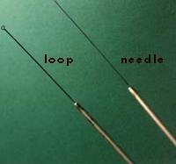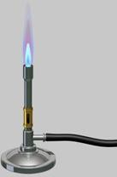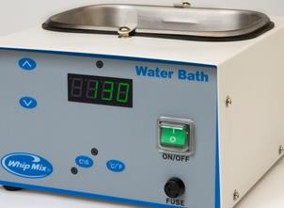
Inoculation Loop & Needle Bunsen Burner Water Bath
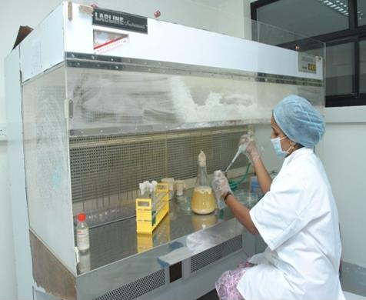
Laminar Air Flow

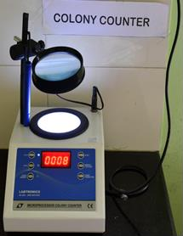

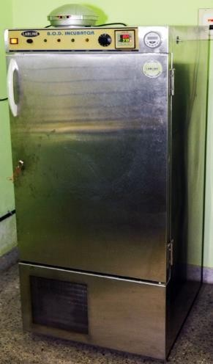
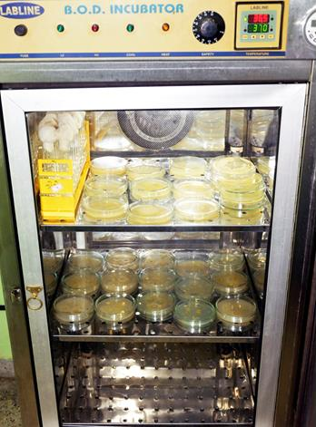
Colony Counter
Incubator

Fig. 1. Tools in microbiology laboratory

The Microscope

A good microscope is an essential tool for any microbiology laboratory. There are many kinds of microscopes but the type most useful in diagnostic work is the compound microscope. By means of a series of lenses and a source of bright light, it magnifies and illuminates minute objects such as bacteria and other microorganisms that would otherwise be invisible to the eye. This type of microscope will be used throughout your laboratory course. As you gain experience using it, you will realize how precise it is and how valuable for studying microorganisms present in clinical specimens and in cultures. Even though you may not use a microscope in your profession, a firsthand knowledge of how to use it is important. Your laboratory experience with the microscope will give you a lasting impression of living forms that are too small to be seen unless they are highly magnified. As you learn about these “invisible” microorganisms, you should be better able to understand their role in transmission of infection.

Instructions

- Observe that a flat platform, or stage as it is called, extends between the upper lens system and the lower set of devices for providing light. The stage has a hole in the center that permits light from below to pass upward into the lenses above. The object to be viewed is positioned on the stage over this opening so that it is brightly illuminated from below. Note the adjustment knobs at the side of the stage, which are used to move the slide in vertical and horizontal directions on the stage. This type of stage is referred to as a mechanical stage.
- A built-in illuminator at the base is the source of light. Light is directed upward through the abbe condenser. The condenser contains lenses that collect and concentrate the light, directing it upward through any object on the stage. It also has a shutter or iris diaphragm which can be used to adjust the amount of light admitted. A lever is provided on the condenser for operating the diaphragm.
- The condenser can be lowered or raised by an adjustment knob. Lowering the condenser decreases the amount of light that reaches the object. This is usually a disadvantage in microbiological work. It is best to keep the condenser fully raised and to adjust light intensity with the iris diaphragm.

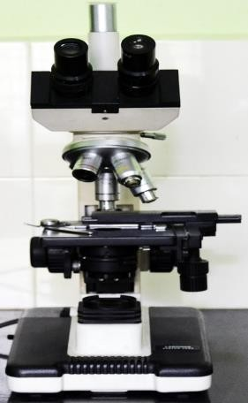

Fig. 2. Microscope

- Above the stage, attached to the arm, a tube holds the magnifying lenses through which the object is viewed. The lower end of the tube is fitted with a rotating nosepiece holding three or four objective lenses. As the nosepiece is rotated any one of the objectives can be brought into position above the stage opening. The upper end of the tube holds the ocular lens, or eyepiece (a monocular scope has one; a binocular scope permits viewing with both eyes through two oculars).
- Depending on the brand of microscope used, either the rotating nosepiece or the stage can be raised or lowered by coarse and fine adjustment knobs. These are located either above or below the stage. On some microscopes they are mounted as two separate knobs; on others they may be placed in tandem with the smaller fine adjustment extending from the larger coarse wheel. Locate the coarse adjustment on your microscope and rotate it gently, noting the upward or downward movement of the nosepiece or stage. The coarse adjustment is used to bring the objective down into position over any object on the stage, while looking at it from the side to avoid striking the object and thus damaging the expensive objective lens. The fine adjustment knob moves the tube to such a slight degree that movement cannot be observed from the side. It is used when one is viewing the object through the lenses to make the small adjustments necessary for a sharp, clear image.

Care and Handling of the Microscope
- Always use both hands to carry the microscope, one holding the arm, other under the base.
- Before each use, examine the microscope carefully and report any unusual condition or damage.
- Keep the oculars, objectives, and condenser lens clean. Use dry lens paper only.
- At the end of each laboratory period in which the microscope is used, remove the slide from the stage, wipe away the oil on the oil-immersion objective, and place the low-power objective in vertical position.
- Replace the dust cover, if available, and return the microscope to its box.

Handling and Examining Cultures

Microscopic examination of microorganisms provides important information about their morphology but does not tell us much about their biological characteristics. To obtain such information, we need to observe microorganisms in culture. If we are to cultivate them successfully in the laboratory, we must provide them with suitable nutrients, such as protein components, carbohydrates, minerals, vitamins, and moisture in the right composition. This mixture is called a culture medium. It may be prepared in liquid form, as a broth, or solidified with agar, a nonnutritive solidifying agent extracted from seaweed. Agar media may be used in tubes as a solid column or as slants, which have a greater surface area. They are also commonly used in petri dishes, or plates.
Solid media are essential for isolating and separating bacteria growing together in a specimen collected from a patient, for example, urine or sputum. When a mixture of bacteria is streaked across the surface of an agar plate, it is diluted out so that single bacterial cells are deposited at certain areas on the plate. These single cells multiply at those sites until a visible aggregate called a colony is formed. Each colony represents the growth of one bacterial species. A single, separated colony can be transferred to another medium, where it will grow as a pure culture. Colonies of several different species are regularly present on the same agar plate when certain patient specimens are inoculated onto them. Working with pure cultures permits the microbiologist to study the properties of individual species without interference from other species.
The appearance of colonial growth on agar media can be very distinctive for individual species. Observation of the noticeable, gross features of colonies, that is, of their colonial morphology, is therefore very important. The colour, density, consistency, surface texture, shape, and size of colonies all should be observed, for these features can provide clues as to the identity of an organism, although final identification cannot be made by morphology alone.
In liquid media, some bacteria grow diffusely, producing uniform clouding, whereas others look very granular. Layering of growth at the top, center, or bottom of a broth tube reveals something of the organisms’ oxygen requirements. Sometimes colonial aggregates are formed and the bacterial growth appears as small puff balls floating in the broth. Observation of such features can also be helpful in recognizing types of organisms.
Disposal of Laboratory Wastes and Cultures
During laboratory practices, it has been noticed that the untreated waste is generally disposed off by the laboratory staff. It happens due to their unskilled work culture. Most of the laboratories situated in the rural area used discarded hospital material for land filling purposes. Any material which contains microorganisms should be treated first and thereafter, with the proper treatment should be thrown properly.
The treatment is necessary due to the reasons:
- If it contains pathogenic microorganisms, the disease may transmit or spread to the healthy persons.
- It may contaminate soil and causes soil, water and air-pollution. Hence, to check from such hazards, proper treatment is required to kill microorganisms.

The infected material is generally the solid or liquid culture media used for cultivation of microorganisms, or it may also contain cotton plugs, paper, cotton or cotton swabs, gloves, pins, PCR tubes, gel material etc.
Some of the materials such as cotton plugs, paper, napkins, swabs etc. should be autoclaved first and then it is incinerated. But the microbial contaminants containing materials should be treated with some disinfectant and thereafter autoclaved by putting them in suitable containers. The molten material should be discarded.
Sometimes, HCl is also added to hydrolyze the agar, if present in the medium. This is added before their safe disposal. All such laboratory materials should be disposed of after autoclaving.

