States of matter
- Gaseous state
- Liquid state
- Solid and crystalline state
- Liquid crystalline state

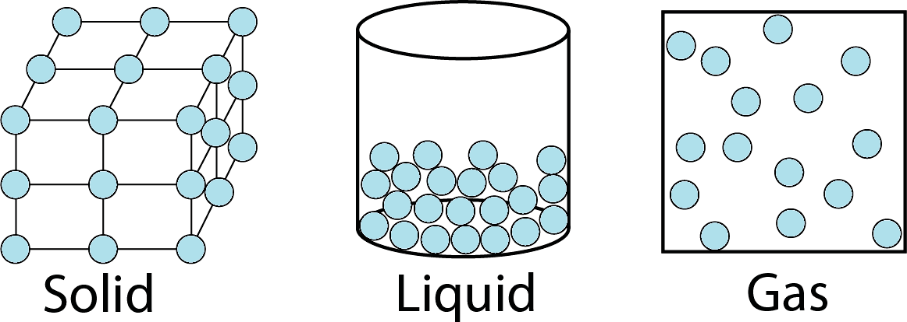

The gaseous state:

Gas general properties Ideal gas
Real gas

Gas general properties
Gases can be expanded infinitively, therefore gases can fill containers and take their volume and shape.
Gases diffuse and mix evenly and rapidly.
Gases have much lower densities than liquids and solids (There is a lot of free space in a gas, therefore; It is the most compressible state of matter).

Gas molecules travel in random paths and collide with one another and with the walls of the container in which they are confined
A gas exerts a pressure (a force per unit area) expressed in dynes/cm2, atmospheres or in mmHg (1 atm = 760 mmHg = 760 Torr).
Gases have volumes that is expressed in liters or cubic centimeters (1 cm3 = 1 mL).
The temperature involved in the gas equations is expressed by the absolute or Kelvin scale (0°C=273.15 K (Kelvin)).
Ideal gas is a gas where no intermolecular interactions exist and collisions are perfectly elastic, and thus no energy is exchanged during collision.
The properties of the ideal gas can be described by the general ideal gas law, which are derived from Boyle, Charles and Gay-Lussac laws


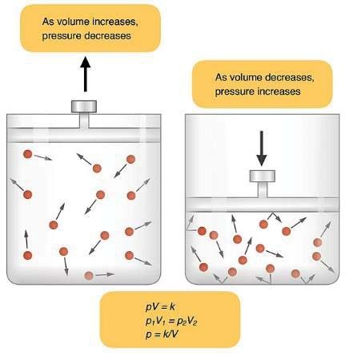
Boyle’s law states that the volume and pressure of a given mass of gas is inversely proportional (i.e. when the pressure of a gas increases, its volume decreases).
32
University of Kerbala

P α ¹ V
or P = ^{K}
V

P1V1 = P2V2
P: pressure, K: constant,
V: volume

Charles law states that the volume and absolute temperature of a given mass of gas at constant pressure are directly proportional (i.e when the temperature of a gas increases, its volume increases as well).


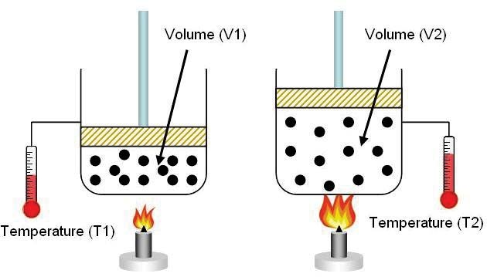
V α T or V= kT
33
University of Kerbala

V1 = V2 T1 T2
T: temperature in Kelvin

GaThe law of Gay-Lussac states that the pressure and absolute temperature of a given mass of gas at constant volume are directly proportional (i.e when the temperature of a gas increases, its pressure increases as well).

P α T or P= k T

P1 = P2 T1 T2
Boyle, Gay-Lussac and Charles law can be combined to obtain the familiar relationship:

P1 V1 T1
= P2 V2
T2

A gas occupies a volume of 30.0 mL at a temperature of 20°C and a pressure of 740 mm Hg. Assuming the gas is ideal, what is the volume at 0°C and 760 mm Hg?

P1 V1 T1
= P2 V2
T2

740 × 30

273 + 20
= 760 × V2
273
V2 = 27.2 mL

A sample of methane CH4 has a volume of 7.0 dm3 at a temperature of 4°C and a pressure of 0.848 atm. Calculate the volume of methane at a temperature of 11°C and a pressure of 1.52 atm.

P1 V1 T1
= P2 V2
T2

0.848 ×7 = 1.52 × V2

V = 4 dm3

273 +4
273 + 11 ²

General ideal gas law (also called equation of state) relates the specific conditions, that is, the pressure, volume, and temperature of a given mass of gas.

P1 V1

T1
= P2 V2
T2
‹ PV = R
T

R: the molar gas constant value for the PV/T ratio of an ideal gas.
For n moles it becomes:
The volume of 1 mole of an ideal gas under standard conditions of temperature and pressure (i.e., at 0°C and 1 atm) has been found by experiment to be 22.414 liters.
Substituting this value in general ideal gas law:

R PV = T
=
1 × 22.414

273.16

= 0.08205 atm L/mole K

The molar gas constant can also be expressed by energy units:

R = 8.314 Joules/mole K or
R = 8.314 × 107 erg/mole K 1 joule = 107 erg

Kinetic molecular theory explains the behavior of gases according to the ideal gas law:
- Gases are composed of particles called atoms or molecules, the total volume of which is so small (negligible) in relation to the volume of the space in which the molecules are confined.
- Gas molecules exert neither attractive nor repulsive forces on one another.
- The particles exhibit continuous random motion. The average kinetic energy, E, is directly proportional to the absolute temperature of the gas, or E = (3/2) RT.
- The molecules exhibit perfect elasticity; there is no net loss of speed or transfer of energy after they collide with one another and with the walls of the confining vessel.

Real gas
Real gases do not interact without energy exchange, and therefore do not follow the laws of Boyle, Charles, and Gay-Lussac.
Real gases are not composed of infinitely small and perfectly elastic non-attracting spheres.
They are composed of molecules of a finite volume that tend to attract one another.
The significant molecular volume and the intermolecular attractions between gas molecules affect both the volume and the pressure of a real gas respectively.

The van der Waals equation is a modified ideal gas equation that takes into account the factors that affect the volume and pressure of a real gas.

For 1 mole of gas:
For n moles of gas:
V—b = RT
V— nb = nRT
P+ a
V2
P+
an2
V2

The term a/V2 accounts for the internal pressure per mole resulting from the intermolecular forces of attraction between the molecules;
b accounts for the excluded volume, which is about four times the molecular volume.

Real Gas

Van der Waals Equation
The influence of non-ideality is greater when the gas is compressed (At high pressure and low temperature).
When the volume of a gas is large (At low pressure and high temperature), the molecules are well dispersed and far apart. Under these conditions, a/V2 and b become insignificant with respect to P and V, respectively, and the van der Waals equation for the real gas reduces to the ideal gas equation:
PV = nRT
At these conditions, real gases behave in an ideal manner.

References
Sinko, P. J. M. A. N. 2006. Martin's physical pharmacy and pharmaceutical sciences: physical chemical and biopharmaceutical principles in the pharmaceutical sciences, Philadelphia, Lippincott Williams & Wilkins.

