Technology transfer is the process by which the manufacturing process and analytical method are transferred from one manufacturing unit to another unit or from R&D to manufacturing unit.

Technology transfer from R&D to manufacturing site is critical because of the scale-up of the product from pilot batch to large-scale commercial batch. A typical technology transfer process can be divided into production part, quality control part and documentation part.
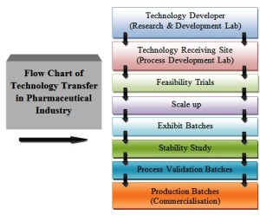
- Production Technology Transfer:
Receiving unit and sending unit both should develop the product transfer protocol jointly to transfer the product related information. Information should be transferred according to the technical expertness of the staff and the manufacturing site capabilities to run the process smoothly.

1.Raw Materials:
The material used for manufacturing on receiving unit should have consistency with the material used at the sanding unit. The properties of the raw material those can alter the quality of the product should be identified.

i)Active Pharmaceutical Ingredients (API):
Sending unit should provide the drug master file (DMF) and other related information of the active materials. It may include the following information
- Flowchart of the manufacturing process of the drug material
- Physical properties including bulk and tap density
- Moisture content including water activity
- Bioburden, endotoxin and sterility as required
- Solubility and pH of solution
- Particle size distribution and its dissolution profile
- Manufacturer and the supply chain of the material
- Other information like heat, light and moisture sensitivity

ii)Excipients:
Excipients also have the considerable effect on the final product so their detailed information should also be provided by the sending unit to receiving unit. It may include the following information:
- Viscosity of material
- Flowchart of the manufacturing process of the drug material
- Physical properties including bulk and tap density
- Moisture content range
- Melting range
- Bioburden, endotoxin and sterility as required Ion strength of material
- Solubility and pH of solution
- Specific gravity
- Particle size distribution and its dissolution profile
- Manufacturer and the supply chain of the material
- Compliance with TSE and BSE requirements
- MSDS and heat, light and moisture sensitivity
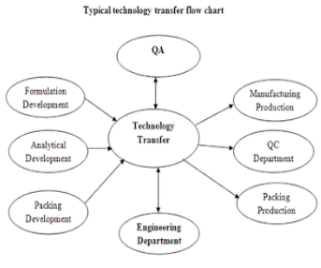
- In-process Materials:
Sending unit should provide the detailed information of manufacturing process, physical description, specification and in-process controls.

- Finished Products:
History of the development of the product should also be provided for the further development or process optimization after the successful technology transfer.
Information regarding the environment, health and safety should also be provided to the receiving unit. It should also include the information on product quality review, validation, stability and environmental conditions for manufacturing.
Generally, trial batches are taken at the receiving unit to test the manufacturing parameters and capability of the manufacturing process before running the validation batch.

4.Packing Process:
All the information regarding the packing should be transferred as the manufacturing process. It includes the specification of foils or containers and closures, and other related information as design labeling, artwork and drawings.

5.Cleaning Process
To prevent the contamination in the pharmaceutical products, it is essential the follow the adequate cleaning procedure. It can minimize the risk of cross-contamination during manufacturing. Receiving unit should validate the cleaning procedure and sending unit should provide the required information such as existing cleaning procedure, the solubility of all materials, therapeutic dose, the toxicity of the API, cleaning agents and recovery studies.

6.Manufacturing Facility
Sending unit should provide the information related to the facility design.
i)Premises
It should include the layout of facility, buildings, utility services, fire risk, health and safety requirements for operators and environmental issues.
ii)Equipment
A list of required equipment with their make and models should be provided by the sending unto. It should include the manuals, drawings and cleaning, operating and maintenance procedures. IQ, OQ and PQ of the equipment should be done by the receiving unit.

B)Quality Control: Analytical Method Transfer
The analytical method has its own importance because the manufactured product shall be tested by the developed analytical method and accuracy in the analytical method can save time. Receiving unit should implement the method of analysis for the finished product, raw materials, packing materials and cleaning residues before the starting of the process validation.

Analytical method transfer protocol should be prepared including responsibilities of both sanding unit and receiving unit, the specification of product, acceptance criteria, interpretation of results, report formats, reference standards and deviations during analysis. Training should be provided to the analysts and should be documented in training record.

C)Documentation
Every step followed during the technology transfer process should be documented and a summary report should be prepared to contain the conclusion of the technology transfer. Discrepancies found during the process should be listed and should be resolved by taking the appropriate action. Following documents should be prepared during the successful tech transfer.
1.Technology transfer protocol
2.Facility qualification protocol and report
3.Equipment qualification protocol and report
4.Process validation protocol and report
5. Cleaning validation protocol and report

