Interface is the boundary between two phases.
Surface is a term used to describe either a gas-solid or a gas- liquid interface.
Interfacial phase is a term used to describe molecules forming the interface between two phases which have different properties from molecules in the bulk of each phase.

i

Surface Tension

Molecules in the bulk liquid are surrounded in all directions by other molecules for which they have an equal attraction (only cohesive forces).
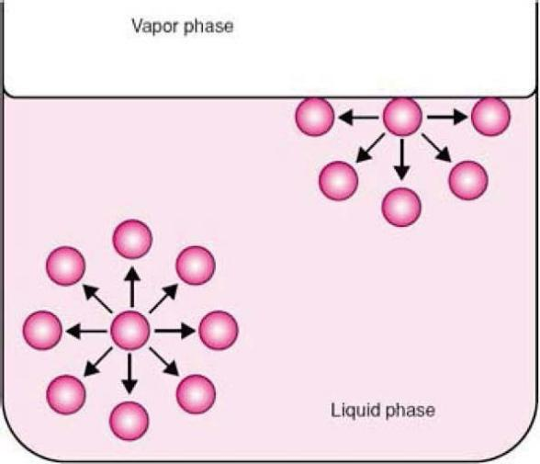
Molecules at the surface can only develop cohesive forces with other molecules that are below and adjacent to them; and can develop adhesive forces with molecules of the other phase.

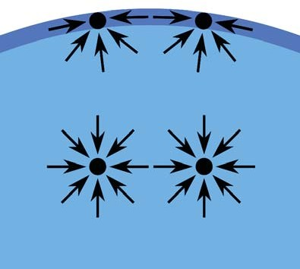
This imbalance in the molecular attraction will lead to an inward force toward the bulk that pulls the molecules of the interface together and contracts the surface, resulting in a surface tension.

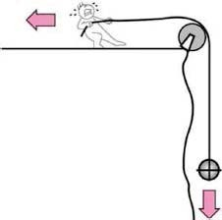
Surface tension is the force per unit length that must be applied parallel to the surface to counterbalance the net inward pull.
It has the units of dynes/cm or N/m.

i

7

Interfacial Tension

Interfacial tension is the force per unit length existing at the interface between two immiscible phases (units are dynes/cm or N/m).
The term interfacial tension is used for the force between: Two liquids = yLL
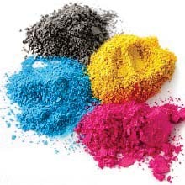
Two solids = ySS
Liquid-solid = yLS
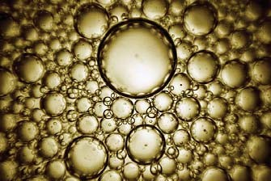
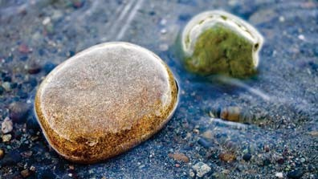

The term surface tension is reserved for the tensions: Liquid-vapor = yLV (written simply as yL).
Solid-vapor = ySV (written simply as yS).

Interfacial tensions are weaker than surface tensions because the adhesive forces between two liquid phases forming an interface are greater than that between liquid and gas phases.

i
9

Surface Free Energy
The surface layer of a liquid possesses additional energy as compared to the bulk liquid.
If the surface of the liquid increases (e.g. when water is broken into a fine spray), the energy of the liquid also increases.
Because this energy is proportional to the size of the free surface, it is called a surface free energy:
W = y 6 A
W:surface free energy (ergs) y: surface tension (dynes/cm) AA: increase in area (cm2).
Therefore, surface tension can also be defined as the surface free energy per unit area of liquid surface.

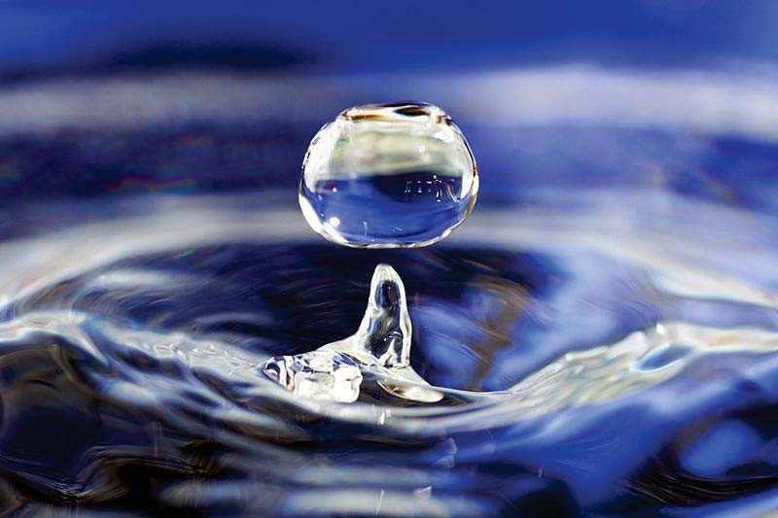
Each molecule of the liquid has a tendency to move inside the liquid from the surface; therefore, when the surface is increased, the liquid takes the form with minimal surface and as a result, minimal surface energy:

Sphere!

i
11

Measurement of Tensions

Capillary Rise Method
When a capillary tube is placed in a liquid contained in a beaker, the liquid rises up in the tube to a certain distance.
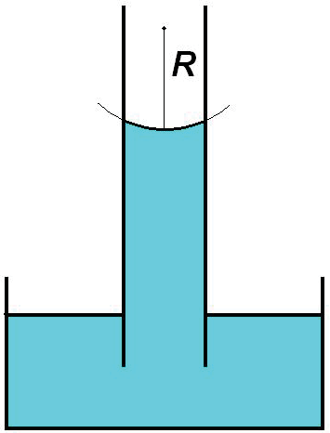
By measuring this rise in the capillary, it is possible to determine the surface tension of the liquid using the formula:

y = ½ r M p g
y: surface tension r: radius of capillary M: height
p: density of the liquid
g: acceleration of gravity
This method cannot be used to obtain interfacial tensions.

The DuNoüy Ring Method
The force necessary to detach a platinum–iridium ring immersed at the surface or interface is proportional to the surface or interfacial tension. The surface tension is given by the formula:
Dial reading in dynes
y =
2 × Ring circumference × Correction factor
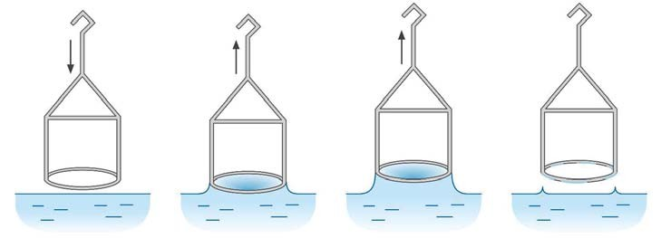
The DuNoüy tensiometer is widely used for measuring surface and interfacial tensions.

i
13

