Types of Adsorption
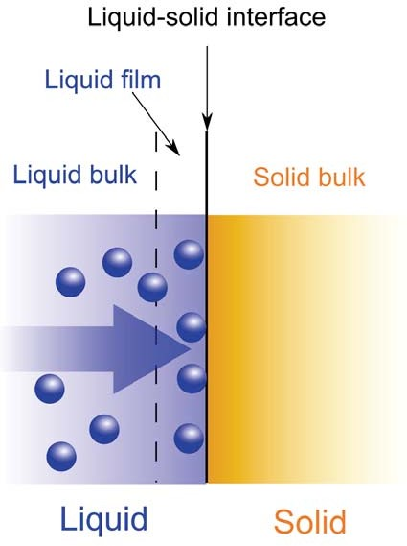
Adsorption is the adhesion of atoms, ions, or molecules from a gas, liquid, or dissolved solid to a interface.
There are two general types of adsorption:
- Physical adsorption, in which the adsorbate is bound to the surface through the weak van der Waals forces.
- Chemical adsorption or chemisorption, which involves the stronger valence forces.

31

Adsorption

Langmuir Equation

Adsorption may be analysed using the Langmuir equation:

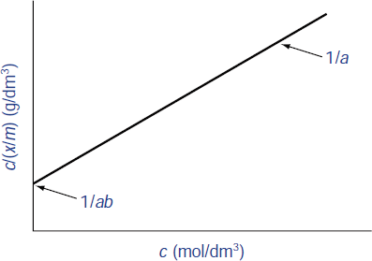
c 1 c
= +
x/m ab a
x = amount of solute adsorbed.
m = weight of adsorbent.
c = conc. of solution at equilibrium.
b = constant related to the enthalpy of adsorption
a = constant related to the surface area of the solid
Values of a and b can be determined from the intercept (1/ab) and slope (1/a) by plotting c/(x/m) against c

Factors Affecting Adsorption at S-L Interface

Solubility of the adsorbate
The extent of adsorption of a solute is inversely proportional to its solubility in the solvent from which adsorption occurs.

pH
For simple molecules adsorption increases as the ionization of the drug is suppressed, reaching a maximum when the drug is completely unionized.

33

Adsorption

Factors Affecting Adsorption at S-L Interface

Nature of the adsorbent
The extent of adsorption is proportional to the surface area of the adsorbent. Thus, the more finely divided or the more porous the solid, the greater its adsorption capacity.

Temperature
Since adsorption is generally an exothermic process, an increase in temperature normally leads to a decrease in the amount adsorbed.

Pharmaceutical Applications
- Adsorption of poisons/toxins: Activated charcoal are used in adsorbing the toxins and reducing the effects of poisoning by the oral route.
- Taste masking: Drugs such as diazepam may be adsorbed onto solid substrates to minimize taste problems.

Adsorption in drug formulation:
  - Suspensions are stabilized by adsorption of surfactants and polymers on the dispersed solid.
  - Adsorption of surfactants onto poorly soluble solids increase their dissolution rate by increased wetting.
- Separation: HPLC and TLC techniques rely on the
principle of adsorption.

35

HLB System

Definition


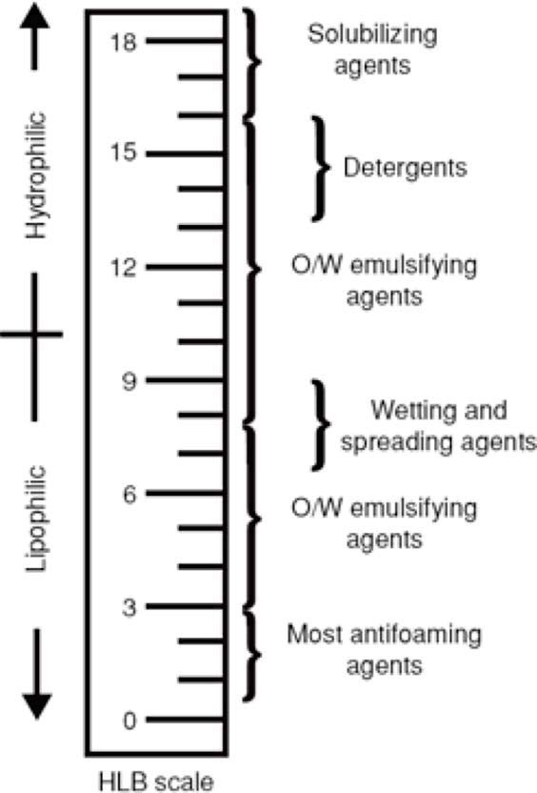
The hydrophile-lipophile balance (HLB) system is an arbitrary scale for expressing the hydrophilic and lipophilic characteristics of an emulsifying agent.

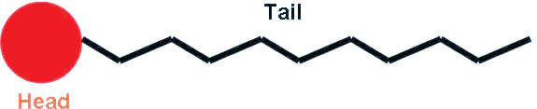
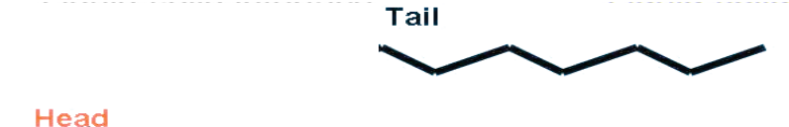
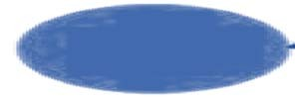

36

Definition
Agents with HLB value of 1-8 are lipophilic and suitable for preparation of w/o emulsion, and those with HLB value of 8- 18 are hydrophilic and good for o/w emulsion.
The oil phase of an o/w emulsion requires a specific HLB, called the required hydrophile–lipophile balance (RHLB).


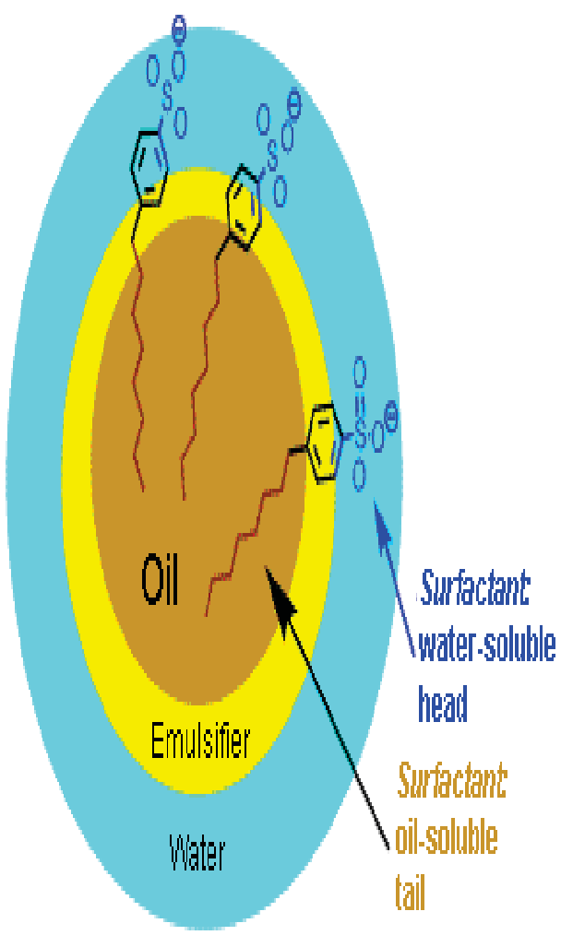
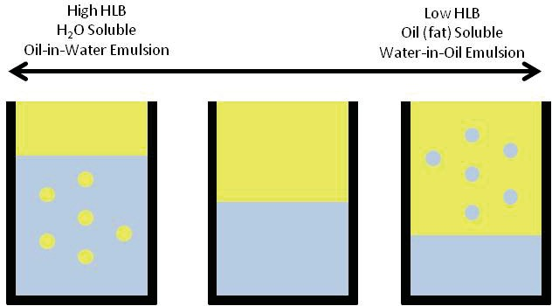

37

HLB System

Calculations

Example

Calculate the amounts (ml) of each of the emulsifiers (tween 80 and span 80) that are required to prepare the emulsion:

Ingredient | Amount | RHLB (O/W)
1. Beeswax | 15 g | 9
2. Lanolin | 10 g | 12
3. Paraffin wax | 20 g | 10
4. Cetyl alcohol | 5 g | 15
5. Emulsifiers (Tween 80 + Span 80) | 5 ml
6. Preservative | As required
7. Color | 0.2 g
8. Water, purified | q.s. 100 ml

Calculations

Example
First, calculate the overall RHLB of the emulsion by multiplying the RHLB of each oil-like component (items 1-4) by their weight fraction from the oil phase. The total weight of the oil phase is 50 g. Therefore:
Beeswax 15/50 × 9 = 2.70
Lanolin 10/50 × 12 = 2.40
Paraffin 20/50 × 10 = 4.00
Cetyl alcohol 5/50 × 15 = 1.50
Total RHLB for the emulsion = 10.60

39

HLB System

Calculations

Example

Next, a blend of two emulsifying agents is chosen, one with an HLB above the RHLB of the emulsion (Tween 80, HLB = 15) and the other with an HLB below the RHLB (Span 80, HLB
= 4.3)
Calculate the percentages of the emulsifiers using the formula:

% Sur†actant witM HLB

MigM
= RHLB — HLBlow
HLBMigM — HLBlow

% Tween =
10.6 — 4.3

15 — 4.3
= 0.59

Therefore, 5 ml × 0.59 = 2.95 ml of Tween 80
and the remainder, 2.05 ml, must be supplied by Span 80

Wetting Agents
A wetting agent is a surfactant that lowers the contact angle by displacing an air phase at the surface, and replacing it with a liquid phase.
The contact angle is the angle between a liquid droplet and the surface over which it spreads.
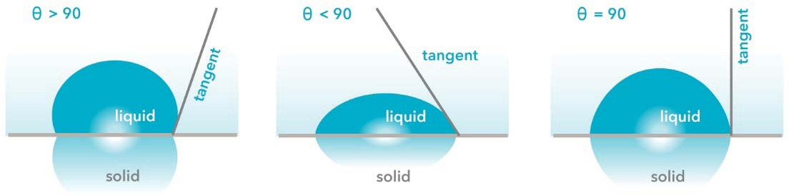

41

Wetting

Applications

Application of wetting to pharmacy and medicine include:
  - The displacement of air from the surface of pharmaceutical powders in order to disperse them in liquid vehicles.
  - The displacement of air from the matrix of cotton pads and bandages so that medicinal solutions can be absorbed for application to various body areas.
  - The displacement of air from the surface of the skin and mucous membranes when medicinal lotions and sprays are applied.

