Introduction
Complexes are compounds that result from donor–acceptor mechanisms between two or more chemical species.
Complexes can be divided broadly into three classes depending the type of the acceptor substance:
  - Metal ion complexes
  - Organic molecular complexes
  - Inclusion complexes
Intermolecular forces involved in the formation of complexes:
- Van der Waals forces.
- Hydrogen bonds (important in molecular complexes).
- Coordinate covalence (important in metal complexes).
- Charge transfer.

- Hydrophobic interaction.

5

Introduction

Types of Complexes

Metal Ion Complexes
  - Inorganic type
  - Chelates
  - Olefin type
  - Aromatic type

Organic Molecular Complexes
  - Quinhydrone type
  - Picric acid type
  - Caffeine and other drug complexes
  - Polymer type

Inclusion Compounds
  - Channel lattice type
  - Layer type
  - Clathrates
  - Monomolecular type
  - Macromolecular type

Metal ion complex (coordination complex) consists of a transition-metal ion (e.g. cobalt, iron, copper, nickel and zinc) linked or coordinated with one or more counter ions or molecules to form a complex.
The ions or molecules (e.g. Cl–, NH3, H2O, Br–, I–, CN–, etc.) directly bound with the metal are called ligands.
The interaction between the metal and the ligand represents a Lewis acid-base reaction in which the metal ion (Lewis acid) combines with a ligand (Lewis base) by accepting a pair of electrons from the ligand to form the coordinate covalent or electrostatic forces:
Co³⁺ + 6 : NH3 ‹ [Co NH3 6]³⁺

7

Metal ion Complexes

Inorganic Complexes
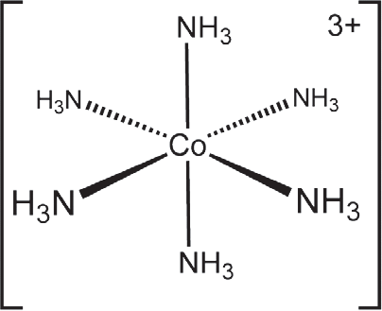
The number of ligands bound to the metal ion is defined as coordination number.
The coordination number of cobalt is six, since it complexed with six NH3 groups.

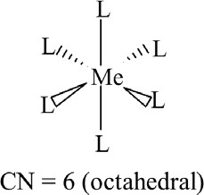
Coordination number usually determine the geometry of the complex.

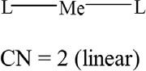
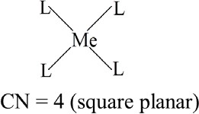
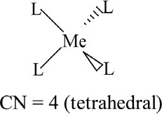

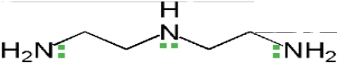
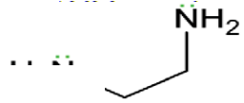
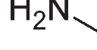
Compound (e.g. NH3) which has a single pair of electrons for bonding with the metal ion, is called unidentate ligand.

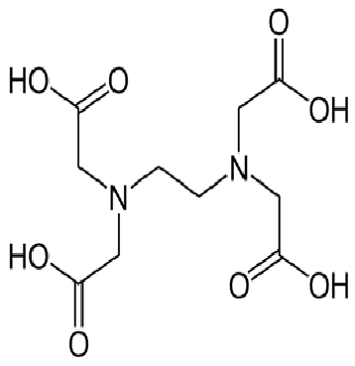
Ligands with two or three groups are known as bidentate or tridentate respectively.

Ethylenediaminetetraacetic acid (EDTA) has six points for attachment (two nitrogen and four oxygen donor groups) and is called hexadentate.

9

Metal ion Complexes

Chelates

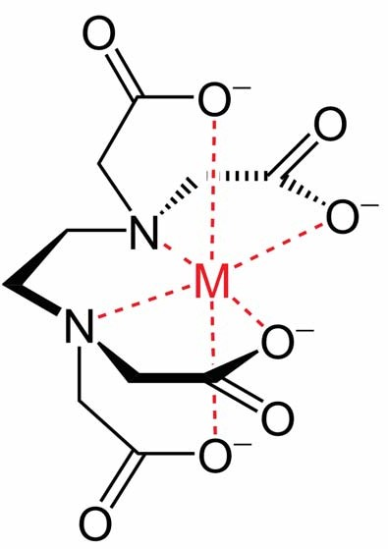
Chelation is the formation of two or more coordinate bonds between a multidentate ligand (organic compound called chelating agent) and a single central atom.
EDTA Complex
The bonds in the chelate may be ionic, primary covalent, or coordinate type.

Organic molecular complexes are formed as a result of non- covalent interactions between a ligand and a substrate.
The interactions can occur through van der waals forces, charge transfer, hydrogen bonding or hydrophobic effects.
Many organic complexes are so weak that they cannot be separated from their solutions as definite compounds, and they are often difficult to detect by chemical and physical means.

11

Organic Molecular Complexes
Complexation differs from the formation of organic compounds in the forces between the constituents:
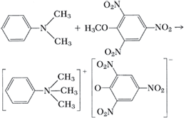
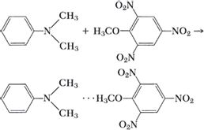
E.g. Dimethylaniline and 2,4,6-trinitroanisole react in the cold to give a molecular complex. However at elevated temperature, they react to yield a salt, in which the molecules are held together by primary valence bonds.
Salt Complex

Charge transfer complex is an association of two or more molecules in which a fraction of electronic charge is transferred between the molecular entities.
The molecules from which the charge is transferred is called the electron donor and the receiving species is called the electron acceptor
Attraction in charge-transfer complexes is weaker than in covalent forces.
Usually these complexes is formed by sharing of w-electrons

13

Organic Molecular Complexes
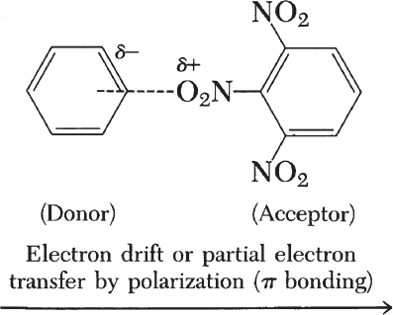
E.g. Complex between benzene and trinitro benzene (1:1 type). (polar nitro group of trinitro benzene induce a dipole in the readily polarizable benzene molecules, resulting in electrostatic attraction).
The difference between a donor–acceptor and a charge transfer complex is that in the latter type, resonance makes the main contribution to complexation, whereas in the former, London dispersion forces contribute more to the stability of the complex.

Quinhydrone Complex
This molecular complex is formed by mixing equimolar quantities of benzoquinone with hydroquinone.
Complex formation is due to overlapping of the w-framework of the electron-defficient benzoquinone with the w-framework of the electron-rich hydroquinone (charge transfer).
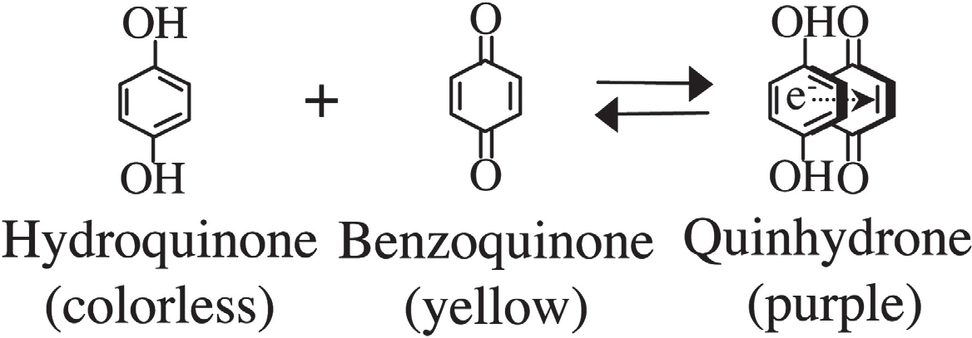

15

Organic Molecular Complexes

Picric Acid Complexes
Picric acid (2,4,6-trinitrophenol), is a strong acid that forms complexes with many weak bases such as poly-nuclear aromatic compounds.
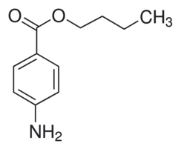
An example is Butesin picrate (local anaesthetic) which is a complex formed between two molecules of butyl p- aminobenzoate with one molecule of picric acid.
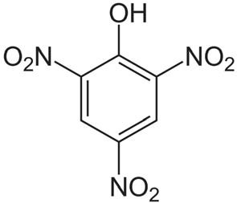
2

Caffeine Complexes
Caffeine forms complexes with a number of drugs owing to the following factors:
Hydrogen bonding between the polarizable carbonyl group of caffeine and the hydrogen atom of the acidic drugs such as p-amino benzoic acid and gentisic acid.
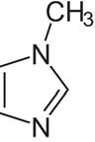
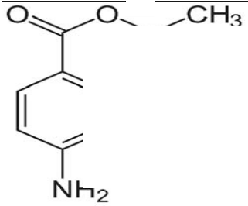
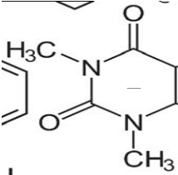
Dipole-dipole interaction between the electrophilic nitrogen of caffeine and the carboxy oxygen of esters such as benzocaine or procaine
ð
+
ð–
ð–
ð

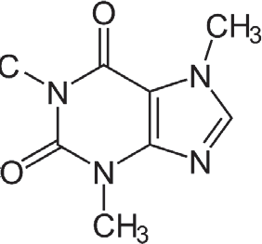
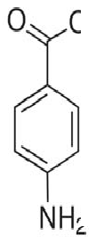
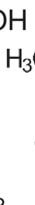
ð+
ð–

17

Organic Molecular Complexes

Caffeine Complexes
Caffeine forms water soluble complexes (more soluble than caffeine itself) with organic acid anions, but the complexes formed with organic acids, such as gentisic acid, are less soluble than caffeine alone.
Such insoluble complexes provide caffeine in a form that masks its normally bitter taste in chewable tablets.

Polymer Complexes
Polymeric materials such as eudragit, chitosan, polyethylene glycols (PEG), polyvinylpyrrolidone (PVP) and sodium carboxymethyl cellulose (CMC), which are usually present in liquid, semisolid and solid dosage forms, can form complexes with a large number of drugs.
Such interactions can result in precipitation, flocculation, solubilization, alteration in bioavailability or other unwanted physical, chemical, and pharmacological effects.

19

Organic Molecular Complexes

Polymer Complexes
Polymer–drug complexes however can also be used to modify biopharmaceutical parameters of drugs.
Polymeric complex between naltrexone and eudragit improves the dissolution rate of naltrexone.
Povidine-iodine is a stable complex of PVP and iodine, which possess superior antibacterial activity.
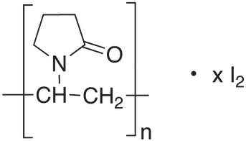

An inclusion compound is a complex in which one chemical compound (the ‘host’) forms a cavity in which molecules of a second compound (‘guest’) are entrapped.
These complexes generally do not have any adhesive forces working between their molecules and are therefore also known as no-bond complexes.

21

Inclusion Complexes

Channel Lattice Type
In this complex, the host component crystallizes to form channel-like structure into which the guest molecule can fit.
The guest molecule must possess a geometry that can be easily fit into the channel-like structure
Channel lattice complexes provides a mean of separation of optical isomers.
The cholic acids (bile salt) is an example of this complex type. The crystals of deoxycholic acid are arranged to form a channel into which the complexing molecule can fit.
The well-known starch–iodine complex is a channel-type complex consisting of iodine molecules entrapped within spirals of the glucose residues

Channel Lattice Type
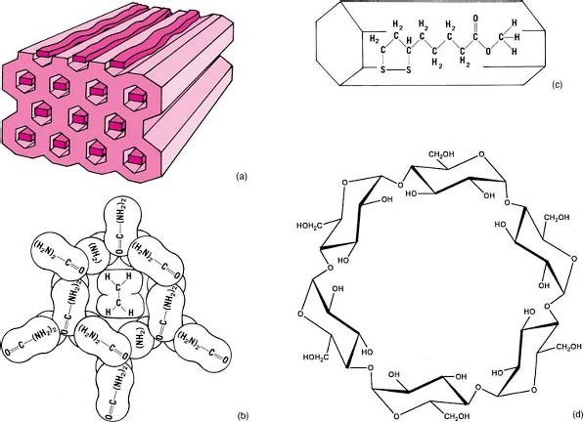

23

Inclusion Complexes

Layer Type
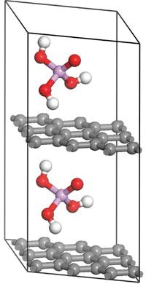
Layer type complex (or intercalation compound) is a type of inclusion compound in which the guest molecule is diffused between the layers of carbon atom, to form alternate layers of guest and host molecules.
Montmorillonite, the principal constituent of bentonite, can trap hydrocarbons, alcohols, and glycols between the layers of their lattices.
Graphite can also intercalate compounds between its layers.

Clathrates
The clathrates are compounds that crystallize in the form of a cage-like lattice in which the coordinating compound is entrapped.
One official drug, warfarin sodium, is in the form of crystalline clathrate containing water and isopropyl alcohol.
Clathrates can be used to separate optical isomers.

25

Inclusion Complexes

Clathrates
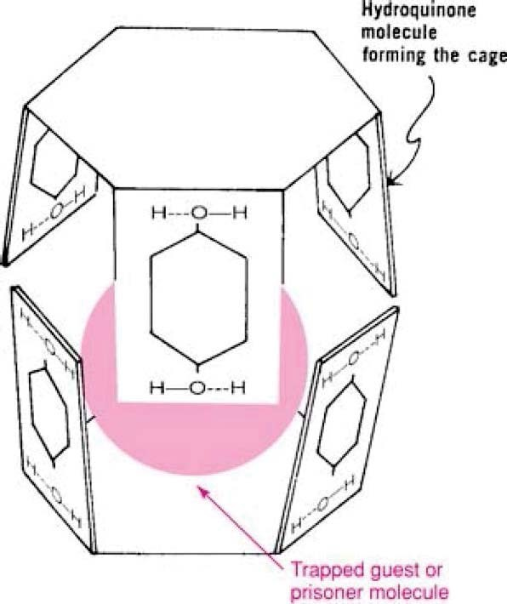
Hydroquinone crystallizes in a cage-like hydrogen-bonded structure, in which small molecules such as methyl alcohol, CO2, and HCl may be trapped in these cages.
Size of the guest molecule is important for complex formation.
If the size is too small, the guest molecule will escape from the cage of the host and if the size is too big, it will not be fit inside the cage.

Monomolecular inclusion complex involves the entrapment of guest molecules into the cage-like structure formed from a single host molecule.
Cyclodextrins are a family of compounds made up of sugar molecules bound together in a ring (cyclic oligosaccharides)
They consist of 6, 7, and 8 units of glucose referred to as a, þ, and ç cyclodextrins, respectively.

Cyclodextrin type Glucose
 | units | diameter
a-cyclodextrins | 6 | 4.7-5.3 Å | 14.5 g/100 mL | Alfadex
þ-cyclodextrins | 7 | 6.0-6.5 Å | 1.85 g/100 mL | Betadex
ç-cyclodextrins | 8 | 7.5-8.3 Å | 23.2 g/100 mL | Gammadex

Internal
Aqueous solubility USP name

27

Inclusion Complexes

Monomolecular Inclusion Compounds: Cyclodextrins
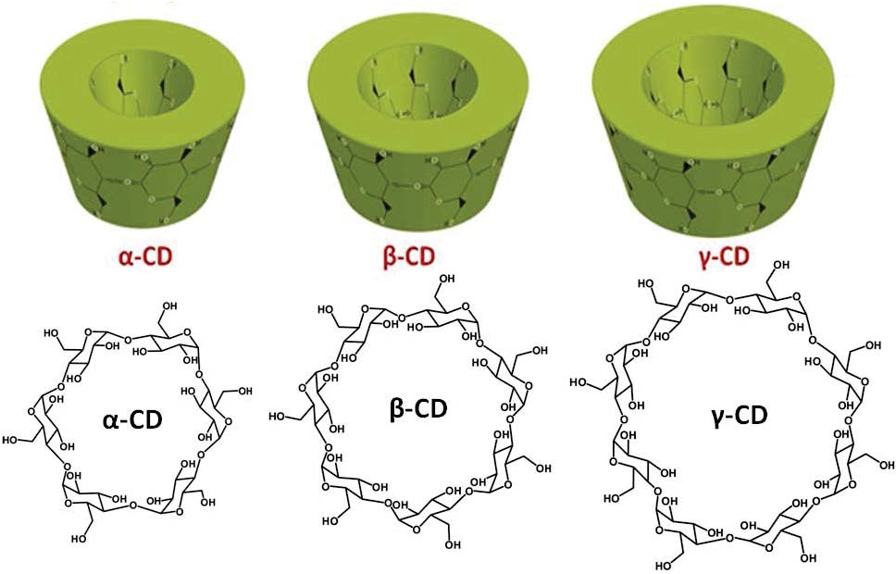
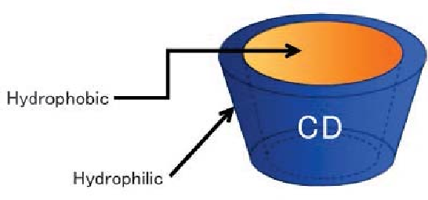
Cyclodextrons have truncated cone structure with a hydrophobic interior cavity because of the CH2 groups, and a hydrophilic exterior due to the presence of hydroxyl group.

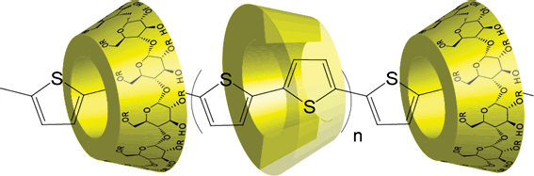
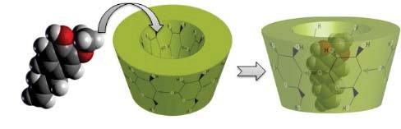
Molecules of appropriate size and stereochemistry get entrapped in the cyclodextrin cavity by hydrophobic interaction by squeezing out water from the cavity.

29

Inclusion Complexes

Monomolecular Inclusion Compounds: Cyclodextrins
Cyclodextrins can enhance the solubility and bioavailability of hydrophobic compounds due to the large number of hydroxyl groups on the CDs.
Cavity size is the major determinant as to which cyclodextrin is used in complexation.
a-Cyclodextrins have small cavities that are not capable of accepting many molecules. ç-Cyclodextrins have much larger cavities than many molecules to be incorporated.
The cavity diameter of þ-cyclodextrins has been found to be the most appropriate size for most drugs. For this reason, þ- cyclodextrin is most commonly used as a complexing agent

Although þ-CD contains a high number of hydroxyl groups, þ- CD solubility is the lowest compared to the a-CD or ç-CD.

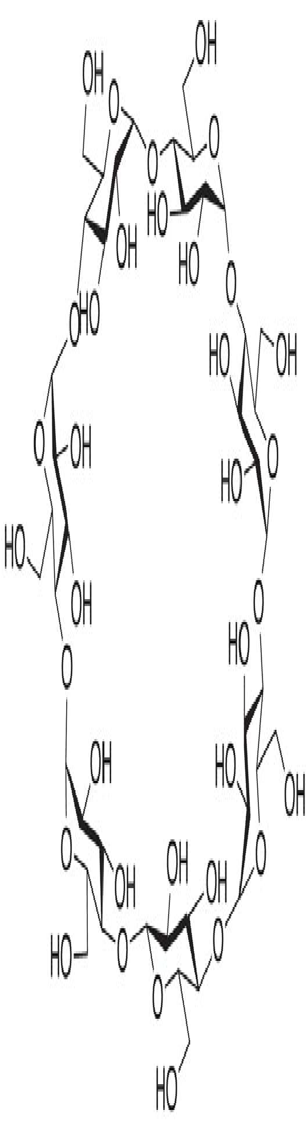
This is due to the formation of an internal hydrogen bond network between the secondary hydroxyl groups.
31

Inclusion Complexes

Monomolecular Inclusion Compounds: Cyclodextrins
Partial alkylation of some of the OH groups in CD reduces the intermolecular hydrogen bonding, leaving some OH groups free to interact with water, thus increasing the aqueous solubility of CD.
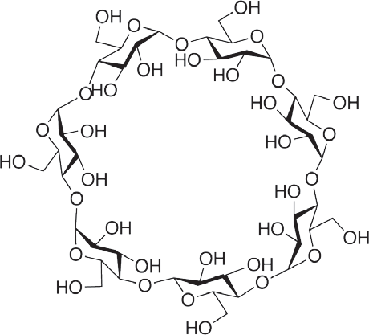
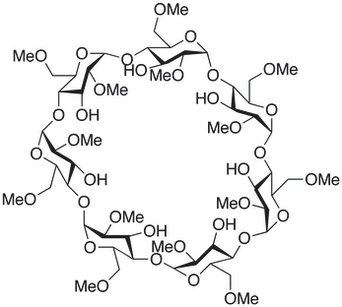
In addition to hydrophilic derivatives, hydrophobic forms of þ- CD have been used as sustained release drug carriers.

In addition to improving the solubility of compounds, complexation with cyclodextrin has been used to improve the stability of many drugs by inclusion of the compound and protecting certain functional groups from degradation.
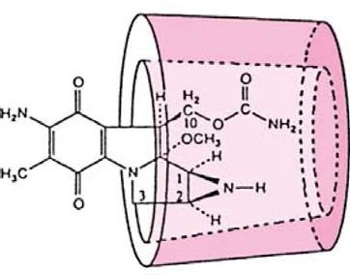
Complexation with cyclodextrins has also been used to mask the bitter taste of certain drugs such as femoxetine.

33

Inclusion Complexes

Macromolecular Inclusion Compounds
Macromolecular inclusion compounds, (molecular sieves) include substances such as zeolites, dextrins, and silica gel.
The atoms are arranged in three dimensions to produce cages and channels in which the guest molecules are entrapped.
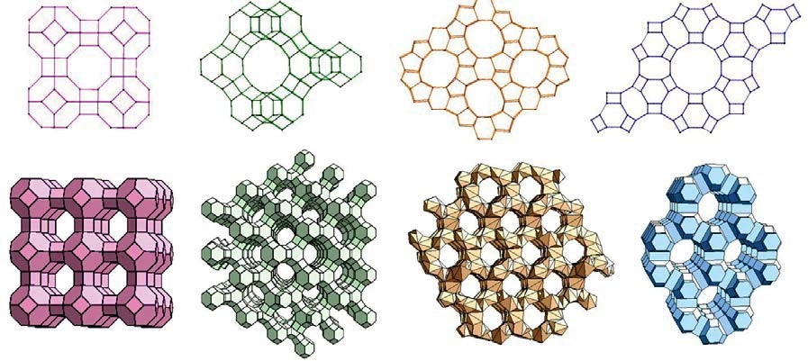
Synthetic zeolites can be made to a definite pore size to separate molecules of different dimensions.

