Complexation and Protein Binding
Complexes or coordination compounds, according to the classic definition, result from a donor–acceptor mechanism or Lewis acid–base reaction between two or more different chemical constituents.
Any nonmetallic atom or ion, whether free or contained in a neutral molecule or in an ionic compound, that can donate an electron pair can serve as the donor. The acceptor, or constituent that accepts a share in the pair of electrons, is frequently a metallic ion, although it can be a neutral atom.
Intermolecular forces involved in the formation of complexes are
1- the van der Waals forces of dispersion. 2- dipolar, and induced dipolar types.
- Hydrogen bonding provides a significant force in some molecular complexes.
- coordinate covalence is important in metal complexes.

Classification of Complexes

Metal ion complexes
  - Inorganic type
  - Chelates
  - Olefin type
  - Aromatic type
    - Pi (π) complexes
    - Sigma (σ) complexes
    - “Sandwich” compounds

Organic molecular complexes
  - Quinhydrone type
  - Picric acid type
  - Caffeine and other drug complexes
  - Polymer type

Inclusion/occlusion compounds

  - Channel lattice type
  - Layer type
  - Clathrates
  - Monomolecular type
  - Macromolecular type

Inorganic Complexes
The ammonia molecules in hexamminecobalt (III) chloride, as the compound [Co(NH3)6]3+ Cl - is called, are known as the ligands and are said to be coordinated to the cobalt ion. The coordination number of the cobalt ion, or number of ammonia groups coordinated to the metal ions, is six. Other complex ions belonging to the inorganic group include [Ag(NH3)2]+, [Fe(CN)6]4-, and [Cr(H2O)6]3+.
3
Each ligand donates a pair of electrons to form a coordinate covalent link between itself and the central ion having an incomplete electron shell. For example,

Ligands such as H2Ö H3 , C -, or l- donate a pair of electrons in forming a complex with a metal ion, and the electron pair enters one of the unfilled orbitals on the metal ion.

Hybridization plays an important part in coordination compounds in which sufficient bonding orbitals are not ordinarily available in the metal ion.
Table 10-2shows some compounds in which the central atom or metal ion is hybridized differently and the geometry that results.

Table 10-2 Bond Types of Representative Compounds

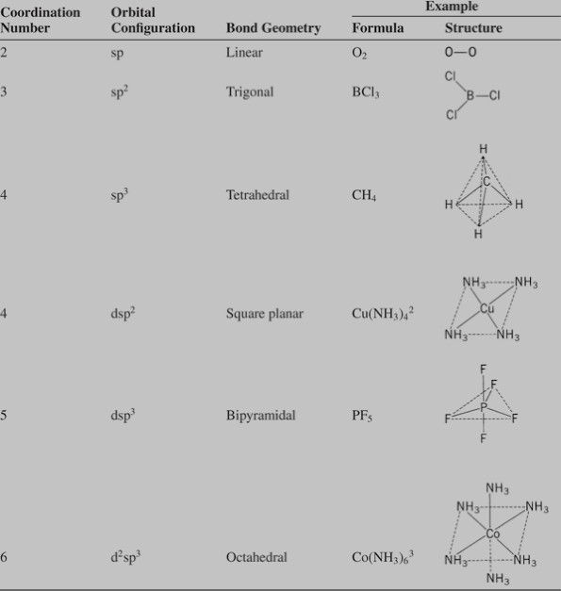

Chelates
A substance containing two or more donor groups may combine with a metal to form a special type of complex known as a chelate .Some of the bonds in a chelate may be ionic or of the primary covalent type, whereas others are coordinate covalent links. When the ligand provides one group for attachment to the central ion, the chelate is called monodentate.
Molecules with two and three donor groups are called bidentate and tridentate, respectively.
Ethylenediaminetetraacetic acid has six points for attachment to the

metal ion and is accordingly hexadentate; however, in some complexes, only four or five of the groups are coordinated.

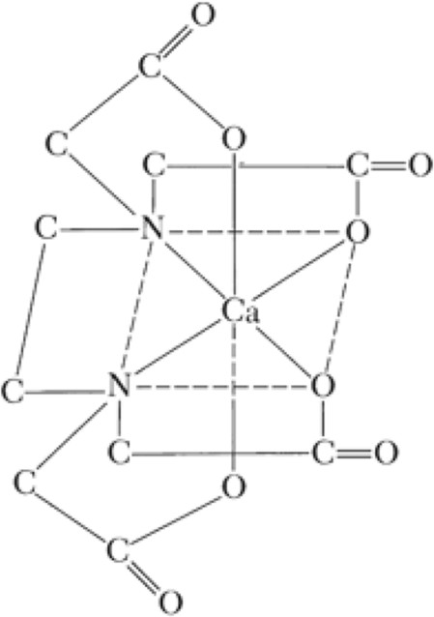
Fig. 10-1. Calcium ions sequestered by ethylendediaminetetraacetic acid.
The synthetic chelating agent ethylenediaminetetraacetic acid (Fig. 10-1) has been used to tie up or sequester iron and copper ions so that they cannot catalyze the oxidative degradation of ascorbic acid in fruit juices and in drug preparation.
Chelation places stringent steric requirements on both metal and ligands. Ions such as Cu(II) and Ni(II), which form square planar complexes, and Fe(III) and Co(III), which form octahedral complexes, can exist in either of two geometric forms. As a consequence of this isomerism, only cis-coordinated ligands— ligands adjacent on a molecule—will be readily replaced by reaction with a chelating agent.
- Vitamin B12 and the hemoproteins are incapable of reacting
with chelating agents because their metal is already coordinated in such a way that only the transcoordination positions of the metal are available for complexation. In contrast, the metal ion in

- certain enzymes, such as alcohol dehydrogenase, which contains zinc, can undergo chelation, suggesting that the metal is bound in such a way as to leave two cis positions available for chelation.

Organic Molecular Complexes
An organic coordination compound or molecular complex consists of constituents held together by weak forces
1-hydrogen
bonds.
The compounds dimethyl aniline and 2,4,6- trinitroanisole react in the cold to give a molecular complex:
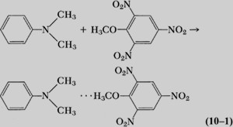
2-electron donor–acceptor mechanism :- The type of bonding existing in molecular complexes in which hydrogen bonding plays no part is not fully understood ,but it may be considered as electron donor–acceptor mechanism
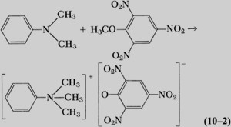
3- charge transfer complexes. one molecule polarizes the other, resulting in a type of ionic interaction or charge transfer, For example, the polar nitro groups of trinitrobenzene induce a dipole in the readily polarizable benzene molecule, and the electrostatic interaction that results leads to complex formation:
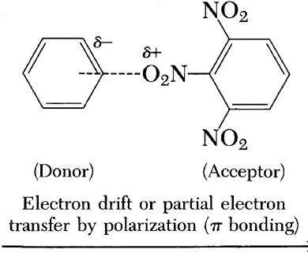

4-London dispersion forces and dipole–dipole interactions contribute more to the stability of the complex. A resonance interaction is shown in Figure 10-2 .
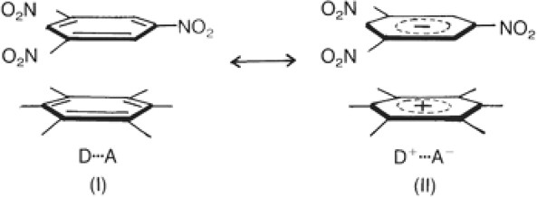
Fig. 10-2. Resonance in a donor–acceptor complex of trinitrobenzene (acceptor, top) and hexamethylbenzene (donor, bottom).
Trinitrobenzene is the acceptor, A, molecule and hexamethylbenzene is the donor, D. On the left side of the figure, weak dispersion and dipolar forces contribute to the interaction of A and D; on the right side of the figure, the interaction of A and D results from a significant transfer of charge, making the electron acceptor trinitrobenzene negatively charged (A-) and leaving the donor, hexamethylbenzene, positively charged (D+). The overall donor–acceptor complex is shown by the double-headed arrow to resonate between the uncharged D … A and the charged D+ … A- moieties.
Many organic complexes are so weak that they cannot be separated from their solutions as definite compounds, and they are often difficult to detect by chemical and physical means. The energy of attraction between the constituents is probably less than 5 kcal/mole for most organic complexes. Because the bond distance between the components of the complex is usually greater than 3 Å,
In both charge transfer and donor–acceptor complexes, Charge transfer complexes are of importance in pharmacy. Iodine forms 1:1 charge transfer complexes with the drugs disulfiram, chlomethiazole, and tolnaftate. These drugs have recognized pharmacologic actions of their own:
Disulfiram is used against alcohol addiction, clomethiazole is a sedative–hypnotic and anticonvulsant, tolnaftate is an antifungal agent.

Each of these drugs possesses a nitrogen–carbon–sulfur moiety . and a complex may result from the transfer of charge from the pair of free electrons on the nitrogen and/or sulfur atoms of these drugs to the antibonding orbital of the iodine atom. Thus, by tying up iodine, molecules containing the N—C==S moiety inhibit thyroid action in the body.
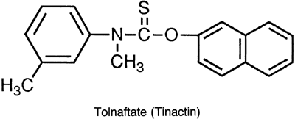

Drug Complexes
Caffeine complexing with a number of acidic drugs. such as a sulfonamide or a barbiturate to a dipole–dipole force or hydrogen bonding between the polarized carbonyl groups of caffeine and the hydrogen atom of the acid. A secondary interaction probably occurs between the nonpolar parts of the molecules, and the resultant complex is “squeezed out” of the aqueous phase owing to the great internal pressure of water. These two effects lead to a high degree of interaction.
Caffeine forms complexes with organic acid anions that are more soluble than the pure xanthine, but the complexes formed with organic acids, such as gentisic acid, are less soluble than caffeine alone. Such insoluble complexes provide caffeine in a form that masks its normally bitter taste and should serve as a suitable state for chewable tablets.
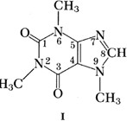
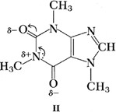
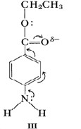

Polymer Complexes

Polyethylene glycols, polystyrene, carboxymethylcellulose, and similar polymers containing nucleophilic oxygens can form complexes with various drugs., can be attributed to these interactions. the interactions that may occur in
1-suspensions 2- emulsions, 3-ointments,
4-suppositories.
The incompatibilities of certain polyethers, such as the Carbowaxes, Pluronics, and Tweens with tannic acid, salicylic acid, and phenol may be manifested as a
1- precipitate, 2- flocculate,
3- delayed biologic absorption, 4- loss of preservative action,
5- undesirable physical, chemical, and pharmacologic effects.

Inclusion or Occlusion Compounds Channel Lattice Type
The cholic acids (bile acids) can form a group of complexes principally involving deoxycholic acid in combination with paraffins, organic acids, esters, ketones, and aromatic compounds and with solvents such as ether, alcohol, and dioxane. The crystals of deoxycholic acid are arranged to form a channel into which the complexing molecule can fit (Fig. 10-3).
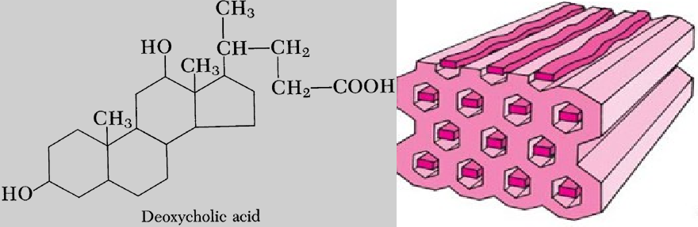

Clathrates
The clathrates crystallize in the form of a cage like lattice in which the coordinating compound is entrapped. Chemical bonds are not involved in these complexes, and only the molecular size of the encaged component is of importance. The stability of a clathrate is due to the strength of the structure, that is, to the high energy that must be expended to decompose the compound.
Powell and Palin made a detailed study of clathrate compounds and showed that the highly toxic agent hydroquinone (quinol) crystallizes in a cage like hydrogen-bonded structure, as seen in Figure 10-4.
The holes have a diameter of 4.2 Å and permit the entrapment of one small molecule to about every two quinol molecules. Small molecules such as methyl alcohol, CO2, and HCl may be trapped in these cages, but smaller molecules such as H2and larger molecules such as ethanol cannot be accommodated.

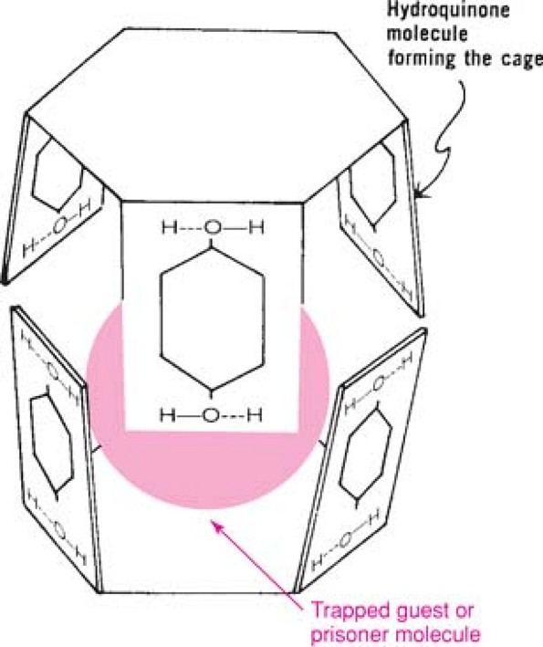
Fig. 10-4. Cagelike structure formed through hydrogen bonding of hydroquinone molecules. Small molecules such as methanol are trapped in the cages to form the clathrate

Monomolecular Inclusion Compounds: Cyclodextrins
Monomolecular inclusion compounds involve the entrapment of a single guest molecule in the cavity of one host molecule.
Monomolecular host structures are represented by the cyclodextrins (CD). These compounds are cyclic oligosaccharides containing a minimum of six D-(+)-glucopyranose units attached by α-1,4 linkages. The natural α-, β-, and γ-cyclodextrins (α-CD, β-CD, and γ-CD, respectively) consist of six, seven, and eight units of glucose, respectively.
The cyclodextrin structure exists as a truncated cone, which is seen in Figure 10-5a; it can accommodate molecules such as mitomycin C to form inclusion compounds (Fig. 10-5b).
The interior of the cavity is relatively hydrophobic because of the CH2 groups, whereas the cavity entrances are hydrophilic owing to the presence of the primary and secondary hydroxyl groups.
α-CD has the smallest cavity (internal diameter almost 5 Å). β-CD and γ-CD are the most useful for pharmaceutical technology owing to their larger cavity size (internal diameter almost 6 Å and 8 Å, respectively).
Water inside the cavity tends to be squeezed out and to be replaced by more hydrophobic species. Thus, molecules of appropriate size and stereochemistry can be included in the cyclodextrin cavity by hydrophobic interactions. Complexation does not ordinarily involve the formation of covalent bonds. Some drugs may be too large to be accommodated totally in the cavity. As shown in Figure 10-5b, mitomycin C interacts with γ-CD at one side of the torus. Thus, the aziridine ring of mitomycin C is protected from degradation in acidic solution.
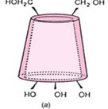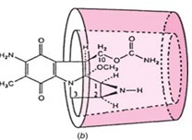

Fig. 10-5. (a) Representation of cyclodextrin as a truncated cone. (b) Mitomycin C partly enclosed in cyclodextrin to form an inclusion complex.
Cyclodextrins are studied as solubilizing and stabilizing agents in pharmaceutical dosage forms. and used to trap, stabilize, and solubilize sulfonamides, tetracyclines, morphine, aspirin, benzocaine, ephedrine, reserpine, and testosterone. The aqueous solubility of retinoic acid (0.5 mg/liter), a drug used topically in the treatment of acne , is increased to 160 mg/liter by complexation with β-CD. Dissolution rate plays an important role in bioavailability of drugs, fast dissolution usually favoring absorption. Thus, the dissolution rates of famotidine,a potent drug in the treatment of gastric and duodenal ulcers, and that of tolbutamide, an oral antidiabetic drug, are both increased by complexation with β-cyclodextrin.

Molecular Sieves
Macromolecular inclusion compounds, or molecular sieves as they are commonly called, include zeolites, dextrins, silica gels, and related substances. The atoms are arranged in three dimensions to produce cages and channels. Synthetic zeolites may be made to a definite pore size so as to separate molecules of different dimensions, and they are also capable of ion exchange.

