Methods of Analysis

A determination of the (1) stoichiometric ratio of ligand to metal (or donor to acceptor) and the (2) stability constant for complex formation are important in the study and application of complexes.
Several methods for estimation of these parameters have been developed:

Method of continuous variation
- pH Titration method
- Distribution Method
- Solubility Method
- Spectroscopy

The stoichiometry of a metal–ligand complexation reaction can be determined by three methods:
(A) Job's method (B) Mole ratio method (C) Slope ratio method

Job's Method
In Job’s method, a series of solution are prepared with variable ratios of metal and ligand but with fixed total concentrations (the total ligand + metal concentration are the same for al solutions).
An additive property that is proportional to the concentration of the formed complex (e.g. absorbance) is measured and plotted against the mole fraction from 0 to 1 for one of the components of a mixture (e.g. Ligand).

37

Method of Continuous Variation

Job's Method
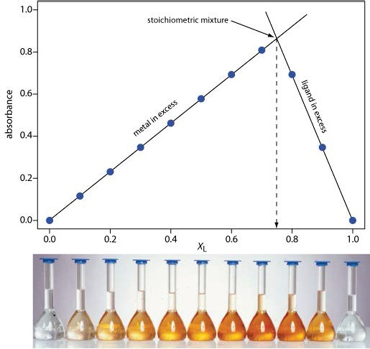
For a constant total concentration of A and B, the complex is at its greatest concentration at a point where the species A and B are combined in the ratio in which they occur in the complex.
The line therefore shows a break or a change in slope at the mole fraction corresponding to the complex.

Job's Method
E.g. the change in slope occurs at a mole fraction of 0.75:

Mole fraction = 0.75 indicating a 3:1 complex
XL 0.75
= = 3
XM 1 — 0.75

This indicate a complex formation of the 3:1 type (ligand : metal).
The calibration curve flattens out when there is no longer enough ligand to react with all of the metal ions.
Job’s method is restricted to the formation of a single complex
39



Method of Continuous Variation

Mole Ratio Method
In the mole ratio method, a series of solutions are prepared with a fixed amount of the metal and a variable amount of the ligand (or vice versa).
An additive property that is proportional to the concentration of the formed complex (e.g. absorbance) is measured and plotted against the mole ratio of the component with the variable amounts (e.g. Ligand).
The formed complex is at its greatest concentration at a point where the species A and M are combined in the ratio in which they occur in the complex (indicated by a change in the slope at the mole ratio that forms the complex).

Mole Ratio Method
The change in slope (a) occurs at a mole ratio of 1 indicating a complex of the 1:1 type, while the change in slope (b) occurs at a ratio of 2 indicating a complex of the 2:1 type.
The calibration curve flattens out when there is no longer enough ligand to react with all of the metal ions.

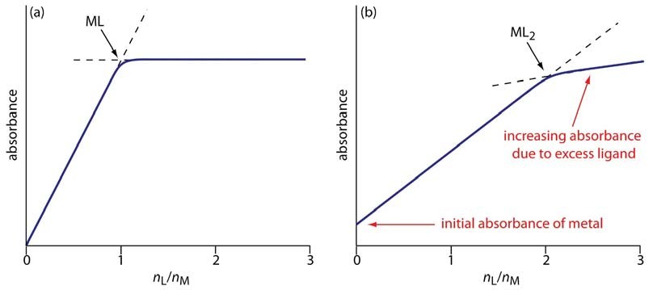

41

Method of Continuous Variation

Mole Ratio Method
Unlike Job’s method, the mole-ratio method can be used to investigate the formation of higher complexes in solution.

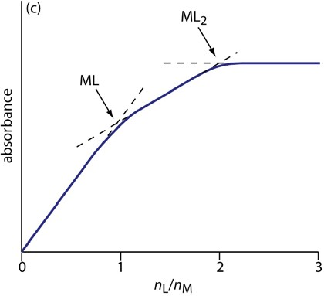

Slope Ratio Method
In the slope-ratio method two sets of solutions are prepared:
The first set of solutions contains a large excess of metal and a variable concentrations of ligand (all the ligand reacts in forming the metal–ligand complex).
The absorbance of the formed complex is plotted against the ligand concentration and the slope of the line is determined.
A second set of solutions is prepared with a large excess of ligand and a variable concentration of metal (all the metal reacts in forming the metal–ligand complex). .
The absorbance of the formed complex is plotted against the metal concentration and the slope of the line is determined.

43

Method of Continuous Variation

Slope Ratio Method
The stoichiometric ratio of metal to ligand is inversely proportional to the ratio of the slopes:
Stoichiometric ratio (L:M)= SlopeM
SlopeL

E.g. The slope of the first line (variable metal) is 1.56×10-3 and the slope of the other line (variable ligand) is 5.3×10-4. What is the stoichiometric ratio of this complex?

Stoichiometric ratio (L:M)= SlopeM
SlopeL
1.56 × 10^{–3}
= 5.3 × 10–4 = 3

Stoichiometric ratio (L:M)= 3:1 (L:M)
The slope-ratio method also is limited to systems in which only a single complex is formed.

pH titration method can be used whenever the complexation is accompanied by a change in pH.
E.g. The chelation of the cupric ion by glycine:
Cu²⁺ + 2NH⁺ CH2COO– = Cu(NH2CH2COO)2+2H⁺
3
Because 2 protons are formed in the reaction, the addition of glycine to Cu²⁺ solution should result in a decrease in pH.
Titration curves can be obtained by adding a strong base to a solution of glycine alone and to another solution containing (glycine + copper salt) and plotting the pH against the volume of base added.

46

pH Titration Method
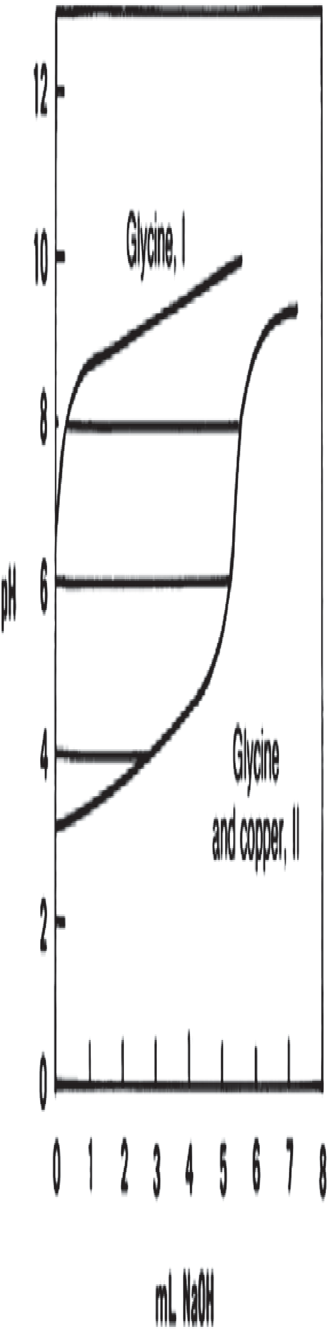
The curve for the metal-glycine mixture is well below that for the glycine alone.
47

The difference in pH for a given quantity of base added indicates the occurrence of a complex.

Lec. 2 Complexation
Hamid Alghurabi

The method of distributing a solute between two immiscible solvents can be used to determine the stability constant for certain complexes.
The complexation of iodine by potassium iodide is an example to illustrate this Method.
I2 + I– ‹ I–
3
The distribution method has been used to study caffeine and polymer complexes with a number of acidic drugs such as benzoic acid, salicylic acid, and acetylsalicylic acid.
Note: This method is described in details in “lab. 2 Complexation”.

49

Solubility Method

Solubility method is the most widely used method is the study the inclusion complexation.
According to the solubility method, excess quantities of the drug are placed in well-stoppered containers, with a solution of the complexing agent in various concentrations.
The bottles are agitated in a constant temp. bath until equilibrium is reached. Then, the supernatant liquid are removed and analyzed to obtain the total drug concentration.
The concentration of the drug is plotted against the concentration of caffeine to obtain a curve that can be used to calculate the stability constant.

This method is used for charge transfer complexes.
When Iodine is analyzed with non-complexing solvent (e.g.
CCl4) a curve is obtain with a single peak at about 520 nm.

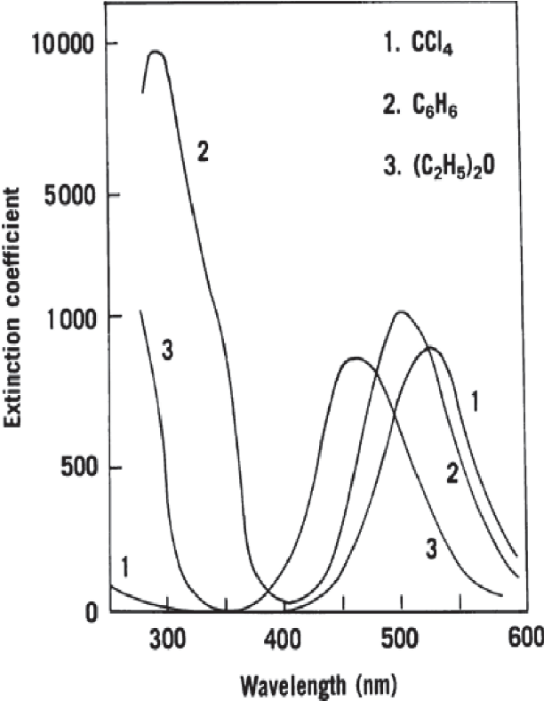
A solution of iodine in benzene exhibits a maximum shift to 475 nm, and a new peak with higher intensity at 300 nm.

A solution of iodine in diethyl ether shows a still greater shift to lower wavelength and the appearance of a new maximum.

In benzene and ether, iodine is electron acceptor and the organic solvent is donor, while in CCI4, no complex is formed.
The shift towards the UV region becomes greater as the electron donor solvent becomes a stronger electron- releasing agent.

