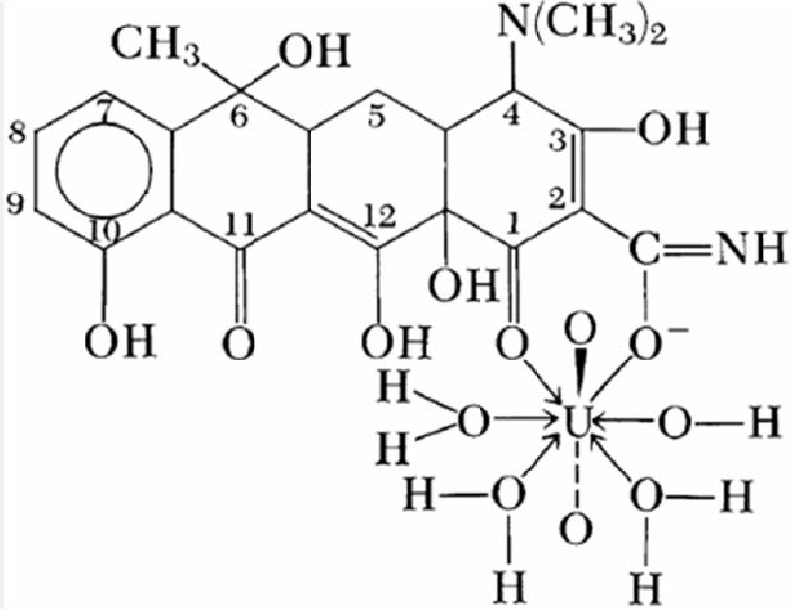
ability to bind both acidic and basic drugs. Another plasma protein, α₁-acid glycoprotein, has
been shown to bind numerous drugs; this protein appears to have greater affinity for basic than for acidic drug molecules.

Protein Binding
A complete analysis of protein binding, including the multiple equilibria that are involved, would go beyond our immediate needs. Therefore, only an abbreviated treatment is given here.

Binding Equilibria
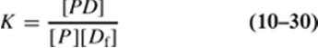
We write the interaction between a group or free receptor P in a protein and a drug molecule D as The equilibrium constant, disregarding the difference between activities and concentrations, is

or
where K is the association constant, [P] is the concentration of the protein in terms of free binding sites, [Df] is the concentration, usually given in moles, of free drug, sometimes called the ligand, and [PD] is the concentration of the protein–drug complex. K varies with temperature and would be better represented as K(T); [PD], the symbol for bound drug, is sometimes written as [Db], and [D], the free drug, as [Df].
If the total protein concentration is designated as [Pt], we can write
or
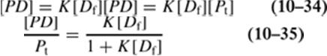
Substituting the expression for [P] from equation (10-32) into (10-31)gives
P.216

Let r be the number of moles of drug bound, [PD], per mole of total protein, [Pt]; then r = [PD]/[Pt], or
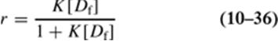
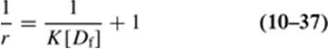
The ratio r can also be expressed in other units, such as milligrams of drug bound, x, per gram of protein, m. Equation (10-36) is one form of the Langmuir adsorption isotherm. Although it is quite useful for expressing protein-binding data, it must not be concluded that obedience to this formula necessarily requires that protein binding be an adsorption phenomenon. Expression (10-36) can be converted to a linear form, convenient for plotting, by inverting it:

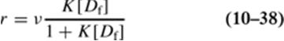
If v independent binding sites are available, the expression for r, equation (10-36), is simply v times that for a single site, or

and equation (10-37) becomes
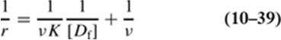
Equation (10-39) produces what is called a Klotz reciprocal plot.67
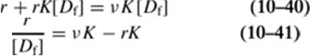
An alternative manner of writing equation (10-38) is to rearrange it first to
Data presented according to equation (10-41) are known as aScatchard plot.67,68 The binding of bishydroxycoumarin to human serum albumin is shown as a Scatchard plot in Figure 10-17.
Graphical treatment of data using equation (10-39) heavily weights those experimental points obtained at low concentrations of free drug, D, and may therefore lead to misinterpretations regarding the protein- binding behavior at high concentrations of free drug. Equation (10-41) does not have this disadvantage and is the method of choice for plotting data. Curvature in these plots usually indicates the existence of more than one type of binding site.
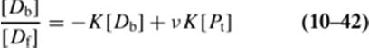
Equations (10-39) and (10-41) cannot be used for the analysis of data if the nature and the amount of protein in the experimental system are unknown. For these situations, Sandberg et al.69recommended the use of a slightly modified form of equation (10-41):

where [Db] is the concentration of bound drug. Equation (10-42) is plotted as the ratio [Db]/[Df] versus [Db], and in this way K is determined from the slope and vK[Pt] is determined from the intercept.

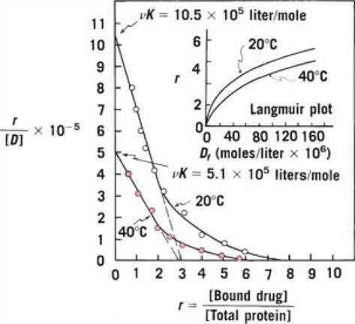
Fig. 10-17. A Scatchard plot showing the binding of bishydroxycoumarin to human serum albumin at 20°C and 40°C plotted according to equation(10-41). Extrapolation of the two lines to the horizontal axis, assuming a single class of sites with no electrostatic interaction, gives an approximate value of 3 for v. (From M. J. Cho, A.
G. Mitchell, and M. Pernarowski, J. Pharm. Sci.60, 196, 1971; 60, 720, 1971. With permission.) The inset is a Langmuir adsorption isotherm of the binding data plotted according to equation(10-36).
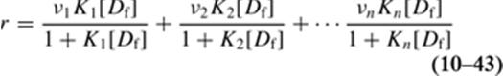
The Scatchard plot yields a straight line when only one class of binding sites is present. Frequently in drug-binding studies, nclasses of sites exist, each class i having vi sites with a unique association constant Ki. In such a case, the plot of r/[Df] versus r is not linear but exhibits a curvature that suggests the presence of more than one class of binding sites. The data in Figure 10-17 were analyzed in terms of one class of sites for simplification. The plots at 20°C and 40°C clearly show that multiple sites are involved. Blanchard et al.70 reviewed the case of multiple classes of sites. Equation (10-38) is then written as

or
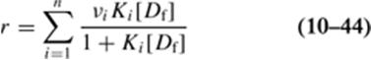
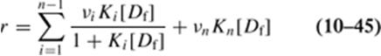
As previously noted, only v and K need to be evaluated when the sites are all of one class. When n classes of sites exist, equations(10-43 and 10-44) can be written as

The binding constant, Kn, in the term on the right is small, indicating extremely weak affinity of the drug for the sites, but this class may have a large number of sites and so be considered unsaturable.
P.217

Equilibrium Dialysis (ED) and Ultrafiltration (UF)

A number of methods are used to determine the amount of drug bound to a protein. Equilibrium dialysis, ultrafiltration, and electrophoresis are the classic techniques used, and in recent years other methods, such as gel filtration and nuclear magnetic resonance, have been used with satisfactory results. We shall discuss the equilibrium dialysis, ultrafiltration, and kinetic methods.
The equilibrium dialysis procedure was refined by Klotz et al.71 for studying the complexation between metal ions or small molecules and macromolecules that cannot pass through a semipermeable membrane.
According to the equilibrium dialysis method, the serum albumin (or other protein under investigation) is placed in a Visking cellulose tubing (Visking Corporation, Chicago) or similar dialyzing membrane. The tubes are tied securely and suspended in vessels containing the drug in various concentrations. Ionic strength and sometimes hydrogen ion concentration are adjusted to definite values, and controls and blanks are run to account for the adsorption of the drug and the protein on the membrane.
If binding occurs, the drug concentration in the sac containing the protein is greater at equilibrium than the concentration of drug in the vessel outside the sac. Samples are removed and analyzed to obtain the concentrations of free and complexed drug.
Equilibrium dialysis is the classic technique for protein binding and remains the most popular method. Some potential errors associated with this technique are the possible binding of drug to the membrane, transfer of substantial amounts of drug from the plasma to the buffer side of the membrane, and osmotic volume shifts of fluid to the plasma side. Tozer et al.72 developed mathematical equations to calculate and correct for the magnitude of fluid shifts. Briggs et al.73 proposed a modified equilibrium dialysis technique to minimize experimental errors for the determination of low levels of ligand or small molecules.
Ultrafiltration methods are perhaps more convenient for the routine determination because they are less time-consuming. The ultrafiltration method is similar to equilibrium dialysis in that macromolecules such as serum albumin are separated from small drug molecules. Hydraulic pressure or centrifugation is used in ultrafiltration to force the solvent and the small molecules, unbound drug, through the membrane while preventing the passage of the drug bound to the protein. This ultrafiltrate is then analyzed by spectrophotometry or other suitable technique.
The concentration of the drug that is free and unbound, Df, is obtained by use of the Beer's law equation:
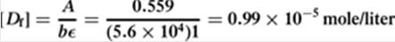
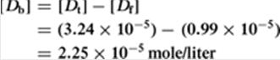
where A is the spectrophotometric absorbance (dimensionless), ε is the molar absorptivity, determined independently for each drug, c (Dfin binding studies) is the concentration of the free drug in the ultrafiltrate in moles/liter, and b is the optical path length of the spectrophotometer cell, ordinarily 1 cm. The following example outlines the steps involved in calculating the Scatchard r value and the percentage of drug bound.
Example 10-5
Binding to Human Serum Albumin
The binding of sulfamethoxypyridazine to human serum albumin was studied at 25°C, pH 7.4, using the ultrafiltration technique. The concentration of the drug under study, [D_{t}], is 3.24 × 10⁻ ⁵ mole/liter and the human serum albumin concentration, [P_{t}], is 1.0 × 10⁻⁴ mole/liter. After equilibration the ultrafiltrate has an absorbance, A, of 0.559 at 540 nm in a cell whose optical path length, b, is 1 cm. The molar absorptivity, ε, of the drug is 5.6 × 10⁴ liter/mole cm.
Calculate the Scatchard r value and the percentage of drug bound. The concentration of free (unbound) drug, [D_{f}], is given by

The concentration of bound drug, [D_{b}], is given by

The r value is

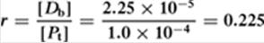

The percentage of bound drug is [D_{b}]/[D_{t}] × 100 = 69%.

A potential error in ultrafiltration techniques may result from the drug binding to the membrane. The choice between ultrafiltration and equilibrium dialysis methods depends on
P.218

the characteristics of the drug. The two techniques have been compared in several protein-binding studies.74,75,76
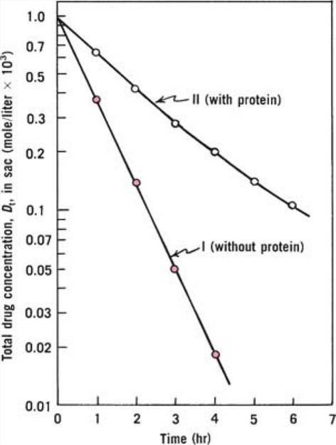
Fig. 10-18. The dynamic dialysis plot for determining the concentration of bound drug in a protein solution (From M. C. Meyer and D. E. Guttman, J. Pharm. Sci. 57, 1627, 1968. With permission).
Key Concept Protein Binding
Protein binding (PB) plays an important role in the pharmacokinetics and pharmacodynamics of a drug. The extent of PB in the plasma or tissue controls the volume of distribution and affects both hepatic and renal clearance. In many cases, the free drug concentration, rather than the total concentration in plasma, is correlated to the effect. Drug displacement from drug–protein complex can occur by direct competition of two drugs for the same binding site and is important with drugs that are highly bound (>95%), for which a small displacement of bound drug can greatly increase the free drug concentration in the plasma. In order to measure free fraction or PB of a drug, ultrafiltration (UF), ultracentrifugation, equilibrium dialysis (ED), chromatography, spectrophotometry, electrophoresis, etc. have been used.
Essential methodologic aspects of PB study include the selection of assay procedures,
devices, and materials. The most commonly used method for PB measurement is ED, which

is believed to be less susceptible to experimental artifacts. However, it is time consuming and is not suitable for unstable compounds because it requires substantial equilibration time (3–24 hr) depending on drugs, membrane materials, and devices. Many researchers have used UF centrifugal devices for PB measurement. UF is a simple and rapid method in which centrifugation forces the buffer containing free drugs through the size exclusion membrane and achieves a fast separation of free from protein-bound drug. However, the major disadvantage of this method is nonspecific binding of drugs on filter membranes and plastic devices. When the drug binds extensively to the filtration membrane, the ultrafiltrate concentration may deviate from the true free concentration. (From K.-J. Lee, R. Mower, T. Hollenbeck, J. Castelo, N. Johnson, P. Gordon, P. J. Sinko, K. Holme, and Y.-H. Lee, Pharm.
Res. 20, 1015, 2003. With permission.)

Dynamic Dialysis
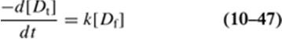
Meyer and Guttman77 developed a kinetic method for determining the concentrations of bound drug in a protein solution. The method has found favor in recent years because it is relatively rapid, economical in terms of the amount of protein required, and readily applied to the study of competitive inhibition of protein binding. It is discussed here in some detail. The method, known as dynamic dialysis, is based on the rate of disappearance of drug from a dialysis cell that is proportional to the concentration of unbound drug. The apparatus consists of a 400-mL jacketed (temperature-controlled) beaker into which 200 mL of buffer solution is placed. A cellophane dialysis bag containing 7 mL of drug or drug–protein solution is suspended in the buffer solution. Both solutions are stirred continuously. Samples of solution external to the dialysis sac are removed periodically and analyzed spectrophotometrically, and an equivalent amount of buffer solution is returned to the external solution. The dialysis process follows the rate law

where [Dt] is the total drug concentration, [Df], is the concentration of free or unbound drug in the dialysis sac, –d[Dt]/dt is the rate of loss of drug from the sac, and k is the first-order rate constant (seeChapter
13) representative of the diffusion process. The factor k can also be referred to as the apparent permeability rate constant for the escape of drug from the sac. The concentration of unbound drug, [Df], in the sac (protein compartment) at a total drug concentration [Dt] is calculated using equation (10-45), knowing k and the rate –d[Dt]/dt at a particular drug concentration, [Dt]. The rate constant, k, is obtained from the slope of a semilogarithmic plot of [Dt] versus time when the experiment is conducted in the absence of the protein.
Figure 10-18 illustrates the type of kinetic plot that can be obtained with this system. Note that in the presence of protein, curve II, the rate of loss of drug from the dialysis sac is slowed compared with the rate in the absence of protein, curve I. To solve equation (10-47)for free drug concentration, [Df], it is necessary to determine the slope of curve II at various points in time. This is not done graphically, but instead it is accurately accomplished by first fitting the time-course data to a suitable empirical equation, such as the following, using a computer.

The computer fitting provides estimates of C1 through C6. The values for d[Dt]/dt can then be computed from equation (10-49), which represents the first derivative of equation (10-48):

Finally, once we have a series of [Df] values computed from equations (10-49) and (10-
47) corresponding to experimentally determined values of [Dt] at each time t, we can proceed to calculate the various terms for the Scatchard plot.
Example 10-6*
Calculate Scatchard Values
Assume that the kinetic data illustrated in Figure 10-18 were obtained under the following conditions: initial drug concentration, [D_{t0}], is 1 × 10⁻³ mole/liter and protein concentration is 1
× 10⁻³ mole/liter. Also assume that the first-order rate constant, k, for the control (curve I) was

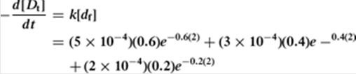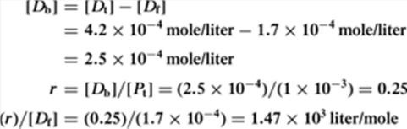
determined to be 1.0 hr⁻¹ and that fitting of curve II to equation (10-48) resulted in the following empirical constants: C₁ = 5 × 10⁻⁴ mole/liter, C₂ = 0.6 hr⁻¹, C₃ = 3 × 10⁻
⁴ mole/liter, C₄ = 0.4 hr⁻¹, C₅ = 2 × 10⁻⁴ mole/liter, andC₆ = 0.2 hr⁻¹.
Calculate the Scatchard values (the Scatchard plot was discussed in the previous section) for r and r[D_{f}] if, during the dialysis in the presence of protein, the experimentally determined value for [D_{t}] was 4.2 × 10⁻⁴ mole/liter at 2 hr. Here, r = [D_{b}]/P_{t}, where [D_{b}] is drug bound
and P_{t} is total protein concentration. We have Using equation (10-49),

where the (2) in the exponent stands for 2 hr. Thus,

It follows that at 2 hr,

Additional points for the Scatchard plot would be obtained in a similar fashion, using the data obtained at various points throughout the dialysis. Accordingly, this series of calculations
permits one to prepare a Scatchard plot (seeFig. 10-17).

P.219

Judis78 investigated the binding of phenol and phenol derivatives by whole human serum using the dynamic dialysis technique and presented the results in the form of Scatchard plots.

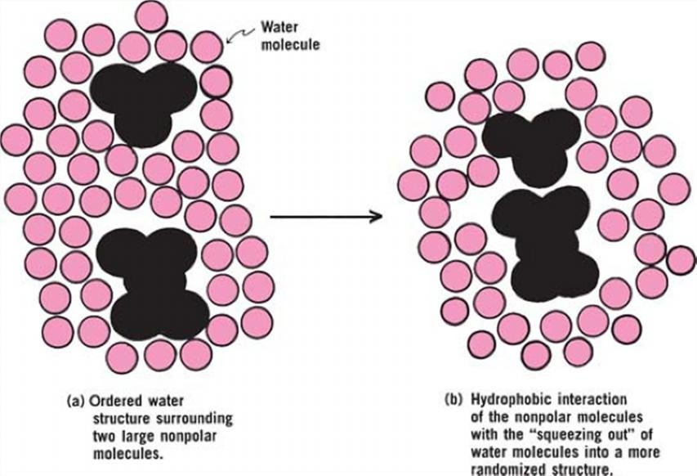
Fig. 10-19. Schematic view of hydrophobic interaction. (a) Two hydrophobic molecules are separately enclosed in cages, surrounded in an orderly fashion by hydrogen-bonded molecules of water (open circles). The state at (b) is somewhat favored by breaking of the water cages of (a) to yield a less ordered arrangement and an overall entropy increase of the system. Van der Waals attraction of the two hydrophobic species also contributes to the hydrophobic interaction.

Hydrophobic Interaction
Hydrophobic “bonding,” first proposed by Kauzmann,79 is actually not bond formation at all but rather the tendency of hydrophobic molecules or hydrophobic parts of molecules to avoid water because they are not readily accommodated in the hydrogen-bonding structure of water. Large hydrophobic species such as proteins avoid the water molecules in an aqueous solution insofar as possible by associating into micellelike structures (Chapter 15) with the nonpolar portions in contact in the inner regions of the “micelles,” the polar ends facing the water molecules. This attraction of hydrophobic species, resulting from their unwelcome reception in water, is known as hydrophobic bonding, or, better, hydrophobic interaction. It involves van der Waals forces, hydrogen bonding of water molecules in a three- dimensional structure, and other interactions. Hydrophobic interaction is favored thermodynamically because of an increased disorder or entropy of the water molecules that accompanies the association of the nonpolar molecules, which squeeze out the water. Globular proteins are thought to maintain their ball-like structure in water because of the hydrophobic effect. Hydrophobic interaction is depicted
in Figure 10-19.
Nagwekar and Kostenbauder80 studied hydrophobic effects in drug binding, using as a model of the protein a copolymer of vinylpyridine and vinylpyrrolidone. Kristiansen et al.81 studied the effects of organic solvents in decreasing complex formation between small organic molecules in aqueous solution. They attributed the interactions of the organic species to a significant contribution by both hydrophobic bonding and the unique effects of the water structure. They suggested that some nonclassic “donor– acceptor” mechanism may be operating to lend stability to the complexes formed.

P.220

Feldman and Gibaldi82 studied the effects of urea, methylurea, and 1,3-dimethylurea on the solubility of benzoic and salicylic acids in aqueous solution. They concluded that the enhancement of solubility by urea and its derivatives was a result of hydrophobic bonding rather than complexation. Urea broke up the hydrogen-bonded water clusters surrounding the nonpolar solute molecules, increasing the entropy of the system and producing a driving force for solubilization of benzoic and salicylic acids. It may be possible that the ureas formed channel complexes with these aromatic acids as shown inFigure 10-3 a, b, and c.
The interaction of drugs with proteins in the body may involve hydrophobic bonding at least in part, and this force in turn may affect the metabolism, excretion, and biologic activity of a drug.

Self-Association
Some drug molecules may self-associate to form dimers, trimers, or aggregates of larger sizes. A high degree of association may lead to formation of micelles, depending on the nature of the molecule (Chapter 16). Doxorubicin forms dimers, the process being influenced by buffer composition and ionic strength. The formation of tetramers is favored by hydrophobic stacking aggregation.83 Self-association may affect solubility, diffusion, transport through membranes, and therapeutic action. Insulin shows concentration-dependent self-association, which leads to complications in the treatment of diabetes.
Aggregation is of particular importance in long-term insulin devices, where insulin crystals have been observed. The initial step of insulin self-association is a hydrophobic interaction of the monomers to form dimers, which further associate into larger aggregates. The process is favored at higher concentrations of insulin.84 Addition of urea at nontoxic concentrations (1.0–3 mg/mL) has been shown to inhibit the self-association of insulin. Urea breaks up the “icebergs” in liquid water and associates with structured water by hydrogen bonding, taking an active part in the formation of a more open “lattice” structure.85 Sodium salicylate improves the rectal absorption of a number of drugs, all of them exhibiting self- association. Touitou and Fisher86chose methylene blue as a model for studying the effect of sodium salicylate on molecules that self-associate by a process of stacking. Methylene blue is a planar aromatic dye that forms dimers, trimers, and higher aggregates in aqueous solution. The workers found that sodium salicylate prevents the self-association of methylene blue. The inhibition of aggregation of porcine insulin by sodium salicylate results in a 7875-fold increase in solubility.87 Commercial heparin samples tend to aggregate in storage depending on factors such as temperature and time in storage.88

Factors Affecting Complexation and Protein Binding
Kenley et al.55 investigated the role of hydrophobicity in the formation of water-soluble complexes. The logarithm of the ligand partition coefficient between octanol and water was chosen as a measure of hydrophobicity of the ligand. The authors found a significant correlation between the stability constant of the complexes and the hydrophobicity of the ligands. Electrostatic forces were not considered as important because all compounds studied were uncharged under the conditions investigated. Donor– acceptor properties expressed in terms of orbital energies (from quantum chemical calculations) and relative donor–acceptor strengths correlated poorly with the formation constants of the complex. It was suggested that ligand hydrophobicity is the main contribution to the formation of water-soluble complexes. Coulson and Smith89 found that the more hydrophobic chlorobiocin analogues showed the highest percentage of drug bound to human serum albumin. These workers suggested that chlorobiocin analogues bind to human albumin at the same site as warfarin. This site consists of two noncoplanar hydrophobic areas and a cationic group. Warfarin, an anticoagulant, serves as a model drug in protein- binding studies because it is extensively but weakly bound. Thus, many drugs are able to compete with and displace warfarin from its binding sites. The displacement may result in a sudden increase of the free (unbound) fraction in plasma, leading to toxicity, because only the free fraction of a drug is pharmacologically active. Diana et al.90investigated the displacement of warfarin by nonsteroidal anti- inflammatory drugs. Table 10-8 shows the variation of the stability constant, K, and the number of binding sites, n, of the complex albumin–warfarin after addition of competing drugs. Azapropazone

markedly decreases the K value, suggesting that both drugs, warfarin and azapropazone, compete for the same binding site on albumin. Phenylbutazone also competes strongly for the binding site on albumin. Conversely, tolmetin may increase K, as suggested by the authors, by a conformational change in the albumin molecule that favors warfarin binding. The other drugs (see Table 10-8) decrease the K value of warfarin to a lesser extent, indicating that they do not share exclusively the same binding site as that of warfarin.
Plaizier-Vercammen91 studied the effect of polar organic solvents on the binding of salicylic acid to povidone. He
P.221

found that in water–ethanol and water–propylene glycol mixtures, the stability constant of the complex decreased as the dielectric constant of the medium was lowered. Such a dependence was attributed to hydrophobic interaction and can be explained as follows. Lowering the dielectric constant decreases polarity of the aqueous medium. Because most drugs are less polar than water, their affinity to the medium increases when the dielectric constant decreases. As a result, the binding to the
macromolecule is reduced.
Table 10-8 Binding Parameters (± Standard Deviation) for Warfarin in the Presence of Displacing Drugs*
Competing Drug |  | Racemic Warfarin
 |  | n K × 10⁻⁵ M⁻¹
 | None | 1.1 ± 0.0 | 6.1 ± 0.2
 | Azapropazone | 1.4 ± 0.1 | 0.19 ± 0.02
 | Phenylbutazone | 1.3 ± 0.2 | 0.33 ± 0.06
 | Naproxen | 0.7 ± 0.0 | 2.4 ± 0.2
 | Ibuprofen | 1.2 ± 0.2 | 3.1 ± 0.4
 | Mefenamic acid | 0.9 ± 0.0 | 3.4 ± 0.2
 | Tolmetin | 0.8 ± 0.0 | 12.6 ± 0.6
 | *From F. J. Diana, K. Veronich, and A. L. Kapoor, J. Pharm. Sci. 78, 195, 1989. With permission.
Protein binding has been related to the solubility parameter δ of drugs. Bustamante and Selles92 found that the percentage of drug bound to albumin in a series of sulfonamides showed a maximum at Δ =
12.33 cal^{1/2} cm^{-3/2}. This value closely corresponds to the δ value of the postulated binding site on albumin for sulfonamides and suggests that the closer the solubility parameter of a drug to the δ value of its binding site, the greater is the binding.

Chapter Summary
Complexation is widely used in the pharmaceutical sciences to improve properties such as solubility. The three classes of complexes or coordination compounds were discussed in the context to identify pharmaceutically relevant examples. The physical properties of chelates and what differentiates them from organic molecular complexes were also described. The types of forces that hold together organic molecular complexes also play an important role in determining the function and use of complexes in the pharmaceutical sciences. One widely used complex system, the cyclodextrins, was described in detail with respect to pharmaceutical applications. The stoichiometry and stability of complexes was described as well as methods of analysis to determine their strengths and weaknesses. Protein binding is important for many drug substances. The ways in which protein binding could influence drug action were discussed. Also, methods such as the equilibrium dialysis and ultrafiltration were described for determining protein binding.

