Handling of Out of Specification Results

INTRODUCTION
Handling of out of specifications
The term out of specifications, are defined as those results of in process or finished product testing, which falling out of specified limits, that are mentioned in compendia, drug master file, or drug application1.The OOS, may arise due to deviations in product manufacturing process, errors in testing procedure, or due to malfunctioning of analytical equipment. When an OOS has arrived, a root cause analysis has to be performed to investigate the cause for OOS. The reasons for OOS can be classified as assignable and non-assignable. When the limits are not in specified limits, called out of specifications. When OOS has occurred, the analyst should inform to QC manager. Then the senior manager will ask QA for issuing OOS form to analyst. The designated personnel will classify the OOS as either assignable cause or non-assignable cause2.
Each out of specification will be identified with a unique identification number.
E.g.: OOS/RM-001/2014
Where,
OOS – out of specification
RM – raw material (department) 001 – OOS for that year
2014 – Year
The OOS investigation involves 2 phases3.
Phase – I: (laboratory investigation)
The purpose of the laboratory investigation is to identify the cause for OOS result. The reason for the OOS may be defect in measurement process or in manufacturing process.Irrespective of the rejection of batches, the OOS results must investigate for their trend. The investigation can be done to only those batches that are resulted in OOS, or also to other batches and even other products associated with OOS.The OOS investigation should be thorough, timely, unbiased, well documented and scientifically sound.The phase I investigation should commence well before the test and standard preparations are discarded.During phase I, the root cause analysis has to be performed to recognize the error that may be arisen due to

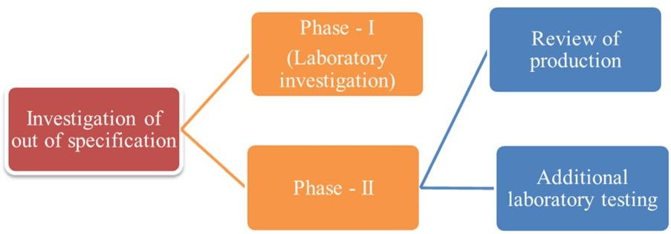
Fig. 1: Investigation of OOS results

*Author for Correspondence

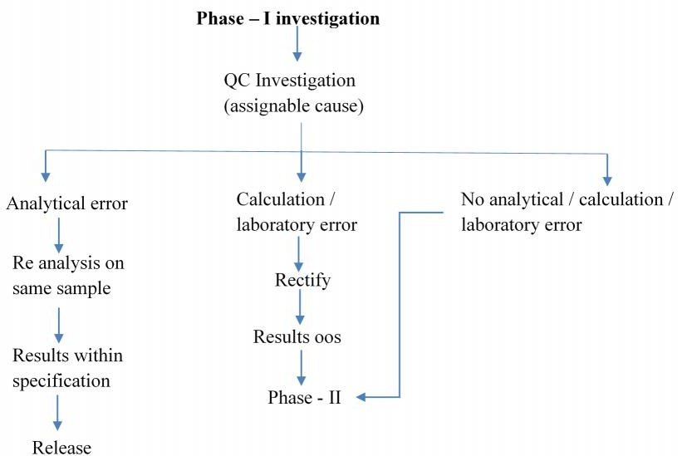
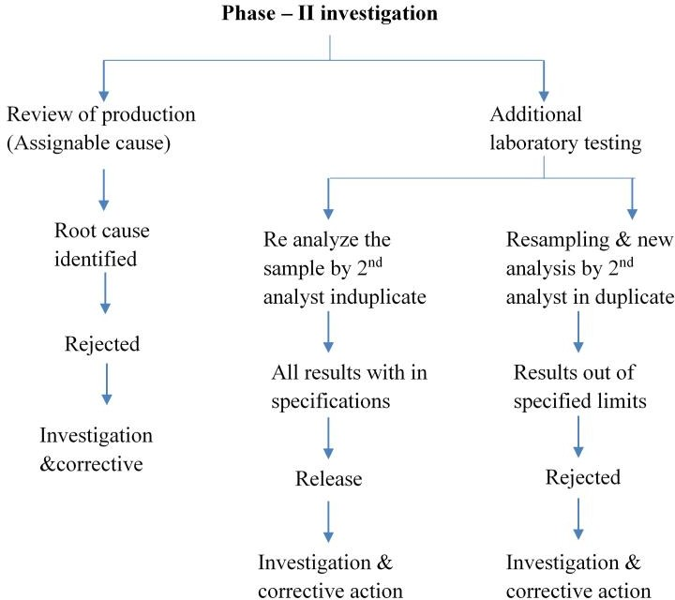
Fig. 2: OOS Investigation – Phase I
Fig. 3: OOS Investigation – Phase II

- Dilution error of standard and sample solution.
- Errors in analysis method
- Equipment malfunction
- Errors in calculation
If no assignable cause or error is identified during phase I investigation, phase II investigation has to be started.
Table 1 protocol is a prototype to conduct phase – I investigation of out of specification results Responsibilities of analyst
The analyst should ensure that o
  - Only qualified equipment can be used for analysis.

  - The analyst must know about the potential problems that may arise during analysis, which may result in OOS.
  - Certain systems like HPLC, should have system suitability requirements for analysis. Unless otherwise the system suitability is meeting the criteria, the instrument should not be used for analysis.
  - The cause for the malfunctioning of the equipment or instrument should be identified, if necessary, corrective actions should be taken to prevent future malfunctioning occurrences.
  - If any results were found out of specified limits, then the same samples should be retained for further investigation.
Responsibilities of laboratory supervisor
When an OOS result occurs, the laboratory supervisor should respond objectively and timely manner.
  - At very first, the laboratory supervisor should check the analysis data, which indicates the error in analytical procedure or manufacturing method.
  - Then the actual samples, glass ware, instruments and equipment used for analysis should be examined.
  - The laboratory supervisor should discuss with analyst to examine the correctness of the analyst.
  - He should cross examine the chromatograms and reports.
  - He should verify the calculations.
  - Confirm the performance of the instruments and equipment
  - He should determine that all the standard solutions, solvents, reagents used for the test resulted in OOS are met quality control specifications.
  - The analytical method should be validated and data should be submitted to ensure the validity of the analytical procedure.
  - The historical data of analytical procedure, instrument and equipment should be obtained to examine for possible trends.
  - This whole phase I investigation should be documented and preserved by laboratory supervisor for future use.
Example for Phase I investigation
In case of HPLC malfunctioning, the sample should be re injected to different HPLC’s for multiple times to ensure that the OOS is a result of instrument malfunctioning, rather than sample dilution or analyst error. The laboratory errors resulting in OOS results are relatively rare. In case, it is evident that the OOS is a result of laboratory error, then the laboratory methods are invalid. The occurrence of the OOS results is frequent, when the analysts are not properly trained or equipment are poorly maintained. So, it is the responsibility of the higher management to train the analysts properly and to maintain the equipment in valid conditions. Whenever a laboratory error is resulted in OOS result, the investigation should not be stopped at phase I, but instead, the whole investigation should be carried away with phase I along with phase II investigation.
Phase II investigation
When there is no possible outcome has obtained from the phase I investigation, the phase II investigation should be

commenced in context to investigate the errors occurred in manufacturing processes, sampling procedures along with other additional laboratory testing.
Production Review
An investigation committee comprising representatives from every department i.e. production, quality control, quality assurance, regulatory affairs, utilities, material management should be appointed to investigate the OOS results.
  - The whole manufacturing process has to be checked for errors.
  - In the manufacturing happens at different sites, all the sites should be investigated.
  - In some cases, the cause for the error may be complex, some processes may it be robust to produce the products with consistent quality. In such cases, the process has to be resigned and validated.
A typical production review report should include,
- Review of manufacturing process
- Causes identified resulting in OOS results
- Data of previous batches or products affected
- A description of corrective actions to prevent the reoccurrence of OOS results.
Additional laboratory testing
The additional laboratory testing at phase II investigation should involve
- Retesting
- Resampling
Retesting
The main objective behind retesting of the same sample is to determine the analytical or dilution error. The sample for retesting should be taken from the same lot of the initial test. The person, who is going to retest the sample should be more or at least equally qualified and experienced as of the first analyst. If the retest results falls within limits, then the initial results should be replaced with later, but should be included in the report along with explanation regarding failure at the first time .If the retested results are also out of limits, then the batches should be re injected and the investigation should further expanded to other associate batches and products.
Resampling
While retesting refers to analysis of the original, homogenous sample material, resampling involves analyzing a specimen from any additional units collected as part of the original sampling or from a new sample collected from the same batch. When the results of resampling or within specified limits, then the initial results should be superseded. If the error is due to improper sampling, then the sampling procedures should be validated, and new sampling procedure should be proposed, if needed, and documented.
Table 2 protocol is a prototype to conduct phase – I investigation of out of specification results4.
Reporting test results
Generally, the interpreted results are reported by
- Averaging
- Outlier test
Averaging

The use of averaging is recommended in some situations, but not at all situations.
Appropriate use of average
e.g. 1: In case of weight variation during compression stage of tablet manufacturing, the weights of 20 tablets will be checked at every 30 minutes interval. It is difficult to represent the data of every tablet at every point of sampling time. In such cases the averaging is a best tool to represent the weight variation data with appropriate relative standard deviation values.The limit for standard should be pre- determined to interpret the data. If the standard is within specified limit, then the compression process is said to be good enough to produce the product of consistent quality.
e.g. 2: During assay by HPLC method, a single sample will be injected at multiple times to exhibit the reproducibility of the analytical method. At the end the average of all peak areas will be considered for assay.
Inappropriate use of average
The use of average is not always recommended.
e.g.: when blending is done using octagonal blender, the samples should be taken from varied numbers of sampling points. For instance, say 8 sampling points, and the assay limit is 90 % - 110 %. Among the 8 samples, 3 are falling outside limit, like 89 %, 87 %, 90 %, 92 %, 97 %, 99 %,
100 %, 101 %, the average of all the 8 assay is 94.37%, which is within specified limits. But actually, 3 of the samples were out of specified limits, which indicates that the content uniformity is not achieved. In such cases the use of averaging is inappropriate, which leads to falls interpretations.
Outlier test

It is rare that a value may be obtained, that is markedly different from the others in a series obtained using validated method. Such a value may qualify as a statistical outlier.
These test s are used to determine the variance of a value from an array of results. The possible use of outlier tests should be determined in advance. This should be written in to sop’s for data interpretation and be well documented5. Concluding the investigation
In a case where OOS is confirmed from investigation, then the OOS investigation turns to batch failure investigation, which may be extended to other batches and other products. The OOS confirmed batches will be destroyed and documented.
In other case, where OOS in non-conclusive, then the quality assurance department will take decision to release the batch in following scenario – when a product has an assay range from 90 % - 110 % and the initial assay results were 89.5 %, 90 %, 92 %, 97 %, 99 %, 100 %, 95 %, 93%.
Then a comprehensive investigation is performed to determine the cause for OOS result. At phase I – laboratory testing investigation, where the analytical method, sampling procedure, dilutions were found robust and validated, then the investigation leads to phase II investigation, where all the manufacturing procedures found to be robust, additional tests were found to be valid, then the QA will conclude the initial OOS did not reflect the true quality of the batch. After concluding the investigation, the OOS result should be documented as OOS report for future encounters.

Table 1: Protocol for phase – I investigation (assignable cause) of out of specification results
s.no. | Parameter | Observation | Sign & date
1 | check condition of the sample  - Physical examination  - Storage condition  - Storage container  - Labeling
2 | Check balance& its calibration  - ID no. of balance:  - Calibration due date:
3 | Check instrument calibration  - Name of the instrument:  - ID of the instrument:  - Calibration due date:
4 | Check the reagent used for analysis  - Raw data, physical appearance, validity of reagent used.
5 | Check the volumetric standard solution  - Raw data, physical appearance, validity of standard solution used.
6 | Check the indicator solution  - Raw data, physical appearance, validity of indicator used.
7 | Check for dilution, calculation, weighing, titer volume, readings
8 | Check working standard  - ID, Raw data, physical appearance, validity of working standard used
9 | Check chromatograms and TLC plates
10 | Check glassware for its accuracy and calibration
11 | Check system suitability (HPLC / TLC)

12 | Check bracketing standard for RSD
13 | Check method of analysis followed  - Method reference no.:
Discussion with analyst
S.no | Discussion points |  |  | Remarks of investigator
1
2
3
Summary of investigation by investigator:

Re-analysis with same sample (if found genuine analytical error)
s.no. | Test | Limit |  |  | Result
1
2
3
RSD
Analyzed by: Date & sign:
Conclusion of phase I investigation:
Corrective action taken:
Senior manager - QC  Sign & date: |  |  | Senior manager – QA  Sign & date:

Table 2: Protocol for phase – II investigation (review of production – assignable causes) of out of specification results
Cause | Check for | Yes | No
I. Personnel | - Was the person properly trained?  - Does he know the job properly?  - Was he wearing the necessary personnel protective?  - Were the critical operations supervised by a supervisor?
II. Equipment | - Was correct equipment used?  - Was condition of the equipment is good?  - Were the equipment inspected by QA before use?  - Was the equipment provided with required utilities?  - Was the equipment calibrated?  - Was the preventive maintenance carried as per the schedule?
III. Production | - Was the correct material used in right condition?  - Was the right material added as per BMR?  - Was the total process carried out as per BMR?

- Were utilities, e.g. steam, water, air quality, temperature, humidity, pressure difference, etc. are as per the requirement throughout the process?
- Were the in-process checks carried out as per the BMR?
- Were the in-process checks results with in specifications?
- Were all the steps & results documented in BMR?
- Was the quality of the intermediate as per the specification?
- Were the yields as per the standard?
- Were the product or intermediate stored properly?
- Was there any breakdown during process?
IV. Quality control |  | - Was any material used in manufacturing released under deviation?  - Were there any other observations during chemical & instrumental analysis, which could result in OOS?
V. History |  | Have there been similar errors in past?
*- if ticked yes, needs investigation
Phase – II investigation (additional laboratory testing)
1. Re-analysis in duplicate with different analysts for the same sample:
s.no. | Test |  |  | Limit | Result
RSD
Conclusion:
2. Resampling & retesting induplicate with different analysts:
Justification for resampling:
Resampling authorized by:
Senior manager – QA Sign & date:
s.no. | Test |  | Limit |  |  | Result
RSD
Conclusion of the investigation:
Investigation & corrective action:
Senior manager – QC Senior manager - QA
Sign & date: Sign & date:
Acceptance criteria for retest comparison:
Final conclusion:
Corrective action:
Senior manager – QC Senior manager - QA
Sign & date: Sign & date:

Table 3: Out of specification report
OOS no.: | Issued by:
Issued to: | Date:
Product / item: | Batch no. / analytical reference no.:
Reason for OOS:
OOS investigation

s.no. | Test |  | Limit |  |  | Result
1
2
3
Analyzed by: |  | Date: |  |  | Reference:
Senior manager – QC  Sign & date: |  |  |  | Senior manager – QA  Sign & date:

