Introduction
Environment Management System refers to an organization’s management system which is defined as set of interrelated elements used to establish policy and objectives and to achieve these objectives which encompasses organizational structure, planning activities, responsibilities, practices, procedures, processes and resource. EMS is used to develop and implement its environmental policy and manage its environmental aspects (MS ISO 14001, 2004 ) which adhere to the International standards ISO 14001 .To date, empirical evidence has proven that ISO 14001 EMS bring significant improvement in firm’s performance (Goh Yeh Nee, 2010) According to Khanna and Anton (2002) EMS “represent an organizational change within firms and a self-motivated effort at internalizing environmental externalities by adopting management practices that integrate environment and production decisions, which identify opportunities for pollution reduction and enable the firm to make continuous improvements in production methods and environmental performance”. Standards for environmental management systems have been developed and evolving for several years (Brorson and Larsson, 1999).
The British Standards Institution (BSI) introduced the first standard for environmental management in 1992 (BS 7750). The International Organization for Standardization (ISO) introduced the ISO 14000 series in September 1996 and it specifies the requirements for an EMS (Clements, 1996, Brorson and Larsson, 1999). Clement (1996) notes that the standard applies to “those environmental aspects over which the firm either has control or could be expected to have an influence on”. Aboulnaga (1998) pointed out that, the adoption and use of an EMS can be a source of competitive advantage to industries and organizations wishing to compete on the international stage (Roy and Vezina 2001) also show that environmental initiatives can be used to enhance a firm’s innovative capability. (Sheldon 1997) also shows that ISO 14001 has been heartily welcomed by people in government, business and academia. It is believed globally that the standard is useful and one that augurs well for the future of environmental management (Moxen and Strachan, 2000). Other proponents of ISO 14001 like Stapleton et al. (2001) argued that the standard could act as a framework for significantly improving organizational performance.
As far as literature in this subject matter is concerned, no comprehensive review directly related to the identification of benefits arising from implementing an environmental management system according to ISO 14001 standard has been compiled. Knowledge about the benefits arising from environmental management system implementation is based on the review of literature, ISO 14000 series requirements and surveys conducted among a group of experts in the field of environmental management. Environmental management systems based on the requirements of the international ISO 14001 standard are becoming more and more popular in Poland as well as around the world (Matuszak- Flejszma, 2009).
Environmental Management System
A very important element in understanding environmental management is to understand what the environment is? ISO defined the environment as “the surroundings in which an organization operates, including air, water, land, natural resources, flora fauna, humans and their interrelation” (ISO, 1996). Environmental Management (EM) can be said to mean different thing to different people, however Hewitt and Gary (1998) defined it as “management of an organization’s or company’s impact on the environment”. Therefore, in this study, EM is ‘the process of reducing the environmental impact of an organization or people’s activities through the control of all aspects of their operation that can cause or lead to an impact on the environment’.
The ISO 14001 standard defines EMS as “that part of the overall management system which includes the organizational structure, planning activities, responsibilities, practices, procedures, processes and resources for developing implementing, achieving, reviewing and maintaining the environmental policy” (ISO, 1996). It can be said that EMS is derived from the environmental policy of an organization. A policy is a set of rules or principles that an individual or organization adopts for a chosen course of action (Hewitt and Gary, 1998). It can be formal and documented. Environmental policy, to these authors, is the “formal and documented set of principles and intentions of an enterprise with respect to the environment”. It serves as the guiding document for environmental improvement and adherence to it is very important to the integrity and success of the EMS. Below are the components of an EMS.
ISO 14000 Standard
ISO 14000 is a family of standards related to environmental management that exists to help organizations:
(a) minimize how their operations (processes, etc) negatively affect the environment (i.e. cause adverse changes to air, water, or land)
(b) comply with applicable laws, regulations, and other environmentally oriented requirements and (c) continually improve in the above.
The current version of ISO 14001 is ISO 14001:2015 which was published in September 2015.
ISO 14000 is similar to ISO 9000 quality management in that both pertain to the process of how a product is produced, rather than to the product itself. As with ISO 9001, certification is performed by third-party organizations rather than being awarded by ISO directly. The ISO 19011 and ISO 17021 audit standards apply when audits are being performed.
The ISO 14000 family includes most notably the ISO 14001 standard, which represents the core set of standards used by organizations for designing and implementing an effective Environmental Management System (EMS). Other standards included in this series are ISO 14004, which gives additional guidelines for a good EMS, and more specialized standards dealing with specific aspects of environmental management. The major objective of the ISO 14000 series of norms is "to promote more effective and efficient environmental management in organizations and to provide useful and usable tools that are cost-effective, system-based, and flexible, and reflect the best organizations and the best organizational practices available for gathering, interpreting, and communicating environmentally relevant information".
ISO 14000 series is based on a voluntary approach to environmental regulation. The series includes the ISO 14001 standard, which provides guidelines for the establishment or improvement of an EMS. The standard shares many common traits with its predecessor, ISO 9000, the international standard of quality management, which served as a model for its internal structure (National Academy Press 1999), and both can be implemented side by side. As with ISO 9000, ISO 14000 acts both as an internal management tool and as a way of demonstrating a company's environmental commitment to its customers and clients.

ISO 14001 standard
ISO 14001 sets out the criteria for an Environmental Management System (EMS). It does not state requirements for environmental performance, but maps out a framework that a company or organization can follow to set up an effective EMS. It can be used by any organization that wants to improve resource efficiency, reduce waste, and drive down costs. Using ISO 14001 can provide assurance to company management and employees as well as external stakeholders that environmental impact is being measured and improved. ISO 14001 can also be integrated with other management functions and assists companies in meeting their environmental and economic goals. ISO 14001, as with other ISO 14000 standards, is voluntary, with its main aim to assist companies in continually improving their environmental performance, while complying with any applicable legislation. Organizations are responsible for setting their own targets and performance measures, with the standard serving to assist them in meeting objectives and goals and in the subsequent monitoring and measurement of these.
The requirements of ISO 14001 are an integral part of the European Union's Eco-Management and Audit Scheme (EMAS).

Components of an EMS
EMS, according to ISO 14001 has four components.
It is like a cycle of, plan, do, check and act. If the cycle is adhered to constantly it leads to continuous improvement of the system. Figure 1 shows the EMS cycle which is an abstract description of the different components. The design and analysis of an EMS requires a considerable time and effort therefore requiring the commitment of management of the organization. Management needs to communicate their support to the system and emphasize that “they aim to improve their environmental performance”.
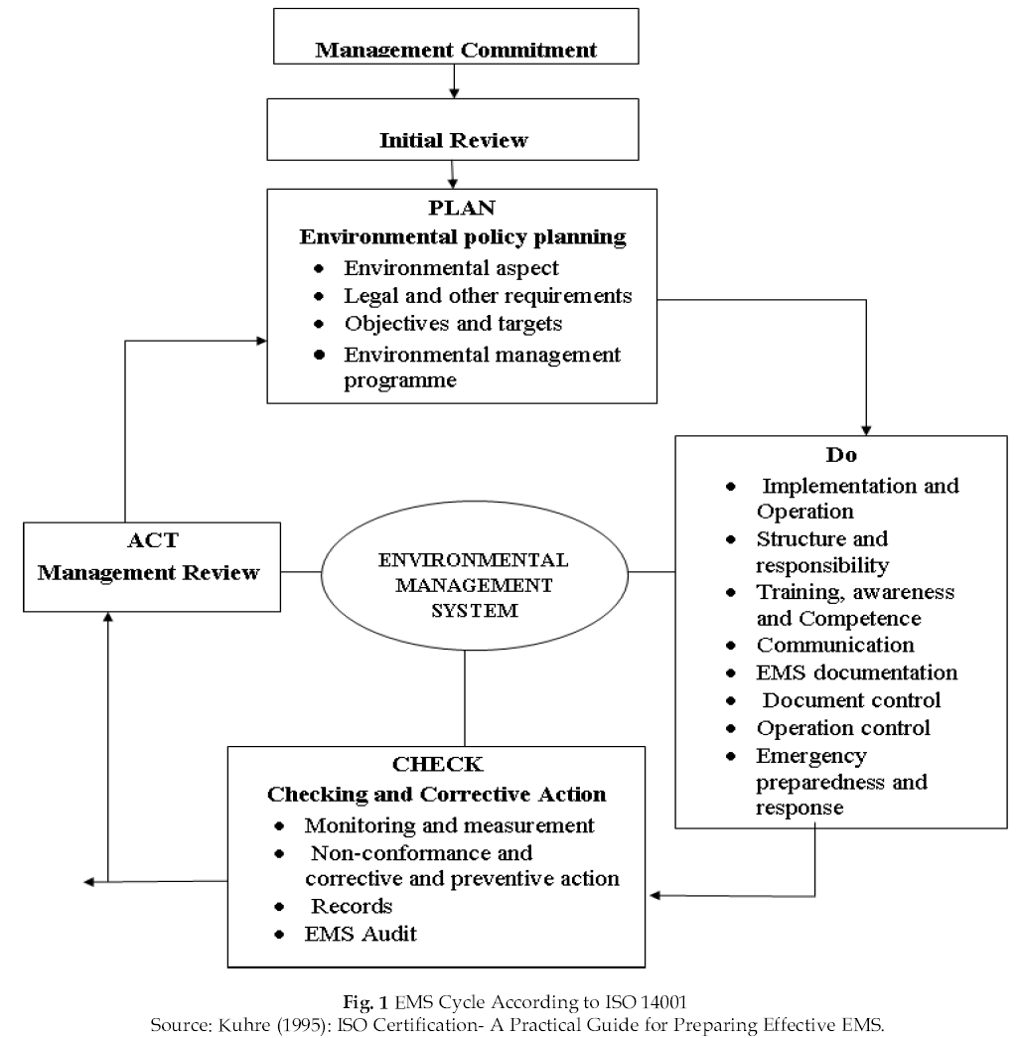
Figure 1
An inventory is then needed to access how the organization currently deals with environmental issues. This is the initial review and it focuses on all elements of which an EMS consists in order to see the activities that have been undertaken and with what results. Some of the topics to be treated here according to ISO 14001 include environmental impact, use of resources like raw materials, water and energy, relevant regulations, organizational structures and culture, products and marketing, training and communications, instructions and handling of incidents. Deficiencies will emerge as the system is used and the gaps that need to be filled will become clear.
The ‘Plan’ Phase
This stage is helpful in the formulation of an environmental policy. It serves the direction for future action and communication of the organization’s environmental commitment and targets. According to ISO (1996) environmental policy deals with: the nature, scale, and environmental impacts of the organization’s activities, products or services; a commitment to continual improvement and pollution prevention; a commitment to comply with relevant environmental legislation and regulations, and other requirements to which the organization subscribes; provides framework for setting and reviewing environmental objectives and targets; it is documented, implemented and maintained; it is communicated to all employees and; it is available to the general public.
Environmental policy and planning starts with the assessment of the environmental aspects and impacts of the organization’s activities, products and services (Kuhre, 1995). Aspects can be said to be the ‘potential effects’, which can be good or bad. They become impacts when they manifest themselves and lead to changes on the landscape. Aspects can be direct or indirect resulting respectively from the firm’s activities or from those of supplies.
The organization’s environmental programme specifies how the objectives and targets will be met by stipulating the actions, methods responsibilities, time frames and resources. These should be fully integrated in and coordinated with other areas of management and new structures can be identified if possible to enable total environmental management.
The ‘Do’ Phase
An organizational chart is defined and laid down at this stage in order to embed the environmental management in the organization. Individual roles and responsibilities are outlined in addition to the allocation of resources like finance, personnel, skills and technology. The next step is the identification of training needs to build environmental awareness and competence. This can be done from current staff or new employees recruited. Communication, both internally and externally is relevant for an EMS implementation since it helps keep people informed. Communication is best if it is top-down and bottom-up. It directs attention to the fact that environmental management involves more than a system with procedures, instructions, performance indicators, requirements and checks, laid down in manuals, plans, schemes and reports (ISO, 1996). Documentation is very important in any EMS since it points to implementation and operation. Document control entails designation of someone to be responsible for revision and change. Operations and activities must be controlled to ensure that policy addressing the most significant environmental aspects is carried out.
The ‘Check’ Phase
This stage aims at checking how the firm performs in terms of environmental management and if necessary, to analyze the causes of problems, identify possibilities for improvement and take subsequent action to realize these changes (ISO, 1996). Operations and activities of significant environmental impacts are to be monitored, their performance measured and compared with the objectives and targets, and compliance with regulations assessed.
The ‘Act’ Phase
Management review here aims at making sure that the EMS continues to produce the desired effects as outlined in the policy. Apart from the information derived from audits, other internal reports on performance and incidents, external reports on regulatory and environmental changes, and suggestions for improvement received from internal and external sources can play a role for the organization to act upon. The process is then repeated again. The drivers or motivations to use EMS are internal and external involving different forces.
Quality Management System In Pharmaceuticals
Implementation of an effective quality assurance policy is the most important goal of pharmaceutical industry. The concept of quality assurance and quality control together develops towards assuring the quality, safety and efficacy of pharmaceutical products. Thus, quality is critically important ingredient to organizational success today, which can be achieved by total quality management (TQM), an organizational approach that focuses on quality as an over arching goal, aimed at the prevention of defects rather than detection of defects. It is a philosophy and practice of integrative quality management system adopted worldwide in pharmaceutical industries along with other regulatory requirements. The TQM perspective views quality as the pivotal purpose of the organization. (Bhaskar et al., 2011)
This kind of training includes topics such as managing quality, quality processes, auditing, total quality, ISO standards, fault proofing, an adaptive learning culture and sustainable change vmanagement. This work describes the main predicted benefits according to the results of a European project which aimed to create and validate an online platform which was related to the field of quality management to provide effective quality training for SMEs. The international standards covered by this project are: ISO 9001 (quality management systems), ISO 14001 (environmental management systems) and HACCP (hazard analysis and control of the critical points) ( Inderscience Enterprises Ltd., 2011).
Rising to the challenge of increased scrutiny of drug quality and safety, seizing the opportunity for development, manufacturing, and distribution of pharmaceuticals for the global network and anticipating the rapid growth of the domestic pharmaceutical market in the years to come, China, with support from the international community, has been making sweeping changes to improve its environment for pharmaceutical R&D. The government, industry, and academia are joining together to improve the regulatory framework, industrial capacity, and human resources that will be needed( Mao Donglei, 2009)
Industrial Waste Management
Pollution prevention with the use of modern cleaner technologies in industrial sectors is the cornerstone of successful environmental policy certified according to the requirements of the international standard ISO 14001. The analyses were performed with the objective of assessing general aspects of technology modernization as a result of the ISO 14001 certification in industrial enterprises in order to develop a better understanding whether the ISO 14001 certification can accelerate initiatives for the adoption of new and cleaner technologies within the certified firms on one hand, and, on the other hand, to find out to what extent it helped to upgrade their environmental performance. companies which are committed to the IPPC Directive. Companies in chemical and related industries, to a much higher extent, used predominantly modified technologies to diminish their environmental impacts, while companies in metal industries, to a higher extent, used a combination of existing and new technologies after ISO 14001 certification. It seems that better environmental performance is associated with higher productivity in ISO 14001 certified firms (Radonjic, 2005)
With better awareness in today’s era, the nations and countries cannot ignore ecological issues, which includes the cleanness of municipalities and stronger community mandates for environmental accountability. The industrial wastes are volumes of the gaseous, liquid or hard wastes produced by developed and other industrial processes. These emissions are merely partially controlled by pollution manage methods. Industrial waste is discharged into the surroundings in substantial quantities. The matter of consequence is to what level and to what degree is this trash damaging to health and environment (Gupta, 1995).
A great deal of the country suffers as of a lack of potable water owing to industrial waste and undeveloped flow off that contaminates drinking irrigate supplies. Poverty and far above the ground population growth have aggravated, to an extent it has caused ecological dilemmas and problems (Ghaffar et al., 2000). Moreover, from viewpoint of a day-to-day routine, people throw away many things ranging from ordinary trash to old packaged items, cleaning resources and various junks, big quantities of pesticides and fertilizers are also on leach in the environment (Walton & Melnyk, 1998). It is obvious that the commodities i.e. food, drinks, clothing, medicines, furnishings, computers, cleaning resources, publications etc are in diverse forms of packaging. The main purposes of these packagings are to defend the contents from germs/viruses/dirt (Sarkis, 1995), hence, most of them are not destructive to the environment in conditions of toxicity, but their after use bulk cause and create the solid waste and hence the environmental degradations (Hanna & Newman, 1995). Other significant sources of pollution are transport and the pharmaceutical waste, (Johnson & Wang, 1998) are the causes of acute poison. Plastics can reason the blockage of drainage and hence water natural diseases (Batool & Ch, 2009).
This report focuses primarily on hazardous wastes, but will also provide a general overview of the other types of wastes generated by the pharmaceutical industry. Based on our SB 14 document reviews and site visits, we found that a large portionv of pharmaceutical facilities’ hazardous wastes are collected and sent off-site for incineration. In order to learn more about the Pharmaceutical industry’s overall waste management practices, we requested general waste information from the reporting facilities. Table 1 provides a compilation of data from those facilities that chose to respond. While Table 1 includes all wastes identified by our responders, the results for individual facility vary with no facility producing all of the wastes noted.
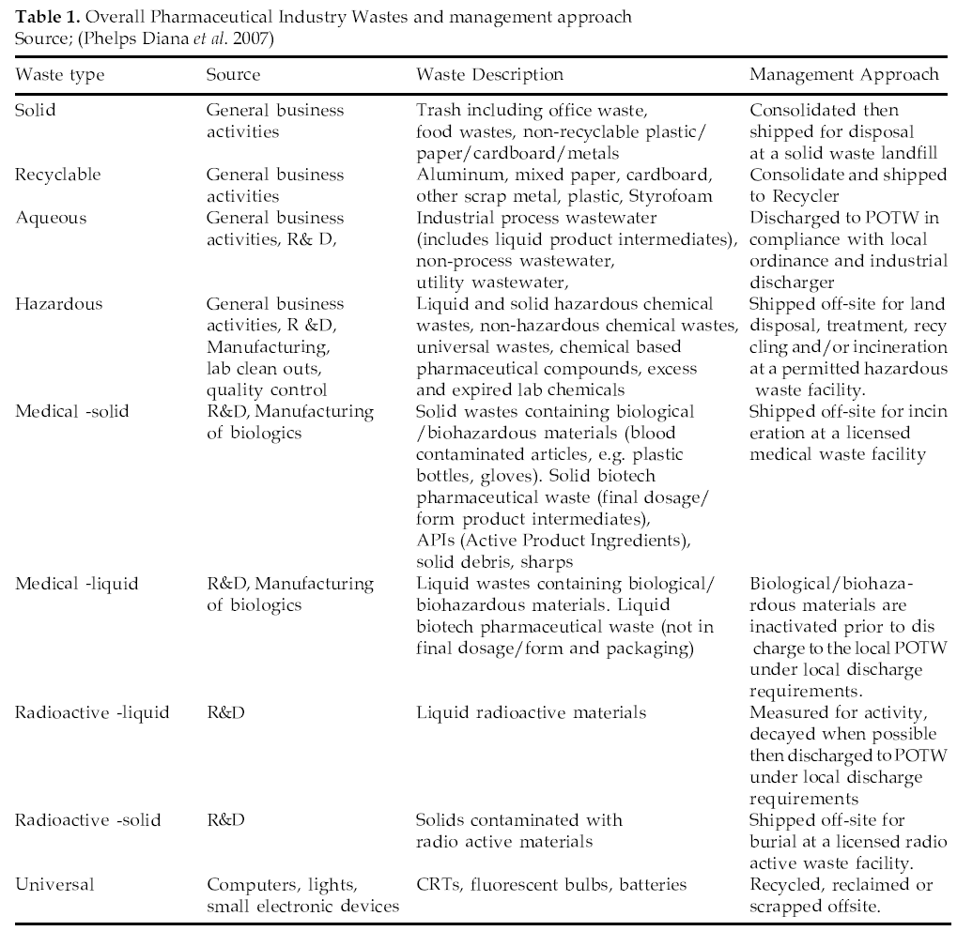
Table 1
The FDA (Food and Drug Administration) requires companies to conduct environmental assessments of the impact that their drug can have in the environment due to manufacturing related releases and also via human use.

Conclusion
The objective of this paper includes identifying actual and potential study of management, pollution control management, environmental management system, development and implementation of typical pharmaceutical plant and assessing the impact of new technology that may either improve or retard the prospects of pollution control management of environment. The goals are to meaningful data, unbiased analysis and assessment of the role of management technique will play in the future for the technology.
In this paper, has been evaluate and organized to assist all interested organizations in the development of an Environmental Management System (EMS) that is consistent with the ISO 14001 Standard, achieves
EMS Registration, and improves the overall environmental performance of the organization.
The study could not prove if standardized EMS results in significantly improved environmental performance, leading to decrease environmental impacts. The reliance on EIA, EMP and market incentives to influence environmental management is highly recommended, however this is not adequate in solving environmental problems in the country. It is essential for regulatory authorities, industrial associations, ENGOs and the media to embark on continued and ad hoc monitoring and inspection of factories for water pollution and hazardous wastes measurement. Industries need to establish waste treatment facilities to prevent or minimize pollution. Means should be found to include EMS within the environmental regulations. The sustainable use of resources could be encouraged through legislation, regulations, education and awareness creation activity as well as the enforcement of existing regulation, legislation and improve their environmental performance.

