Platform Manufacturing of Biopharmaceuticals

Objective and Scope

Technology and process platforms are now used extensively in the biopharmaceutical industry, both throughout the various phases of product development and in the facilities used to manufacture clinical and commercial biopharmaceutical products. This document provides background information on the practical application of technology & manufacturing platforms within the biopharmaceutical industry. While examples and references are primarily made to proteins, the principles and approaches may equally be applied to other biopharmaceutical product classes such as conjugate molecular vaccines, live viral vaccines and so on. The value of data and knowledge gathered from platform manufacturing or platform‐based process development is explored, and the advantages of the application and use of platforms, both to drug sponsors and the drug regulatory agencies, are considered.

Definitions

Platform technology / platform process: a common or standard method, equipment, procedure or work practice that may be applied to the research, development or manufacture of different products
Platform manufacturing: implementation of standard technologies, systems and work practices within manufacturing facilities, and their use for the manufacture of different products
OR
the approach of developing a production strategy for a new drug starting from manufacturing processes similar to those used by the same manufacturer to manufacture other drugs of the same type
QbD: Quality by Design

IND: Investigational New Drug
IMPD: Investigational Medicinal Product Dossier EBE: European Biopharmaceutical Enterprises Mab or mAb: Monoclonal antibody
HCP: Host cell protein
CHO: Chinese hamster ovary
GS‐NS0: Glutamine synthetase‐NS0

Introduction

A platform technology or process may be generally defined as a common or standard method, equipment, procedure or work practice that may be applied across multiple products under development or manufacture. For example, ‘platform’ may be used to refer to an expression system such as Chinese Hamster Ovary (CHO) cells, a high throughput screening system based on robotics, an analytical method such as capillary electrophoresis, a drug product formulation, a mode of cell culture such as perfusion culture, a process unit operation such as affinity chromatography or even a complete process comprising multiple unit operations, Figure 1.

Figure 1 Examples of different types of platform‐based tools or methods in biotechnology product development and manufacture. The term ‘platform’ can be applied broadly.
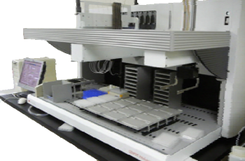
A cell line (expression system)
Robotics
Low pH Inactivation
Centrifuge Affinity
Capture
Ion Nanofiltration
UF/DF
A process
(ProA)
exchange (AEX)

The use of platform technologies emerged in biopharmaceutical product development programs during the 1990s and primarily focused on monoclonal antibody production processes, Figure 2. As companies’ biologics portfolios expanded to more than just a few molecules, the benefits of consistency and similarity of tools and methods across product development programs was becoming apparent. There are multiple benefits of using platform approaches for development and manufacturing.
Standardisation of approaches and tools across multiple products leads to improved quality and consistency, substantial cost‐savings primarily as a result of more efficient resource utilisation (equipment/people), and faster process and product development. Platform approaches provide deep understanding of the impact of the process design and control stategy on process performance and product quality. This would have benefits in the implementation of QbD, and in understanding the likely impacts of manufacturing deviations or process changes. The use of platform technologies represents considerable opportunities to reduce risk to patient safety, providing access to platform technologies with proven performance and known safety profiles. Platform technologies applied to a particular product type, for example monoclonal antibodies (Mabs), introduces a degree of consistency to the products under development thereby benefitting their process and clinical development. Modern commercial biotech manufacturing facilities are now beginning to use platform technologies and standardised work practices to create efficiencies and flexibility, and to be capable of the manufacture of multiple products using a consistent set of well‐established technologies.
In the past few years, platform approaches have evolved to a mature state within manufacturing operations of the biopharmaceutical industry. For many reasons, principally economic ones, commercial manufacturing facilities of the future must be capable of the manufacture of multiple products. Some newer facilities constructed in the past few years will have this flexibility built‐in, and will have the capability of manufacturing multiple products usually in a particular product family e.g., Mabs. The evolution of multi‐product facilities will be enabled through the implementation of standard technologies and work practices within the facilities (platform manufacturing),

and the development of similar processes from product to product using standardised technology and unit operations (platform processes) for transfer into these facilities.

Figure 2 The evolution of platform‐based approaches in biotechnology product development and manufacture. In the 1980s, platform approaches were not employed. Currently, platforms are widespread within product development organisations and many production facilities.




1980s 1990s 2000+

■ Companies often deve1ll9o9p0sing just one
lead product
■ Innovative and research-driven environment
■ Little focus on ‘manufacturability’. Any of a multitude of technologies selected to make product
■ No concept of “Platform”
■ Biotechnology products approved
■ New manufacturing facilities established
■ Broad array of technologies used e.g., batch, fed-batch, perfusion (multiple systems), roller- bottle culture, different cell lines etc. – ‘whatever worked!’
■ ‘Inflexible’ facilities
■ First Platform approaches introduced within company development programs
■ Mature Platforms within process and product development programs
■ Many manufacturing facilities using platforms and standardised practices and capable of multi- product manufacture
■ ‘New/different’ products (to a standard Mab) can still pose implementation issues for manufacture in established facilities


Maturation of Platform Technologies/Processes

Platform Manufacturing Approaches and their Application: Phases of Product Development and Commercial Product Manufacture

The pharmaceutical industry is continuously striving to increase the efficiency of process development in order to move promising products faster and more cost‐ effectively into clinical studies. One preferred approach for rapid implementation of manufacturing processes for new biologics is to develop and implement early‐stage platform processes that are designed to be suitable for the greater part of a company’s product pipeline. A major intent of the approach is to prevent process development and clinical material manufacture becoming bottlenecks in the overall clinical development of new products. For example, production cell lines are created using the same parental cell

line, a similar vector and transfection method, and selected using a standardised approach (usually a high‐throughput technology). The final choice of the production cell line would be based on its performance in the ‘platform process’ using standardized culture media and culture conditions and the product would be purified using the same series of downstream process steps: this is different to past approaches to process development whereby a new process would be developed to accommodate the recombinant cell line. The product would be formulated in a standard formulation (fixed buffer composition) and presented in a consistent format, generally lyophilised or liquid. Process platforms should, by definition, meet a number of a company’s pre‐determined requirements regarding yield, process operability, product quality and so on for early stage development programs.

A platform manufacturing process used in the clinical development phases would be expected to deliver the product requirements for supply of phase I clinical studies and would usually be satisfactory for phase II study supply. In some cases, a need for changes or improvements might emerge, e.g., to improve the robustness of the phase I process or to adjust or modify product quality attributes for phase II supply, but these changes would generally be slight modifications of the platform. Pivotal (phase III) clinical studies are usually supplied by the final version of the manufacturing process, and often at the intended manufacturing scale for commercial product supply. Late stage process development for phase III clinical material manufacture is usually based on the initial phase I/II platform process. Depending on the company’s development strategy, the need for optimization, and the availability of alternative innovative technologies, single or multiple steps of the phase I/II process might be re‐developed or optimised in order to specify the final, commercial manufacturing process.

The platform process concept allows the reconciliation of what might, at first pass, appear to be incompatible requirements and outcomes of process and product development. That is, reduced costs and duration of development programs (a concern

for the drug sponsors, and the patients waiting for drugs) can be matched with increased process understanding, increased consistency of quality and heightened assurance of safety (a concern for patients, the drug sponsors and the Health Authorities). The quality of a new product can be assessed much earlier in the development process owing to the availability of standard platform analytical methods which would be evaluated, adapted and optimized on previous projects. In addition, the knowledge accumulated on previous projects may be leveraged in order to predict process capabilities under a given set of operating conditions. The increased process knowledge accumulated from several years of experience with a platform process therefore creates opportunities to employ QbD‐ based approaches to process development, enabling the definition of unit operation and process design spaces and at the same time, decreasing the development workload for any given project. These benefits are linked to, and dependent on, the implementation and use of effective data and knowledge management systems.
Another opportunity is the concept of setting ‘platform specifications’ for new molecules for those product quality attributes that are common across most, if not all, mAb programs. The broad experience the industry has with multiple mAb programs in terms of patient exposure means that the specification‐setting exercise for a new program can be simplified for a number of “standard” attributes by defaulting to a template list of limits. This would primarily encompass those attributes that are related to “safety” of the product, for example purity, percent aggregate, percent residual DNA, percent residual HCP, and endotoxin (if normalized based on highest target dose). In keeping with regulatory expectations, these specifications could be relatively broad for phase I clinical programs, so that clinical trial data are acquired with product that has some range of attribute variability, and then systematically tightened as more manufacturing experience with the particular molecule is gained and process capability is understood. An extension of this concept would be to apply “platform specifications” even to those structural characteristics, such as oxidation, disulphide content, N‐terminal and C‐terminal

modification, glycosylation variants, etc., that have been shown through structure‐activity studies to be not significant for the activity of a particular new product.
Platform processes are currently most established in the biopharmaceutical industry for the manufacture of monoclonal antibodies. Monoclonal antibodies are regarded as well‐characterized molecules and are known to exhibit very similar physico‐chemical properties. In these cases, development and application of a platform process is regarded as cost‐reducing, efficiency‐increasing and in general, accelerative of programs. Most of the process platforms developed for monoclonal antibodies are based on a standard process structure: fed‐batch cell culture usually in chemically‐defined media, clarification by centrifugation and/or depth filtration, affinity chromatography capture, low pH viral inactivation step, followed by a combination of polishing steps including an anion exchange chromatography step (bind/elute or flow‐through mode), a cation exchange chromatography step, a virus filtration step, and the final UF/DF and filtration steps. The main benefits of an established platform process such as this include;

- Reduction of process development effort, time and costs.
- Prior platform data informs risk assessments on new process weak‐points, and focuses development effort where most needed.
- Consistency in process performance and product quality (especially important when developing a particular class of products, e.g., monoclonal antibodies
- Simplification of technology transfer activities to production facilities
- Improved asset utilisation: one facility / same equipment for multiple products
- Documentation preparation can be simplified; e.g., only minor adjustments to production batch records may be required from one process (product) to the next
- Ability to translate learnings from one product to another as process database grows. Greater significance of a ‘multi‐product’ dataset as compared to a ‘one‐off’ study on a single product.
- Raw materials and consumables are standardized allowing the use of materials with safety profiles proven to be acceptable, cost reductions through volume

purchasing and waste reduction as inventory stocks may be used across several different products
- Reduction in time and resources leading up to and including pre‐clinical and clinical studies
- Reduction in failure rates during manufacturing due to accumulated process experience
- Reduced personnel training burden owing to similar processes and equipment
- Improved speed through repetition
- Routine procedures for in‐process and batch release testing lead to reduction of errors
- ‘Platform specifications’ for early‐phase clinical programs
- Broad database and experience to speed troubleshooting of manufacturing processes
- Preparation of INDs/IMPDs/marketing authorisation applications may be facilitated more readily: pre‐populated templates may be created which reduce the time necessary for manufacturers to author and prepare the submissions

A platform process should not be regarded as a static, non‐changing procedure. Its performance should be reviewed on a periodic basis. The manufacturer should ensure that the platform process is delivering a minimum acceptable level of process robustness, product yield, product quality etc. during clinical development of different products: these criteria would be developed based on a company’s own specific needs. Changes to the platform should be introduced through controlled implementation of improvements and uptake of innovations. Such controls are important to understand the impact of improvements on the platform.

Presentation of Platform Process Data for Regulatory Review

Regulatory submissions efforts become more efficient through the use of platform process‐based data and knowledge. Internal to companies, templates may be created for

sections of IND/IMPD and commercial licensure submissions which reduce the time necessary for manufacturers to author the submissions. Regulatory agency reviewers will also appreciate submissions that make use of platform‐based knowledge to demonstrate more complete understanding of the manufacturing process and the product. Site inspections, especially for multi‐product plants, can also be simplified when platform approaches have been used, owing to the reduced number of unique manufacturing processes and the concomitant reduction in complexity of the associated quality systems necessary to manage them.
Platform data should also prove useful to streamline the filing process for post‐ approval changes to a manufacturing process or analytical method. For example, in instances where there is sufficient platform and product‐specific evidence that changes to manufacturing steps and/or equipment or changes to analytical methods etc. have no impact on the quality, safety or efficacy of the product, then it may be possible to downgrade the classification of the post‐approval submission.

The application of platform‐based experience and data to newer products under development without necessarily having to re‐do every study for every product signals a maturation of the science, experience and knowledge underpinning biotechnological drug development. While there will always be some product‐specific nuances to deal with in every development program, we are entering the phase of evolution of the industry where platform data are available to be presented for review to support clinical trial and marketing authorisation applications. These platform data packages might include those describing viral clearance capabilities of process steps, clearance of process related impurities, cleaning regimes for process equipment etc. How might these data be made available for review? Some possible means are considered here using a viral clearance step as an example (Figure 4), but as stated previously, the principles are not exclusive to viral clearance/inactivation unit operations. Current filing structures and mechanisms in place in many global regions at present do not work as described in Figure 4: this discussion below is intended to explore possibilities.

Platform‐process data could be compiled for multiple products to demonstrate generic applicability of the viral clearance step. Additional development data could also be presented, demonstrating the robustness of the step across the intended ranges of critical process parameters e.g., pH, temperature, time etc. and other process conditions providing assurance that the step performs acceptably within the operating ranges intended for manufacture. This data package as a whole could be submitted for each product in each clinical trial application or alternatively, might be lodged in a reference document similar to a Drug Master File at the agency and would be available for consultation by reviewers at each new clinical trial application submission by the drug sponsor. The reference document or ‘Master File’ could be updated by the drug sponsor if a significant process change was introduced to the viral clearance step, or if a new replacement clearance step was introduced. If available data were insufficient to support the generic applicability of the changed or replacement clearance step across multiple products, product‐specific virus clearance data would be submitted under normal practice until data accumulate to support the step as a platform or ‘generic’ step. The ‘Master File’ would then be updated with new data, and the package applied to subsequent products under clinical trial or marketing authorisation application.

Figure 4 Possibilities for presentation of platform‐derived data for regulatory review. A ‘generic’ virus clearance data package is shown as an example, but this illustration could apply to any package of platform process data. Data could be presented for review by submitting the same data package with each new clinical trials application (Path A) or presented once to the agency to be maintained as a type of ‘Master File’ (Path B). The principles shown could equally be applied to Marketing Authorisation Applications.

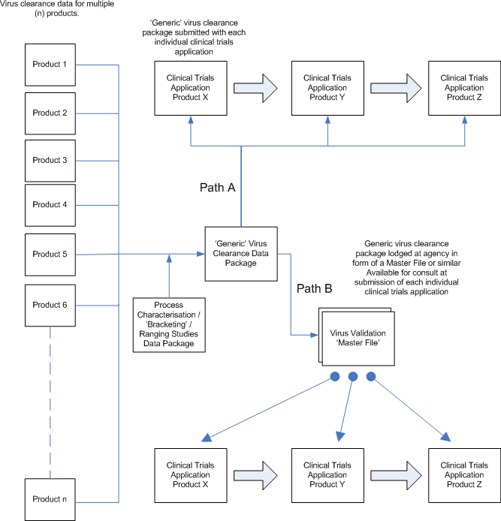

Conclusions

The evolution and benefits of platform technology and processes throughout biopharmaceutical drug development and manufacture have been discussed. The benefits of using a platform approach are apparent: standardisation of approaches and tools across multiple products leads to improved quality and consistency, substantial

cost‐savings, efficient resource utilisation (equipment/people) and faster process and product development. Modern commercial manufacturing facilities use standard/platform technologies and work practices to improve efficiencies and flexibility, and to be more capable of the manufacture of multiple products. Platform process‐ derived data at many drug developers/manufacturers have accumulated to extensive databases. The biopharmaceutical industry, including the regulatory bodies/health authorities, is now in a position to exploit these data to improve biopharmaceutical drug development, manufacture and regulation.

