What is LoRaWAN? 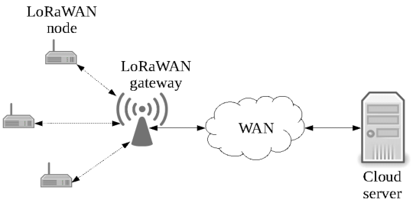
The LoRa Alliance describes LoRaWAN as, "a Low Power, Wide Area (LPWA) networking protocol designed to wirelessly connect battery operated ‘things’ to the internet in regional, national or global networks, and targets key Internet of Things (IoT) requirements such as bi-directional communication, end-to-end security, mobility and localization services.".

LoRa and LoRaWAN

The LoRaWAN protocol is a Low Power Wide Area Networking (LPWAN) communication protocol that functions on LoRa. The LoRaWAN specification is open so anyone can set up and operate a LoRa network. LoRa is a physical layer protocol that uses spread spectrum modulation and supports long-range communication at the cost of a narrow bandwidth. It uses a narrow band waveform with a central frequency to send data, which makes it robust to interference.

Characteristics of LoRaWAN technology

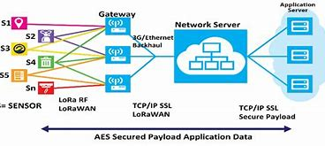

- Long range communication up to 10 miles in line of sight.
- Long battery duration of up to 10 years. For enhanced battery life, you can operate your devices in class A or class B mode, which requires increased downlink latency.
- Low cost for devices and maintenance.
- License-free radio spectrum but region-specific regulations apply.
- Low power but has a limited payload size of 51 bytes to 241 bytes depending on the data rate. The data rate can be 0,3 Kbit/s – 27 Kbit/s data rate with a 222 maximal payload size.

Advantages of loRaWan:

- LoRaWAN (Long Range Wide Area Network) is a wireless communication protocol designed for low-power, wide-area networks. Here are some advantages of LoRaWAN:

- Long Range: LoRaWAN offers exceptional range capabilities, enabling communication over several kilometers in outdoor environments. This makes it suitable for applications that require wide coverage areas, such as smart cities, agriculture, and industrial monitoring.

- Low Power Consumption: LoRaWAN devices are designed to operate on low power, which allows for extended battery life. This makes it ideal for applications where devices need to operate for long periods without frequent battery replacements, such as remote sensors and asset tracking.

- Scalability: LoRaWAN networks can support thousands of devices simultaneously. The protocol utilizes a star-of-stars topology, allowing for easy deployment and management of devices within the network infrastructure.

- Cost-effective: LoRaWAN operates in unlicensed frequency bands, which reduces deployment costs and eliminates the need for costly infrastructure setup. The technology's low-power requirements also contribute to overall cost savings by reducing energy consumption and maintenance expenses.

- Flexibility: LoRaWAN supports bi-directional communication, enabling devices to both transmit data and receive commands or updates from the network. It offers different classes of devices to accommodate various applications, allowing for customization and flexibility in network design.

- Security: LoRaWAN incorporates robust security measures to protect data transmission. It uses AES-128 encryption for secure communication between devices and the network server. Additionally, LoRaWAN supports end-to-end encryption and device authentication to ensure data integrity and prevent unauthorized access.

- Interoperability: LoRaWAN is an open standard, which means that devices from different manufacturers can work together seamlessly within the same network. This promotes interoperability and fosters a diverse ecosystem of devices and solutions.

- These advantages have made LoRaWAN a popular choice for a wide range of applications, including smart city infrastructure, environmental monitoring, asset tracking, agriculture, and industrial automation, among others.
Disadvantages of loRaWan:
- While LoRaWAN offers several advantages, it's important to consider some of its potential disadvantages:

- Lower Data Rates: LoRaWAN prioritizes long-range coverage and energy efficiency over high data rates. As a result, the data transmission speed is relatively low compared to other wireless protocols like Wi-Fi or cellular networks. This limitation makes it less suitable for applications that require real-time, high-bandwidth data transfer.

- Limited Bandwidth: LoRaWAN operates in unlicensed frequency bands, which means the available bandwidth is shared with other devices and technologies. In congested areas or environments with numerous LoRaWAN devices, the available bandwidth may become limited, potentially affecting network performance.

- Network Capacity: While LoRaWAN can support thousands of devices, the network's overall capacity is limited. In scenarios where a large number of devices are concentrated in a specific area, such as densely populated urban environments, the network's capacity may be strained, leading to reduced performance or potential connectivity issues.

- Limited Message Length: LoRaWAN imposes restrictions on the length of messages that can be transmitted, typically in the range of a few hundred bytes. This limitation can be a challenge when trying to transmit larger data sets or when dealing with complex protocols that require extensive message exchanges.

- Latency: Due to its low-power, long-range nature, LoRaWAN introduces some latency in data transmission. The time required to send data from a device to the network server and receive a response can be longer compared to technologies like Wi-Fi or cellular networks. This latency can impact real-time applications that require immediate responsiveness.

- Regulatory Constraints: LoRaWAN operates in unlicensed frequency bands, which means that the use of these bands is subject to regulatory constraints and limitations imposed by local authorities. Compliance with these regulations may require additional considerations and adjustments in deployment.

- Limited Mobility Support: LoRaWAN is primarily designed for static or slow-moving devices rather than high-speed mobile applications. While it can support some degree of mobility, its range and network handover capabilities are not optimized for fast-moving devices like vehicles or high-speed trains.

- It's important to evaluate these disadvantages in the context of specific use cases and requirements to determine whether LoRaWAN is the appropriate solution or if other wireless technologies may be more suitable.

Comparing loRaWan with other internet protocol:

Comparing lorawan with bluthooth:

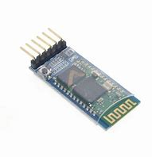vs 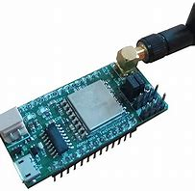
- Range: LoRaWAN offers significantly longer range compared to Bluetooth. LoRaWAN can achieve coverage over several kilometers in outdoor environments, while Bluetooth typically has a range of around 100 meters (Bluetooth Low Energy) or 10 meters (Classic Bluetooth).

- Power Consumption: LoRaWAN is designed to operate on low power, enabling long battery life for connected devices. Bluetooth, particularly Bluetooth Low Energy (BLE), also emphasizes power efficiency, but it consumes more power compared to LoRaWAN. Bluetooth Classic consumes even more power than BLE.

- Data Rate: Bluetooth generally provides higher data transfer rates compared to LoRaWAN. Bluetooth technology can support higher bandwidth applications, such as streaming audio or transferring files, while LoRaWAN is optimized for low-data-rate applications, focusing on small periodic data transmissions.

- Application Focus: Bluetooth is commonly used for short-range wireless communication between devices in personal area networks (PAN). It is often employed for connecting peripherals like headphones, speakers, keyboards, and fitness trackers to smartphones or computers. LoRaWAN, on the other hand, is designed for long-range, low-power applications that require wide area coverage, such as smart city infrastructure, agriculture, and industrial monitoring.

- Network Topology: Bluetooth typically operates in a point-to-point or star network topology, connecting devices to a central hub. LoRaWAN, in contrast, uses a star-of-stars topology, allowing devices to communicate directly with gateways that act as intermediaries between the devices and the network server.

- Scalability: Both Bluetooth and LoRaWAN can support multiple devices, but LoRaWAN is better suited for large-scale deployments with thousands of devices spread across wide areas. Bluetooth is more commonly used for smaller networks or one-to-one device connections.

- Interoperability: Bluetooth has excellent device interoperability, with standardized profiles that ensure compatibility between different manufacturers' devices. LoRaWAN also promotes interoperability, but due to its open standard nature, it may require more attention to ensure compatibility and adherence to regional regulatory requirements.

- Ultimately, the choice between LoRaWAN and Bluetooth depends on the specific requirements of the application. If long-range coverage, low power consumption, and wide area connectivity are crucial, LoRaWAN is a suitable choice. Bluetooth, on the other hand, excels in short-range, high-bandwidth applications that require device-to-device connectivity within close proximity.

Comparing loraWan with WiFi:
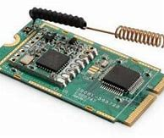vs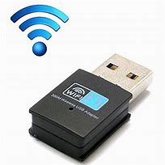
- Range: LoRaWAN offers much longer range compared to Wi-Fi. Wi-Fi typically has a range of around 30 meters indoors and up to a few hundred meters outdoors, while LoRaWAN can achieve coverage over several kilometers in outdoor environments.

- Power Consumption: LoRaWAN is designed for low-power, battery-operated devices, offering extended battery life. Wi-Fi devices consume more power compared to LoRaWAN, which can result in shorter battery life for battery-powered devices.

- Data Rate: Wi-Fi provides significantly higher data transfer rates compared to LoRaWAN. Wi-Fi can support high-bandwidth applications, such as video streaming, file transfers, and online gaming, while LoRaWAN is optimized for low-data-rate applications that require intermittent, small data transmissions.

- Coverage Area: Wi-Fi is typically designed for local area network (LAN) deployments, providing coverage within a limited area like a building or a specific space. LoRaWAN, on the other hand, is designed for wide area coverage, making it suitable for applications that require connectivity over a larger geographic area.

- Network Topology: Wi-Fi operates in a point-to-point or infrastructure mode, where devices connect to a central access point (AP) or router. LoRaWAN, in contrast, uses a star-of-stars topology, with devices communicating directly with gateways that serve as intermediaries between the devices and the network server.

- Interference and Spectrum Usage: Wi-Fi operates in licensed or unlicensed frequency bands, which can result in congestion and interference in areas with numerous Wi-Fi networks. LoRaWAN uses unlicensed frequency bands, but it employs a spread spectrum technique that provides robustness against interference and allows for efficient spectrum usage.

- Deployment Cost: Wi-Fi infrastructure typically requires access points, routers, and wired network connections, which can result in higher deployment costs compared to LoRaWAN. LoRaWAN, with its long-range capabilities and low-power requirements, can be deployed with fewer gateways and at lower infrastructure costs.

- Application Focus: Wi-Fi is commonly used for high-bandwidth, real-time applications that require fast data transfer and low latency, such as streaming media, online gaming, and video conferencing. LoRaWAN is well-suited for low-power, long-range applications that involve intermittent or periodic data transmission, such as smart city infrastructure, asset tracking, and environmental monitoring.

- When choosing between LoRaWAN and Wi-Fi, it's important to consider the specific requirements of the application, including range, power consumption, data rate, and coverage area, to determine the most suitable wireless technology.

Comparing loRaWan with RFID:

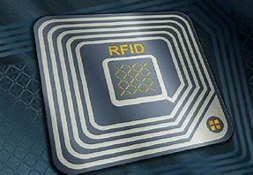 VS 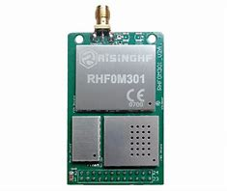

- Communication Range: LoRaWAN typically offers a longer communication range compared to RFID. LoRaWAN can transmit data over several kilometers, while RFID has a much shorter range, typically within a few meters or centimeters.

- Identification Capability: RFID is primarily used for identification purposes, allowing the unique identification of objects or tags. Each RFID tag contains a unique identifier that can be read by an RFID reader. LoRaWAN, on the other hand, provides both identification and data communication capabilities, allowing for bi-directional data exchange between devices and the network.

- Power Source: LoRaWAN devices can be battery-powered, enabling long-lasting operation. RFID tags, in contrast, are typically passive and do not have their own power source. They draw power from the RFID reader's electromagnetic field during communication, which limits their operational lifetime and range.

- Data Transfer: LoRaWAN supports the transmission of larger amounts of data, enabling the exchange of sensor data, status updates, and more. RFID, however, is primarily used for transmitting small amounts of data, such as identification numbers or basic information.

- Network Infrastructure: LoRaWAN requires the deployment of gateways and network servers to establish a network infrastructure. RFID, on the other hand, operates in a peer-to-peer or point-to-point manner, typically involving an RFID reader directly communicating with RFID tags.

- Scalability: Both LoRaWAN and RFID can support a large number of devices. LoRaWAN is designed to handle thousands of devices simultaneously, making it suitable for applications with a massive number of connected devices. RFID can also handle multiple tags within the range of the reader, but scalability may be limited by the number of readers and the simultaneous reading capabilities of the system.

- Application Focus: LoRaWAN is commonly used for wide area applications, such as smart city infrastructure, asset tracking, agriculture, and industrial monitoring. RFID is often used for applications like inventory management, access control, supply chain management, and asset tracking in shorter-range scenarios.

- Cost: The cost of implementing LoRaWAN and RFID can vary depending on the specific application requirements. Generally, RFID tags are relatively low-cost, but the cost of RFID readers and infrastructure can add up. LoRaWAN may require more initial investment in gateways and network infrastructure but can provide more extensive coverage and flexibility in the long run.

- The choice between LoRaWAN and RFID depends on the specific application requirements, including range, data transfer needs, power source, and scalability. LoRaWAN is more suitable for long-range, bi-directional data communication applications, while RFID excels in shorter-range identification and tracking applications.

