Cyber bullying, hacking, cracking-
- Cyberbullying: Cyberbullying refers to the use of digital technologies, such as social media, messaging apps, or online forums, to harass, intimidate, or humiliate individuals. It involves the deliberate and repeated targeting of someone through electronic means to cause emotional distress or harm. Cyberbullies may engage in activities such as sending threatening messages, sharing embarrassing or private information, spreading rumors, or posting derogatory comments. The anonymity and wide reach of the internet amplify the impact of cyberbullying, making it more difficult for victims to escape or seek help. Cyberbullying can have severe consequences on the mental and emotional well-being of individuals, leading to depression, anxiety, social isolation, or even self-harm. 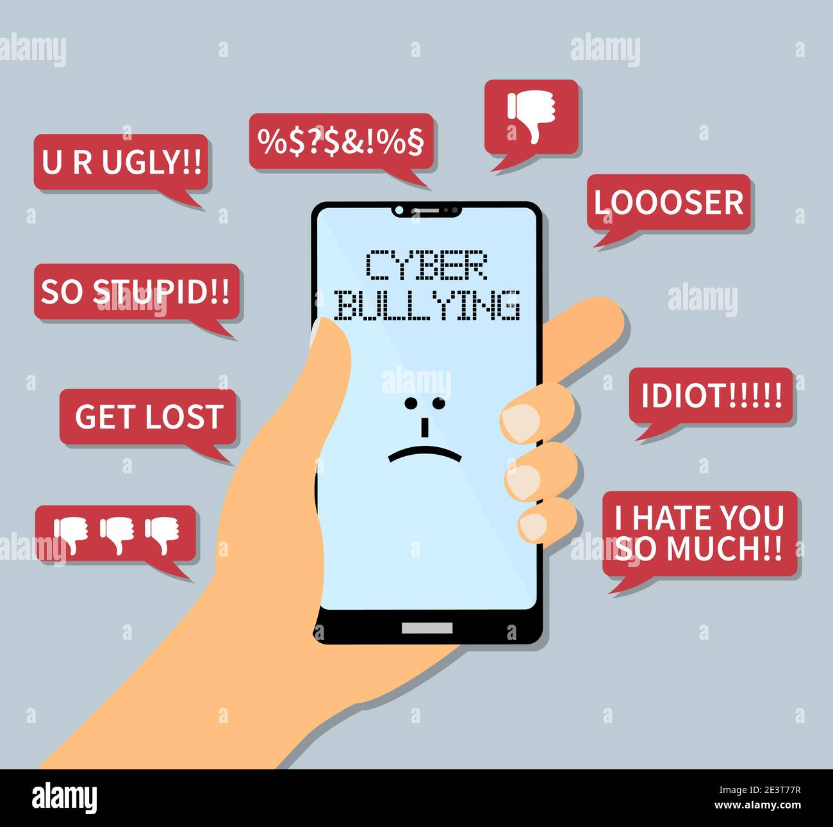
- Hacking: Hacking involves gaining unauthorized access to computer systems, networks, or electronic devices. Hackers exploit vulnerabilities in software, systems, or networks to breach security measures and access confidential or sensitive information. Hacking can be motivated by various factors, including financial gain, political activism, personal gratification, or sabotage. Depending on the intent and actions performed, hacking activities can range from relatively benign exploration to more malicious actions such as data theft, system disruption, or the creation of backdoors for future exploitation. Ethical hacking, also known as penetration testing or white-hat hacking, involves authorized individuals testing the security of systems to identify vulnerabilities and assist in strengthening defenses.
- Cracking: Cracking, often used interchangeably with hacking, specifically refers to the unauthorized modification or circumvention of software or digital content protection mechanisms, such as software licensing or copy protection. Crackers aim to remove or bypass restrictions on software usage, access premium features without payment, or create counterfeit copies of protected content. Cracking typically involves tampering with the code or altering system configurations to deceive the software into behaving as if it has been legitimately licensed or authorized. Crackers may distribute these modified versions of software or copyrighted content through illicit channels, contributing to copyright infringement and financial losses for software developers or content creators.
It is important to note that while hacking and cracking are often associated with illegal activities, ethical hacking and software cracking (for research or personal experimentation, with permission) are recognized in specific contexts. However, engaging in unauthorized hacking or cracking activities without proper consent or legal authority is illegal and can lead to severe legal consequences.

