Data diddling, salami attacks, phishing-
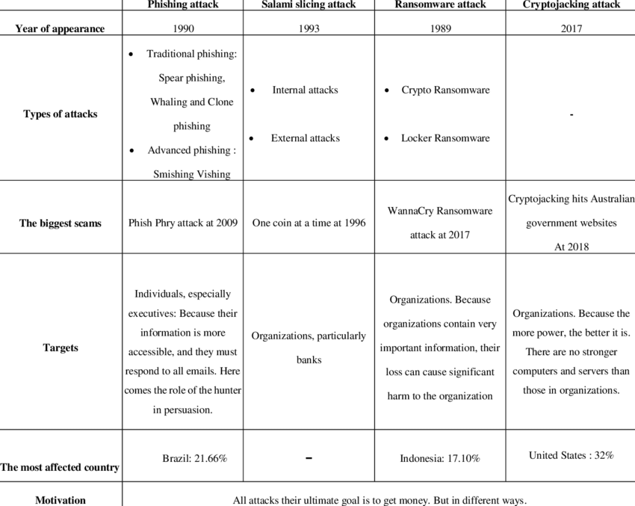
- Data Diddling: Data diddling, also known as data manipulation, is a form of cybercrime where unauthorized modifications or alterations are made to data in order to deceive or gain an advantage. It involves tampering with data in a way that may go undetected, resulting in fraudulent or misleading information. Data diddling can occur at various stages, such as during data entry, transmission, storage, or processing. It can be carried out by individuals with authorized access to the data or through unauthorized access gained by exploiting vulnerabilities in computer systems or networks. 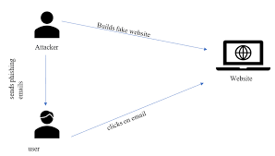
The goal of data diddling is typically financial gain or covering up other illicit activities. For example, an employee might manipulate financial records to divert funds into their own account, or an attacker might modify data to alter the outcome of a transaction or gain unauthorized access to sensitive information. Data diddling can have serious consequences, including financial losses, compromised integrity of data, and damage to reputation.
- Salami Attacks: Salami attacks, also known as salami slicing or penny shaving attacks, involve stealing small amounts of money or resources from a large number of transactions over time. The idea behind a salami attack is to take such small amounts that they go unnoticed individually but accumulate into significant gains when done repeatedly. 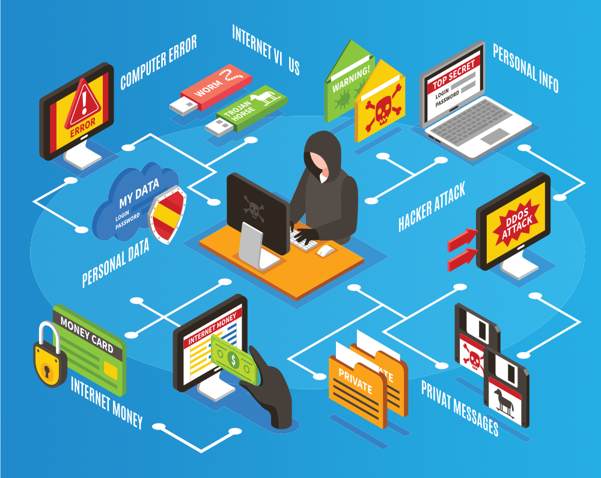
In the context of cybercrime, salami attacks often occur in financial systems or online transactions. For example, a perpetrator might round down fractions of currency during financial transactions and redirect those fractions into their own account. Over time, the accumulated fractions can result in substantial financial gain for the attacker.
Salami attacks can be difficult to detect as they involve minimal alterations to each transaction. Organizations need robust fraud detection mechanisms and monitoring systems in place to identify and prevent such attacks.
- Phishing: Phishing is a type of cyber attack where attackers deceive individuals into revealing sensitive information, such as usernames, passwords, credit card details, or other personal information. Phishing attacks typically occur through fraudulent emails, text messages, or websites that mimic legitimate entities, such as banks, social media platforms, or online services.
Attackers use various social engineering techniques to make their communications appear legitimate and trustworthy. They often create a sense of urgency or create scenarios that require immediate action from the targeted individual. For example, a phishing email may claim that the recipient's account has been compromised and prompt them to click on a link to verify their account details, leading to a fake website where the information is captured.
The purpose of phishing attacks is to gain unauthorized access to sensitive information, commit financial fraud, or facilitate other cybercrimes. It is crucial for individuals to exercise caution when interacting with emails, messages, or websites, and to verify the authenticity of communication channels before providing any personal or sensitive information.
Protecting against phishing involves being vigilant, avoiding clicking on suspicious links or downloading attachments from unknown sources, and regularly updating security software and applications.
It's important to stay informed about these types of cybercrimes and to take necessary precautions to protect personal information and assets from malicious actors.

